Orgaplex-Analyzer Guide

Step 1: Open Visual Studio Code (VS Code) and Open the Software:

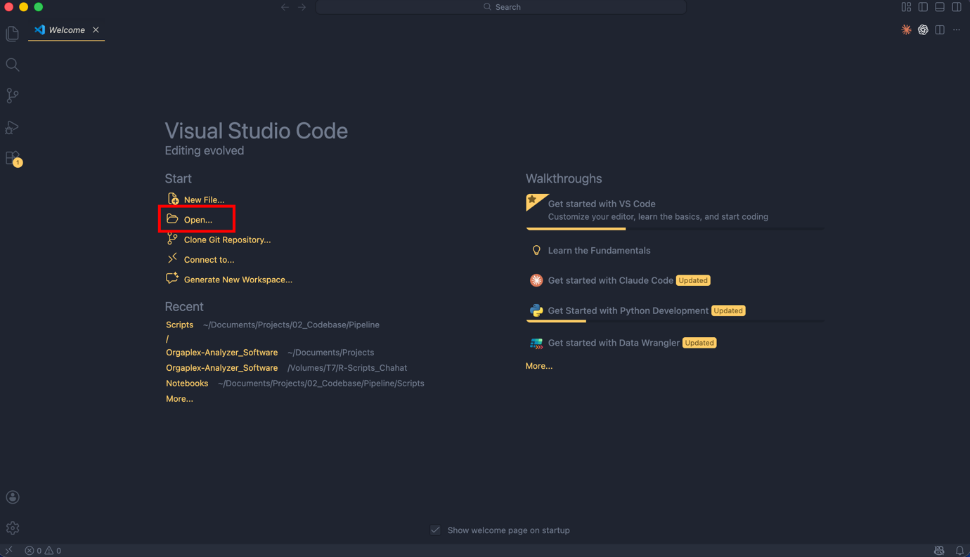

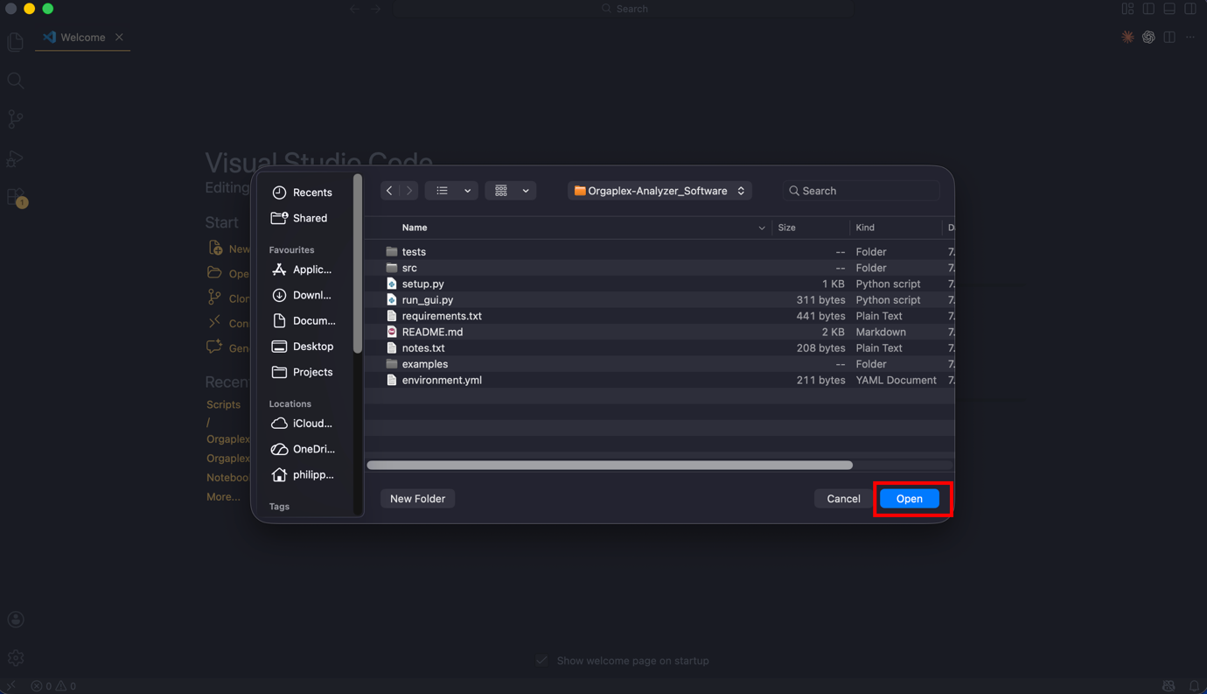
Step 2: Select the correct Conda Environment

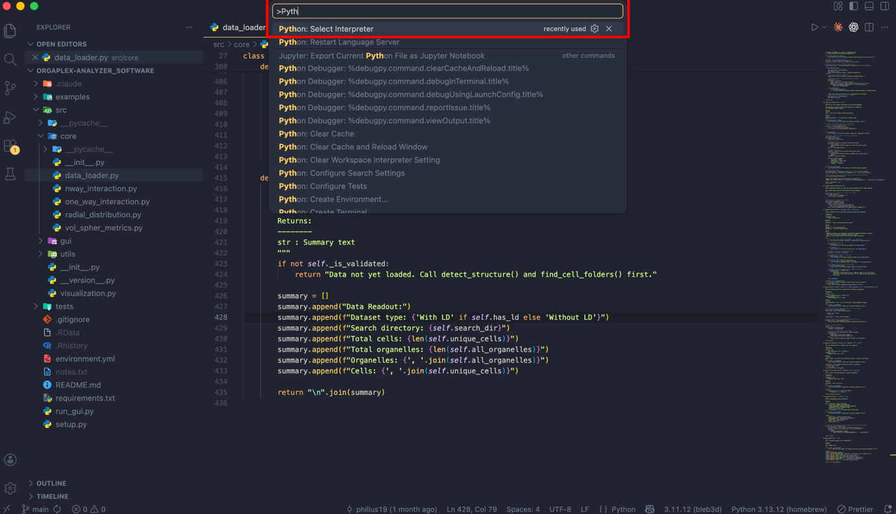
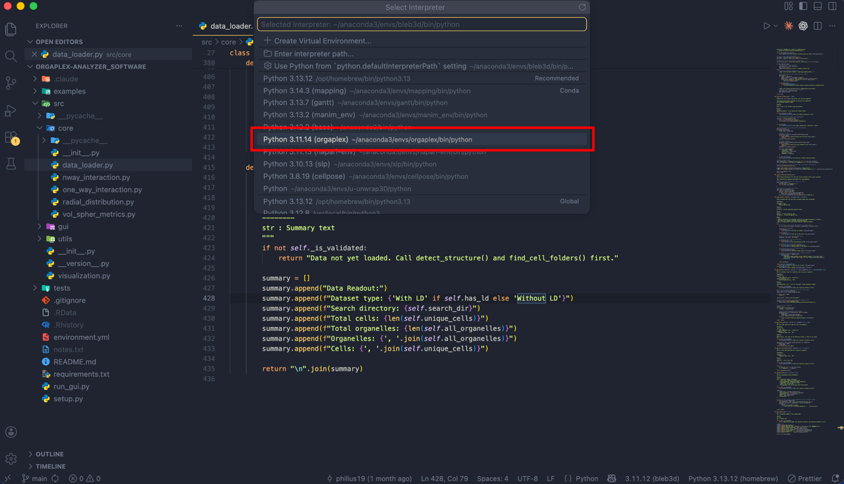

After you have selected the correct environment, you should see the active environment here:
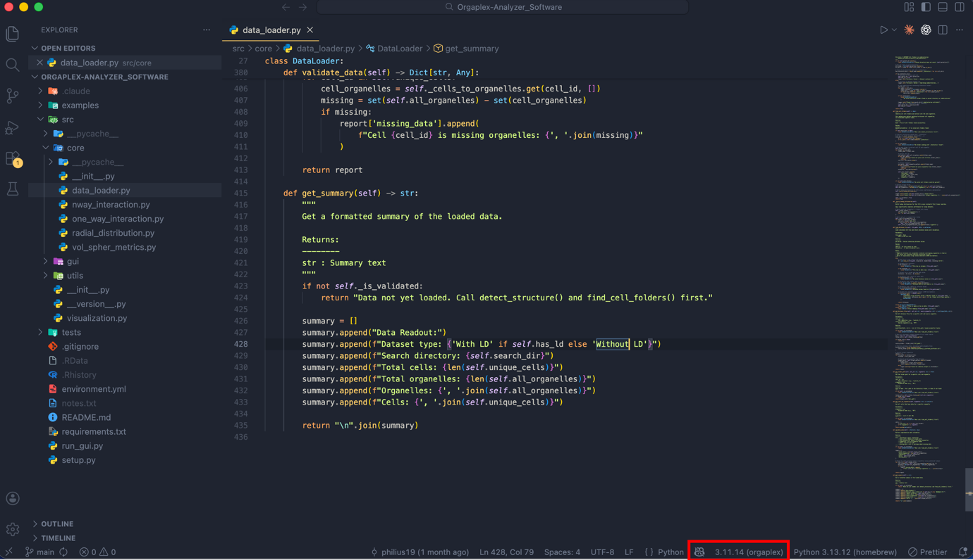
Step 3: Start the GUI
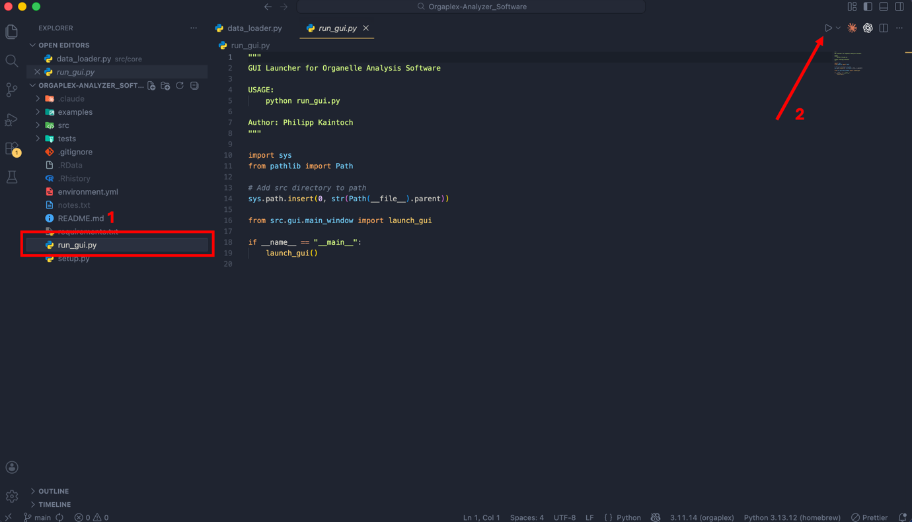

Step 4: Set parent-dir into input + define your Output dir
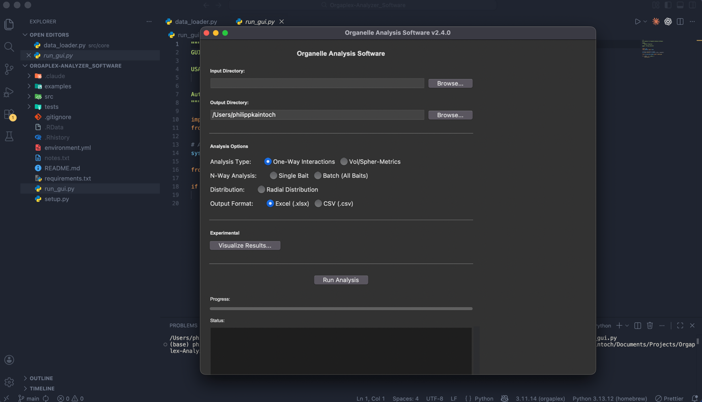

When you decide to use the Radial Distribution Module for Data analysis, please also try the “Visualize Results…” button. This is experimental and should provide you an initial visualisation of the output data. I am looking forward for feedback .

