Homework 0

Philip Kirwin

20067261

CMPT 440

January 30, 2019

Java and Java Compiler Versions

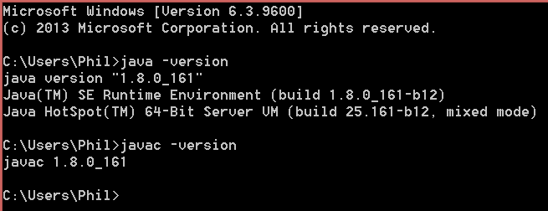

GitHub profile

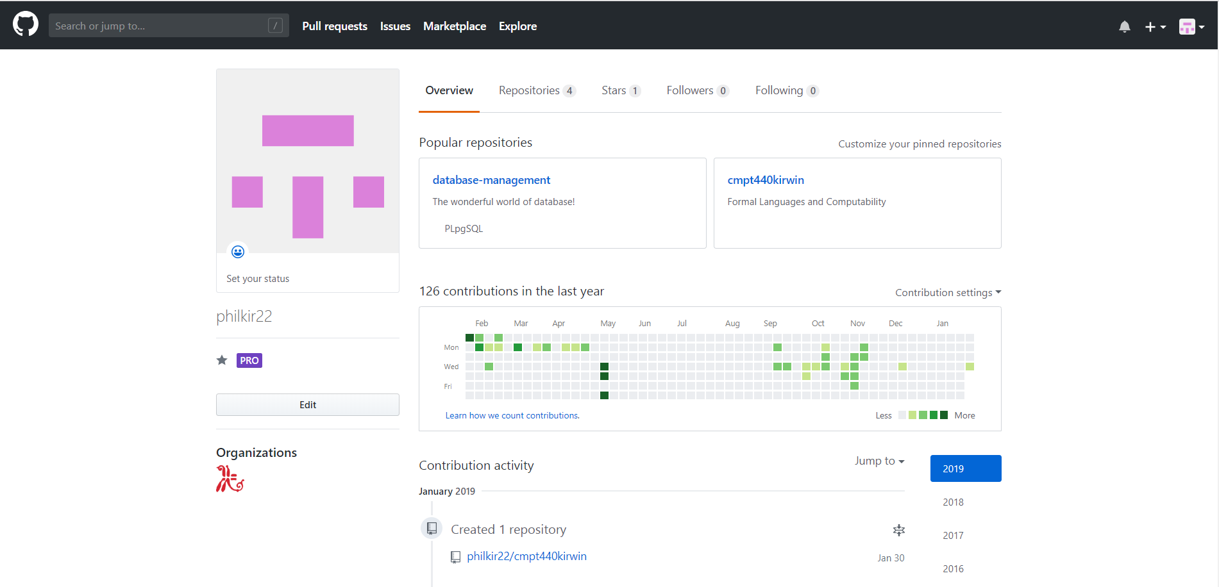

Repository working properly

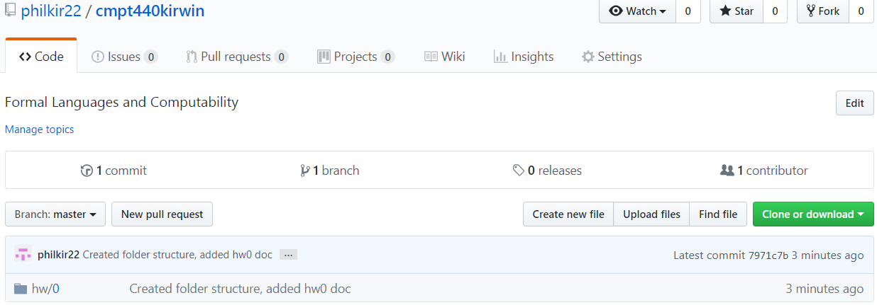

HTTPS link to this repository

<https://github.com/philkir22/cmpt440kirwin>

Proof of work being done on my computer

