Energy Harvesting Circuit

5V DC Signal

Buck Converter

Full Bridge Rectifier & Capacitor

Bottle Generator

Boost Converter

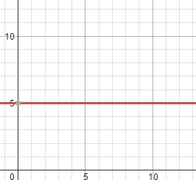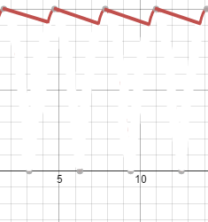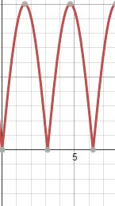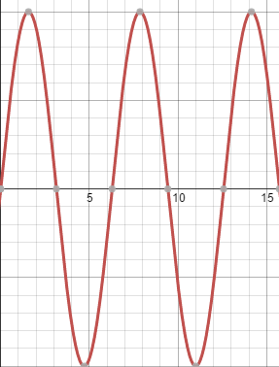

Devices need a 5 Volt DC signal to charge. Using a small alternator made for bicycles, an AC sine wave of approximately 20 V peak to peak can be generated. This signal is passed through a full bridge rectifier. The rectified signal is passed through a large smoothing capacitor to obtain a DC voltage level with a small ripple. The signal is then passed through a boost converter, upping the voltage to a 12 V DC signal. The boost converter ensures proper voltage level for the operation of the buck converter. The buck converter lowers the 12 V DC signal to a 5 V DC signal. The 5 V signal is then used to charge the battery pack.