**Poster Board Stuff:**

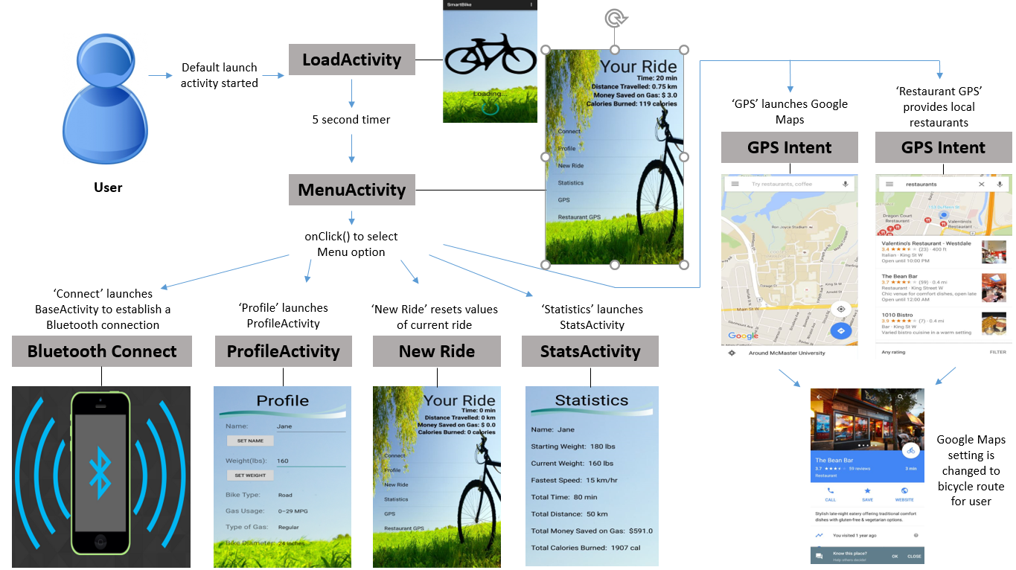

This diagram maps the user’s experience through the SmartBike application. It gives a visual representation of how the user will navigate through different features.

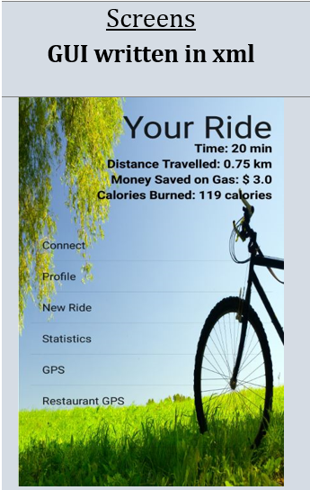 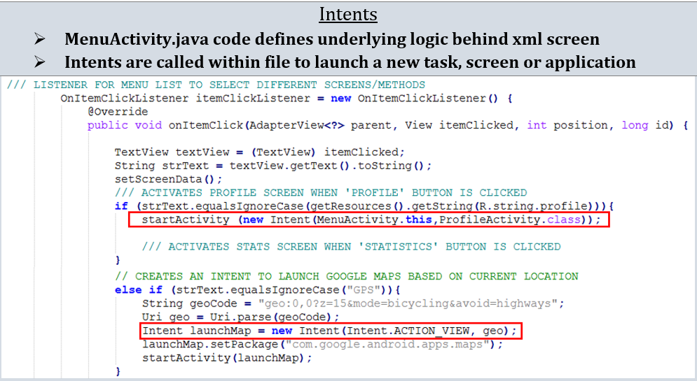

The framework for the application can be divided into two sections, screens and intents. Screens map out the structure for the user interface within the application. They enable the user to interact with the application’s functionality. Each screen has a corresponding ‘Activity’ file. These ‘Activity’ files are java classes that outline the underlying logic behind the graphical interface. The graphical interface’s structure of a screen is identified with a corresponding xml file. These xml files define the text boxes, text sizes, images, lists, input boxes, scrolls and various other fields for the screen’s interface.

The second component to the framework of the application consists of intents. An intent is an object within the Android operating system that handles task requests. It enables the application to launch from one screen to another or pass information through to other applications such as Google Maps.

**Composition of Stuff** – in case you need to change fonts, structure, prefer table look, etc

|  |  |
| --- | --- |
| Screens  GUI written in xml | Intents   * MenuActivity.java code defines underlying logic behind xml screen * Intents are called within file to launch a new task, screen or application |
|  |  |

// Composition of word boxes to highlight Intents

