The **GWAS Lasso** Package

Version 0.20

NatingWang

# 1. Introduction

The GWAS Lasso package is developed to identify significant SNPs that control phenotypic variation and estimate their additive and dominant genetic effects based on the Bayesian Lasso or Group Lasso model. Two statistical models are encapsulates to reveal the relation between gene and trait in the GWAS Lasso package. The first proposed Bayesian lasso named ***BLS*** model in this package can detect the association using one single time measure, while the second group lasso named ***GLS*** model focuses on the longitudinal phenotype. This guide gives some brief instructions on how to perform the tasks of SNP detection by the GWAS Lasso package. The outline of this guide is as follows.

Section 2: Installation

Section 3: Data Format

Section 4: Statistical model

Section 5: Summary

Section 6: plot

Section7: Parallel computing

We refer to Li et al. (2011) and Li et al (2015) for the theoretical foundation of this package. If you benefited from this software, then please cite the following papers in your work:

1. Li, J., Das, K., Fu, G., Li, R., & Wu, R. (2011). The Bayesian lasso for genome-wide association studies. Bioinformatics, 27(4), 516-523.

2. Li. J., Wang, Z., Li, R., Wu, R.(2015).Bayesian Group Lasso for nonparametric varying-coefficient models with application to functional genome-wide association studies. The Annals of Applied Statistics. 9(1).

# 2. Installation

The GWAS Lasso package depends on the ***snpStats***, ***nlme*** and ***snowfall*** package (the ***snpStats*** and ***nlme*** package are required, but the ***snowfall*** package is optional for parallel computation), so these packages should be installed firstly. To install GWAS Lasso, download the package file and type the appropriate command in Linux command window or R console window.

1) For Linux command Window

*$ R CMD INSTALL gwas.lasso_0.20.tar.gz*

2) For R console window

*>install.packages(“gwas.lasso_0.20.tar.gz”)*

Before the package isused in R, the package importation is necessary by the following R command:

*>library(gwas.lasso)*

# 3. Data format

The GWAS Lasso package can detect the joint effects of multiple significant SNPs through the analysis of the data files containing the appropriately formatted genotype and phenotype information. There are two genotypic data formats and two phenotypic data formats used in this package. Below introduces these formats.

## 3.1. Phenotypic data

For two statistical models, the phenotypic data employs the CSV (Comma-separated values) file containing individual information, covariates and response values to store data as the following format.

**3.1.1. One single measure for the BLS model**

Below example demonstrates a phenotype file contains ID column (ID), two covariates (X_1, X_2) and one single time measure values(Y).

ID,X_1,X_2,Y

1,0,0.663,33.72

2,1,0.728,36.78

3,0,NA,38.92

…

The phenotype file should be filled with numerical values and missing values encoded as NA. There are limited data checks in the current version, and the package requires individual ID　in the phenotype file and the genotype file to be consistent. In this example, one row represents one subject. The names of covariate columns are optional but the phenotype column is required to call the functions of BLS model.

**3.1.2. Longitudinal data for the GLS model**

The GLS model, which can illustrate time varying curves for additive and dominant effects of each significant SNPs, requires the longitudinal data as phenotypic traits. Below example lists one ID column (ID), two covariate columns (X_1, X_2), measuring time columns (Z_1, Z_2, Z_3, Z_4, Z_5, … ) and measured phenotype columns(Y_1, Y_2, Y_3, Y_4, Y_5,…). In this example, X_* columns stand for covariate values, Z_* columns stand for measuring times and Y_* columns stand for longitudinal phenotypic values.

ID,X_1,X_2,Z_1,Z_2,Z_3,Z_4,Z_5,…, Y_1,Y_2,Y_3,Y_4,Y_5,…

1, 1,-0.946,40.000,42.000,43.000,48.000,50.000,…,18.853,14.289,11.529,15.920,22.203,…

2, 3, -0.846,41.000,40.000,38.000,39.000,NA,…,17.853,12.289,13.529,15.920,NA,…

…

## 3.2.Genotypicdata

Genotypic data is supposed to be huge or mess if hundreds of thousands SNPs are stored.In general, PLINK is a very common and ideal tool to compress, convert and analyze these big data. This package not only employs PLINK to pack genotype data, but also designs a user-defined, simple format to store some small genotype data which is produced by small experiments or outputted by other package.

**3.2.1. PLINK format**

Specifically, taking into consideration the store space and loading time, the binary PLINK files are used in this package. If the binary data file is not available at hand, the following command can convert the common PED and MAP paired files into the binary group files, which including one binary file (*.bed) and two plain text files (*.bim and *.fam) which can be viewed with a standard text editor.

*$ plink --file mydata --out mydata --make-bed*

**1) *bed* file**

The *bed* file is a compressed binary file containing genotype information. If you try to view it you'll only see lots of strange characters on the screen.

**2) *bim* file**

The *bim* file is an extended MAP file where each line of this file describes a single individual and it must contain exactly 4 columns: chromosome, SNP identifier, genetic distance and base-pair position (bp units). The following two extra columns are allele names.

0 ss66369915 0 0 G A

0 ss66112992 0 0 G A

…

**3) *fam* file**

Phenotypic information are stored in the *fam* file where one row represents one subject and the first six columns are mandatory: Family ID, Individual ID, Paternal ID, Maternal ID, Sex (1=male; 2=female; other=unknown) and phenotype. In particular, the phenotype defined here is ***not*** used in this package.

957 2274 13631 2615 2 30.6367470222222

137 2349 0 0 2 34.4484237154545

…

**3.2.1 Simple format**

In addition to the PLINK format, a user-defined format named simple format is designed to store small amount of SNPs for these who do not use PLINK. The genotypic data are stored in the CSV format, where each line describes a single SNP and must start with 2 columns of chromosome information (chromosome number and SNP position).Three genotypes (aa=0,Aa=1,AA=2) and missing data (coded as -1 or NA ) are valid SNP values.

CHR,POS,Sub1,Sub2,Sub3,Sub4,Sub5, …

0,1, 2, 0, 1, 1, 1, …

0,2, 2, 1, 1, 0, 0, …

…

# 4. Statistical model

This package collects two statistical models: the BLS model and GLS model. The difference between two models is whether the longitudinal phenotype can be handled. More specifically, one single time measure is regressed in BLS model, while longitudinal data are expected to discover the dynamic pattern of the trait in GLS model.

## 4.1 The BLS model

In BLS model, a number of important covariates, which are either discrete or continuous, along with additive and dominant effects are integrated into one statistical framework to estimate simultaneously. The response value yi measured at with one time point for subject i is dissected as equation (1).

$$\tilde{y_{i}}=μ+X_{i}^{T}α+Z_{i}^{T}β+ξ_{i}^{T}a+ζ_{i}^{T}d+ϵ_{i}, i=1,…,n, (1)$$

where $μ$ is the overall mean, Xi is the vector of discrete covariates, α is the vector of regression coefficients for discrete covariates, Zi is thevector of continuous covariates, β is the vector of regression coefficients for continuous covariates, a = (a1,…, ap)T and d = (d1,…, dp)T are the p-dimensional vectors of the additive and dominant effects of SNPs, respectively, $ξ_{i}$ and $ζ_{i}$ are the indicator vectors of the additive and dominant effects of SNPs, and $ϵ_{i}$ isthe residual error assumed to follow a N(0; σ2) distribution. The j-th elements of $ξ_{i}$ and $ζ_{i}$ are defined as

$$ξ_{ij}= \left\{\begin{aligned}1, if the genotype of SNP j is AA \\ 0, if the genotype of SNP j is Aa \\ -1 if the genotype of SNP is aa\end{aligned}\right.$$

$$ζ_{ij}=\left\{\begin{aligned}1, if the genotype of SNP j is Aa \\ 0, if the genotype of SNP is AA or aa\end{aligned}\right.$$

## 4.2 The GLS model

The GLS model employs the Legendre Polynomials to fit the curve points of each subject, which are measured at the repeated time points and stored in the longitudinal data. Letyi be the ti-dimensional vector of measurements on subject i where ti = (ti1, …, tiTi)T is the corresponding vector of measurement time points after standardization. Thus, at time point tij,

where μ(til) is thevector of overall mean, α(til) is the a vector of covariate effects, Xi be the observed covariate vector, aj(til) is additive effect of j-th SNP, and dj(til) is dominant effect of j-th SNP, and ei(til) is the residual error assumed to follow a N(0; σ2(til)) distribution. The j-th elements of $ξ_{i}$ and $ζ_{i}$ are defined as above.

In the GLS model, the effects of covariates and SNPs are assumed to be a time-varying curve modeled by the 4th-order Legendre Polynomials.

$${L(t_{il})=r}_{0}+r_{1}*t_{il}+r_{2}*\frac{1}{2}\left(3t_{il}^{2}-1\right)+r_{3}*\frac{1}{2}\left(5t_{il}^{3}-3t_{il}^{}\right)$$

By approximating time-varying effects using Legendre polynomials, the expansion coefficients can be solved through regression, and the effect of k-th covariate can be approximated by a Legendre polynomial of order.

# 5. Work flow

## 5.1. Preparing data

The package have two types of genotypic data: PLINK format or simple CSV file described in 3.2.1. Whichever format is used, the imputation and quality control are supposedly finished according to the experiment requirement. The package ***does not provide any quality control functions***. For the imputation function, the package only can impute the missing SNPs based on the genotype frequency.

Although PLINK has simple phenotypic data, the package use the user-defined CSV files to store the phenotypic data. The definition has been elaborated in 3.1.

The simulation function is provided for who try this package without any real data. The BLS model and GLS model have respective functions as follows.

*>bls.simulate(“bls.phe.csv”, “bls.gen.csv”);*

*> gls.simulate (“gls.phe.csv”, “gls.gen.csv”);*

## 5.2Starting computation

Each statistical model has three functions to do data analysis for PLINK data, simple SNP data and SNP matrix. Totally six functions are available.

*>r.bls<-bls.simple(“bls.phe.csv”, “bls.gen.csv”, Y.name="Y", covar.names=c("X_1","X_2"));*

*>r.bls<-bls.plink (file.phe.long, file.plink.bed, file.plink.bim, file.plink.fam, Y.name="Y", covar.names=c());*

*>r.bls<-bls.snpmat(tb.phe, tb.snp, Y.name="Y", covar.names=c("X_1","X_2"));*

*>r.gls<-gls.simple(“gls.phe.csv”, “gls.gen.csv”,Y.prefix="Y",Z.prefix="Z", covar.names=c("X_1","X_2"));*

*>r.gls<-gls.plink(file.phe.long, file.plink.bed, file.plink.bim, file.plink.fam, Y.prefix="Y", Z.prefix="Z", covar.names=c("X"));*

*>r.gls<-gls.snpmat(tb.phe, tb.snp, Y.prefix="Y", Z.prefix="Z", covar.names=c("X_1","X_2"))*

The function of ***bls.simple*** and ***gls.simple*** are designed to load files encoded by the Simple format, ***bls.plink*** and ***gls.plink*** are intended to load PLINK files, but ***bls.snpmat*** and ***gls.snpmat*** are aimed to loading the genotype matrix rather than a data file.

Except the parameters for data source are different, the control parameters are same for the overall six functions. Four types of control parameters allow the users to set up the following infotmation.

1. Response variable(Y.name) and covariate names(covar.name)
2. If the filter implemented by fGWAS is used to pre-select significant SNPs?
3. If either additive or dominant effect is estimated?
4. If only variable selection procedure is applied to data analysis

The whole computation task will involve the several procedures, including data loading, SNP filter by fGWAS model if applicable, variable selection procedure and final refit procedure. The following example shows how to do a computation using variable selection procedure only.

*>ret1 <- bls.plink( file.phe.long, file.plink.bed, file.plink.bim, file.plink.fam, Y.name="Y", covar.names=c(), fgwas.filter = T, refit = F , options=list(nParallel.cpu=7));*

*[ BLASSO PLINK ] Procedure.*

*Checking the parameters ......*

*\* Phenotypic Data File = /work/bmi-pheno-age-mean.csv*

*\* PLINK BED File = /work/FHS-bmi-v1-chr2.bed*

*\* PLINK BIM File = /work/FHS-bmi-v1-chr2.bim*

*\* PLINK FAM File = /work/FHS-bmi-v1-chr2.fam*

*\* Response Variable = Y*

*\* Covariate Columns =*

*\* fGWAS Filter Used = Yes*

*\* Additive Effects Used = Yes*

*\* Dominant Effects Used = Yes*

*\* Refit Procedure = No*

*Checking the optional items......*

*\* Parallel Computing: Yes, 7 CPU(s)*

*\* Piecewise Ratio: 2*

*\* Threshold of fGWAS filter: 0.05*

*\* Iteration of Markov chain: 2000*

*\* fBurnInRound: 0.3*

*\* fRhoTuning: 0.095*

*\* fQval.add: 0.05*

*\* fQval.dom: 0.09*

*\* Debug Output: No*

*SNP Filtering by fGWAS method......*

*\* SNP Count = 29295*

*\* Sample Count = 819*

*\* p-value Threshold = 0.05*

*Calculated SNP Range = 1 20000*

*\* H0 = Y ~ 1*

*\* H1 = Y ~ 1 + as.factor(SNP)*

*Starting parallel computing, snowfall/snow......*

*R Version: R version 3.1.2 (2014-10-31)*

*Stopping parallel computing......*

*SNPs with p-value <= 0.05 : 1634*

*\* 1634 SNPs( 5.58 %) are left after fGWAS filtering.*

*Genetic Effect Analysis by BLASSO/GLASSO method......*

*\* Final LASSO calling.*

*Wrapping the results ......*

## 5.3. Summarizing results

In the R console, ***summary*** is a generic function used to show the summary information of results object exported from the BLS model or the GLS model. It may include:

1) Significant SNPs estimated by the fGWAS method

2) Covariates coefficients estimated in the variable selection procedure

3) Pre-selected SNPs and effects estimated in the variable selection procedure

4) Covariates coefficients estimated in the refit procedure

5) Significant SNPs and effects estimated in the final refit procedure

*>summary( r.bls );*

*>summary(r.gls);*

## 5.4. Plotting figures

The function *plot* can output three types of PDF figure***,*** including:

1)The Manhattan figure exported by the fGWAS method (*.fgwas.pdf)

2)The genetic effects of all SNPs estimated by the variable select procedure (*. varsel.pdf.)

3) The genetic effects of significant SNPs estimated by the refit procedure (*.refit.pdf).

The BLS result object or GLS result object are required to call the function *plot*.

*>plot (r.bls, fig.prefix="bls-ret");*

*>plot (r.gls, fig.prefix="gls-ret");*

The Manhattan figure gives –log10(p-values) for each SNP, **from which the SNP with –log10 p-values greater than the threshold value specified in the control parameters will be selected to variable selection.** The figures of genetic effects are different depending on which model are used. The BLS model will output heritability sub-graph, but the GLS model can output the curve modeled by the additive and dominant effects for each significant SNP.

# 6. Internal Details

## 6.1 Simulation

Simulation is a good way to understand the functions and learn how to use them. The simulation in this package uses the pre-defined parameters to create a data object. This data object has same structure as real data. All pre-defined parameters can be customized. The following two tables show the common part of simulation parameters.

**Table1：**Simulation Parameters of Bls Model

|  |  |
| --- | --- |
| **Items** | **Description** |
| phe.out | String, the name of the output phenotypic data file |
| snp.out | String, the name of the output genotypic data file |
| simu_n | Integer, the size of samples |
| simu_p | Integer, the number of SNPs |
| simu_snp_rho | Float, correlation coefficient between two adjacent SNPs |
| simu_rho | Float, correlation coefficient between two adjacent time points |
| simu_sigma2 | Float, the residual error assumed to follow a N(0,σ2(til)) distribution |
| simu_mu | Float, the overall mean of phenotypic data |
| simu_a_pos | Vector, positions of the significant SNPs with additive effects |
| simu_a_effect | Vector, additive effects of significant SNPs. |
| simu_d_pos | Vector, positions of the significant SNPs with dominant effects |
| simu_d_effect | Vector, dominant effects of significant SNPs. |
| simu_cov_range | Vector, the range of covariates |
| simu_t_range | Vector, the range of time points |

**Table2：**Simulation Parameters of Gls Model

|  |  |
| --- | --- |
| **items** | **Description** |
| file.phe.out | String, the name of the output phenotypic data file |
| file.snp.out | String, the name of the output genotypic data file |
| simu_n | Integer, the size of samples |
| simu_p | Integer, the number of SNPs |
| simu_snp_rho | Float, correlation coefficient between two adjacent SNPs |
| simu_rho | Float, correlation coefficient between two adjacent time points |
| simu_sigma2 | Float, the residual error assumed to follow a N(0,σ2(til)) distribution |
| simu_mu | Vector, the overall mean of phenotypic data |
| simu_add_effect | Matrix, additive effects of significant SNPs where the first column represents positions of these SNPs |
|
| simu_dom_effect | Matrix, dominant effects of significant SNPs where the first column represents positions of these SNPs |
|
| simu_covar_effect | Matrix, effects of covariates |
| simu_covar_range | Vector, the range of covariates |
| simu_z_range | Numeric, the number of measurements |
| simu_z_count | Numeric, the number of measurements |

*bls.simulate* and *gls.simulate* function can create two simulation data files: the phenotypic data file and the genotypic data file. The following codes show how to create simulation data and how to change some parameters by R command.

*bls.simulate("bls.simple.phe", "bls.simple.snp");*

*bls.simulate("bls.simple.phe", "bls.simple.snp", simu_sigma2=4, simu_mu=26);*

These above examples show how to use the BLS model. The first command generates simulation data by default parameter values, and the second one creates data using some customized parameters. The following example shows how to generate data for the GLS model.

*a_effect <- array(c(1,2, runif(8,-4,5)), dim=c(2,5))*

*d_effect <- array(c(1,2, runif(8,-4,5)), dim=c(2,5))*

*gls.simulate ("gls.phe.mat.csv", "gls.snp.mat.csv", simu_n=300, simu_p=3000, simu_snp_rho=0.4, simu_rho=0.1, simu_add_effect=a_effect, simu_dom_effect=d_effect,);*

## 6.2. The SNP filter by fGWAS method

If the SNP number is greatly large, formulating Bayesian Group lasso to select significant SNPs may lower the selection power and increase the false positive rate, so first filtering out the less significant SNPs could avoid the problem.

The filter results can be viewed by two methods, summarize the result object or plotting the Manhattan figure. The following will show

1) Significant SNPs estimated by fGWAS method:

2) A figure gives –log10 p-values for each SNP, from which the SNP with –log10 p-values greater than the threshold value set before will be selected.

--- Significant SNPs Estimate by fGWAS method:

Top 25 SNPs:

SNP.ID CHR POS L.Ratio pv

G0-SNP1271 1271 0 1271 117.167049 0.000000000

G0-SNP6728 6728 0 6728 112.728633 0.000000000

G0-SNP6883 6883 0 6883 260.680776 0.000000000

G0-SNP6899 6899 0 6899 102.708899 0.000000000

G0-SNP7897 7897 0 7897 151.950033 0.000000000

G0-SNP1683 1683 0 1683 13.695838 0.001061663

…….

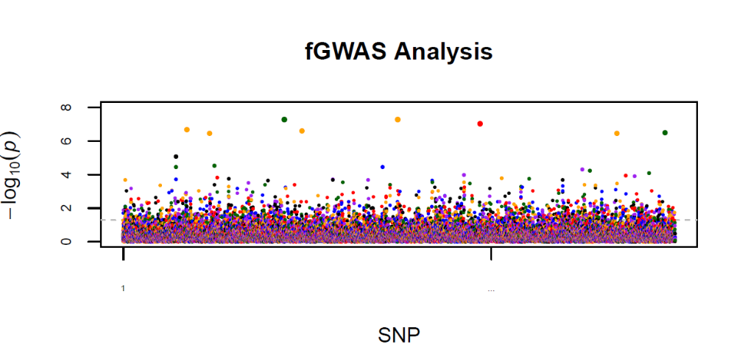

## 6.3.Variable selection

This step formulates Bayesian Group lasso to select a subset of significant SNPs by selecting Legendre coefficients that are not identically zero, at the same time, estimate additive and dominant effects of significant SNPs. The unknown parameters could be estimated by using the MCMC algorithm.

The results of variable selection include the following:

1. Variable Selection Result
2. A figure shows addictive effects and dominant effects of selected SNPs
3. A figure shows heritability of selected SNPs.

--- Covariate Estimate in Refit Procedure:

Mode L1 L2 L3 L4

Intercept 194.903 13.079 -3.153 1.928 -3.191

X_1 10.291 2.629 -1.512 0.894 0.541

--- Refit Result

chr pos add.sig add.mode add.mu1 add.mu2 add.mu3 add.mu4

1 0 6728 2 0.3253068 -0.05632611 -0.13656087 -0.34259138 -0.45600212

2 0 6883 3 9.0963385 1.39688597 -2.43336304 1.10625151 0.05672361

3 0 6899 4 5.3871507 1.03125835 0.91000256 -1.73414760 0.69877344

4 0 7897 4 23.2958857 1.27028639 -0.32635179 0.95085732 -4.54660567

5 0 1271 0 0.0000000 0.04612361 0.03978521 -0.08060622 0.08770705

dom.sig dom.mode dom.mu1 dom.mu2 dom.mu3 dom.mu4

1 4 9.752713 1.33940947 0.9981518 2.0343131 1.6804636

2 4 33.455043 1.40182206 -2.0304856 5.0462396 1.3793230

3 2 0.114697 0.16038721 0.2982834 -0.1270506 -0.2547293

4 0 0.000000 0.09405818 0.2397407 -0.3175207 -0.2058939

5 4 13.728352 1.23633519 -1.1626640 2.7197024 -1.8577562

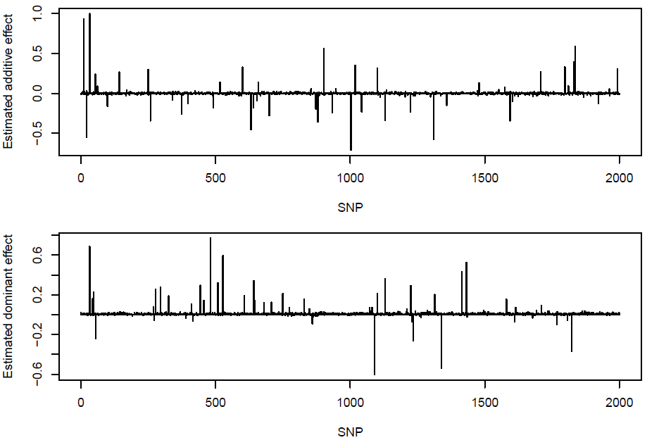

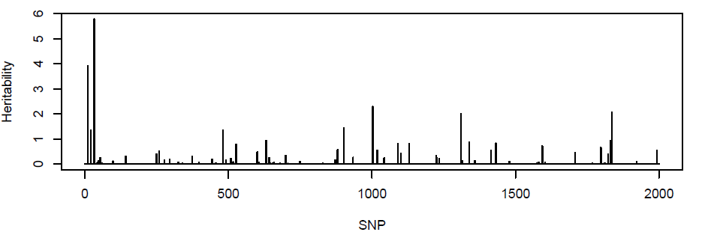

## 6.4. Refit

To ameliorate the bias of the parameter estimates introduced by Group Lasso penalties, it is necessary to refit the fGWAS model after variable selection, where only selected SNPs are included in the final model.

The results of result procedure include the following:

1. Significant SNPs and covariate estimation
2. A figure shows addictive effects and dominant effects of significant SNPs.
3. A figure shows heritability of significant SNPs.

*--- Covariate Estimate in Refit Procedure:*

*Mode L1 L2 L3 L4*

*Intercept 194.903 13.079 -3.153 1.928 -3.191*

*X_1 10.291 2.629 -1.512 0.894 0.541*

*--- Refit Result*

*chr pos add.sig add.mode add.mu1 add.mu2 add.mu3 add.mu4*

*1 0 6728 2 0.3253068 -0.05632611 -0.13656087 -0.34259138 -0.45600212*

*2 0 6883 3 9.0963385 1.39688597 -2.43336304 1.10625151 0.05672361*

*3 0 6899 4 5.3871507 1.03125835 0.91000256 -1.73414760 0.69877344*

*4 0 7897 4 23.2958857 1.27028639 -0.32635179 0.95085732 -4.54660567*

*5 0 1271 0 0.0000000 0.04612361 0.03978521 -0.08060622 0.08770705*

*dom.sig dom.mode dom.mu1 dom.mu2 dom.mu3 dom.mu4*

*1 4 9.752713 1.33940947 0.9981518 2.0343131 1.6804636*

*2 4 33.455043 1.40182206 -2.0304856 5.0462396 1.3793230*

*3 2 0.114697 0.16038721 0.2982834 -0.1270506 -0.2547293*

*4 0 0.000000 0.09405818 0.2397407 -0.3175207 -0.2058939*

*5 4 13.728352 1.23633519 -1.1626640 2.7197024 -1.8577562*

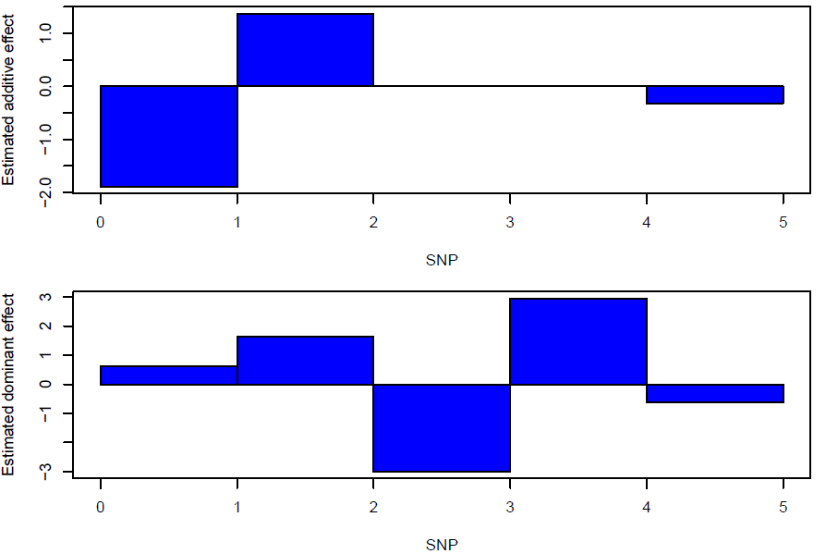

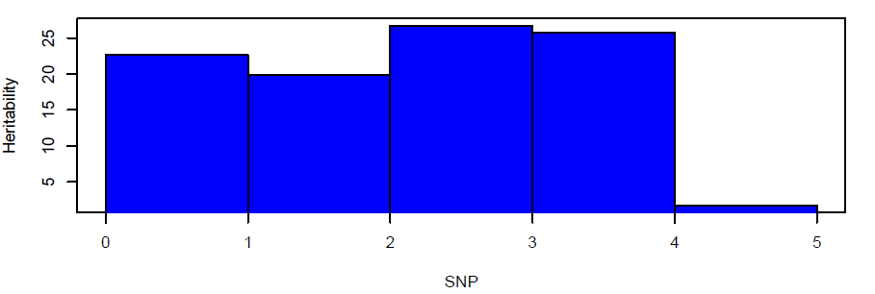

## 6.5. Parallel computing

The SNPs data is so huge that it will spend plenty of time processing the program. To save the computing time, it is necessary to adopt parallel computing. In the function ***bls.simple, bls.plink, bls.snpmat, gls.simple, gls.plink*** and ***gls.snpmat,*** the parameter nParallel.cpu controls the number of the CPU used to compute.

The following codes show how to set the parallel computing.

*ret<-gls.simple(phe.out,snp.out,Y.prefix="Y",Z.prefix="Z",covar.names=c("X_1"),*

*options=list(nParallel.cpu=7) );*