Phillip Thoendel - 11/15/2023 – Assignment 8.2 Updates and Deletes

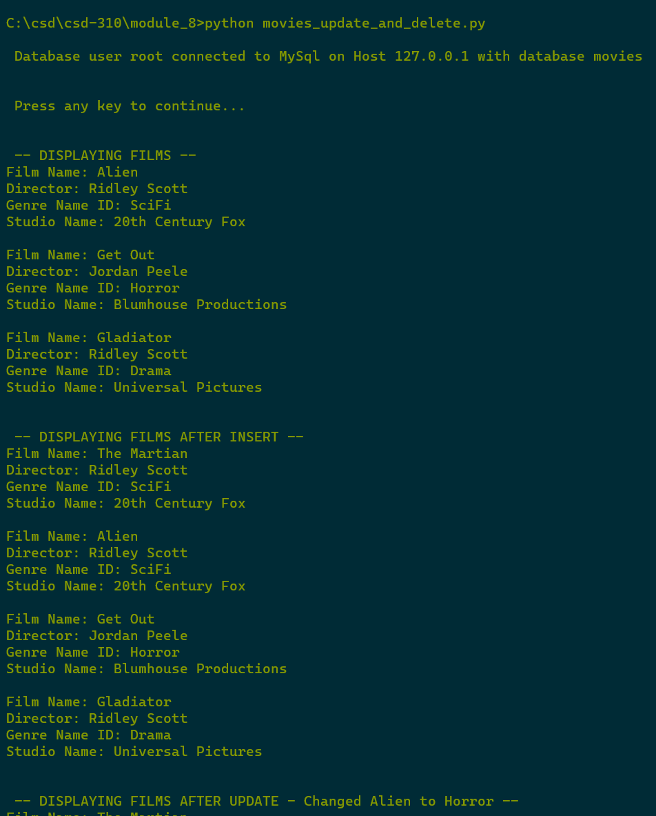Script Results:

