Profit Analysis Report

Philly B

2025-05-08

## # A tibble: 10 × 11  
## Date Product Units_Sold Price In_Stock Revenue Category Cost Supplier  
## <date> <chr> <dbl> <dbl> <lgl> <dbl> <chr> <dbl> <chr>   
## 1 2023-01-01 iPad 12 35.0 TRUE 420. Electron… 25 TechZone  
## 2 2023-01-02 Pouch 8 15.0 FALSE 120. Accessor… 6 PackIt   
## 3 2023-01-03 Mug 5 9.99 TRUE 50.0 Drinkware 3 MugCo   
## 4 2023-01-04 Hoodie 10 40.0 TRUE 400. Apparel 20 ClothHo…  
## 5 2023-01-05 iPad 15 35.0 TRUE 525. Electron… 25 TechZone  
## 6 2023-01-06 Mug 6 9.99 FALSE 59.9 Drinkware 3 MugCo   
## 7 2023-01-07 Pouch 7 15.0 FALSE 105. Accessor… 6 PackIt   
## 8 2023-01-08 Hoodie 9 40.0 TRUE 360. Apparel 20 ClothHo…  
## 9 2023-01-09 iPad 11 35.0 TRUE 385. Electron… 25 TechZone  
## 10 2023-01-10 Mug 4 9.99 TRUE 40.0 Drinkware 3 MugCo   
## # ℹ 2 more variables: Profit <dbl>, Profit_Margin <dbl>

## # A tibble: 4 × 4  
## Category Total_Revenue Total_Profit Avg_Profit_Margin  
## <chr> <dbl> <dbl> <dbl>  
## 1 Accessories 225. 135. 0.6   
## 2 Apparel 760. 380. 0.5   
## 3 Drinkware 150. 105. 0.7   
## 4 Electronics 1330. 380. 0.29

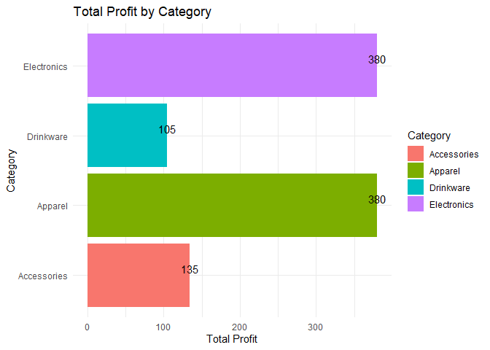

## 🔍 Key Insights

* **Electronics** (iPad) generated the most profit overall.
* **Accessories** and **Drinkware** had the lowest profit margins.
* Profit margins reveal pricing strategy opportunities for underperforming categories.