Sales Analysis Report

Philly B

2025-05-08

## # A tibble: 4 × 3  
## Product Total_Units Total_Revenue  
## <chr> <dbl> <dbl>  
## 1 Hoodie 19 760.  
## 2 Mug 15 150.  
## 3 Pouch 15 225.  
## 4 iPad 38 1330.

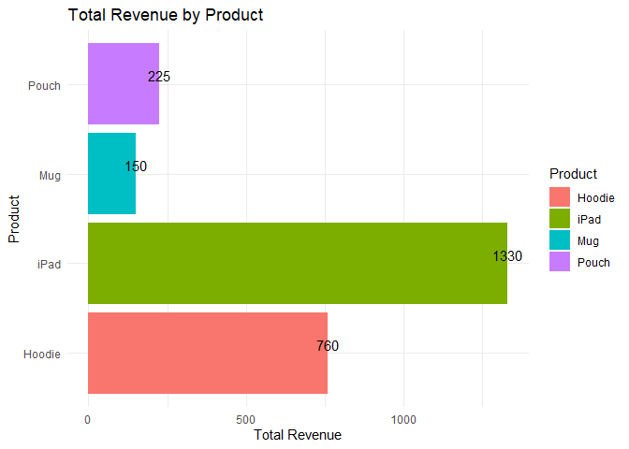

## 🔍 Key Insights

* **iPad** generated the highest revenue overall.
* **Hoodie** also performed well and is worth continuing to promote.
* **Mug** and **Pouch** underperformed and may need a discount or bundling strategy.