Reminder HLD

Document History

Date | Author | Comment
2010/11/03 | Li Wei | Initial Draft
2010-11-5 | Li Wei | Add Chapter 4.1 Real time flow

Core Concepts

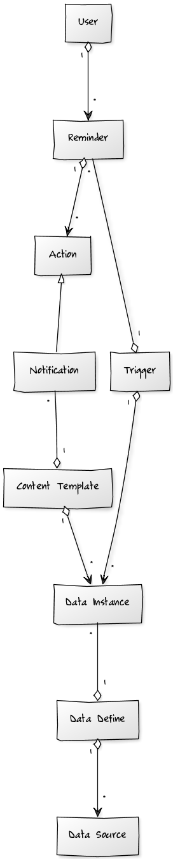
User
Who can create, edit, and delete his own reminders.

Reminder
Is a definition of when … then...

Trigger
Is When

Action
Is Then

Notification
Notify the end user of what he need, several ways, like Email, SMS etc…

Content Template
Define what the user what to be notified.

Data Instance
Stands for one specific data, for example, the stock price of HP.

Data Define (template)
Stands for one kind of data, for example, the stock price.

Data Source (widget)
Stands for one domain of data, for example, the information of all stock in China market, includes the price, Revenue, etc…
It's the abstract layer of raw data.

User Cases
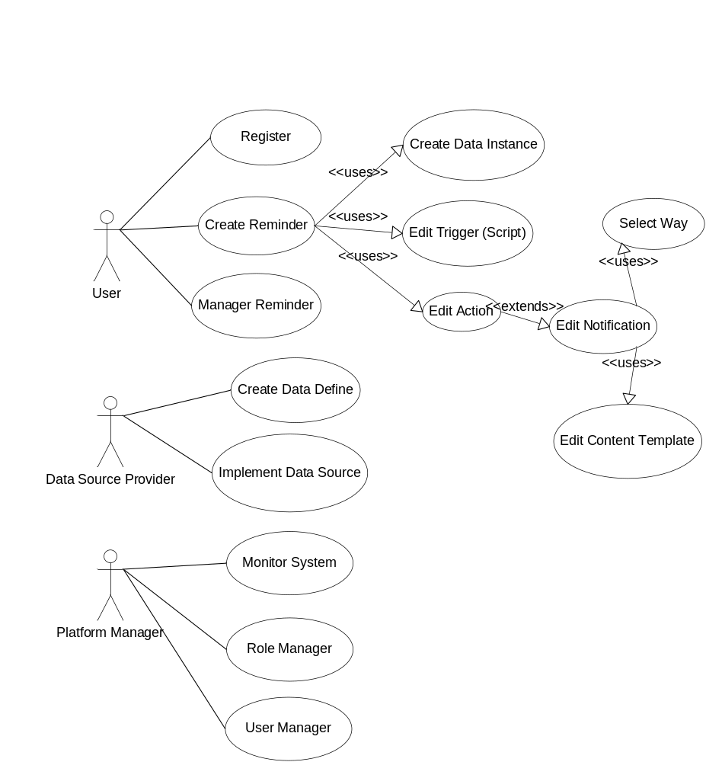

Architecture
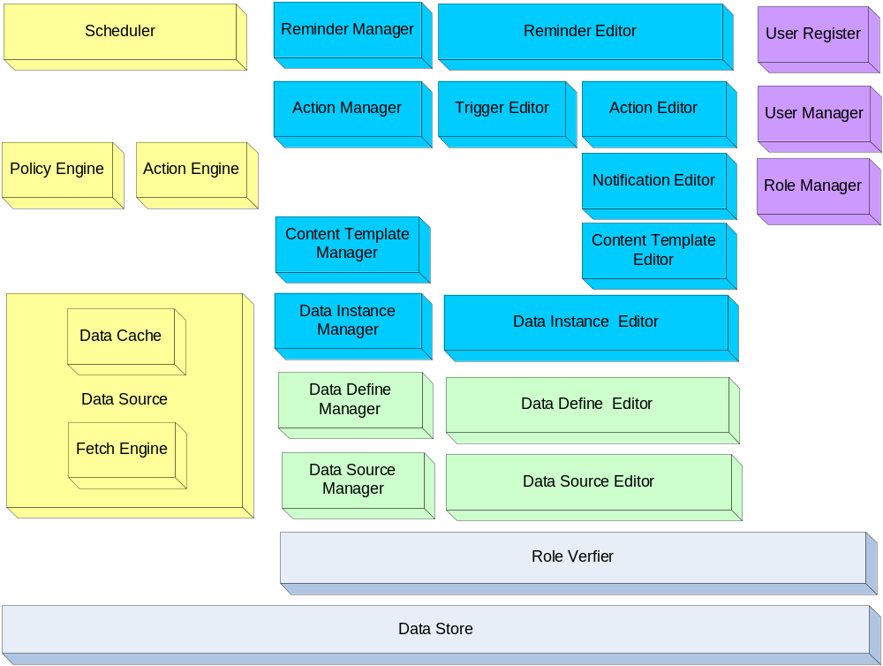

Blue: User related modules
Green: Data Source Provider related modules
Yellow: Background Runtime related modules
Purple: System Admin related modules

Real time Flow
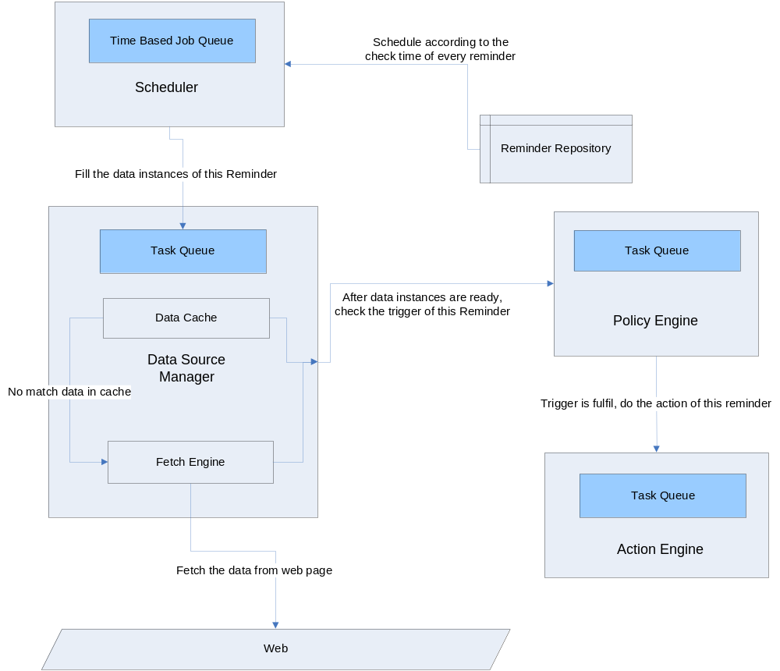

The modules can run in a single process, or in several processes, in the future, for scalability, cluster service need be enabled.

Class Diagram
Only demonstrate the Domain Related Classes.
