Effects on Support Success in Overwatch 2

Experiment Background
My friends and I enjoy playing the hit game Overwatch 2. The main purpose of the game is to create a synergetic team consisting of high health/medium damage tanks, and medium health/high damage “dps” players, and low health/low damage support heroes that have the ability to heal their teammates. I have recently dedicated myself to learning a new support hero by the name of Zenyatta. Overwatch 2 keeps track of in game statistics including damage done and healing done. Being able to maximize both of those as a support hero is key to in game success. After observing professional Overwatch 2 players play as Zenyatta, I have narrowed down between 3 factors that vary the most between the professionals. Factor 1 is hero sensitivity. The low level represents a sensitivity level of 20% and the high is 80%. A low sensitivity will allow for better aim on targets and however, a higher sensitivity will allow for quicker movements, making the player less accurate but able to more quickly react to their environment. Factor 2 is positioning type. The low level is back line positioning. Back line positioning means that the player situates themselves close to their tank, which gives them protection from the enemy team. A flank play style on the other hand, sacrifices the safety of the tank on the hope that the player can catch the team at a spot they are not expecting, giving the player more chances to kill the enemy team. My final Factor is play style. Compared to most support heroes, Zenyatta offers more damage to opposing team than he does healing for his own. A heal play style will offer more support for fellow teammates at the expense of damage to the other team and vice versa.

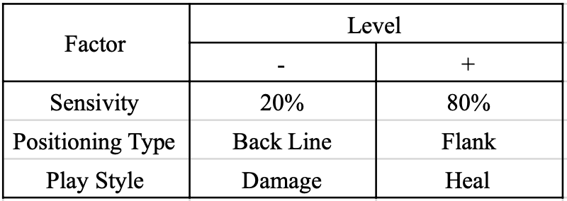
Figure 1: Experiment Factors and Levels

Experiment Setup
To test this experiment, I will use a full factorial design with 3 levels and 2 factors shown in Figure 1 resulting in 8 runs shown in Figure 2. To better normalize the data, each run will be conducted for a total of 5 times for a total trial that consists of 40 runs. The run order, also shown in Table 2, has a randomized run order in order to reduce learning effect for the one person running the 40 trials.
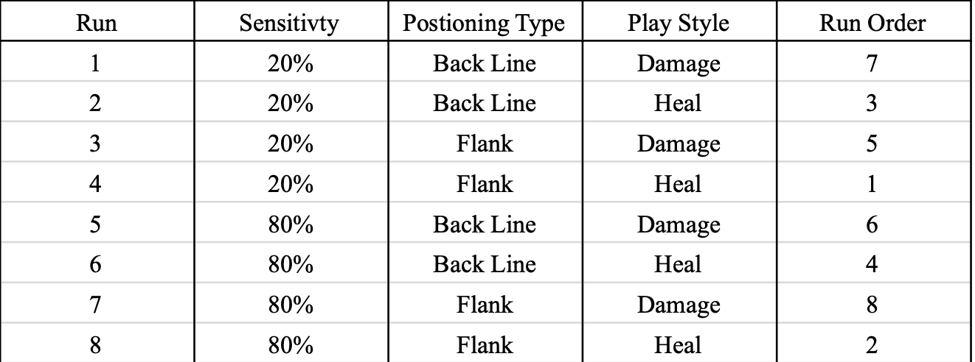
Figure 2: Experiment Planning Matrix

Statistical Model
The means and variance represented by $\overline{y}$ and $s^{2}$, where $\overline{y}$ is the mean for a run and $s^{2}$ is the variance for a run, represented by Equation 1 and 2, respectively.
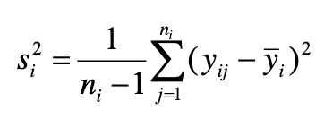
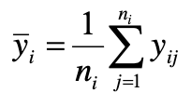
Equation 1: Run Means Equation 2: Run Variance

To calculate the main effects of a factor, Equation 3will be used. For the two-way interaction, Equation 4 will be used. All two-way interactions (AB AC AB) will be calculated using the same formula in Equation 4 but using the design matrix in figure 2. The thee-way interaction of ABC will be calculated by using Equation 5.
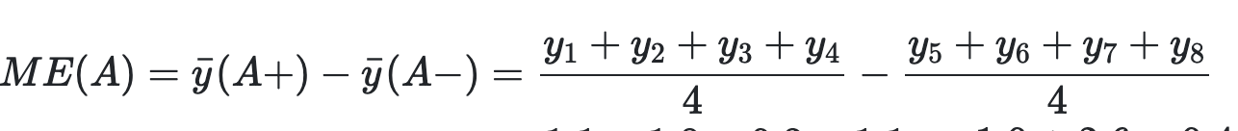
Equation 3: Main Effects
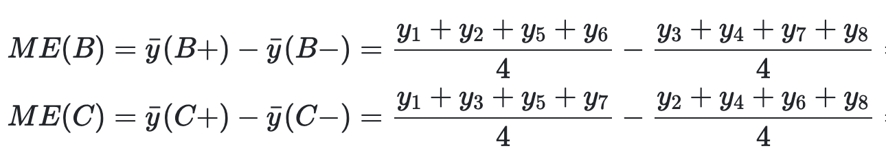

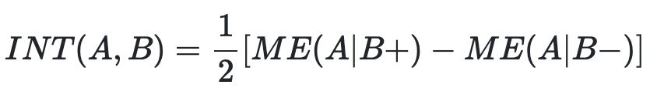
Equation 4: Two-Way Interaction Between Factor A and B
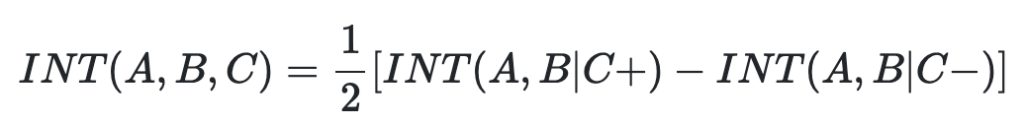
Equation 5: Three-Way Interaction

Data Analysis
After collecting all my data, I put my data into a .csv using excel and exported the .csv into r and read it using the built in read.csv() function.
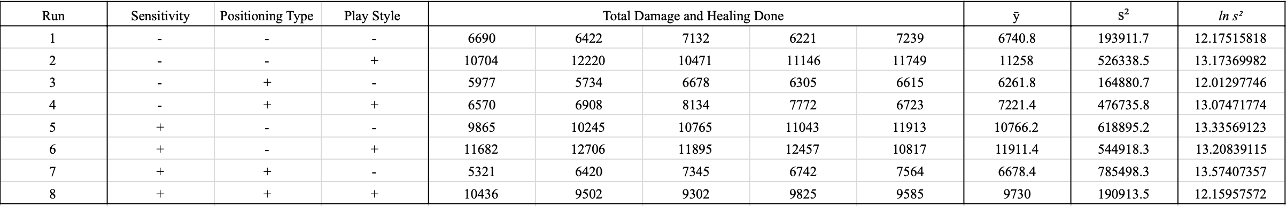
Figure 3: Model Matrix of Zenyatta Experiment

The model matrix and factorial effects are represented by Figure 3 and Figure 4, respectively.
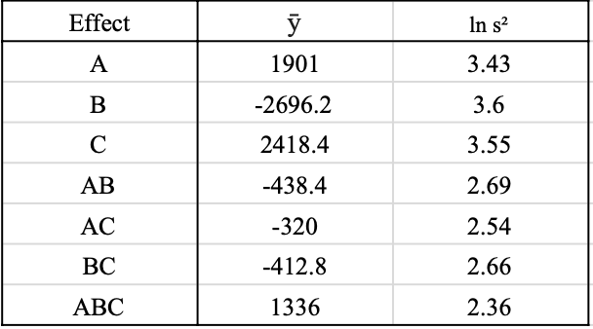
Figure 4: Factorial Effects for Zenyatta Experiment

The factorial effects from Figure 4 show that factor B has the greatest impact on the total healing and damage done. Figure 3 and Figure 4 both show the ideal factor levels for maximizing damage and healing done is the level combinations of A+, B- and C+ which results in playing at a high sensitivity, in the back line, while focusing on healing. Figure 4 also shows us that the main effects of all A,B,C appear to be significant and the three-way effect of ABC may also be significant but is less clear.

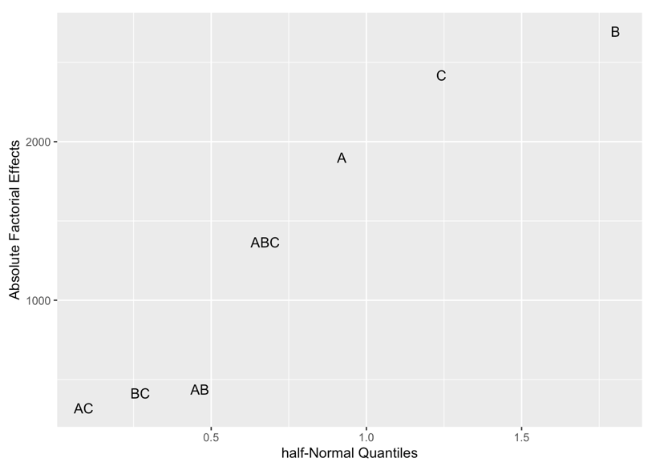
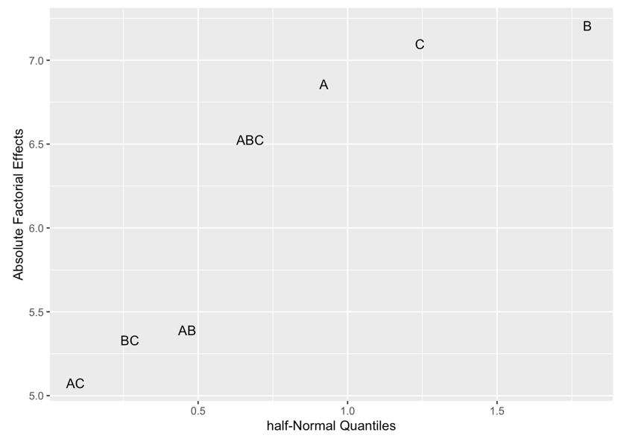
Figure 5: Half-Normal Plot for Location Figure 6: Half-Normal for Dispersion

Both of the half-normal plots for location and dispersion shown by Figure 5 and Figure 6, respectively, solidify the assertions made by the factorial effects. The main effects of A,B,C appear to be the most significant with the three-way factor of ABC also appearing to be significant.
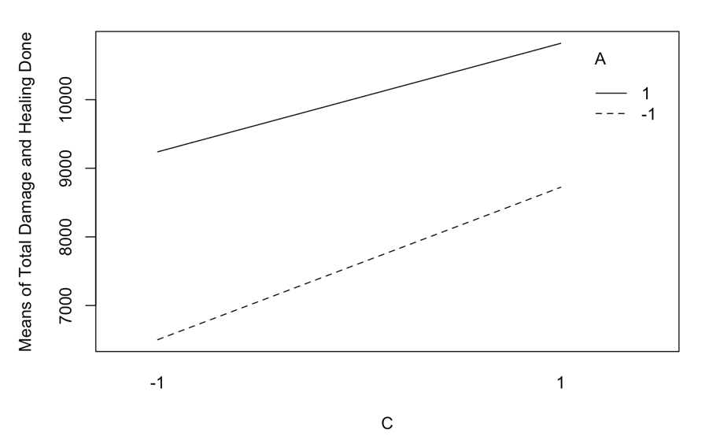
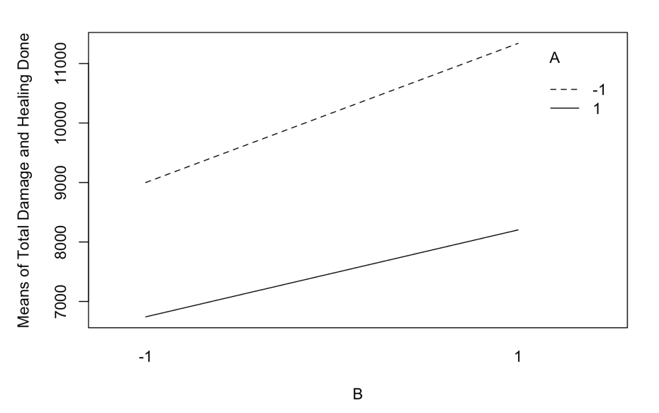
Figure 7: Sensitivity vs Positioning Figure 8: Sensitivity vs Play Style

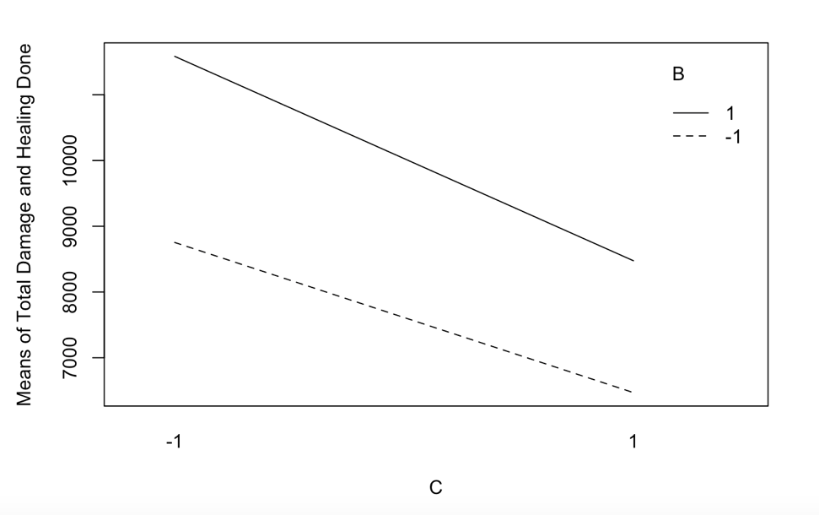
Figure 9: Positioning vs Play Style

Figure 7 shows us that a lower sensitivity will increases total damage and healing done more than a high sensitivity for both positioning types. Although A- will increase more, the relationship between A and B is still synergetic. Figure 8 also shows us that a lower sensitivity will have a higher increase on total damage done for both play styles. Although A- has the higher increase, the total damage and healing done by A+ remains higher. Figure 9 shows that there is an about equal decrease in total damage and healing done between positioning type and play style. This indicated that it is not recommended to play flank angles when prioritizing both damage and healing.
Conclusion
Through all of our analysis of data, it appears to be clear that the recommended settings for playing Overwatch 2 with the hero Zenyatta is to have a high sensitivity (80%), play in the back line and to focus healing in order to maximize total damage and healing done, given all assumptions are met. The biggest weakness to this experiment is that all runs were done with a single person. Therefore, this conclusion is only helpful to people of similar skill level and play style to that of myself and is not universal for all players wishing to maximize their Zenyatta play.

R input/output
*All programing submitted on separate .html file*

