Efficient Communication Across the Internet in Wide-Area MPI

Rajkumar Vinkat and Phillip M. Dickens
Department of Computer Science
Illinois Institute of Technology
Chicago, Illinois

William Gropp

MCS Division
Argonne National Laboratory

Argonne, Illinois

Abstract

In this paper, we present a highly customized, user-level communication protocol called the Wide-Area MPI Protocol (WAMP), developed as an alternative to the TCP/IP protocols for communication across the Internet in wide-area MPI. We discuss the design of WAMP, and present experimental results showing up to a nine-fold improvement in performance over TCP/IP in a heavily loaded network. However, TCP/IP outperforms WAMP by up to a factor of three in a lightly loaded network environment. These results lead us to believe that the best solution for wide-area MPI is an adaptive communication protocol that can switch between TCP/IP and WAMP based on the current network conditions.

Key Words: Wide-area MPI, Communication protocols, Internet-based computing, TCP/IP.

1 Introduction

As the Internet continues its explosive growth, the size and complexity of distributed applications executing on top of this infrastructure is also exploding. This grid-based computational environment, in which perhaps hundreds or thousands of computers are communicating and coordinating their computational activity across the public Internet, is becoming a dominant force in the High Performance Computing arena. Given the increasing significance of this distributed computational environment, it is critical to develop portable mechanisms through which such geographically distributed computers can communicate and synchronize over the Internet.
The Message Passing Interface (MPI [1]) has emerged as the de facto standard for writing portable parallel programs, and an important area of current research is the efficient implementation of wide-are MPI (that is, MPI over the Internet). Clearly, the performance of wide-area MPI applications is dictated (in no small measure) by the cost of communication across the Internet, and thus an important area of current research is the development of communication techniques that can minimize such costs.
In this paper, we present a highly customized user-level communication protocol developed to significantly decrease the communication costs of wide-area MPI applications executing in the Internet environment. This communication protocol, termed the Wide-Area MPI Protocol (WAMP), is proposed as an alternative to the standard transport protocol (TCP) currently used for both local-area and wide-area MPI communication. We present experimental results demonstrating up to an order of magnitude increase in performance in end-to-end transfer times compared to TCP in a heavily loaded network. The rest of this paper is organized as follows. In Section 2, we provide a brief overview of communication in MPI. In Section 3, we discuss the current approach to wide-area communications in MPI using TCP/IP, and propose WAMP (Wide-Area MPI), a highly customized user-level protocol, as an alternative protocol for wide-area communications. In Section 4 we present experimental results comparing the performance of the two protocols. In Section 5, we discuss related work, and we provide conclusions and future research directions in Section 6.

2 Process Communication in MPI

One of the fundamental concepts in MPI is the process group, which is essentially an ordered set of processes. Each process in a process group is identified by its rank, which is (generally) an integer value between ‘0’ and ‘n-1’ for a group consisting of ‘n’ processes. All communication between processes occurs within a communication domain, which is represented by an object termed a communicator. There are two types of communicators: intra-communicators, representing communication within the same process group, and inter-communicators representing communication between two distinct process groups. It is the inter-communicators that are of interest in this research.
Inter-communicators are important because they represent a non-trivial generalization of the SPMD programming model to include cooperating SPMD computations. Also, the semantics of such inter-group communications are well defined within the MPI programming model, and (with the contributions of this research) can be efficiently implemented. Thus inter-communicators are designed to enable grid-based computations, where different process groups may reside on different high-performance computational clusters all of which are interconnected through the global Internet.
Processes in MPI communicate with one another by sending and receiving messages, whether the communication is taking place within the context of an inter-communicator or intra-communicator. Data transfer from one process to another requires operations to be performed by both processes. Thus, for every MPI send, there must be a corresponding MPI receive performed by the process for which the message is bound. This implies that the recipient of a message has (or will) allocated a buffer large enough to accommodate all of the data within the given message. This fact can be leveraged by our protocol to significantly reduce communication times across the Internet.

3 Communication Protocols

Currently, MPI employs TCP for all communication between processes both within a process group and between process groups. In this section, we discuss and compare TCP and WAMP for Internet-based communication.

3.1 TCP/IP

TCP/IP is the standard transport protocol over the Internet and provides adaptive algorithms that cater to a wide variety of network conditions while guaranteeing the reliability of data transfer. TCP requires an explicit logical connection to be established at the beginning of a data transfer that stays open during the entire period of the transfer and is torn down at the end of the sending cycle. At the heart of TCP is a sliding window algorithm that guarantees reliable, in-order transfer of data. The window starts at the beginning of the data buffer and gradually slides towards the end of the buffer as packets start reaching their destination and are acknowledged. TCP supports out-of-order arrival within the current window limits, and the reliability of the data transfer is guaranteed through packet acknowledgements (termed ACKs) and retransmissions.
TCP employs a slow-start mechanism for network congestion control. When ACKs do not arrive for packets that were sent out, or when the rate of ACK receipt is very low compared to the rate of sending packets, then TCP assumes congestion in the network and slows down its rate of sending packets. In slow-start mode, TCP sends out one packet at a time and waits for the ACK of that packet. As the rate of receiving ACKs starts to improve, TCP gradually increases the rate at which packets are transmitted. While this approach does not yield particularly good performance, it does ensure that TCP does not create/worsen congestion in a heavily loaded network.

3.2 Wide-Area MPI Protocol (WAMP)

Given that TCP is a generic all-purpose protocol, there are significant opportunities for performance enhancements to suit specific applications. WAMP is one such example that is suited particularly for wide-area MPI communications. It leverages the fact that the communication requirements of wide-area MPI can be met with a very simple, scaled-down user level protocol. There are three aspects of this user level protocol that have a tremendous impact on the performance of WAMP: the transmission window size, the ability to handle out-of-order data arrival, and a less intensive acknowledgement and retransmission policy.

3.2.1 Transmission Window Size

The size of the transmission window is generally determined by the size of the buffer space available. Since TCP operates at the kernel level, the size of the transmission window is governed by the amount of kernel buffering available (which is generally quite small when compared to the amount of memory available at the user level). WAMP on the other hand operates at the user level, with a pre-allocated send and receive buffer. This essentially gives WAMP a window size that spans the full extent of the send/receive buffer.

    - Out-of-Order Data Arrival

TCP supports out-or-order data arrival only when a packet falls within the given transmission window, and out-of-order packets arriving outside of this window are simply discarded. This is in contrast to WAMP that, as discussed above, has a transmission window that effectively spans the entire (user-level) data buffer. WAMP supports random arrival times by the sender attaching a sequence number to each packet. The receiver uses this sequence number to place the data in its rightful place within the receive buffer.

3.2.2 Acknowledgements and Retransmissions

WAMP adapts a less stringent acknowledgement scheme that that employed by TCP. Instead of waiting for an individual ACK for each packet sent, the protocol continually sends out data packets during what can be termed a data sending cycle. The sending cycle continues until some percentage of the whole data transfer has been sent out on the network. The sender then moves into what can be termed an ACK receiving cycle, where the sender waits for some pre-specified amount of time to receive ACKs from the destination process.
An acknowledgement message is simply an array of bits with one bit representing one particular packet. When an ACK message arrives during the receiving phase, the sender scans the array of bits and resends any packets that were sent but that have not (yet) been received by the destination process. In a similar fashion, the destination process receives the packets, reads the packet number, and places the data at the appropriate place within the receive buffer. The destination process sends an ACK message to the sender when either a timeout interval has expired or a pre-specified percentage of the total amount of data has been received.

4 Experimental Results

All experiments were conducted between the IIT campus SGI Challenge L Server and an SGI Origin200 located at Argonne National Laboratory. The experiments used only a single processor on each machine. Data transfers between the hosts took place through the Internet with a hop count of at least 16. Thus all typical wide-area network behavior, including congestion, high latency, and packet losses were observed during experimentation. WAMP employed UDP/IP for all data transfers.

4.1 Impact of WAMP Parameters on Performance

The first task was to decide on certain parameter settings that optimized the performance of WAMP. We found two such parameters that had a significant impact on performance: the size of the UDP packet (datagram) and the acknowledgement frequency. First consider the UDP packet size. Figure 1 shows the averaged variation of the end-to-end transfer times based on the packet size. As can be seen, the optimal packet size (or at least optimal with respect to this set of experiments) was 4KB. While there was some variation of results with different total buffer sizes, loads on the two hosts, and network conditions, our experimentation suggested there was not enough of a difference to warrant the extra complexity of an adaptive packet size.
Next, we investigated the impact of acknowledgement frequency on the performance of WAMP. Figure 2 shows the results of this experimentation. We again observed variations in results based on network and hosts loads, but this variation was not significant enough to warrant an adaptive acknowledgement rate. As can be seen, an ACK rate of approximately 10% provided the best results, and this was the acknowledgement rate used in all experiments reported here.

4.2 Comparison of TCP/IP and WAMP

We now compare the performance of WAMP and TCP/IP. It turns out that the relative performance of the two protocols was significantly affected by the load on the network. In particular, TCP/IP provided better performance than WAMP on a lightly loaded network, and the opposite was observed in a heavily loaded network. We present these results in Figure 3.
As can be seen, TCP/IP offers better performance when the network is lightly loaded. This difference is largest with a total buffer size of 400 KB, where TCP/IP achieves a bandwidth approximately three times that achieved by WAMP. Such a lightly loaded network serves as the best case environment for TCP/IP since it results in a smooth and (almost) uninterrupted sliding of the transmission window without experiencing significant packet loss and retransmission.
The results are completely reversed when the network is heavily loaded. In this case, WAMP achieves significantly higher bandwidth than TCP/IP, this difference approaching a factor of nine with the 400 KB total buffer size. The reason for this significant performance disparity has to do with the slow start mechanism of TCP when the network becomes congested. In particular, TCP starts to send out data packets at a very slow rate when congestion in the network is detected. WAMP on the other hand does not attempt to modify its behavior based on network congestion, and maintains a near constant flow of packets onto the network regardless of network conditions.

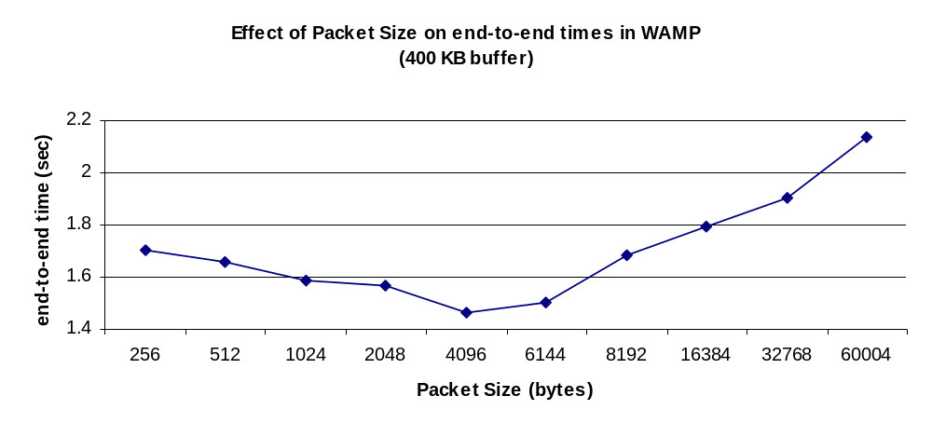

Figure 1. This figure shows the effect of UDP packet size on the performance of WAMP.

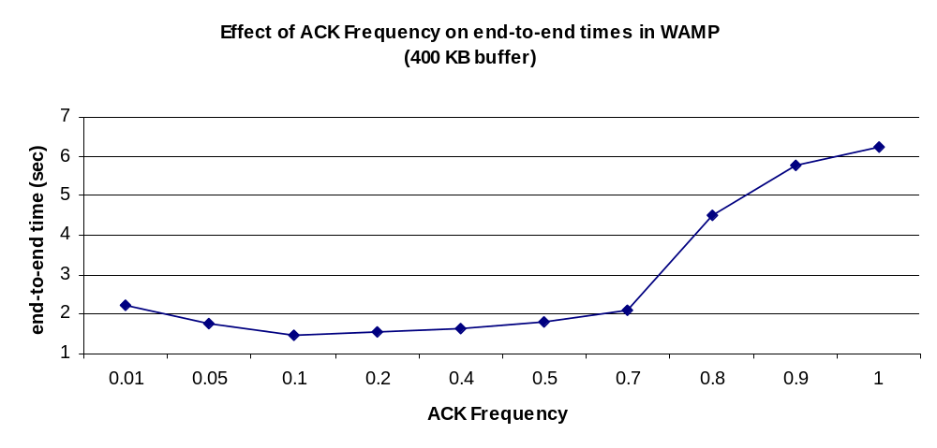

Figure 2. This figure shows the impact of the acknowledgement frequency on the performance of WAMP.

5 Related Work

Significant research has been performed on the optimization of point-to-point and/or collective communications in MPI (e.g. [2,3,4]). However, the bulk of this research has been performed within the context of intra-communicators (i.e. communications within the same process group), and the results do not generalize to the inter-communicator case where the communication is between process groups
that are (in general) separated by a wide-area network.

Several papers (e.g. [5,6,7]) discuss the performance of TCP across wide-area networks, highlighting the limitations of TCP for high-performance wide-area transfers. These studies provide significant motivation for our research, and add weight to our claim that alternative approaches to TCP for wide-area transfers should be investigated.
There has also been significant investigation related to improving the performance of TCP in wide-area networks In general, this research is addressing modifications at the kernel/OS layer to improve performance. Other researches have proposed user-level UDP protocols as an alternative to TCP [8,9]. This work is complementary to the work presented here in that it is proposing mechanisms to inject data into the network at high, steady rates. Our approach is to both minimize the number of communications across a wide area as well as maintaining a steady flow of packets into the network.

6 Conclusions and Future Research
This paper has described WAMP, a highly customized user-level communication protocol for communication between process groups across the Internet in wide-area MPI. It was shown that WAMP achieves up to a nine-fold increase in performance relative to TCP/IP in a heavily loaded network. However, it was also shown that TCP/IP outperforms WAMP by up to a factor of three in a lightly loaded network. These results suggest that the best implementation option for wide-area MPI would be an adaptive protocol that uses TCP/IP when the network load is light, but shifts to the WAMP protocol when the network becomes congested. This is an area of current research.

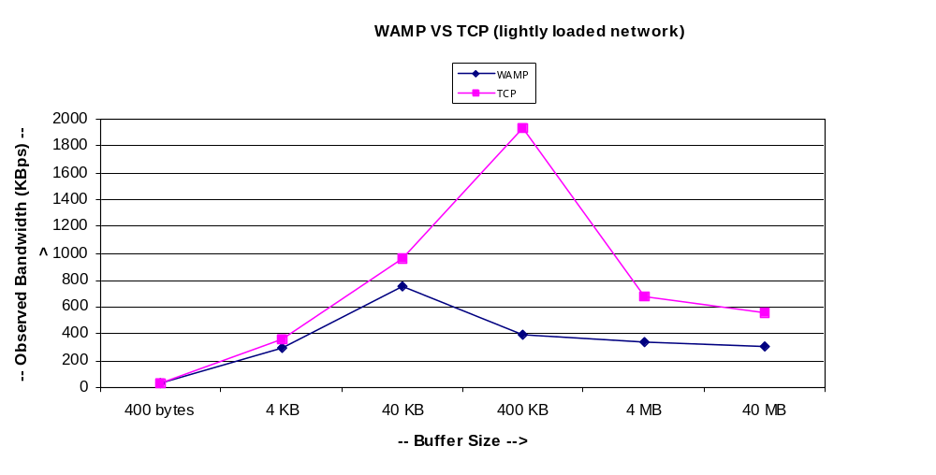

Figure 3. This figure depicts the bandwidth achieved by TCP and WAMP when the network is lightly loaded.

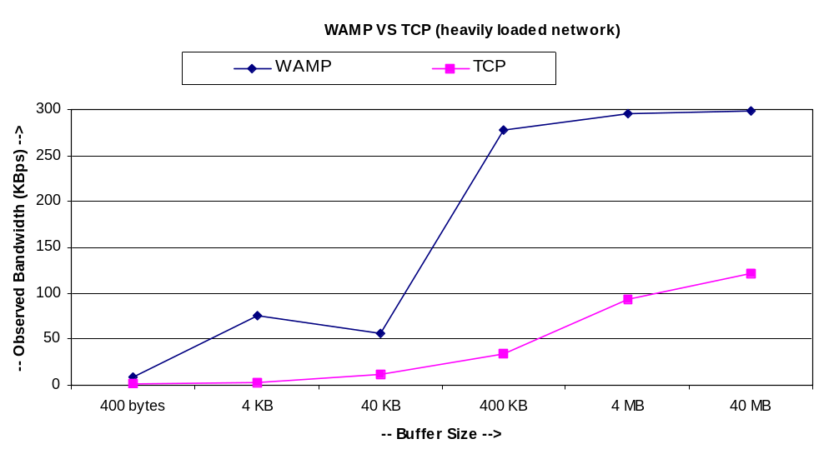

Figure 4. This figure depicts the bandwidth achieved by TCP and WAMP when the network is heavily.

References

[1] Message Passing Interface Forum, “MPI: A Message-Passing Interface Standard”, International Journal of Supercomputer Applications, Vol.3, No.4, pp 165-414, August 1994.

[2] Mohak Shroff and Robert A. van de Geijn, “CollMark: MPI Collective Communication Benchmark”, International Conference on Supercomputing 2000, December 1999.

[3] Nicholas T. Karonis, Bronis R. de Supinski, Ian Foster, William Gropp, Ewing Lusk and John Bresnahan, “Exploiting Hierarchy in Parallel Computer Networks to Optimize Collective Operation Performance”

[4] Thilo Kielmann, Rutger F. H. Hofman, Henri E. Bal, Aske Plaat, Raoul A. F. Bhoedjang, "MagPIe: MPI's Collective Communication Operations for Clustered Wide
Area Systems", Proceedings of the Seventh ACM SIGPLAN Symposium on Principles and Practice of Parallel Programming, Atlanta, GA, USA, May 4-6, 1999.

[5] Vern Paxson, "Empirically Derived Analytic Models of Wide-Area TCP connections", IEEE/ACM Transactions on Networking, Vol.2, No.4, August 1994.

[6] T. V. Lakshman, Upamanyu Madhow and Bernhard Suter, “TCP/IP Performance with Random Loss and Bidirectional Congestion", IEEE/ACM Transactions on Networking, Vol.8, No.5, October 2000.

[7] T. V. Lakshman and Upamanyu Madhow, "The Performance of TCP/IP for Networks with High Bandwidth-Delay Products and Random Loss", IEEE/ACM Transactions on Networking, Vol.5, No.3, June 1997.

[8] R. Gopalakrishnan and Gurudutta M. Parulkar, "Efficient User-Space Protocol Implementations with QoS Guarantees Using Real-Time Upcalls", IEEE/ACM Transactions on Networking, Vol.6, No.4, August 1998.

[9] Craig Partridge and Stephen Pink, "A Faster UDP", IEEE/ACM Transactions on Networking, Vol.6, No.4, August 1998.

