Problem 1:

**public** **static** **void** main(String[] args) {

ArrayList<Integer> A = **new** ArrayList<>();

A.add(10);

A.add(20);

A.add(30);

*prob1*(A);

}

**public** **static** **void** prob1(ArrayList<Integer> list) {

// iterate the list in reverse order

**for** (**int** i = list.size() - 1; i >= 0; i--) {

// if current index is even, add the element at current index to the

// end of the list

**if** (i % 2 == 0)

list.add(list.get(i));

// else add the element at current index to the beginning of the list **else**

list.add(0, list.get(i));

}

System.***out***.println(list);

}

/**

* i = 2 : 10, 20, 30, 30

* i = 1 : 20, 10, 20, 30, 30

* i = 0 : 20, 10, 20, 30, 30, 20

*/

Problem 2:

The program creates a window with 3 buttons (Button1, Button2, Button3) at the top and four buttons at the center (Button4, Button5, Button6, Button7) and a label and textbox at the bottom in a frame with Border Layout

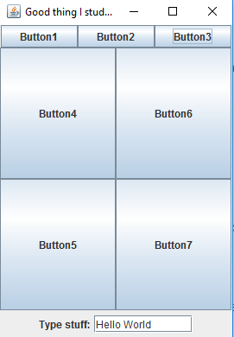

Problem 3:

Code to run the program

**public** **class** Prob3 {

**public** **static** **void** main(String[] args) {

Prez[] p = { **new** FDR(), **new** Lincoln(), **new** Truman() };

**for** (**int** i = 0; i < p.length; i++) {

System.***out***.println(p[i]);

p[i].democrat();

p[i].republican();

System.***out***.println();

}

}

}

Output

FDR

FDR - D

Republican Prez

Democratic Prez

Republican Prez

I am the President!

Republican Prez

Lincoln-RDemocratic Prez

Republican Prez

Lincoln-R

FDR

Truman - DRepublican Prez

Problem 6:

Step Wise Execution:

list2.getLink().getLink().setLink (list); // 2-> 3-> 4-> 1 -> null

list = list2.getLink (); // 3-> 4-> 1 -> null

list.getLink().getLink().setLink (**null**);// 3->4->1-null

list.getLink().setData (17);// 3-> 17-> 1 -> null

list: 3 -> 17 -> 1 -> null

list2:2 -> 3 -> 4 -> 1 -> null