Effect of Social Media on Mental Health

(COMP3125 Individual Project)

Luke Phillips   
*Wentworth Institute of Technology Department of Computer Science*

*Abstract*—This report seeks to find out if there is a correlation between social media usage and mental health. To accomplish this, various statistical methods are used to find what, if any, mental health markers are affected by social media. This is used to analyze the harm of social media, if it exists, who it affects the most, and what could be the potential causes of these effects.

Keywords—Social Media, Mental Health, Depression, Anxiety

# Introduction

Social media has exploded in popularity in recent years, with some networks like Facebook already surpassing 3 billion monthly active users. This increasing popularity has led to an increasing number of problems, making it easier than ever before to become distracted from work, or waste hours on entertainment that has little to no impact on anyone. This increased ability to communicate with others has allowed the world to stay afloat in a pandemic, but it has also put advertisers and large companies closer to our unprotected psyche. This technological boom allowed social media to reach billions of people before any proper research had the chance to analyze the effects and potential downsides of it. Since social media now takes up such a sizeable portion of many peoples’ lives, it is worth looking into which of these hypothesized negative effects are real and which are tall tales to get kids to play outside.

# Datasets

## Source of dataset

All the datasets were sourced as comma separated value files (CSV’s) from kaggle.com, a trusted source for sharing quality data. The chosen datasets have many views and downloads, are highly rated, and cover a large sample size for this field of research. Both datasets were generated through surveys where participants filled out answers to a set of multiple-choice survey questions asking about the nature of their interaction with social media and their mental health state. Dataset 1 [1] had questions focused primarily on the type of social media interaction and amount of time spent and how this affected general emotional state. Most of the questions from dataset 2 [2] asked participants to describe how often or how intensely or frequently they experience certain mental health markers. While these datasets are from a trustworthy source for data, the people taking the survey originally were not going to be able to perfectly assess their mental health, so results are bound to be somewhat inaccurate. On top of this, the responses are only multiple-choice, so this bias may round up and cause even larger errors. Unfortunately, some bias like this will always be present with mental health studies, since it’s very hard to perfectly estimate your own mental state, and anyone else trying to do so won’t be inside your head to get clear enough answers.

## Character of the datasets

Both datasets contained some information that wasn’t relevant or would be hard to statistically analyze, such as the ID number of the survey participant or the time that the survey took place, which was ignored. Both datasets also had an extra empty row in the file for each actual row of data, making early visualization harder, so the python script “remove_newlines.py” was used to remove these, which were introduced by the first pre-processing step.

There are 3 categories of relevant information from dataset 1 [1], the usage time, amount of interaction, and their dominant emotion at the time. The usage time is their estimated average daily amount of time spent on social media, measured in minutes. Dominant emotion is one of 6 options that the participants chose between to describe their most prevalent emotional state throughout the whole day, choosing from: Happiness, Neutral, Boredom, Anxiety, Anger, Sadness. This emotional state was converted to an integer that roughly corresponds to level of emotional distress, previously mentioned in order from the least distressing to the most distressing. The order they were introduced in is used to convert them to numbers from 0 to 5, with 0 being Happiness, the best emotional state available here, and 5 being Sadness, which isn’t necessarily the worst emotional state even though it is the highest number, and it was treated roughly equally as Anxiety and Depression in my analysis.

For dataset 2 [2], more cleaning was required, first, the average social media usage time per day from this survey was a multiple-choice question, with each answer covering a 1-hour range, from 0-1 hours, 1-2 hours, 2-3 hours, etc. up to 5 or more hours per day, which was the largest available option. This range of answers was converted into an integer value, with 0 representing 0-1 hours, 1 representing 1-2 hours, and so on until 5 represents 5+ hours per day. This dataset also had participants select all the social medias that they used, not just one, so that column needed to be split into a column for each social media so that pandas' data frame slicing could be used to easily restrict the population to certain characteristics. This dataset also had multiple questions asking about closely related characteristics, for example there are some that resemble symptoms of addiction. These questions asked if participants felt restless when away from social media for long periods, how often they use social media with no purpose, and how often they’re distracted by it when they should be doing something else. These questions do sometimes cover multiple categories, there are 2 other questions related to distractibility and concentration, and the question that was already mentioned that targets addiction and the ability to concentrate. There is another group of questions that are all related to seeking validation from others on the internet, asking how often participants compare themselves to others and how those comparisons make them feel. The last grouped set of columns are related to depression, with one directly asking how often participants feel depressed or down, and the other asking about how much their motivation fluctuates for simple, daily activities, which is a key sign of depression. The columns within these groupings are added together to form another column that should be able to represent multiple similar factors at once. Without these groupings, it would be much harder to combine the results of multiple survey questions related to the same characteristic, and correlated groupings can hint that we might be working on the right idea.

# Methodology

## Linear Regression

My hypothesis was that social media usage may influence mental health variables, but to say anything quantitatively we need to find a pair of columns to plot so that we can check how closely correlated their relationship is, but right now we only have data. The first step is already done, we need to reduce the number of possible combinations that we need to investigate, since the number of ways we can select a unique pair of two columns grows exponentially according to the number of columns, so we’d need to sort through far too much random nonsense data to start looking at potential solutions to our questions. The most important reduction made was selecting only one or two columns to use up against every other valid column like an X axis, reducing the potential solution space drastically. The manual groupings also help reduce the solution space, giving us fewer, better options to choose from, strengthening correlations that aren’t necessarily linked to those specific traits, but to the root cause of the traits that is harder to show with raw data. These manual groupings are chosen based off rumors about the effects of social media, to try and test them as closely as possible, and are improved through trial and error and a large analysis of the remaining data. The columns that haven’t been weeded out at this point for being irrelevant then have their regression lines calculated from the chosen X axis, time spent, and all potential Y axes, and other statistics like mean, standard deviation, and r2 are calculated. The results of these statistics are then color coded based on an adjustable threshold value to make promising correlations easier to notice. We are left with a table of potential correlations that can be investigated, where many are just random chance overcoming the threshold, but a few correlations stand out above the crowd and hold potential to be significant. This table is too large to comfortably fit in this report and can be found as a CSV file in the GitHub repository under “data/meta_stats.csv”. These correlations are then examined further to see how they compare to other similar correlations to find other relationships in the data that may have been missed. After a thorough sifting, most of the promising relationships in the data are put into scatter plots, and the regression line is drawn and the data is visually examined, since sometimes data will seem to be a fitting regression line from the numbers, but it may just be a line through random noise. This is done primarily with the python libraries Pandas and Matplotlib, with the linear regressions done by in NumPy.

## Paired t-test

The data in dataset 2 [2] unfortunately isn’t well suited to a regression test, since almost all the columns that we would want to plot against average time spent on social media can’t have more than 10 possible values, like dominant emotion. In this case we can see from the graph that there likely is some kind of trend regarding Happiness and time spent on social media, and to prove it we perform a paired sample t-test, which will give us the probability that this variation happened due to chance, assuming that emotion and time spent on social media is roughly normally distributed. The results of the t-test are shown below in fig 7, and our calculated p value is astronomically low, showing that there is a very significant difference between the means of the two distributions. This is done using mainly the same libraries, Matplotlib, Pandas, and NumPy, but here SciPy is also used to calculate the paired t-test.

# Results

## Linear Regression

Of the correlations that were found, they were rather weak, and correlation on its own does not amount to causation. For example, what if people with high levels of distractibility and low attention spans prefer social media’s quick short-term rewards to other long-term prospects. The same goes for people with addictive personality traits, who might be disproportionately attracted to social media for the same reasons, it doesn’t necessarily mean that social media causes addictions. They could both be caused by an outside third factor that isn’t being measured, or it could be 2 separate outside factors that just happen to make it seem correlated, it could be anything, and further research is needed to find that out. Figs 1-3 show the highest correlations found in the data, with figure 4 showing the linear regression statistics. Fig 1 showed the highest correlation, pictured below, and the other linear regression graphs are at the end of the results section.

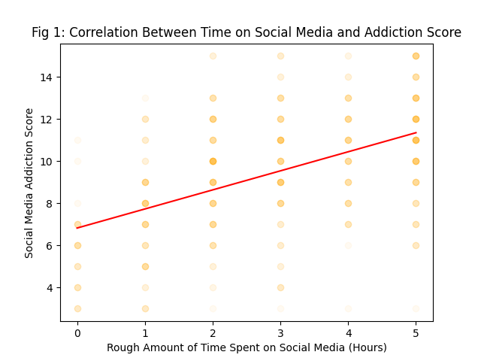

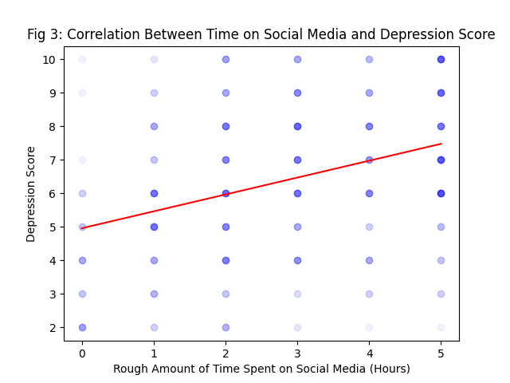

|  | Fig 4: Statistics of Regression Lines | | | |
| --- | --- | --- | --- | --- |
| slope | intercept | R2 | Residuals |
| Addiction | 0.9055 | 6.8277 | 0.2412 | 3132.0671 |
| Distractibility | 0.8437 | 7.4608 | 0.1660 | 4341.3301 |
| Depression | 0.5039 | 4.9605 | 0.1301 | 2061.3524 |

## Results of Paired t-test

There seem to be very few definitive negative effects of social media usage, at the rates observed in these surveys. In fact, one survey showed an undeniable, statistically significant difference in the time spent by participants reporting their dominant emotion as Happiness. This is seen in Fig 7, where the p-value is listed as 9.016*10^(-60), which is the probability for that much of a difference in the data to appear by random chance. My hypothesis before performing research was that there would likely be some kind of detrimental effect shown obviously because of social media usage or overuse, but sometimes a ‘failed’ experiment can tell us more than a ‘successful’ one. If there were obvious correlations in the data, there would have been no need to scour as many combinations as possible, and finding a very small correlation between social media and these negative effects is a far better outcome than finding out social media has negative effects on our health. Figs 5 and 6 show both a boxplot and scatterplot version of dataset 2 [2], showing off the large difference in the populations. The test statistic also shows a statistical difference between the people who reported their emotional state as happy and those who didn’t. In Fig 5 you can see the difference in social media time usage between the people who reported different emotional states, which are: happiness, neutral, boredom, anxiety, anger, and sadness. In order from left to right. Fig 7 shows the test statistic and p-value, which is low enough to show a statistical significance

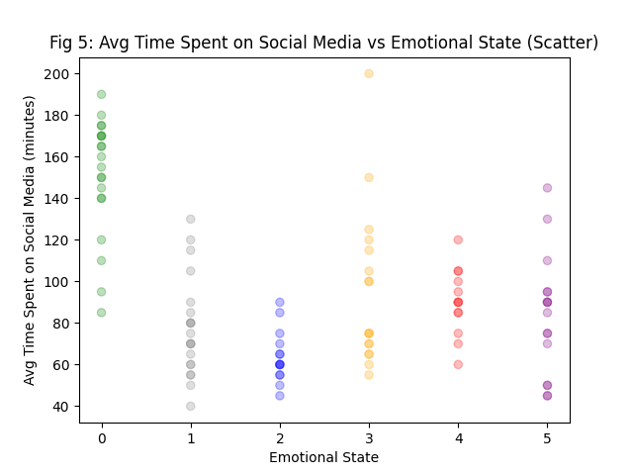

|  | Fig 7: T-Test Statistics | |
| --- | --- | --- |
| t-value | p-value |
| Happiness | 17.459 | 9.016*10^(-60) |

## 

| Fig 8: Mean & Std Dev of Time on Social Media by Mental State | | |
| --- | --- | --- |
|  | Mean (minutes) | Std Dev (minutes) |
| Happiness | 150.5 | 27.9042 |
| Neutral | 77.5 | 23.5896 |
| Boredom | 63.9286 | 12.1706 |
| Anxiety | 95.5882 | 37.0464 |
| Anger | 90 | 15.3764 |
| Sadness | 83.75 | 28.1226 |

# Discussion

If the datasets I chose were more detailed and had more participants, perhaps there could have been better correlations to find in the data. I may have been looking for the wrong indicators of mental health or I may have tried to numerically represent more than I should have in a way that skews the data. Measuring and describing mental state accurately with numbers and statistical models is not possible with our current technology, and our data collection will always suffer from being an imperfect representation of that mental state. This inability to perfectly measure mental state may have caused the higher average time on social media for people reporting a happy mental state, since people may have biases that want to reinforce their actions and say that they’re happier than they are. Social media is also a new enough invention that there isn’t a whole field of research that's been working with it for years, so the data is even more sparse and generally lower quality than physical measurements or closely watched statistics like for sports or other fields. Future researchers should focus on collecting quality data that can be used to narrow down the potential candidates for potential correlations between social media usage and positive or negative side effects. This data also doesn’t cover long time periods or children, both future areas of study that could be improved on.

# Conclusion

Social media is not likely to ruin our lives or destroy everyone’s attention spans, not immediately at least, we haven’t yet gotten long-term data surrounding the potential side effects. It probably is somewhere around neutral to us, and it may even make us happier, with the data showing that there seems to be upsides to having easy opportunities to scratch our brain’s reward systems. Overall though a definitive answer cannot be reached, almost none of the data had statistically significant conclusions, with no correlation coefficients high enough to suggest much, and data that doesn’t agree on the how time spent on social media affects your mood. The only data that was statistically significant could have been due to biases in the data collection, munging, and processing, though it does point a potential way for future research.

##### References

1. Bulut E. (2024, May). “Social media usage and emotional well-being.” Retrieved December 8, 2024 from <https://www.kaggle.com/datasets/emirhanai/social-media-usage-and-emotional-well-being/data>
2. S. Ahmed, M. Syeda, (2024, November). “Social media and mental health.” Retrieved December 8, 2024 from <https://www.kaggle.com/datasets/souvikahmed071/social-media-and-mental-health/data>