*PROJECT WRITEUP: Behavioral Cloning*

**Model Architecture and Training Strategy**

*Has an appropriate model architecture been employed for the task?*

[NVDIA model used]

*Has an attempt been made to reduce overfitting of the model?*

*[added l2 normalization and dropout layers]*

*Have the model parameters been tuned appropriately?*

*[main model parameters matched NVDIA model, 20 epochs w best logging worked, adam opt]*

*Is the training data chosen appropriately?*

*[wanted to see what minimum amount of data could be effectively used to train. Started with Udacity base dataset, added out lap forward and one backward then trained. There were two points in the track where additional data was necessary.]*

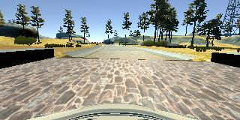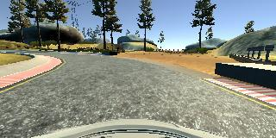

*[The left hand curve after the bridge has a border that is different from most, so the car drove off the track at first. One extra pass was enough to correct this.]*

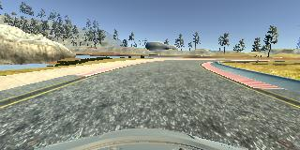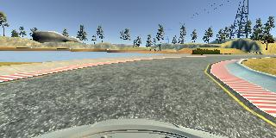

*[The right hand curve just after the curve above was also a challenge, as most curves on the track are to the left, and are not as sharp. On this segment, I recorded the turn again, then duplicated the corresponding lines in the .csv log five times to give it more emphasis in training. After that, this turn became one of the best of the track.]*

**Architecture and Training Documentation**

*Is the solution design documented?*

*[xxx]*

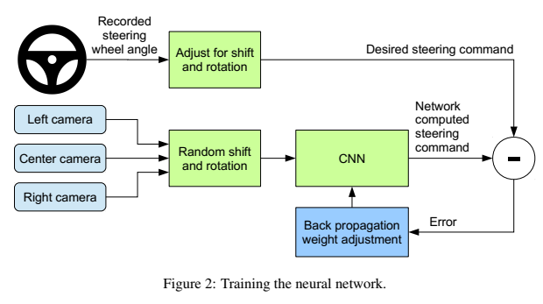

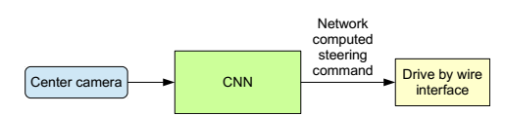

*Is the model architecture documented?*

*[xxx]*

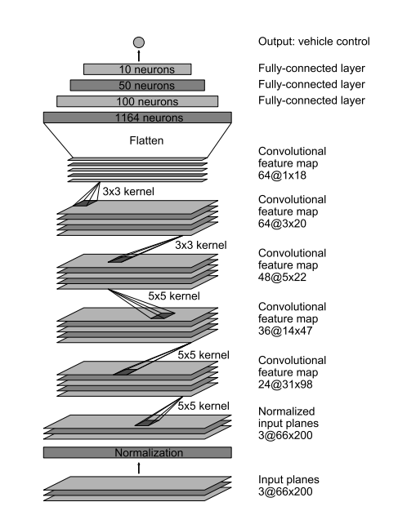

*Is the creation of the training dataset and training process documented?*

*[data aggregation described above. 80/20 split made from data, train/val data shuffled in generator]*

