Can the Basis Be Rebuilt? A Record-Level Documentation Quality Review of 32 Public-Records Cases
Stacyann Young Independent Researcher
Phillip Wikes Creator of the Justification Review Standard; former Lead Civil Rights Officer, Maryland Commission on Civil Rights
Author contributions. S.Y. designed the public-records case protocol, selected and screened all 32 publicly available determinations, recorded the read and its contemporaneous basis note for each case blind to the documented outcome, recorded the outcomes and citations, and leads the public-records framing. P.W. developed the review standard and the Decision Reconstruction Risk construct, designed the pilot, ran the analyses, and co-wrote the manuscript.
Disclosure. Both authors contributed to this work in their personal professional capacities. S.Y. conducted this research voluntarily and independently, using publicly available materials and without institutional affiliation. The research does not represent the views, positions, policies, or practices of the City of New York, any City agency, or any other government entity. No internal, confidential, privileged, or otherwise nonpublic government materials were used. No funding was received for this work.

Abstract
Purpose. Consequential records are often reviewed after the fact by people who did not participate in the original decision. Their ability to assess the decision depends on whether the record preserves enough information to reconstruct its basis. This study examines whether a structured, record-level documentation quality read can identify differences in that reconstructability.
Design/methodology/approach. A three-level read, Ready, Needs work or Gap, was applied to 32 publicly available public-records cases from 32 distinct sources across four document classes and two states, issued between 2005 and 2026. The read and a contemporaneous note explaining its basis were recorded from the source before the documented outcome was consulted. Ten cases were independently re-read.
Findings. The read corresponded with independent government audit findings in all five cases where comparable audit assessments were available. It was associated with reconstructability as reflected in contemporaneous basis notes: six of seven noted Needs work cases recorded that the basis could not be rebuilt, compared with none of 17 noted Ready cases (p = 0.0000520). The read also distinguished document classes according to the extent to which the underlying basis was exposed (p = 0.00466). It was not associated with appellate outcome in the resolved subset (p = 1.000), consistent with reconstructability and appellate disposition representing different properties.
Research limitations/implications. The corpus is small, non-random and limited to two jurisdictions. Reliability evidence is preliminary because only 10 cases received an independent blind re-read.
Practical implications. The findings suggest that reconstructability can be examined at the record level before a consequential record is finalised. A structured review that records both the assessment and its basis may provide an additional quality-assurance mechanism for records subject to later audit, review or challenge.
Originality/value. The study provides an initial empirical examination of a structured record-level approach to assessing whether the basis for a consequential decision remains independently reconstructable from the record itself.
Keywords: Records management; information governance; documentation quality; public records; recordkeeping evidence; decision reconstructability
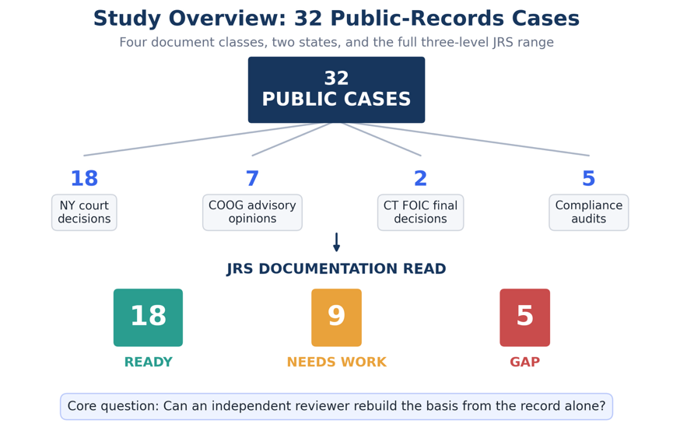
Figure 1. Overview of the 32-case study and documentation-read outcomes. The study examined 32 publicly available cases across four document classes using the three-level documentation read of Ready, Needs work, and Gap.
The blinded second-read data and reproducibility materials are retained with the study records and are available from the authors.

1. The governance problem
A public-records determination is not only a response to a request. It is also a record of administrative action. It may later be examined by an appeals officer, an open-government body, a court, an auditor, or a records professional reviewing whether the agency can account for what it did. By that point, the original decision-maker may no longer be available. The record must therefore carry enough information for a later reviewer to understand how the determination was reached.
Records and information governance provides established approaches to retention, classification, access, disposal and preservation. A separate question arises at the level of the individual consequential record: whether the record preserves enough evidentiary and decision-process information for an independent reviewer to reconstruct how the conclusion was reached.
Completeness alone does not answer that question. A record may contain the required fields, follow an approved format and read as complete while still leaving the later reviewer unable to determine what evidence supported a conclusion, how the relevant information was interpreted, or why one outcome was reached rather than another.
Public-records material provides a useful test corpus because decisions and audits are publicly available, some of the same programmes have been assessed independently, and documented outcomes permit examination of whether reconstructability is distinct from substantive outcome.
The broader question is not limited to freedom of information. It concerns the evidentiary quality of consequential records that must remain understandable and reviewable after the original decision-maker is no longer available.

2. Introduction
A determination can be facially complete, professionally written, and still fail, because the specific basis for each withholding cannot be rebuilt from the record itself. The exemption relied on, the records located and produced, and the reasoning that connects them may simply not be on the page. That is not a technology problem in the ordinary sense. It is a documentation-quality problem, and it decides whether an agency can show what it actually did when someone asks.
The question is timely. On 28 May 2026 the Chief FOIA Officers Council announced a government-wide effort to inventory FOIA technology solutions across federal agencies, covering case-management systems, eDiscovery platforms, document-review tools, and their costs, so that the inventory can inform acquisition and implementation decisions. An inventory of that kind answers what software agencies run. It does not answer whether the determinations coming out of that software hold up when read cold. Software that produces fluent but unreconstructable determinations does not, by itself, establish that the resulting records are defensible.
Existing records and information governance controls do not necessarily assess this property at the level of an individual consequential record. Two agencies can run the same case-management system and produce determinations of very different defensibility. This pilot examines whether a structured record-level read can do so.
From a records-management perspective, reconstructability concerns more than whether information has been retained. A file may contain a large volume of material and still fail to show how a particular administrative conclusion was reached. The relevant question is whether the relationship between the decision, the supporting material, and the stated reasoning remains sufficiently visible for later review. That distinction places documentation quality alongside more familiar concerns about retention, accessibility, authenticity, and accountability.

3. Research questions
- Can the review conditions be applied to real public-records material across document classes and jurisdictions, and do they produce a full range of reads?
- Where an independent government auditor has assessed the sufficiency of the same records, does the read agree?
- What drives the read, and is it the property the instrument claims to measure?

4. Record-level review framework
The study applies a structured record-level review framework developed to assess whether a consequential decision can later be reconstructed from the record itself. The framework is referred to in this study as the Justification Review Standard (JRS). Five conditions carry that question. Reconstructability, whether the conclusion can be rebuilt from the record alone. Basis identification, whether the source of each characterization is identifiable. Chronological integrity, whether dates, sequence, and sources hold together when read cold. Decision-process traceability, whether the reasoning from evidence to conclusion can be followed and the responsible parties identified. Evidentiary sufficiency, whether the record carries enough to support the weight of the decision.
The conditions resolve to a three-level read. Ready, where a later reviewer could rebuild the conclusion from the record alone. Needs work, where the record is partly reconstructable and some basis is visible with gaps. Gap, where the basis is not visible in the record at all.
The risk the standard names is Decision Reconstruction Risk: the condition in which a record cannot, on its own terms, let an independent reviewer rebuild the basis for a consequential decision.

5. Methods

5.1 Design
Retrospective and records-based. Each case pairs a real public determination or audit, in which the sufficiency of the record was at issue, with its documented outcome. Two things are recorded first, from the source alone and before the outcome is consulted: the read, and a short note stating the basis for it. The outcome and the citation are recorded afterwards. Recording both the read and its basis before the outcome is what keeps them independent of the result, and it is what makes the analysis in Section 6.3 possible.

5.2 Materials
Public material only. Each case was de-identified as to any private individual, and each case carries a public citation or source URL. No internal, confidential, privileged, or otherwise nonpublic government material was used.

5.3 Sample
The stated target was 20 to 30 cases with a deliberate spread of outcomes. The achieved sample is 32 cases from 32 distinct public sources, collected 26 June to 8 August 2026, spanning decisions issued between 2005 and 2026 across eleven distinct years.
Four document classes are represented: New York appellate and trial-level decisions (n = 18); New York Committee on Open Government advisory opinions (n = 7); Connecticut Freedom of Information Commission final decisions (n = 2); and compliance audits issued by the New York State Comptroller and the New York City Comptroller (n = 5).
At least twelve distinct FOIL issues appear across the set, including personal privacy (9 cases), law-enforcement disciplinary records (5), burden and volume objections (3), law-enforcement exemptions (2), constructive denial (2), timeliness (2), reasonable description, in-camera review, sealed and erased records, commercial confidentiality, life-and-safety withholding, and refusal to confirm or deny.

5.4 Outcome coding
Outcomes are coded from the cited source in four categories: the determination was sustained; the determination did not survive review; the determination was contested and the source records no resolved disposition; or the auditor recorded an adverse finding about the agency's records or its ability to evidence its own responses. No outcome is inferred. Each traces to the public record.

5.5 Analyses
Five analyses, in the order reported.
Convergent validity compares the read against the independent government auditor's own conclusion in the subset where an auditor examined the same agency's records. This is a concordance count rather than a significance test, because the comparison is between two instruments and not between groups.
Construct validity codes the contemporaneous basis notes for one question: does the note state that the underlying record-level basis could not be rebuilt from the source? Coding requires an explicit statement in the note, not an inference. This coding is post-hoc and is labelled as such wherever it appears. Association with the read is tested with Fisher's exact test.
Discriminant validity tests the read against document class, using a structural variable rather than the reviewer's own words: whether the source reproduces the determination text or instead assessed the underlying records in camera or in aggregate.
The specification check tests the read against appellate disposition. Cases where the source records no resolved disposition are excluded rather than assigned one.
All 32 initial reads were recorded by a single domain reviewer. Documented outcomes were coded by the same reviewer after the record-level read and basis note had been completed. The temporal separation reduces outcome influence on the initial classification but does not remove the broader limitation associated with a single primary reviewer. Section 9 treats that as a limitation.

5.6 Blind second read
To estimate reader dependence, 10 of the 32 cases were re-read by an independent reviewer with no connection to the study and no prior familiarity with the instrument, who recorded his own read and a short reason for each case. The 10 were drawn from the corpus stratified by the original read with a floor of one case per category, ordered by case identifier within each stratum and interleaved so that consecutive cases do not share a category. Six, three and one fell to Ready, Needs work and Gap respectively. No random number generator was used, so the selection is reproducible from the packet builder alone.
The second reader was shown the public source and a short description of what each record is. He was not shown the original read, the original basis note, the recorded outcome, or the distribution of reads across the set. He reported prior familiarity with the instrument as none, and recorded that he knew the documented outcome in 0 of the 10 cases. Agreement was computed after his answers were received, against reads recorded between 26 June and 8 August 2026 and unchanged since.

6. Results

6.1 The instrument applied to real material
Reads across the 32 cases: 18 Ready, 9 Needs work, 5 Gap. Documented outcomes: 15 determinations did not survive review, 7 contested without a recorded disposition, 5 sustained, 5 adverse audit findings. Figure 2 shows the distribution of documentation reads across the documented outcomes.

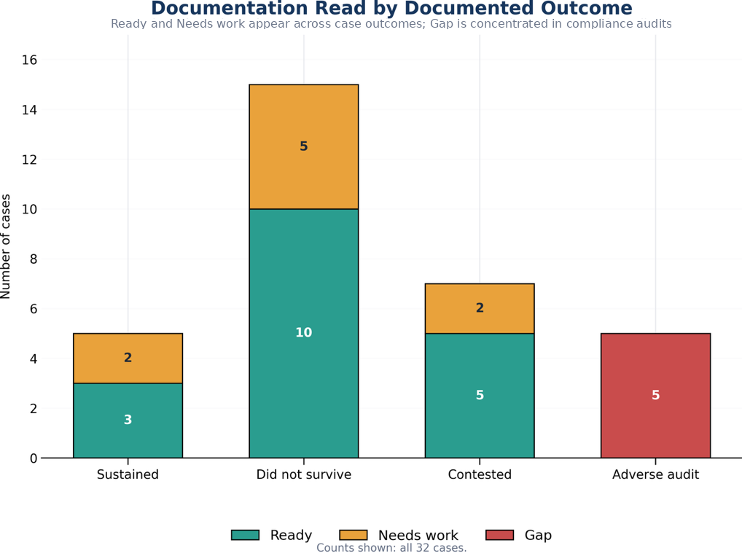
Figure 2. Documentation read by documented outcome. The figure shows the distribution of the three documentation reads across the documented outcomes in the 32-case corpus.
The conditions were applied to 32 publicly available determinations and audits, across four document classes and two states, over decisions spanning twenty-one years, and returned the full three-level range of reads. Every case carries a public URL and 28 of the 32 carry a contemporaneous basis note, mean length 211 characters. That answers the first research question and supplies the applied case set the field did not previously have.

6.2 The read agrees with independent auditors, five of five
Five cases are compliance audits in which a state or city Comptroller had independently examined an agency's FOIL programme, using their own methodology and with no knowledge of this study.
All five received a Gap read, recorded from the source before the auditor's conclusion was consulted. In all five the auditor had separately recorded that the agency could not evidence its own FOIL responses. In the auditors' own terms: records of what had been provided were missing; request tracking was absent or incomplete; one agency supplied an email asserting that records had been sent without the records themselves; and in two audits the auditor stated on the record that they could not determine with reasonable certainty whether the information necessary to complete the audit had been supplied at all.
Concordance is five of five. Two instruments built with no knowledge of each other, a documentation read applied to the source and a government audit applied to the programme, reached the same conclusion in every case where both were available. The agreement with the available Comptroller findings provides preliminary evidence that the record-level read identifies the same type of evidentiary deficiency identified independently through programme-level audit.
Two things this is not. It is not a test of statistical association, because the comparison is between instruments rather than between groups. And five cases are five cases. What it demonstrates is that the Gap read is reachable on real material, and that where an independent government auditor assessed the same records, the two assessments matched.

6.3 The read tracks reconstructability, not outcome
For the 28 cases with contemporaneous basis notes, the note giving the basis for the read was written before the outcome was known. Coding those notes for one question, whether the note states that the underlying record-level basis could not be rebuilt from the source, produces the clearest result in the study.
The construct comparison is restricted to the 27 case-level sources classified Ready or Needs work; the 5 programme-level audit sources classified Gap are analyzed separately in Section 6.2. It is further restricted to the 24 of those 27 that carry a note, because a case with no note cannot be coded for what its note states, and counting it as not stating a reconstructability failure would inflate the comparison group. The 3 case-level sources without a note are excluded rather than assigned a code.
 | Reconstructability failure stated | Not stated | Rate
Needs work (n = 7) | 6 | 1 | 85.7%
Ready (n = 17) | 0 | 17 | 0.0%

Fisher's exact test, two-sided: p = 0.0000520.
The direction is uniform. In the Needs work cases the recorded reason is that the source reports the outcome without reproducing the material that would let a reader test it. The redacted contract and its technical schedules were not reproduced. The 165,000 pages and their redaction universe were not available. The record-by-record exemption analysis was never before the court. The security assessment was reviewed in camera and never published. In the Ready cases the opposite is recorded, and eleven of the 17 notes say so directly: the opinion walks through the original request, the Records Access Officer response, the appeal determination, the lower-court rulings and the holding; the appeal determination is quoted almost verbatim; the source identifies the record category, the exemption, the statutory change, the agency position and the conclusion.
No Needs work note contains an affirmative reconstructability statement, and no Ready note contains a reconstructability failure.
These findings provide preliminary evidence addressing the third research question. The reads were driven by the presence or absence of a rebuildable basis, which is the property the instrument is built to detect, and not by who won or by what kind of case it was. The coding is post-hoc, which is why it is reported as construct evidence rather than as a confirmatory test, and the contemporaneous notes are what make it checkable by anyone re-reading the case set.

6.4 The read separates document classes by how much basis they expose
The same conclusion can be reached without relying on the reviewer's own words, using a structural feature of each source. Figure 3 shows the distribution of documentation reads across the four source classes.
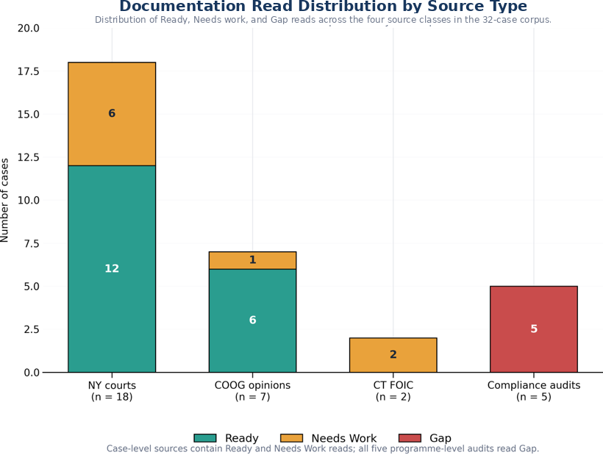
Figure 3. Documentation read distribution by source type. The figure shows the distribution of the three documentation reads across the four source classes in the study corpus.
Among case-level sources, Committee on Open Government advisory opinions read Ready in 6 of 7 cases (86%), court decisions in 12 of 18 (67%), and Connecticut Freedom of Information Commission final decisions in 0 of 2. Advisory opinions typically quote the appeal determination itself. Court decisions summarize it. Both Connecticut decisions turned on records the Commission examined in camera.
Grouping by that structural difference, sources that reproduce the determination text against sources that assessed the underlying records in camera or in aggregate:
 | Ready | Not Ready
Reproduces the determination text (n = 7) | 6 | 1
Assessed the records in camera or in aggregate (n = 7) | 0 | 7

Fisher's exact test, two-sided: p = 0.00466.
Gap reads concentrate completely. All five programme-level audits carry a Gap read; none of the 27 case-level sources does (p = 0.0000050).
The instrument separates document classes by how much reconstructable basis each one carries, in the direction the construct predicts, using a variable independent of the reviewer's notes. Case type and read are not independent in this corpus, which is why Section 6.2 is reported as concordance rather than association, and the same collinearity bounds what Section 6.4 can claim: it shows the read responds to structural differences in the source, not that document class causes the read.

6.5 Appellate outcome is a different variable
The specification check tested the read against appellate disposition, on the 20 determinations where the source records a resolved one.
 | Sustained | Did not survive | Sustained rate
Ready | 3 | 10 | 23.1%
Needs work | 2 | 5 | 28.6%

Odds ratio 0.75. Fisher's exact test, two-sided: p = 1.000. Null.
Read alongside Sections 6.3 and 6.4, this is the expected result and it is informative. Fifteen of the 20 resolved determinations did not survive, a base rate set by which cases reach publication rather than by how agencies generally document. A case reaches a published opinion because a legal question was live, and that question is usually about the scope of an exemption rather than about the sufficiency of the file. The reads were measuring reconstructability. Appellate outcome measures something else.

6.6 Interpreting the null outcome association
The absence of an association between the documentation read and appellate outcome should not be interpreted as evidence that reconstructability lacks practical significance. The published public-records corpus is structured around contested legal questions, and appellate disposition reflects legal and substantive factors that extend beyond the quality of the record.
The present finding therefore establishes an important boundary for this corpus: reconstructability and appellate disposition should not be treated as interchangeable outcome measures. Future studies should examine agency determinations before they enter a publication or litigation pathway and should compare record-level reconstructability with independently established audit and review findings.

6.7 Blind second read
The two readers agreed exactly on 7 of 10 cases, 70.0 percent, 95 percent Wilson interval 39.7 to 89.2. Cohen's kappa is 0.474 unweighted, which is moderate agreement on the conventional scale and is reported here without qualification.
Two further coefficients are reported because the unweighted figure is not the only defensible one for this scale, and reporting only the most favourable of the three would be a choice made after seeing the data. The scale is ordinal, Ready to Needs work to Gap, and all 3 disagreements were between adjacent categories; none was a Ready against a Gap. Linear weighted kappa is 0.559 and Gwet's AC1 is 0.582. All three rest on 10 cases and none of them should be read as a stable estimate.
The disagreements are not symmetric: the second reader was stricter than the original on 2 cases and more lenient on 1. They were case 1, read Ready originally and Needs work on re-read; case 4, read Ready originally and Needs work on re-read; case 5, read Needs work originally and Ready on re-read. Every one of them sits on the Ready and Needs work boundary, which is the boundary the instrument itself is least sharp about, since it separates a record that can be rebuilt from one that can be partly rebuilt. The Gap category was reproduced exactly in the blind second read.

7. Discussion
This pilot provides preliminary evidence that record reconstructability can be examined systematically across public-records materials. The framework produced the full range of classifications across four document classes, corresponded with independent audit findings in the five cases where an external audit provided a comparable assessment, and showed patterns consistent with the construct it was designed to examine.
The practical implication is a records-management one. A determination may be preserved, accessible, and formally complete while still failing to preserve the basis on which the agency acted. Reviewability therefore depends not only on whether the record survives, but also on whether the relationship between the decision, its supporting information, and its stated reasoning remains available to a later reviewer.
That portability is what makes the read a natural companion to a technology inventory rather than a competitor to it. An inventory answers what tools are in use. A documentation read answers whether the outputs hold up. The audit subset shows why both are needed: in all five, the failure the auditor recorded was evidentiary, an agency unable to show what it had done. That failure mode is invisible to an inventory of software and visible to a read of the record. Agencies could, in parallel with technology modernization, sample their own determinations for reconstructability, catching the case where better tooling produces fluent but unreconstructable records.
For public-records programs, the practical form is simpler than the research form. Determinations that rebuild their own basis, that name each exemption, itemize the records located and produced, and connect reasoning to cited authority, are more consistent across officers and cheaper to defend when an auditor or an appeals body asks. The five conditions work as a pre-issuance checklist, not only as a research instrument. This pilot does not establish that using them lowers reversal rates, and no such claim is made.

8. Practical implications for records and information governance
The findings support three potential uses of reconstructability review within records and information governance, while not establishing that the review improves substantive outcomes.
Pre-finalisation quality assurance. A record can be reviewed for reconstructability while the underlying matter remains active. The relevant question is whether an informed reviewer who did not participate in the decision could understand the evidentiary basis and reasoning from the record available to them.
For records programmes, the findings suggest a practical quality-control question that can be applied before a consequential determination is finalized: if the decision-maker were unavailable and a later reviewer had only the record, could that reviewer identify what was decided, what information supported it, and how the stated conclusion followed from that information?
This does not require agencies to preserve every intermediate thought or drafting artifact. It requires attention to whether the record ultimately retained is sufficient to reconstruct the basis of the action it documents.
Retrospective review. Records functions can use reconstructability review to examine consequential records already in the system, particularly where audit, appeal or regulatory exposure makes later explanation likely.
Audit sampling. A structured record-level read may provide a method for identifying recurring documentation weaknesses across a programme. The value is not the rating alone. It is the recorded basis for the rating, which can identify the specific information missing from the record.
What this does not support. The evidence does not establish that applying the read improves documentation, reduces adverse findings, or performs equivalently outside the two states and four document classes sampled. The reliability evidence is interim. These are the questions a larger study would take up.

9. Limitations

The study should therefore be read as an initial validation and feasibility exercise rather than as a population estimate of documentation quality in public-records programmes.
All 32 reads were recorded by a single domain reviewer. 10 of them, not all 32, were re-read blind by an independent reviewer, so reader dependence is estimated on a subset and not removed. Agreement on that subset was 70.0 percent with an unweighted kappa of 0.474, which is moderate: it is evidence that the read is not idiosyncratic to one person, and it is not evidence that two readers would classify the full corpus alike. The interval on the agreement proportion, 39.7 to 89.2 percent, is wide because 10 cases cannot make it narrow.
One second reader is not a panel, and a single re-read cannot separate reader dependence from case difficulty: the 3 cases where the reads differed may be cases two careful readers would always split rather than cases either reader got wrong. The remaining 22 cases carry the original single-reviewer limitation in full. Additional independent reviews would be required before stable estimates of inter-rater reliability could be established.
The note coding in Section 6.3 is post-hoc rather than pre-registered, and is reported as construct evidence rather than as a confirmatory test.
Cases were selected by the domain reviewer from published sources rather than sampled at random, and published sources over-represent contested determinations.
The convergent-validity result rests on five audits, and in this corpus document class and read are not independent, which bounds Sections 6.2 and 6.4 to the readings given there.
The corpus is two states, New York and Connecticut. Generalization beyond them is not claimed.
Seven cases record a contest without a resolved disposition, which reduces the specification check from 27 determinations to 20.
The reviewer read the determination as reported in a published decision or audit, which is not identical to the file the original decision-maker produced.
The standard remains in a validation phase and makes no proven-effectiveness claim.

10. Conclusion
Public-records determinations must often survive the people who created them. When a determination is later reviewed, the relevant question is not whether the original decision-maker could still explain what happened. It is whether the record can do so.
This pilot examined that question across 32 publicly available public-records cases representing four document classes and two jurisdictions. The findings provide preliminary evidence that a structured record-level read can distinguish between sources that expose the basis of a determination and sources that leave that basis difficult or impossible to reconstruct.
The broader implication is not limited to public-records administration. Records management has long concerned itself with whether organizations retain information that is accessible, reliable, and capable of supporting accountability. Reconstructability adds a related question for consequential administrative records: when the decision is examined later, does the record preserve enough of its evidentiary basis and reasoning to explain how the organization acted?
The answer matters independently of the technology used to create the record. Systems will change. Drafting tools will change. The requirement that an organization be able to account for consequential decisions from its own records will remain.

References
Chief FOIA Officers Council. (2026, May 28). Memorandum: data collection and volunteers [Government-wide FOIA technology inventory initiative]. United States Department of Justice.
Gwet, K. L. (2008). Computing inter-rater reliability and its variance in the presence of high agreement. British Journal of Mathematical and Statistical Psychology, 61(1), 29-48.

Cited determinations, opinions, and audits
New York appellate and trial-level decisions: Matter of Russell v Town of Mount Pleasant, N.Y., 2026 NY Slip Op 00966; 2020 NY Slip Op 50815(U); 5 NY3d 84 (2005); 4 NY3d 477 (2005); 31 NY3d 217 (2018); 2024 NY Slip Op 04071; 2024 NY Slip Op 24247; 2025 NY Slip Op 00220; 2025 NY Slip Op 00723; 2025 NY Slip Op 01009; 2025 NY Slip Op 01010; 2025 NY Slip Op 01933; 2025 NY Slip Op 02207; 2025 NY Slip Op 03102; 2025 NY Slip Op 03331; 2025 NY Slip Op 05783; 2025 NY Slip Op 30848(U); 2025 NY Slip Op 32688(U).
New York Committee on Open Government advisory opinions: FOIL AO 19516 (December 5, 2016); FOIL AO 19639 (December 20, 2017); FOIL AO 19646 (February 16, 2018); FOIL AO 19721 (April 12, 2019); FOIL AO 19746 (July 16, 2019); FOIL AO 19780 (September 21, 2020); FOIL AO 19854 (October 18, 2023).
Connecticut Freedom of Information Commission final decisions: FIC2012-276; FIC2015-122.
Compliance audits: New York State Comptroller, compliance with Freedom of Information Law requirements (2020, 2021, 2023); New York City Comptroller, Review of the New York City Police Department's Body-Worn Camera Program (2025).

Data availability
Case-level data, including public citations, classifications, contemporaneous basis notes, outcome coding, and analysis procedures, are maintained in the study database. Verified counts as of 8 August 2026: 32 cases from 32 distinct public sources, collected 26 June to 8 August 2026; reads 18 Ready, 9 Needs work, 5 Gap; outcomes 15 did not survive review, 7 contested, 5 sustained, 5 adverse audit findings. Analysis code and the complete case set will be made available with publication, subject to journal requirements.

