Can Public-Records Determinations Be Independently Reconstructed? Evidence from 32 Public Cases
Stacyann Young Independent Researcher
Phillip Wikes, Independent Researcher; Developer of the Justification Review Standard
Author contributions. S.Y. designed the public-records case protocol, selected and screened all 32 publicly available determinations, recorded the read and its contemporaneous basis note for each case blind to the documented outcome, recorded the outcomes and citations, and leads the public-records framing. P.W. developed the review standard and the Decision Reconstruction Risk construct, designed the pilot, ran the analyses, and co-wrote the manuscript.
Disclosure. Both authors contributed to this work in their personal professional capacities. S.Y. conducted this research voluntarily and independently, using publicly available materials and without institutional affiliation. The research does not represent the views, positions, policies, or practices of the City of New York, any City agency, or any other government entity. No internal, confidential, privileged, or otherwise nonpublic government materials were used. No funding was received for this work.
Competing interests. P.W. developed the Justification Review Standard, the review protocol examined in this study, and has a continuing professional interest in it. The study design places the protocol against independent government audit findings and an independent blind second read. S.Y. declares no competing interests.

Abstract
Purpose. Consequential records are often reviewed after the fact by people who did not participate in the original decision. Their ability to assess the decision depends on whether the record preserves enough information to reconstruct its basis. This study examines whether a structured, record-level documentation quality read can identify differences in that reconstructability.
Design/methodology/approach. A three-level read, Ready, Needs work or Gap, was applied to 32 publicly available public-records cases from 32 distinct sources across four document classes and two states, issued between 2005 and 2026. The read and a contemporaneous note explaining its basis were recorded from the source before the documented outcome was consulted. Ten cases were independently re-read.
Findings. The read corresponded with independent government audit findings in all five cases where comparable audit assessments were available. It was associated with reconstructability as reflected in contemporaneous basis notes: six of seven noted Needs work cases recorded that the basis could not be rebuilt, compared with none of 17 noted Ready cases (p = 0.0000520). The read also distinguished document classes according to the extent to which the underlying basis was exposed (p = 0.00466). It was not associated with appellate outcome in the resolved subset (p = 1.000), consistent with reconstructability and appellate disposition representing different properties.
Research limitations/implications. The corpus is small, non-random and limited to two jurisdictions. Reliability evidence is preliminary because only 10 cases received an independent blind re-read.
Practical implications. The findings suggest that reconstructability can be examined at the record level before a consequential record is finalised. A structured review that records both the assessment and its basis may provide an additional mechanism for identifying documentation weaknesses before records are subject to later audit, review or challenge.
Originality/value. The study provides an initial empirical examination of a structured record-level approach to assessing whether the basis for a consequential decision remains independently reconstructable from the record itself.
Keywords: Records management; information governance; documentation quality; public records; recordkeeping evidence; decision reconstructability
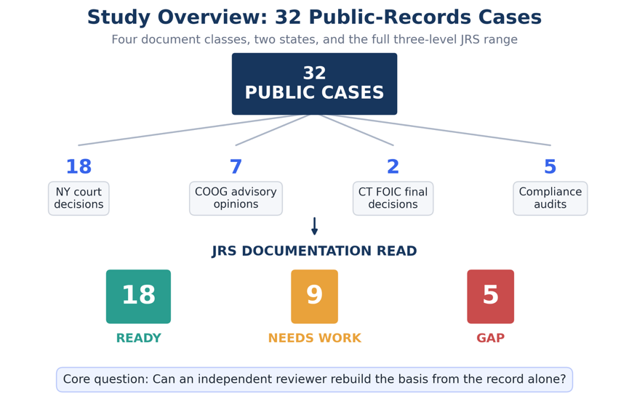
Figure 1. Overview of the 32-case study and documentation-read outcomes. The study examined 32 publicly available cases across four document classes using the three-level documentation read of Ready, Needs work, and Gap.
The blinded second-read data and reproducibility materials are retained with the study records and are available from the authors.

1. The governance problem
A public-records determination is not only a response to a request. It is also a record of administrative action. It may later be examined by an appeals officer, an open-government body, a court, an auditor, or a records professional reviewing whether the agency can account for what it did. By that point, the original decision-maker may no longer be available. The record must therefore carry enough information for a later reviewer to understand how the determination was reached.
Records and information governance provides established approaches to retention, classification, access, disposal and preservation. A separate question arises at the level of the individual consequential record: whether the record preserves enough evidentiary and decision-process information for an independent reviewer to reconstruct how the conclusion was reached.
Records and information governance already has a vocabulary for the qualities a record must hold. ISO 15489-1:2016 requires that a record be authentic, reliable, have integrity and be usable, and Duranti (1995) sets out reliability and authenticity as distinct properties, the first concerning the record's capacity to stand for the facts it asserts and the second its identity and freedom from alteration. Yeo (2007) characterises records as persistent representations of activities, which locates their value in what they allow a later party to understand rather than in their survival alone. Reconstructability sits alongside these rather than replacing them. A record can be authentic, reliable, unaltered and readily retrievable and still not show a later reviewer how the conclusion it documents was reached. That is a question about the sufficiency of a single consequential record as evidence of its own decision.
Work on measuring these qualities exists. Duranti and Makhlouf Shabou (2015) develop a model and instruments for defining and measuring quality dimensions of public electronic records, and Farrell (2024) examines public sector recordkeeping against accountability understood both as a mechanism and as a virtue, finding gaps in the mechanisms through which public bodies can be required to explain their recordkeeping conduct. The present study is narrower than either. It asks whether one property, the reconstructability of the basis for an individual determination, can be assessed consistently from the record alone, and it tests that on public material where an independent assessment of the same programmes already exists.
Completeness alone does not answer that question. A record may contain the required fields, follow an approved format and read as complete while still leaving the later reviewer unable to determine what evidence supported a conclusion, how the relevant information was interpreted, or why one outcome was reached rather than another.
Public-records material provides a useful test corpus because decisions and audits are publicly available, some of the same programmes have been assessed independently, and documented outcomes permit examination of whether reconstructability is distinct from substantive outcome.
The broader question is not limited to freedom of information. It concerns the evidentiary quality of consequential records that must remain understandable and reviewable after the original decision-maker is no longer available.

2. Introduction
A determination can be facially complete, professionally written, and still fail, because the specific basis for each withholding cannot be rebuilt from the record itself. The exemption relied on, the records located and produced, and the reasoning that connects them may simply not be on the page. That is not a technology problem in the ordinary sense. It is a documentation-quality problem, and it decides whether an agency can show what it actually did when someone asks.
The question is timely. On 28 May 2026 the Chief FOIA Officers Council announced a government-wide effort to inventory FOIA technology solutions across federal agencies, covering case-management systems, eDiscovery platforms, document-review tools, and their costs, so that the inventory can inform acquisition and implementation decisions. An inventory of that kind answers what software agencies run. It does not answer whether the determinations coming out of that software hold up when read cold. Software that produces fluent but unreconstructable determinations does not, by itself, establish that the resulting records are defensible.
Existing records and information governance controls do not necessarily assess this property at the level of an individual consequential record. Two agencies can run the same case-management system and produce determinations of very different defensibility. This pilot examines whether a structured record-level read can do so.
From a records-management perspective, reconstructability concerns more than whether information has been retained. A file may contain substantial material and still fail to show how a particular administrative conclusion was reached. The relevant question is whether the relationship between the decision, the information supporting it, and the stated reasoning remains sufficiently visible for later review. Reconstructability therefore complements established concerns with retention, accessibility, authenticity, and accountability at the level of consequential individual records.

3. Research questions
- Can the review conditions be applied to real public-records material across document classes and jurisdictions, and do they produce a full range of reads?
- Where an independent government auditor has assessed the sufficiency of the same records, does the read agree?
- What drives the read, and is it the property the instrument claims to measure?

4. Record-level review protocol
This study applies a structured record-level review protocol designed to examine whether the basis of a consequential determination can later be reconstructed from the record itself. The protocol is referred to in this study as the Justification Review Standard (JRS). Five conditions carry that question. Reconstructability, whether the conclusion can be rebuilt from the record alone. Basis identification, whether the source of each characterisation is identifiable. Chronological integrity, whether dates, sequence, and sources hold together when read cold. Decision-process traceability, whether the reasoning from evidence to conclusion can be followed and the responsible parties identified. Evidentiary sufficiency, whether the record carries enough to support the weight of the decision.
The conditions resolve to a three-level read. Ready, where a later reviewer could rebuild the conclusion from the record alone. Needs work, where the record is partly reconstructable and some basis is visible with gaps. Gap, where the basis is not visible in the record at all.
The risk the standard names is Decision Reconstruction Risk: the condition in which a record cannot, on its own terms, let an independent reviewer rebuild the basis for a consequential decision.

5. Methods

5.1 Design
Retrospective and records-based. Each case pairs a real public determination or audit, in which the sufficiency of the record was at issue, with its documented outcome. Two things are recorded first, from the source alone and before the outcome is consulted: the read, and a short note stating the basis for it. The outcome and the citation are recorded afterwards. Recording both the read and its basis before the outcome is what keeps them independent of the result, and it is what makes the analysis in Section 6.3 possible.

5.2 Materials
Public material only. Each case was de-identified as to any private individual, and each case carries a public citation or source URL. No internal, confidential, privileged, or otherwise nonpublic government material was used.

5.3 Sample
The stated target was 20 to 30 cases with a deliberate spread of outcomes. The achieved sample is 32 cases from 32 distinct public sources, collected 26 June to 8 August 2026, spanning decisions issued between 2005 and 2026 across eleven distinct years.
Four document classes are represented: New York appellate and trial-level decisions (n = 18); New York Committee on Open Government advisory opinions (n = 7); Connecticut Freedom of Information Commission final decisions (n = 2); and compliance audits issued by the New York State Comptroller and the New York City Comptroller (n = 5).
At least twelve distinct FOIL issues appear across the set, including personal privacy (9 cases), law-enforcement disciplinary records (5), burden and volume objections (3), law-enforcement exemptions (2), constructive denial (2), timeliness (2), reasonable description, in-camera review, sealed and erased records, commercial confidentiality, life-and-safety withholding, and refusal to confirm or deny.

5.4 Outcome coding
Outcomes are coded from the cited source in four categories: the determination was sustained; the determination did not survive review; the determination was contested and the source records no resolved disposition; or the auditor recorded an adverse finding about the agency's records or its ability to evidence its own responses. No outcome is inferred. Each traces to the public record.

5.5 Analyses
Five analyses, in the order reported.
Preliminary convergent evidence is assessed by comparing the read against the independent government auditor's own conclusion in the subset where an auditor examined the same agency's records. This is a concordance count rather than a significance test, because the comparison is between two instruments and not between groups.
Internal classification coherence codes the contemporaneous basis notes for one question: does the note state that the underlying record-level basis could not be rebuilt from the source? Coding requires an explicit statement in the note, not an inference. This coding is post-hoc and is labelled as such wherever it appears. Because the same reviewer assigned the classification and wrote the note, this analysis measures whether the classification and its stated reason agree, not whether the classification agrees with an independent assessment. Association between the two is tested with Fisher's exact test.
Structural differentiation is examined by testing the read against document class, using a structural variable rather than the reviewer's own words: whether the source reproduces the determination text or instead assessed the underlying records in camera or in aggregate.
The specification check tests the read against appellate disposition. Cases where the source records no resolved disposition are excluded rather than assigned one.
All 32 initial reads were recorded by a single domain reviewer. Documented outcomes were coded by the same reviewer after the record-level read and basis note had been completed. The temporal separation reduces outcome influence on the initial classification but does not remove the broader limitation associated with a single primary reviewer. Section 9 treats that as a limitation.

5.6 Blind second read
To estimate reader dependence, 10 of the 32 cases were re-read by an independent reviewer with no connection to the study and no prior familiarity with the instrument, who recorded his own read and a short reason for each case. The 10 were drawn from the corpus stratified by the original read with a floor of one case per category, ordered by case identifier within each stratum and interleaved so that consecutive cases do not share a category. Six, three and one fell to Ready, Needs work and Gap respectively. No random number generator was used, so the selection is reproducible from the packet builder alone.
The second reader was shown the public source and a short description of what each record is. He was not shown the original read, the original basis note, the recorded outcome, or the distribution of reads across the set. He reported prior familiarity with the instrument as none, and recorded that he knew the documented outcome in 0 of the 10 cases. Agreement was computed after his answers were received, against reads recorded between 26 June and 8 August 2026 and unchanged since.

6. Results

6.1 The instrument applied to real material
Reads across the 32 cases: 18 Ready, 9 Needs work, 5 Gap. Documented outcomes: 15 determinations did not survive review, 7 contested without a recorded disposition, 5 sustained, 5 adverse audit findings. Figure 1 summarises the corpus and the three-level read. Figure 2 shows the distribution of documentation reads across the documented outcomes.

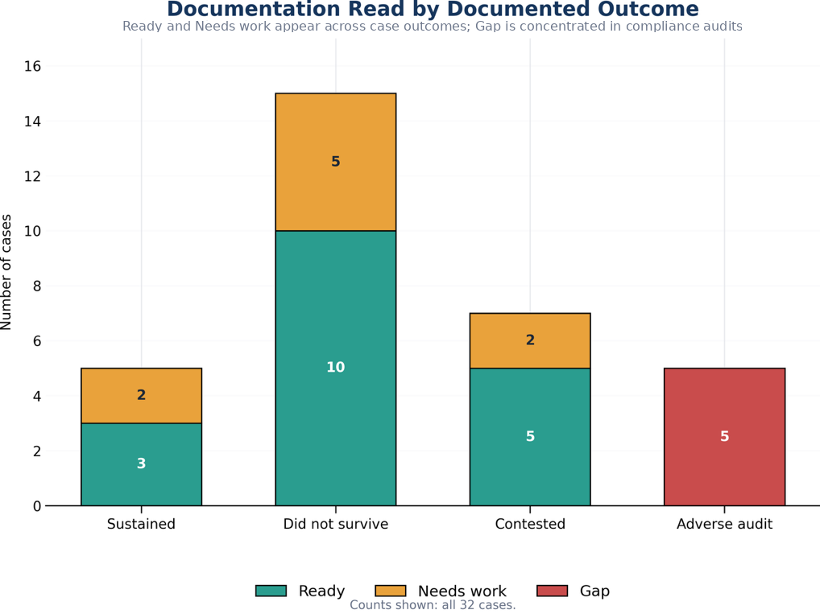
Figure 2. Documentation read by documented outcome. The figure shows the distribution of the three documentation reads across the documented outcomes in the 32-case corpus.
The conditions were applied to 32 publicly available determinations and audits, across four document classes and two states, over decisions spanning twenty-one years, and returned the full three-level range of reads. Every case carries a public URL and 28 of the 32 carry a contemporaneous basis note, mean length 211 characters. That answers the first research question and provides an initial applied case set for examining record-level reconstructability across publicly available public-records materials.

6.2 The read agrees with independent auditors, five of five
Five cases are compliance audits in which a state or city Comptroller had independently examined an agency's FOIL programme, using their own methodology and with no knowledge of this study.
In the five compliance audits included in the corpus, the record-level review classified each source as Gap, consistent with the independent auditors' findings that the relevant programmes could not adequately evidence aspects of their public-records administration. In the auditors' own terms: records of what had been provided were missing; request tracking was absent or incomplete; one agency supplied an email asserting that records had been sent without the records themselves; and in two audits the auditor stated on the record that they could not determine with reasonable certainty whether the information necessary to complete the audit had been supplied at all.
Concordance is five of five. Two instruments built with no knowledge of each other, a documentation read applied to the source and a government audit applied to the programme, reached the same conclusion in every case where both were available. The agreement with the available Comptroller findings provides preliminary evidence of convergence between the record-level read and independently identified evidentiary deficiencies.
Because this comparison is limited to five structurally similar audit cases, it should be interpreted as preliminary evidence of convergence rather than as a stable estimate of instrument validity.
Two things this is not. It is not a test of statistical association, because the comparison is between instruments rather than between groups. And five cases are five cases. What it demonstrates is that the Gap read is reachable on real material, and that where an independent government auditor assessed the same records, the two assessments matched.

6.3 The read tracks reconstructability, not outcome
For the 28 cases with contemporaneous basis notes, the note giving the basis for the read was written before the outcome was known. Coding those notes for one question, whether the note states that the underlying record-level basis could not be rebuilt from the source, produces the clearest result in the study.
The construct comparison is restricted to the 27 case-level sources classified Ready or Needs work; the 5 programme-level audit sources classified Gap are analysed separately in Section 6.2. It is further restricted to the 24 of those 27 that carry a note, because a case with no note cannot be coded for what its note states, and counting it as not stating a reconstructability failure would inflate the comparison group. The 3 case-level sources without a note are excluded rather than assigned a code.
 | Reconstructability failure stated | Not stated | Rate
Needs work (n = 7) | 6 | 1 | 85.7%
Ready (n = 17) | 0 | 17 | 0.0%

Fisher's exact test, two-sided: p = 0.0000520.
The direction is uniform. In the Needs work cases the recorded reason is that the source reports the outcome without reproducing the material that would let a reader test it. The redacted contract and its technical schedules were not reproduced. The 165,000 pages and their redaction universe were not available. The record-by-record exemption analysis was never before the court. The security assessment was reviewed in camera and never published. In the Ready cases the opposite is recorded, and eleven of the 17 notes say so directly: the opinion walks through the original request, the Records Access Officer response, the appeal determination, the lower-court rulings and the holding; the appeal determination is quoted almost verbatim; the source identifies the record category, the exemption, the statutory change, the agency position and the conclusion.
No Needs work note contains an affirmative reconstructability statement, and no Ready note contains a reconstructability failure.
These findings provide preliminary evidence addressing the third research question. The pattern is consistent with the reads reflecting the presence or absence of a rebuildable basis, which is the property the instrument was designed to examine, rather than appellate outcome alone. The coding is post-hoc, and the same reviewer assigned the classification and wrote the note it codes, so this result is evidence that the classifications and their recorded reasons cohere rather than independent construct validation. The contemporaneous notes are what make that coherence checkable by anyone re-reading the case set. The structural comparison in Section 6.4 and the audit concordance in Section 6.2 do not depend on the reviewer's explanatory language and carry the externally meaningful evidence.

6.4 Documentation reads differed across source classes according to the extent of basis exposure
The same conclusion can be reached without relying on the reviewer's own words, using a structural feature of each source. Figure 3 shows the distribution of documentation reads across the four source classes.
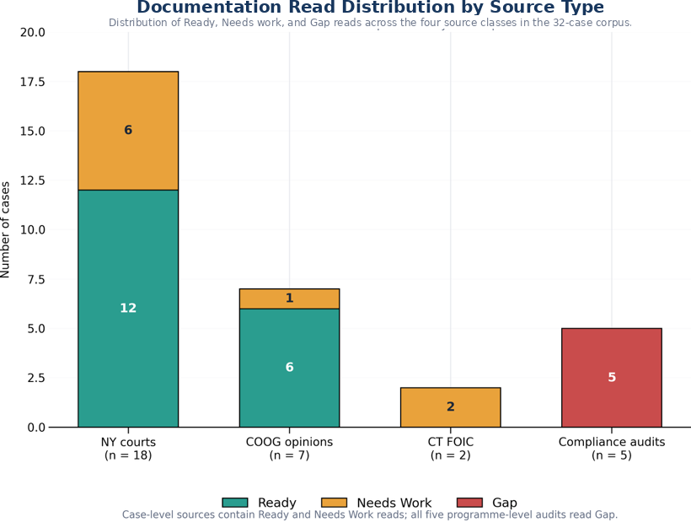
Figure 3. Documentation read distribution by source type. The figure shows the distribution of the three documentation reads across the four source classes in the study corpus.
Among case-level sources, Committee on Open Government advisory opinions read Ready in 6 of 7 cases (86%), court decisions in 12 of 18 (67%), and Connecticut Freedom of Information Commission final decisions in 0 of 2. Advisory opinions typically quote the appeal determination itself. Court decisions summarise it. Both Connecticut decisions turned on records the Commission examined in camera.
Grouping by that structural difference, sources that reproduce the determination text against sources that assessed the underlying records in camera or in aggregate:
 | Ready | Not Ready
Reproduces the determination text (n = 7) | 6 | 1
Assessed the records in camera or in aggregate (n = 7) | 0 | 7

Fisher's exact test, two-sided: p = 0.00466.
Gap reads concentrate completely. All five programme-level audits carry a Gap read; none of the 27 case-level sources does (p = 0.0000050).
The classifications differed across the document classes represented in this corpus, with the observed pattern corresponding to differences in the extent to which the sources exposed the underlying basis for the determination.
Because document class and classification are not independent in this corpus, this finding should be interpreted as descriptive evidence consistent with the proposed construct rather than as independent validation of the review protocol.

6.5 Appellate outcome is a different variable
The specification check tested the read against appellate disposition, on the 20 determinations where the source records a resolved one.
 | Sustained | Did not survive | Sustained rate
Ready | 3 | 10 | 23.1%
Needs work | 2 | 5 | 28.6%

Odds ratio 0.75. Fisher's exact test, two-sided: p = 1.000. Null.
Read alongside Sections 6.3 and 6.4, this is the expected result and it is informative. Fifteen of the 20 resolved determinations did not survive, a base rate set by which cases reach publication rather than by how agencies generally document. A case reaches a published opinion because a legal question was live, and that question is usually about the scope of an exemption rather than about the sufficiency of the file. The reads were measuring reconstructability. Appellate outcome measures something else.

6.6 Interpreting the null outcome association
The absence of an association between the documentation read and appellate outcome should not be interpreted as evidence that reconstructability lacks practical significance. The published public-records corpus is structured around contested legal questions, and appellate disposition reflects legal and substantive factors that extend beyond the quality of the record.
The present finding therefore establishes an important boundary for this corpus: reconstructability and appellate disposition should not be treated as interchangeable outcome measures. Future studies should examine agency determinations before they enter a publication or litigation pathway and should compare record-level reconstructability with independently established audit and review findings.

6.7 Blind second read
The two readers agreed exactly on 7 of 10 cases, 70.0 percent, 95 percent Wilson interval 39.7 to 89.2. Cohen's kappa is 0.474 unweighted, which is moderate agreement on the conventional scale and is reported here without qualification.
Two further coefficients are reported because the unweighted figure is not the only defensible one for this scale, and reporting only the most favourable of the three would be a choice made after seeing the data. The scale is ordinal, Ready to Needs work to Gap, and all 3 disagreements were between adjacent categories; none was a Ready against a Gap. Linear weighted kappa is 0.559 and Gwet's AC1 is 0.582. All three rest on 10 cases and none of them should be read as a stable estimate.
The disagreements are not symmetric: the second reader was stricter than the original on 2 cases and more lenient on 1. They were case 1, read Ready originally and Needs work on re-read; case 4, read Ready originally and Needs work on re-read; case 5, read Needs work originally and Ready on re-read. Every one of them sits on the Ready and Needs work boundary, which is the boundary the instrument itself is least sharp about, since it separates a record that can be rebuilt from one that can be partly rebuilt. Within this 10-case blind re-read, the Gap category was reproduced exactly, although the sample is too small to treat this result as a stable estimate of category-specific reliability.

7. Discussion
This pilot provides preliminary evidence that record reconstructability can be examined systematically across public-records materials. The framework produced the full range of classifications across four document classes, corresponded with independent audit findings in the five cases where an external audit provided a comparable assessment, and differentiated sources by a structural feature that does not depend on the reviewer's own explanatory language. The coding of contemporaneous basis notes adds that the classifications cohere with their recorded reasons; the audit concordance and the structural comparison are the evidence that does not rest on the reviewer's own account.
The practical implication is a records-management one. A determination may be preserved, accessible, and formally complete while still failing to preserve the basis on which the agency acted. Reviewability therefore depends not only on whether the record survives, but also on whether the relationship between the decision, its supporting information, and its stated reasoning remains available to a later reviewer.
That portability is what makes the read a natural companion to a technology inventory rather than a competitor to it. An inventory answers what tools are in use. A documentation read answers whether the outputs hold up. The audit subset shows why both are needed: in all five, the failure the auditor recorded was evidentiary, an agency unable to show what it had done. That failure mode is invisible to an inventory of software and visible to a read of the record. Agencies could, in parallel with technology modernisation, sample their own determinations for reconstructability, catching the case where better tooling produces fluent but unreconstructable records.
For public-records programmes, the practical form is simpler than the research form. Determinations that identify the applicable exemption, document the records located and produced, and connect stated reasoning to cited authority provide a clearer basis for later review by auditors, appeals bodies, and other independent reviewers. The five conditions could be adapted for use as a pre-issuance review checklist as well as a research instrument. This pilot did not test whether using such a checklist improves documentation quality, lowers reversal rates, or produces other substantive outcomes.

8. Practical implications for records and information governance
The findings support three potential uses of reconstructability review within records and information governance, while not establishing that the review improves substantive outcomes.
Pre-finalisation quality assurance. A record can be reviewed for reconstructability while the underlying matter remains active. The relevant question is whether an informed reviewer who did not participate in the decision could understand the evidentiary basis and reasoning from the record available to them.
For records programmes, the findings suggest a practical quality-control question that can be applied before a consequential determination is finalised: if the decision-maker were unavailable and a later reviewer had only the record, could that reviewer identify what was decided, what information supported it, and how the stated conclusion followed from that information?
This does not require agencies to preserve every intermediate thought or drafting artifact. It requires attention to whether the record ultimately retained is sufficient to reconstruct the basis of the action it documents.
Retrospective review. Records functions can use reconstructability review to examine consequential records already in the system, particularly where audit, appeal or regulatory exposure makes later explanation likely.
Audit sampling. A structured record-level read may provide a method for identifying recurring documentation weaknesses across a programme. The value is not the rating alone. It is the recorded basis for the rating, which can identify the specific information missing from the record.
At programme level, reconstructability review could also be incorporated into quality-assurance sampling. A records or information governance function could sample consequential determinations, assess whether their documented basis can be independently reconstructed, identify recurring gaps, and use those findings to examine whether templates, guidance, training, or review controls require adjustment. This pilot did not test those operational interventions, but the findings provide a basis for examining them in subsequent implementation research.
What this does not support. The evidence does not establish that applying the read improves documentation, reduces adverse findings, or performs equivalently outside the two states and four document classes sampled. The reliability evidence is interim. These are the questions a larger study would take up.

9. Limitations

The study should therefore be read as an initial validation and feasibility exercise rather than as a population estimate of documentation quality in public-records programmes.
All 32 reads were recorded by a single domain reviewer. 10 of them, not all 32, were re-read blind by an independent reviewer, so reader dependence is estimated on a subset and not removed. Agreement on that subset was 70.0 percent with an unweighted kappa of 0.474, which is moderate: it is evidence that the read is not idiosyncratic to one person, and it is not evidence that two readers would classify the full corpus alike. The interval on the agreement proportion, 39.7 to 89.2 percent, is wide because 10 cases cannot make it narrow.
One second reader is not a panel, and a single re-read cannot separate reader dependence from case difficulty: the 3 cases where the reads differed may be cases two careful readers would always split rather than cases either reader got wrong. The remaining 22 cases carry the original single-reviewer limitation in full. Additional independent reviews would be required before stable estimates of inter-rater reliability could be established.
The note coding in Section 6.3 is post-hoc rather than pre-registered. The same reviewer assigned the classification and wrote the note that the coding then reads, so an association between them is not independent construct validation and is reported as evidence of internal coherence. The structural comparison and the audit concordance do not share that dependence.
Cases were selected by the domain reviewer from published sources rather than sampled at random, and published sources over-represent contested determinations.
The five-case comparison with independent audits provides preliminary evidence of agreement rather than a stable estimate of convergent validity. In this corpus, document class and read are also not independent, which limits the interpretation of the comparisons in Sections 6.2 and 6.4.
The corpus is two states, New York and Connecticut. Generalisation beyond them is not claimed.
Seven cases record a contest without a resolved disposition, which reduces the specification check from 27 determinations to 20.
The reviewer read the determination as reported in a published decision or audit, which is not identical to the file the original decision-maker produced.
The standard remains in a validation phase and makes no proven-effectiveness claim.

10. Conclusion
Public-records determinations must often survive the people who created them. When a determination is later reviewed, the relevant question is not whether the original decision-maker could still explain what happened. It is whether the record can do so.
This pilot examined that question across 32 publicly available public-records cases representing four document classes and two jurisdictions. The findings provide preliminary evidence that a structured record-level read can distinguish between sources that expose the basis of a determination and sources that leave that basis difficult or impossible to reconstruct.
The broader implication is not limited to public-records administration. Records management has long concerned itself with whether organisations retain information that is accessible, reliable, and capable of supporting accountability.
The contribution of this pilot is not to establish a fully validated measurement instrument or to demonstrate that the use of the review protocol improves administrative outcomes. It is narrower. The findings provide initial empirical evidence that reconstructability can be examined systematically at the level of an individual consequential record. For records and information governance, that raises a practical question alongside retention and preservation: when a decision must later be explained, does the record itself preserve enough of its evidentiary basis and reasoning for an independent reviewer to reconstruct how the organisation acted?

References
Chief FOIA Officers Council. (2026, May 28). Memorandum: data collection and volunteers [Government-wide FOIA technology inventory initiative]. United States Department of Justice.
Duranti, L. (1995). Reliability and authenticity: The concepts and their implications. Archivaria, 39, 5-10.
Duranti, L., & Makhlouf Shabou, B. (2015). Digital diplomatics and measurement of electronic public data qualities: What lessons should be learned? Records Management Journal, 25(1), 56-77. https://doi.org/10.1108/RMJ-01-2015-0006
Farrell, M. (2024). Accountability as a mechanism and a virtue in Irish public sector recordkeeping. Records Management Journal, 34(2-3), 190-204. https://doi.org/10.1108/RMJ-09-2023-0051
Gwet, K. L. (2008). Computing inter-rater reliability and its variance in the presence of high agreement. British Journal of Mathematical and Statistical Psychology, 61(1), 29-48.
International Organization for Standardization. (2016). ISO 15489-1:2016. Information and documentation - Records management - Part 1: Concepts and principles.
Yeo, G. (2007). Concepts of record (1): Evidence, information, and persistent representations. The American Archivist, 70(2), 315-343.

Cited determinations, opinions, and audits
New York appellate and trial-level decisions: Matter of Russell v Town of Mount Pleasant, N.Y., 2026 NY Slip Op 00966; 2020 NY Slip Op 50815(U); 5 NY3d 84 (2005); 4 NY3d 477 (2005); 31 NY3d 217 (2018); 2024 NY Slip Op 04071; 2024 NY Slip Op 24247; 2025 NY Slip Op 00220; 2025 NY Slip Op 00723; 2025 NY Slip Op 01009; 2025 NY Slip Op 01010; 2025 NY Slip Op 01933; 2025 NY Slip Op 02207; 2025 NY Slip Op 03102; 2025 NY Slip Op 03331; 2025 NY Slip Op 05783; 2025 NY Slip Op 30848(U); 2025 NY Slip Op 32688(U).
New York Committee on Open Government advisory opinions: FOIL AO 19516 (December 5, 2016); FOIL AO 19639 (December 20, 2017); FOIL AO 19646 (February 16, 2018); FOIL AO 19721 (April 12, 2019); FOIL AO 19746 (July 16, 2019); FOIL AO 19780 (September 21, 2020); FOIL AO 19854 (October 18, 2023).
Connecticut Freedom of Information Commission final decisions: FIC2012-276; FIC2015-122.
Compliance audits: New York State Comptroller, compliance with Freedom of Information Law requirements (2020, 2021, 2023); New York City Comptroller, Review of the New York City Police Department's Body-Worn Camera Program (2025).

Data availability
Case-level data, including public citations, classifications, contemporaneous basis notes, outcome coding, and analysis procedures, are maintained in the study database. Verified counts as of 8 August 2026: 32 cases from 32 distinct public sources, collected 26 June to 8 August 2026; reads 18 Ready, 9 Needs work, 5 Gap; outcomes 15 did not survive review, 7 contested, 5 sustained, 5 adverse audit findings. Analysis code and the complete case set will be made available with publication, subject to journal requirements.

