Can Public-Records Determinations Be Independently Reconstructed? Evidence from 32 Public Cases
Stacyann Young, Independent Researcher, United States. ORCID: 0009-0001-1727-0117
Phillip Wikes (corresponding author, info@jrsstandard.com), Independent Researcher, [COUNTRY]. ORCID: 0009-0009-7230-3661
Type of manuscript: research paper
Abstract: Consequential administrative records are often reviewed long after the decision, by people who did not take part in it, and their ability to assess the decision depends on whether the record preserves enough information to rebuild its basis. When it does not, the cost of finding out what happened shifts to requesters, appeals bodies, courts and auditors, and the link between transparency and public trust weakens. This paper examines whether that property, called reconstructability, can be assessed systematically at the level of an individual record, and in particular whether such a review can be applied across different kinds of public material, whether it agrees with independent assessments of the same records, and whether it measures something distinct from the substantive outcome of the decision. A structured three-level documentation read (Ready, Needs work or Gap) was applied to 32 publicly available public-records cases from 32 distinct sources, covering court decisions, advisory opinions, commission decisions and compliance audits from two states issued between 2005 and 2026. For each case the read and a contemporaneous note explaining its basis were recorded from the source before the documented outcome was consulted, and ten cases were re-read blind by an independent reviewer. The read agreed with the independent government auditors in all five cases where comparable audit findings existed. Among case-level sources, six of seven cases read as Needs work carried notes recording that the basis could not be rebuilt, against none of seventeen read as Ready, a strong association that held under a stricter coding rule. Reads also differed by whether a source reproduced the determination text or assessed the records out of public view, although this comparison overlaps with the audit cases. The read was not associated with appellate outcome, which suggests that reconstructability and substantive outcome are different properties of a decision. Agreement between the two readers was moderate. The study contributes initial empirical evidence that reconstructability can be examined at the record level and links it to the distribution of accountability costs, public trust and the governance of automated drafting tools. In practice, a short pre-finalisation review asking whether an independent reviewer could rebuild a decision from the record alone may help agencies identify documentation weaknesses before records face audit, appeal or challenge. The corpus is small, non-random and limited to two jurisdictions, and the reliability evidence is preliminary.
Keywords: accountability; administrative justice; audit; documentation quality; freedom of information; information governance; public trust; recordkeeping; transparency.
JEL Classification: D73; H11; H83; K23; M42.
INTRODUCTION
A public-records determination is more than a response to a request. It is a record of administrative action, and it may later be examined by an appeals officer, an open-government body, a court, an auditor or a records professional asking whether the agency can account for what it did. By then the original decision-maker may have moved on, retired or forgotten the file. Whatever a later reviewer can learn about how the determination was reached must therefore come from the record itself.
That dependence has social and economic consequences that extend well beyond records offices. When the basis for a determination cannot be rebuilt from the record, the cost of finding out what happened is shifted onto someone else: onto the requester who must appeal, onto the appeals body or court that must reconstruct the decision from submissions, onto the auditor who must report that a programme cannot evidence its own conduct, and ultimately onto the public whose confidence in the institution depends on its ability to explain itself. Those costs are unevenly distributed. A well-resourced requester can litigate; an individual seeking records about their own case often cannot. An unreconstructable record is therefore not only a documentation weakness. It is a mechanism by which the burden of administrative opacity falls on the people least able to carry it.
The question is also timely. On 28 May 2026 the Chief FOIA Officers Council announced a government-wide effort to inventory freedom of information technology across United States federal agencies, covering case-management systems, electronic discovery platforms, document-review tools and their costs, so that the inventory can inform acquisition and implementation decisions (Chief FOIA Officers Council, 2026). An inventory of that kind answers what software agencies run. It does not answer whether the determinations produced with that software hold up when read cold by someone who was not involved. As automated and AI-assisted tools take on more of the drafting of administrative records, the risk grows that agencies will produce determinations that are fluent, formally complete and yet impossible to reconstruct. Two agencies can run the same case-management system and produce determinations of very different defensibility.
A determination can be facially complete and professionally written and still fail in this way, because the specific basis for each withholding is not on the page. The exemption relied on, the records located and produced, and the reasoning connecting them may simply be absent. That is not a technology problem in the ordinary sense. It is a documentation-quality problem, and it decides whether an agency can show what it did when someone asks.
This paper reports an empirical pilot of a structured record-level review designed to examine that property, which we call reconstructability: whether an independent reviewer can rebuild the basis for a consequential decision from the record alone. The review was applied to 32 publicly available public-records determinations, opinions and audits from two states. Three research questions guided the study:
- Can the review conditions be applied to real public-records material across document classes and jurisdictions, and do they produce a full range of reads?
- Where an independent government auditor has assessed the sufficiency of the same records, does the read agree?
- What drives the read, and is it the property the instrument claims to measure?
The contribution is deliberately narrow. The study does not claim that the review improves administrative outcomes or that its results generalise beyond the material sampled. It provides initial evidence that reconstructability can be examined systematically at the level of an individual consequential record, and it sets out why that property matters for the economics of accountability and public trust.
LITERATURE REVIEW
Record Qualities in Records and Information Governance
Records and information governance already has a vocabulary for the qualities a record must hold. ISO 15489-1:2016 requires that a record be authentic, reliable, have integrity and be usable (International Organization for Standardization, 2016). Duranti (1995) distinguishes reliability, a record’s capacity to stand for the facts it asserts, from authenticity, its identity and freedom from alteration. Yeo (2007) characterises records as persistent representations of activities, locating their value in what they allow a later party to understand rather than in their survival alone, and Shepherd and Yeo (2003) set out how those principles translate into programme-level practice. Reconstructability sits alongside these qualities rather than replacing them. A record can be authentic, reliable, unaltered and readily retrievable and still not show a later reviewer how the conclusion it documents was reached. That is a question about the sufficiency of a single consequential record as evidence of its own decision.
Work on measuring record qualities exists. Makhlouf Shabou (2015) develops a model and instruments for defining and measuring quality dimensions of public electronic records, drawing on digital diplomatics. Farrell (2024) examines public sector recordkeeping against accountability understood both as a mechanism and as a virtue, finding gaps in the mechanisms through which public bodies can be required to explain their recordkeeping conduct. The present study is narrower than either. It asks whether one property, the reconstructability of the basis for an individual determination, can be assessed consistently from the record alone, and it tests that on public material where an independent assessment of the same programmes already exists.
Accountability, Transparency and Public Trust
The governance literature explains why that property matters. Bovens (2007) defines accountability as a relationship in which an actor is obliged to explain and justify conduct to a forum that can pose questions, pass judgement and impose consequences. Every stage of that relationship presupposes information about what the actor did and why. Where the record cannot supply it, the forum is left to reconstruct the conduct from argument and recollection, and the accountability relationship weakens even if every formal step is observed.
Transparency is often treated as the remedy, but the evidence on its effects is more conditional than the policy rhetoric suggests. In an experimental study, Grimmelikhuijsen and Meijer (2014) find that the effect of transparency on the perceived trustworthiness of a government organisation depends on the content of what is disclosed and on the prior dispositions of the citizen. The OECD (2017) treats public trust as an economic as well as a political asset, linking it to compliance, the cost of implementing policy and the willingness of citizens to engage with institutions. These findings suggest that making records available is not sufficient on its own. What matters is whether the record, once available, lets a reader understand the basis for the action.
The freedom of information literature makes a related point about the gap between formal rights and practical access. Roberts (2006) documents how governments have adapted to disclosure regimes in ways that preserve formal compliance while limiting what disclosure reveals. Worthy (2017) shows that the effects of freedom of information laws depend heavily on implementation and on the incentives of the bodies subject to them. A determination that cites an exemption without showing how the records engage it may comply with the letter of a statute while leaving the requester, and any later reviewer, unable to test the decision.
Administrative Justice and Automated Decisions
Administrative justice scholarship adds a procedural dimension. Mashaw (1983) argues that the legitimacy of mass administrative decision-making rests on its capacity to produce accurate, reasoned and reviewable decisions at scale. Tyler (2006) shows that people’s willingness to accept decisions, including adverse ones, depends substantially on whether they perceive the process as fair, and perceived fairness depends in turn on whether the reasons for a decision are visible. A record that does not preserve its own reasoning undermines both the reviewability Mashaw identifies and the procedural legitimacy Tyler describes.
These concerns have sharpened as automated systems enter administrative work. Citron (2008) argues that automated decision systems can erode the procedural protections of notice and hearing when the logic of a decision is embedded in code rather than stated in the record. Pasquale (2015) describes a broader pattern in which consequential decisions become opaque to the people they affect. The present study does not examine automated systems directly. It examines the property that such systems put at risk: whether a consequential record, however it was produced, preserves enough of its basis for an independent reviewer to rebuild it.
Research Gap and Purpose
The literature therefore establishes that accountability depends on explanation, that transparency builds trust only when disclosure is intelligible, and that procedural legitimacy depends on visible reasons. It provides well-developed frameworks for record quality at the level of the programme and the system. It provides much less evidence on whether the specific property of record-level reconstructability can be assessed consistently, whether such an assessment agrees with independent findings, and whether it measures something distinct from the substantive outcome of the decision. The purpose of this study is to provide initial evidence on those three questions.
METHODOLOGY
Record-Level Review Protocol
The study applies a structured record-level review protocol designed to examine whether the basis of a consequential determination can later be reconstructed from the record itself. In this study the protocol is referred to as the Justification Review Standard. Five conditions carry the question. Reconstructability asks whether the conclusion can be rebuilt from the record alone. Basis identification asks whether the source of each characterisation is identifiable. Chronological integrity asks whether dates, sequence and sources hold together when read cold. Decision-process traceability asks whether the reasoning from evidence to conclusion can be followed and the responsible parties identified. Evidentiary sufficiency asks whether the record carries enough to support the weight of the decision.
The conditions resolve to a three-level read. Ready means a later reviewer could rebuild the conclusion from the record alone. Needs work means the record is partly reconstructable, with some basis visible and some gaps. Gap means the basis is not visible in the record at all. The risk the protocol names is Decision Reconstruction Risk: the condition in which a record cannot, on its own terms, let an independent reviewer rebuild the basis for a consequential decision.
Design
The design is retrospective and records-based. Each case pairs a real public determination or audit, in which the sufficiency of the record was at issue, with its documented outcome. Two things are recorded first, from the source alone and before the outcome is consulted: the read, and a short note stating the basis for it. The outcome and the citation are recorded afterwards. Recording both the read and its basis before the outcome is what keeps them separate from the result, and it is what makes the analysis of internal classification coherence possible.
Materials
Only public material was used. Each case was de-identified as to any private individual, and each case carries a public citation or source address. No internal, confidential, privileged or otherwise nonpublic government material was used.
Sample
The stated target was 20 to 30 cases with a deliberate spread of outcomes. The achieved sample is 32 cases from 32 distinct public sources, collected between 26 June and 8 August 2026, spanning decisions issued between 2005 and 2026 across eleven distinct years.
Four document classes are represented: New York appellate and trial-level decisions (n = 18); New York Committee on Open Government advisory opinions (n = 7); Connecticut Freedom of Information Commission final decisions (n = 2); and compliance audits issued by the New York State Comptroller and the New York City Comptroller (n = 5). At least twelve distinct freedom of information issues appear across the set, including personal privacy (9 cases), law-enforcement disciplinary records (5), burden and volume objections (3), law-enforcement exemptions (2), constructive denial (2), timeliness (2), reasonable description, in-camera review, sealed and erased records, commercial confidentiality, life-and-safety withholding, and refusal to confirm or deny.
Outcome Coding
Outcomes are coded from the cited source in four categories: the determination was sustained; the determination did not survive review; the determination was contested and the source records no resolved disposition; or the auditor recorded an adverse finding about the agency’s records or its ability to evidence its own responses. No outcome is inferred. Each traces to the public record.
Analyses
Five analyses are reported, in the following order.
Preliminary convergent evidence is assessed by comparing the read against the independent government auditor’s own conclusion in the subset where an auditor examined the same agency’s records. This is a concordance count rather than a significance test, because the comparison is between two instruments and not between groups.
Internal classification coherence is assessed by coding the contemporaneous basis notes for one question: does the note state that the underlying record-level basis could not be rebuilt from the source? Coding requires an explicit statement in the note, not an inference. The coding is post hoc and is labelled as such wherever it appears. Because the same reviewer assigned the classification and wrote the note, this analysis measures whether the classification and its stated reason agree, not whether the classification agrees with an independent assessment. Association is tested with Fisher’s exact test, two-sided.
Structural differentiation is examined by testing the read against document class, using a structural variable rather than the reviewer’s own words: whether the source reproduces the determination text or instead assessed the underlying records in camera or in aggregate.
The specification check tests the read against appellate disposition. Cases where the source records no resolved disposition are excluded rather than assigned one.
All 32 initial reads were recorded by a single domain reviewer. Documented outcomes were coded by the same reviewer after the record-level read and basis note had been completed. The temporal separation reduces outcome influence on the initial classification but does not remove the broader limitation associated with a single primary reviewer, which is discussed below.
Blind Second Read
To estimate reader dependence, 10 of the 32 cases were re-read by an independent reviewer with no connection to the study and no prior familiarity with the instrument, who recorded a read and a short reason for each case. The 10 were drawn from the corpus stratified by the original read with a floor of one case per category, ordered by case identifier within each stratum and interleaved so that consecutive cases do not share a category. Six, three and one fell to Ready, Needs work and Gap respectively. No random number generator was used, so the selection is reproducible from the packet builder alone.
The second reader was shown the public source and a short description of what each record is, and was not shown the original read, the original basis note, the recorded outcome or the distribution of reads across the set. The second reader reported prior familiarity with the instrument as none and recorded knowing the documented outcome in 0 of the 10 cases. Agreement was computed after the second reader’s answers were received, against reads recorded between 26 June and 8 August 2026 and unchanged since. Agreement is reported as exact percentage agreement with a Wilson (1927) score interval, Cohen’s (1960) kappa, linear weighted kappa and Gwet’s (2008) AC1, and kappa values are described using the conventional scale of Landis and Koch (1977).
RESULTS
The Instrument Applied to Real Material
Across the 32 cases the reads were 18 Ready, 9 Needs work and 5 Gap. Documented outcomes were 15 determinations that did not survive review, 7 contested without a recorded disposition, 5 sustained and 5 adverse audit findings. The corpus and the three-level read are summarised in Figure 1.
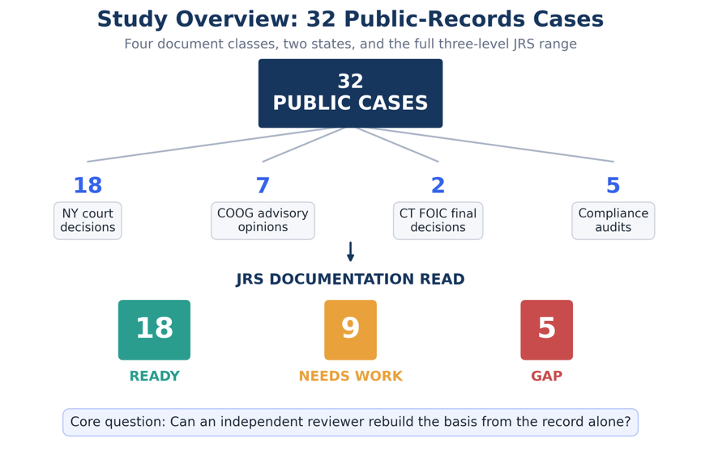
Figure 1. Overview of the 32-case study and documentation-read outcomes
Note: Ready means the basis can be rebuilt from the record alone; Needs work, partly rebuilt; Gap, not visible. NY: New York; COOG: New York Committee on Open Government; CT FOIC: Connecticut Freedom of Information Commission; JRS: Justification Review Standard. Source: developed by the authors.
The conditions were applied to 32 publicly available determinations and audits, across four document classes and two states, over decisions spanning twenty-one years, and returned the full three-level range of reads. Every case carries a public source address and 28 of the 32 carry a contemporaneous basis note, with a mean length of 211 characters. That answers the first research question and provides an initial applied case set for examining record-level reconstructability. The distribution of reads across documented outcomes is shown in Figure 2.
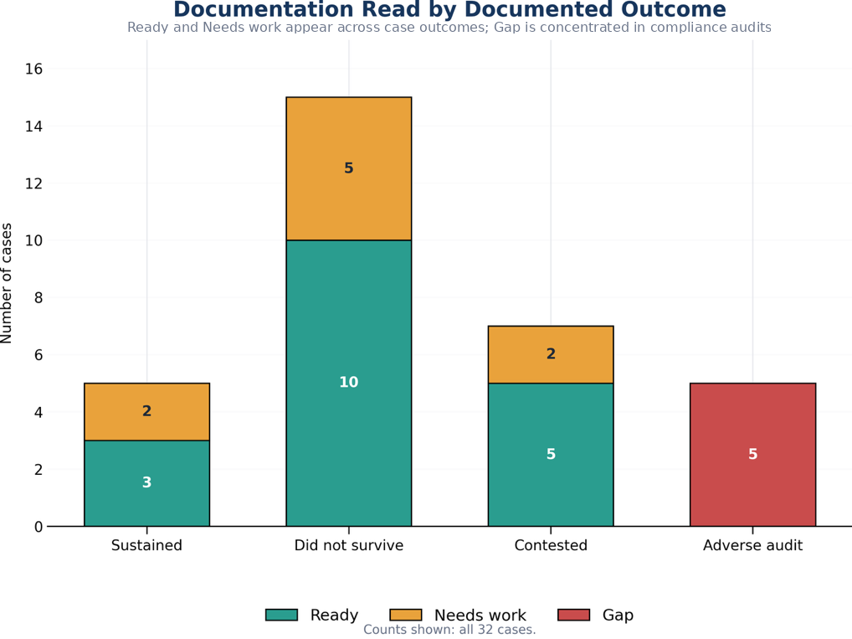
Figure 2. Documentation read by documented outcome
Source: developed by the authors from the 32-case corpus.
Agreement with Independent Auditors
Five cases are compliance audits in which a state or city Comptroller had independently examined an agency’s freedom of information programme, using the auditor’s own methodology and with no knowledge of this study. In each of the five, the record-level review classified the source as Gap, consistent with the auditors’ findings that the programmes could not adequately evidence aspects of their public-records administration. In the auditors’ own terms, records of what had been provided were missing; request tracking was absent or incomplete; one agency supplied an email asserting that records had been sent without the records themselves; and in two audits the auditor stated that they could not determine with reasonable certainty whether the information necessary to complete the audit had been supplied at all.
Concordance is five of five. The read was taken from the published audit reports themselves, so the comparison shows that the instrument reaches the same conclusion as the auditor when applied to the auditor’s own account; it is not a comparison of two independent examinations of the underlying files. No audit in the corpus found records adequate, so the comparison cannot show whether the read would also agree with a favourable audit. Within those limits, the agreement provides preliminary evidence of convergence between the record-level read and independently identified evidentiary deficiencies, and it shows that the Gap read is reachable on real material.
The Read Tracks Reconstructability, Not Outcome
For the 28 cases with contemporaneous basis notes, the note giving the basis for the read was written before the outcome was known. The comparison is restricted to the 27 case-level sources classified Ready or Needs work, because the 5 programme-level audits are analysed separately above. It is further restricted to the 24 of those 27 that carry a note, because a case with no note cannot be coded for what its note states. The 3 case-level sources without a note are excluded rather than assigned a code. The result is presented in Table 1.
Table 1. Contemporaneous basis notes stating a reconstructability failure, by read
Read | Failure stated (cases) | Not stated (cases) | Rate (%)
Needs work (n = 7) | 6 | 1 | 85.7
Ready (n = 17) | 0 | 17 | 0.0
Note: Fisher’s exact test, two-sided, p = 0.0000520. Coding is post hoc. Source: developed by the authors.
The direction is uniform. In the Needs work cases the recorded reason is that the source reports the outcome without reproducing the material that would let a reader test it: a redacted contract and its technical schedules were not reproduced; 165,000 pages and their redaction universe were not available; the record-by-record exemption analysis was never before the court; a security assessment was reviewed in camera and never published. In the Ready cases the opposite is recorded, and eleven of the 17 notes say so directly: the opinion walks through the original request, the records access officer’s response, the appeal determination, the lower-court rulings and the holding; the appeal determination is quoted almost verbatim; the source identifies the record category, the exemption, the statutory change, the agency position and the conclusion. No Needs work note contains an affirmative reconstructability statement, and no Ready note contains a reconstructability failure.
One of the six Needs work notes refers to records reviewed in camera rather than stating in terms that the basis could not be rebuilt. Coded under a stricter rule that excludes that note, the comparison is five of seven against none of 17, and the association remains strong (p = 0.000494). The pattern is consistent with the reads reflecting the presence or absence of a rebuildable basis rather than appellate outcome. Because the same reviewer assigned the classification and wrote the note, this result is evidence that the classifications and their recorded reasons cohere, not independent construct validation.
Reads Differed Across Source Classes According to Basis Exposure
The same conclusion can be approached without relying on the reviewer’s own words, using a structural feature of each source. The distribution of reads across the four source classes is shown in Figure 3.
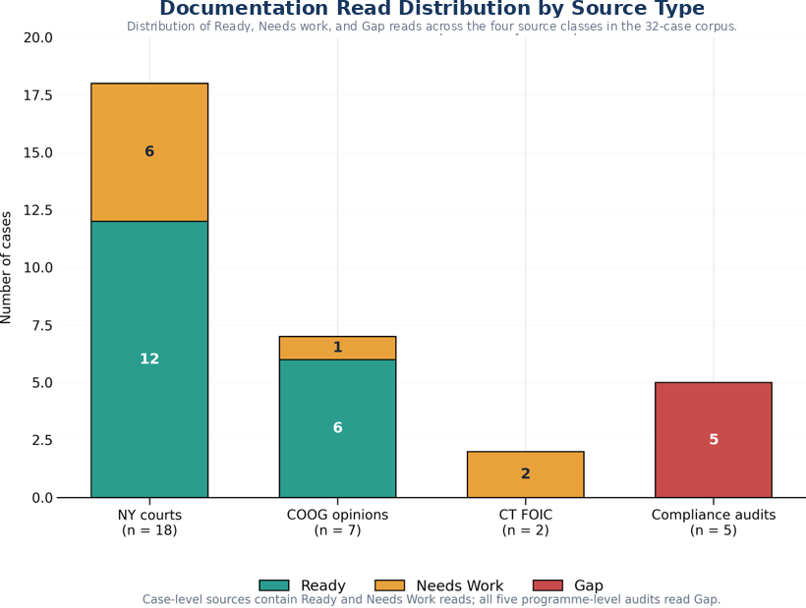
Figure 3. Documentation read distribution by source type
Source: developed by the authors from the 32-case corpus.
Among case-level sources, Committee on Open Government advisory opinions read Ready in 6 of 7 cases (85.7%), court decisions in 12 of 18 (66.7%), and Connecticut Freedom of Information Commission final decisions in 0 of 2. Advisory opinions typically quote the appeal determination itself. Court decisions summarise it. Both Connecticut decisions turned on records the Commission examined in camera. Grouping sources by that structural difference gives the comparison in Table 2.
Table 2. Read by whether the source exposes the determination text
Source type | Ready (cases) | Not Ready (cases)
Reproduces the determination text (n = 7) | 6 | 1
Assessed the records in camera or in aggregate (n = 7) | 0 | 7
Note: Fisher’s exact test, two-sided, p = 0.00466. The second row comprises the 2 Connecticut decisions and the 5 audits. Source: developed by the authors.
Gap reads concentrate completely: all five programme-level audits carry a Gap read and none of the 27 case-level sources does (p = 0.0000050). Five of the seven sources in the second row of Table 2 are the audits examined above, so this comparison and the audit concordance are not independent. Restricted to case-level sources, the in-camera group contains only the two Connecticut decisions, and the comparison (6 of 7 against 0 of 2) is not statistically significant (p = 0.0833). Because document class and classification are not independent in this corpus, the result is best read as descriptive evidence consistent with the proposed construct rather than as independent validation.
Appellate Outcome Is a Different Variable
The specification check tested the read against appellate disposition on the 20 determinations where the source records a resolved one. The result is shown in Table 3.
Table 3. Read by appellate disposition
Read | Sustained (cases) | Did not survive (cases) | Sustained rate (%)
Ready | 3 | 10 | 23.1
Needs work | 2 | 5 | 28.6
Note: Odds ratio 0.75; Fisher’s exact test, two-sided, p = 1.000. Source: developed by the authors.
The null result is expected and informative. Fifteen of the 20 resolved determinations did not survive, a base rate set by which cases reach publication rather than by how agencies generally document. A case reaches a published opinion because a legal question is live, and that question is usually about the scope of an exemption rather than the sufficiency of the file. The absence of an association does not mean that reconstructability lacks practical significance. It establishes a boundary for this corpus: reconstructability and appellate disposition should not be treated as interchangeable outcome measures.
Blind Second Read
The two readers agreed exactly on 7 of 10 cases, 70.0 percent, with a 95 percent Wilson interval of 39.7 to 89.2 percent. Cohen’s kappa is 0.474 unweighted, moderate agreement on the conventional scale. Two further coefficients are reported because the unweighted figure is not the only defensible one for this scale, and reporting only the most favourable would be a choice made after seeing the data. The scale is ordinal, and all 3 disagreements were between adjacent categories; none set Ready against Gap. Linear weighted kappa is 0.559 and Gwet’s AC1 is 0.582. All three rest on 10 cases and none should be read as a stable estimate.
The disagreements are not symmetric. The second reader was stricter than the original on 2 cases and more lenient on 1: two cases read Ready originally were read Needs work, and one case read Needs work originally was read Ready. Every disagreement sits on the boundary between Ready and Needs work, the boundary the instrument is least sharp about, since it separates a record that can be rebuilt from one that can be partly rebuilt. Within this re-read the Gap category was reproduced exactly, although the sample is too small to treat that as a stable estimate of category-specific reliability.
DISCUSSION
What the Pilot Shows
This pilot provides preliminary evidence that record reconstructability can be examined systematically across public-records material. The review produced the full range of classifications across four document classes, agreed with independent audit findings in the five cases where an audit provided a comparable assessment, and differentiated sources by a structural feature that does not depend on the reviewer’s own explanatory language. The coding of contemporaneous basis notes adds that the classifications cohere with their recorded reasons. A determination may be preserved, accessible and formally complete while still failing to preserve the basis on which the agency acted. Reviewability therefore depends not only on whether the record survives, but on whether the relationship between the decision, its supporting information and its stated reasoning remains available to a later reviewer.
Socioeconomic Implications
The findings bear on three wider issues. The first is the distribution of the cost of accountability. Where a record preserves its basis, the cost of reviewing a decision is low and falls largely on the reviewer. Where it does not, the cost is shifted to whoever needs to know what happened: the requester who must appeal, the tribunal or court that must reconstruct the decision from argument, and the auditor who must report that a programme cannot evidence its conduct. The five audits in this corpus illustrate the end point of that shift, in which an oversight body spends its resources establishing that the records needed to assess a programme do not exist. Preventing that outcome at the point a record is finalised is likely to be cheaper than discovering it later, although this pilot did not measure costs and that proposition remains to be tested.
The second is public trust. The evidence reviewed above suggests that transparency builds trust when what is disclosed is intelligible (Grimmelikhuijsen & Meijer, 2014; OECD, 2017) and that people accept adverse decisions more readily when they can see the reasons (Tyler, 2006). A disclosure regime that releases records whose basis cannot be reconstructed delivers the form of transparency without its substance. Record-level reconstructability is one of the conditions under which transparency can do the work that governments and citizens expect of it.
The third is the governance of automated and AI-assisted administration. As drafting tools generate more of the text of administrative records, the risk is not only that decisions become less accurate but that records become fluent without being reconstructable (Citron, 2008; Pasquale, 2015). Technology inventories of the kind announced by the Chief FOIA Officers Council answer what tools are in use. A documentation read answers whether the outputs hold up. The audit subset shows why both are needed: in all five audits, the failure recorded was evidentiary, an agency unable to show what it had done. That failure is invisible to an inventory of software and visible to a read of the record. Agencies could, alongside technology modernisation, sample their own determinations for reconstructability and so detect the case in which better tooling produces fluent but unreconstructable records.
Practical Implications for Records and Information Governance
The findings support three potential uses of reconstructability review, while not establishing that the review improves substantive outcomes. The first is pre-finalisation quality assurance. A record can be reviewed while the underlying matter remains active, by asking whether an informed reviewer who did not participate in the decision could understand its evidentiary basis and reasoning from the record available to them. Put simply: if the decision-maker were unavailable and a later reviewer had only the record, could that reviewer identify what was decided, what information supported it, and how the stated conclusion followed from that information? This does not require agencies to preserve every intermediate thought or drafting artefact. It requires attention to whether the record ultimately retained is sufficient to reconstruct the basis of the action it documents.
The second is retrospective review of consequential records already in the system, particularly where audit, appeal or regulatory exposure makes later explanation likely. The third is audit sampling at programme level. A records or information governance function could sample consequential determinations, assess whether their documented basis can be reconstructed, identify recurring gaps, and use the findings to examine whether templates, guidance, training or review controls require adjustment. The value lies less in the rating than in the recorded basis for it, which identifies the specific information missing from the record. For public-records programmes the practical form is simple: determinations that identify the applicable exemption, document the records located and produced, and connect stated reasoning to cited authority give later reviewers a clearer basis for review. This pilot did not test whether such practices improve documentation quality, lower reversal rates or produce other substantive outcomes.
Limitations
The study should be read as an initial feasibility and validation exercise rather than as a population estimate of documentation quality in public-records programmes.
All 32 reads were recorded by a single domain reviewer. Ten of them were re-read blind by an independent reviewer, so reader dependence is estimated on a subset and not removed. Agreement on that subset was moderate, which is evidence that the read is not idiosyncratic to one person but not evidence that two readers would classify the full corpus alike, and the interval on the agreement proportion is wide because 10 cases cannot make it narrow. One second reader is not a panel, and a single re-read cannot separate reader dependence from case difficulty. The remaining 22 cases carry the single-reviewer limitation in full.
The note coding is post hoc rather than pre-registered, and the same reviewer assigned the classification and wrote the note that the coding reads, so the association between them is evidence of internal coherence rather than independent validation. The five-case audit comparison rests on audit reports from which the read was itself taken, includes no audit that found records adequate, and shares its cases with the structural comparison, so the two analyses are not independent of each other.
Cases were selected from published sources rather than sampled at random, and published sources over-represent contested determinations. The corpus covers two states, New York and Connecticut, and generalisation beyond them is not claimed. Seven cases record a contest without a resolved disposition, which reduces the specification check from 27 determinations to 20. The reviewer read each determination as reported in a published decision or audit, which is not identical to the file the original decision-maker produced. The protocol remains in a validation phase and no claim of proven effectiveness is made.
Future research should apply the review to agency determinations before they enter a publication or litigation pathway, use multiple independent readers across the full corpus, include audits that found records adequate as well as deficient, extend the corpus to other jurisdictions and record types, and measure the costs associated with unreconstructable records directly.
CONCLUSIONS
Public-records determinations must often outlast the people who created them. When a determination is later reviewed, the relevant question is not whether the original decision-maker could still explain what happened. It is whether the record can do so.
This pilot examined that question across 32 publicly available public-records cases representing four document classes and two jurisdictions. A structured record-level read produced the full range of classifications, agreed with independent audit findings in the five cases where they were available, and distinguished sources that expose the basis of a determination from sources that leave it difficult or impossible to reconstruct. The read was not associated with appellate outcome, which indicates that reconstructability and substantive outcome are different properties of a decision.
The contribution is not a fully validated measurement instrument or a demonstration that the review improves administrative outcomes. It is narrower: initial empirical evidence that reconstructability can be examined systematically at the level of an individual consequential record. That matters beyond records offices. Unreconstructable records shift the cost of accountability onto requesters, tribunals and auditors, weaken the link between transparency and public trust, and become more likely as automated tools take on the drafting of administrative records. For records and information governance, the findings raise a practical question alongside retention and preservation: when a decision must later be explained, does the record itself preserve enough of its evidentiary basis and reasoning for an independent reviewer to reconstruct how the organisation acted?
AUTHOR CONTRIBUTIONS
Conceptualisation: S. Y., P. W.; data curation: S. Y.; formal analysis: P. W.; investigation: S. Y.; methodology: S. Y., P. W.; project administration: P. W.; software: P. W.; visualisation: P. W.; writing – original draft: P. W.; writing – review & editing: S. Y., P. W.
S. Y. designed the public-records case protocol, selected and screened all 32 publicly available determinations, recorded the read and its contemporaneous basis note for each case before the documented outcome was consulted, recorded the outcomes and citations, and leads the public-records framing. P. W. developed the review standard and the Decision Reconstruction Risk construct, designed the pilot, ran the analyses and co-wrote the manuscript.
ACKNOWLEDGEMENTS
The authors thank the independent reviewer who completed the blind second read.
STATEMENT ON THE USE OF AI TOOLS
Every research judgement in this paper was made by the authors: which cases to study, how each record was read and classified, every basis note and every coded outcome. Generative AI tools supported the writing and production, helping draft and edit the text, prepare the analysis scripts and produce the figures, under the authors’ direction. The authors reviewed all of it and take full responsibility for the content. AI tools do not meet the criteria for authorship and are not listed as authors.
FUNDING
There is no funding for this research.
DISCLOSURE
Both authors contributed to this work in their personal professional capacities. S. Y. conducted this research voluntarily and independently, using publicly available materials and without institutional affiliation. The research does not represent the views, positions, policies, or practices of the City of New York, any City agency, or any other government entity. No internal, confidential, privileged, or otherwise nonpublic government materials were used.
CONFLICT OF INTEREST
P. W. developed the Justification Review Standard, the review protocol examined in this study, has a continuing professional interest in it, and would benefit professionally and commercially from its adoption. The study design places the protocol against independent government audit findings and an independent blind second read. S. Y. declares no conflict of interest.
DATA AVAILABILITY STATEMENT
Every case in the study is drawn from a publicly available source, listed below under Cited determinations, opinions and audits. The case-level dataset (public citations, classifications, contemporaneous basis notes, outcome coding and the blind second-read results) and the analysis scripts will be deposited in Zenodo: [ZENODO DOI TO BE INSERTED BEFORE SUBMISSION]. Verified counts as of 8 August 2026: 32 cases from 32 distinct public sources; reads 18 Ready, 9 Needs work, 5 Gap; outcomes 15 did not survive review, 7 contested, 5 sustained, 5 adverse audit findings.
INFORMED CONSENT STATEMENT
Ethical approval was not sought because the study analysed only publicly available documents and did not involve human subjects research. The independent second reader was an adult volunteer who consented to take part.
PREPRINT
An earlier version of this paper is available as a preprint on SSRN: https://papers.ssrn.com/sol3/papers.cfm?abstract_id=7591521. The preprint has received no public reviews or comments.
REFERENCES
Bovens, M. (2007). Analysing and assessing accountability: A conceptual framework. European Law Journal, 13(4), 447–468. https://doi.org/10.1111/j.1468-0386.2007.00378.x
Chief FOIA Officers Council. (2026, May 28). Memorandum: Data collection and volunteers [Government-wide FOIA technology inventory initiative]. United States Department of Justice.
Citron, D. K. (2008). Technological due process. Washington University Law Review, 85(6), 1249–1313.
Cohen, J. (1960). A coefficient of agreement for nominal scales. Educational and Psychological Measurement, 20(1), 37–46. https://doi.org/10.1177/001316446002000104
Duranti, L. (1995). Reliability and authenticity: The concepts and their implications. Archivaria, 39, 5–10.
Farrell, M. (2024). Accountability as a mechanism and a virtue in Irish public sector recordkeeping. Records Management Journal, 34(2/3), 190–204. https://doi.org/10.1108/RMJ-09-2023-0051
Grimmelikhuijsen, S., & Meijer, A. (2014). Effects of transparency on the perceived trustworthiness of a government organization: Evidence from an online experiment. Journal of Public Administration Research and Theory, 24(1), 137–157. https://doi.org/10.1093/jopart/mus048
Gwet, K. L. (2008). Computing inter-rater reliability and its variance in the presence of high agreement. British Journal of Mathematical and Statistical Psychology, 61(1), 29–48. https://doi.org/10.1348/000711006X126600
International Organization for Standardization. (2016). Information and documentation: Records management. Part 1: Concepts and principles (ISO Standard No. 15489-1:2016).
Landis, J. R., & Koch, G. G. (1977). The measurement of observer agreement for categorical data. Biometrics, 33(1), 159–174. https://doi.org/10.2307/2529310
Makhlouf Shabou, B. (2015). Digital diplomatics and measurement of electronic public data qualities: What lessons should be learned? Records Management Journal, 25(1), 56–77. https://doi.org/10.1108/RMJ-01-2015-0006
Mashaw, J. L. (1983). Bureaucratic justice: Managing social security disability claims. Yale University Press.
OECD. (2017). Trust and public policy: How better governance can help rebuild public trust. OECD Publishing. https://doi.org/10.1787/9789264268920-en
Pasquale, F. (2015). The black box society: The secret algorithms that control money and information. Harvard University Press.
Roberts, A. (2006). Blacked out: Government secrecy in the information age. Cambridge University Press.
Shepherd, E., & Yeo, G. (2003). Managing records: A handbook of principles and practice. Facet Publishing.
Tyler, T. R. (2006). Why people obey the law. Princeton University Press.
Wilson, E. B. (1927). Probable inference, the law of succession, and statistical inference. Journal of the American Statistical Association, 22(158), 209–212. https://doi.org/10.1080/01621459.1927.10502953
Worthy, B. (2017). The politics of freedom of information: How and why governments pass laws that threaten their power. Manchester University Press.
Yeo, G. (2007). Concepts of record (1): Evidence, information, and persistent representations. The American Archivist, 70(2), 315–343. https://doi.org/10.17723/aarc.70.2.u327764v1036756q
Cited Determinations, Opinions and Audits
New York appellate and trial-level decisions: Matter of Russell v Town of Mount Pleasant, N.Y., 2026 NY Slip Op 00966; 2020 NY Slip Op 50815(U); 5 NY3d 84 (2005); 4 NY3d 477 (2005); 31 NY3d 217 (2018); 2024 NY Slip Op 04071; 2024 NY Slip Op 24247; 2025 NY Slip Op 00220; 2025 NY Slip Op 00723; 2025 NY Slip Op 01009; 2025 NY Slip Op 01010; 2025 NY Slip Op 01933; 2025 NY Slip Op 02207; 2025 NY Slip Op 03102; 2025 NY Slip Op 03331; 2025 NY Slip Op 05783; 2025 NY Slip Op 30848(U); 2025 NY Slip Op 32688(U).
New York Committee on Open Government advisory opinions: FOIL AO 19516 (December 5, 2016); FOIL AO 19639 (December 20, 2017); FOIL AO 19646 (February 16, 2018); FOIL AO 19721 (April 12, 2019); FOIL AO 19746 (July 16, 2019); FOIL AO 19780 (September 21, 2020); FOIL AO 19854 (October 18, 2023).
Connecticut Freedom of Information Commission final decisions: FIC2012-276; FIC2015-122.
Compliance audits: New York State Comptroller, compliance with Freedom of Information Law requirements (2020, 2021, 2023); New York City Comptroller, Review of the New York City Police Department’s Body-Worn Camera Program (2025).

