**Mocks:**

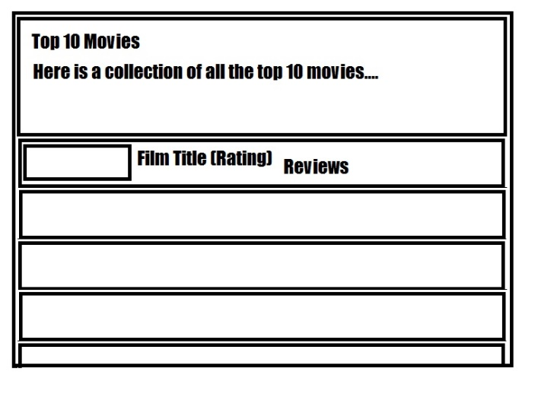**ListView (Main Activity) – Background Dark Grey:**

Top 10 Movies Title – Default Large, Yellow, Static Text

Subtitle – Default Medium, Light Grey, Static Text

ListView – Same Background as ListView

Film Poster – Rectangle, Use internet resource

Film Title – Default Large, Light Grey

Film Rating – Default Small, Light Grey

Film Critics Score – Default Medium, Light Grey

Film Audience Score – Default Medium Light Grey

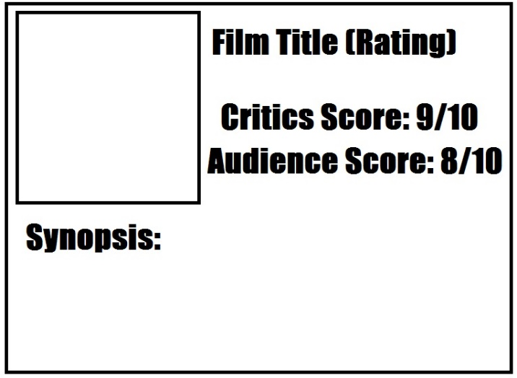

D**etail View:**

Film Poster – Rectangle, Use internet resource

Film Title – Default Large, Light Grey

Film Rating – Default Small, Light Grey

Film Critics Score – Default Medium, Light Grey

Film Audience Score – Default Medium, Light Grey

Film Synopsis – Default Medium, Light Grey

**Master Detail Flow**

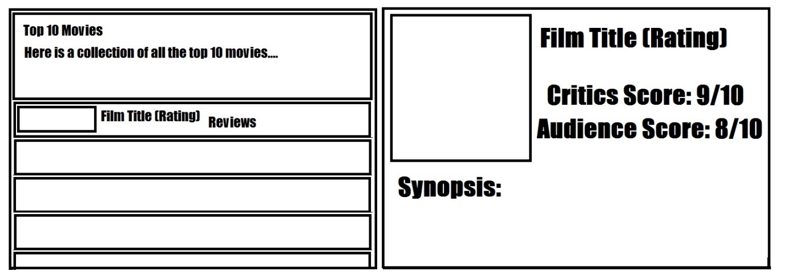Same as above but side by side