L1、基础

准备
  - 使用mybatis-3.2.3.jar，ojdbc6.jar
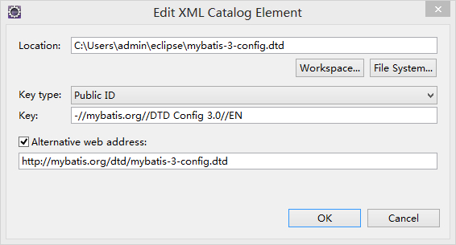

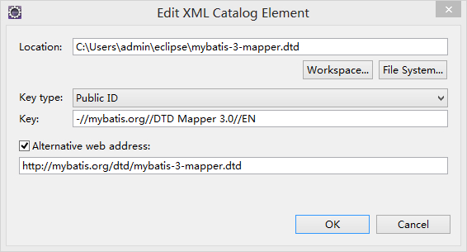
- 基本配置
在src下建立：mybatis.xml
<?xml version="1.0" encoding="UTF-8"?>
<!DOCTYPE configuration PUBLIC "-//mybatis.org//DTD Config 3.0//EN"
"http://mybatis.org/dtd/mybatis-3-config.dtd" >
<configuration>
<typeAliases>
<!-- 给com.phil.erpBasic.entity.Employee类名起别名 -->
<typeAlias type="com.phil.erpBasic.entity.Employee" alias="employee" />
</typeAliases>
<environments default="phil">
<environment id="phil">
<transactionManager type="JDBC">
</transactionManager>
<dataSource type="POOLED">
<property name="driver" value="oracle.jdbc.OracleDriver" />
<property name="url" value="jdbc:oracle:thin:@127.0.0.1:1521:basestore" />
<property name="username" value="admin" />
<property name="password" value="admin" />
</dataSource>
</environment>
</environments>
<mappers>
<mapper resource="com/phil/erpBasic/dao/Employee.xml" />
</mappers>
</configuration>

映射
  - entity
package com.phil.erpBasic.entity;
public class Employee {
private int empId;
private int pcId;
private String empNo;
private String empName;
private boolean empSex;
private String telephone;
private String mobile;
private Date birth;
private String cardId;
private String address;
private String password;
// setter和getter略
}

  - DAO
package com.phil.erpBasic.dao;
public interface EmployeeDAO {
public void saveEmployee(Employee employee);
public void removeEmployee(int empId);
public void updateEmployee(Employee employee);
public List<Employee> findAll();
public Employee findById(int empId);
}

  - Employee.xml
<?xml version="1.0" encoding="UTF-8"?>
<!DOCTYPE mapper SYSTEM "http://mybatis.org/dtd/mybatis-3-mapper.dtd" >
<!-- namespace指定Dao类完全限定名 -->
<mapper namespace="com.phil.erpBasic.dao.EmployeeDAO">
<!-- parameterType的employee可以是别名，#{属性名} -->
<insert id="saveEmployee" parameterType="employee">
insert into employees
values(seq_employees.nextval,#{pcId},#{empNo},#{empName},#{empSex}
,#{telephone},#{mobile},#{cardId},#{address},#{password}
,#{birth});
</insert>
<delete id="removeEmployee" parameterType="int">
delete from employees
e where e.emp_id=#{emp_id}
</delete>
<update id="updateEmployee" parameterType="employee">
update employees set
pc_id=#{pcId}
,emp_no=#{empNo},emp_name=#{empName},emp_sex=#{empSex}
,telephone=#{telephone},cardid=#{cardId},address=#{address}
,password=#{password},birthday=#{birth} where emp_id=#{empId}
</update>
<select id="findAll" resultType="employee">
select * from employees e
</select>
<select id="findById" resultType="employee" parameterType="int">
select * from
employees e
where e.emp_id=#{empId}
</select>
</mapper>

Test
Reader resource = null;
try {
resource = Resources.getResourceAsReader("mybatis.cfg.xml");
SqlSessionFactory sf = new SqlSessionFactoryBuilder().build(resource);
EmployeeDAO empDao = sf.openSession().getMapper(EmployeeDAO.class);
Employee employee=empDao.findById(-1);
employee.setBirth(new Date());
empDao.updateEmployee(employee);
System.out.println(empDao.findAll().get(0).getBirth());
} catch (IOException e) {
e.printStackTrace();
}

事务管理器配置
<transactionManager type="JDBC" />
JDBC – 这个配置直接简单使用了JDBC的提交和回滚设置。它依赖于从数据源得到的连接来管理事务范围
<transactionManager type="MANAGED" />
MANAGED – 这个配置几乎没做什么。它从来不提交或回滚一个连接。而它会让容器来管理事务的整个生命周期（比如Spring或JEE应用服务器的上下文）

数据源配置
<dataSource type="POOLED">
POOLED – 这是JDBC连接对象的数据源连接池的实现，用来避免创建新的连接实例时必要的初始连接和认证时间。这是一种当前Web应用程序用来快速响应请求很流行的方
<dataSource type="UNPOOLED">
UNPOOLED – 这个数据源的实现是每次被请求时简单打开和关闭连接。它有一点慢，这是对简单应用程序的一个很好的选择，因为它不需要及时的可用连接。
不同的数据库对这个的表现也是不一样的，所以对某些数据库来说配置数据源并不重要，这个配置也是闲置的
<dataSource type="POOLED">
JNDI – 这个数据源的实现是为了使用如Spring或应用服务器这类的容器，容器可以集中或在外部配置数据源，然后放置一个JNDI上下文的引用

L2、MyBatis和Spring整合

添加jar包
  - mybatis-spring-1.2.1.jar包和spring的jar包

mybatis配置文件
将environments及其子元素删除，其余不变

在src下建立：mybatis.xml
<?xml version="1.0" encoding="UTF-8"?>
<!DOCTYPE configuration PUBLIC "-//mybatis.org//DTD Config 3.0//EN"
"http://mybatis.org/dtd/mybatis-3-config.dtd" >
<configuration>
<typeAliases>
<!-- 给com.phil.erpBasic.entity.Employee类名起别名 -->
<typeAlias type="com.phil.erpBasic.entity.Employee" alias="employee" />
</typeAliases>

<mappers>
<mapper resource="com/phil/erpBasic/dao/Employee.xml" />
</mappers>
</configuration>

配置applicationContext
<bean id="datasource" class="org.apache.commons.dbcp.BasicDataSource">
<property name="url" value="jdbc:oracle:thin:@127.0.0.1:1521:basestore" />
<property name="username" value="admin" />
<property name="password" value="admin" />
<property name="driverClassName" value="oracle.jdbc.OracleDriver"/>
</bean>
<bean id="sessionFactory" class="org.mybatis.spring.SqlSessionFactoryBean">
<property name="dataSource" ref="datasource" />
<property name="configLocation" value="classpath:mybatis.cfg.xml" />
</bean>
<bean id="scanMapper" class="org.mybatis.spring.mapper.MapperScannerConfigurer">
<property name="basePackage" value="com.phil.erpBasic.dao" />
</bean>
<!---web.xml不再叙述->
事务MyBatis事务是org.springframework.jdbc.datasource.DataSourceTransactionManager

测试
ApplicationContext act = new FileSystemXmlApplicationContext(
"WebContent/WEB-INF/spring-*.xml");
EmployeeDAO empDao = act.getBean("employeeDAO", EmployeeDAO.class);
System.out.println(empDao.findById(-1));

