**Week 3**

Q2.

A.

|  |  |  |
| --- | --- | --- |
| ID | Condition | Conjunct |
| C1 | side1 + side2 > side3 | 1 |
| C2 | side1 == side2 | 2 |
| C3 | side2 == side3 | 2 |
| C4 | side1 != side2 | 3 |
| C5 | side2 != side3 | 3 |

Since C2 is equivalent to C4, and C3 is equivalent to C5, we ignore C4 and C5.

The complete multiple condition table is:

|  |  |  |  |  |
| --- | --- | --- | --- | --- |
| ID | Condition | | | Branch predicate |
| C1 | C2 | C3 |
| 1 | T | T | T | F |
| 2 | T | T | F | T |
| 3 | T | F | T | T |
| 4 | T | F | F | F |
| 5 | F | T | T | F |
| 6 | F | T | F | F |
| 7 | F | F | T | F |
| 8 | F | F | F | F |

B.

C1 is major if we consider ID2 and ID6 or ID3 and ID7

C2 is major if we consider ID2 and ID4 or ID1 and ID3

C3 is major if we consider ID1 and ID2 or ID3 and ID4

To achieve Restricted MCDC

|  |  |  |  |  |  |  |  |
| --- | --- | --- | --- | --- | --- | --- | --- |
| ID | Condition | | | Branch predicate | Input | | |
| C1 | C2 | C3 | side1 | side2 | side3 |
| 1 | T | T | T | F | 3 | 3 | 3 |
| 2 | T | T | F | T | 3 | 3 | 4 |
| 4 | T | F | F | F | 3 | 4 | 5 |
| 6 | F | T | F | F | 1 | 1 | 5 |

C.

To achieve Correlated MCDC we only tests ID3 and ID6

|  |  |  |  |  |  |  |  |
| --- | --- | --- | --- | --- | --- | --- | --- |
| ID | Condition | | | Branch predicate | Input | | |
| C1 | C2 | C3 | side1 | side2 | side3 |
| 3 | T | F | T | T | 3 | 4 | 4 |
| 6 | F | T | F | F | 1 | 1 | 5 |

Q3.

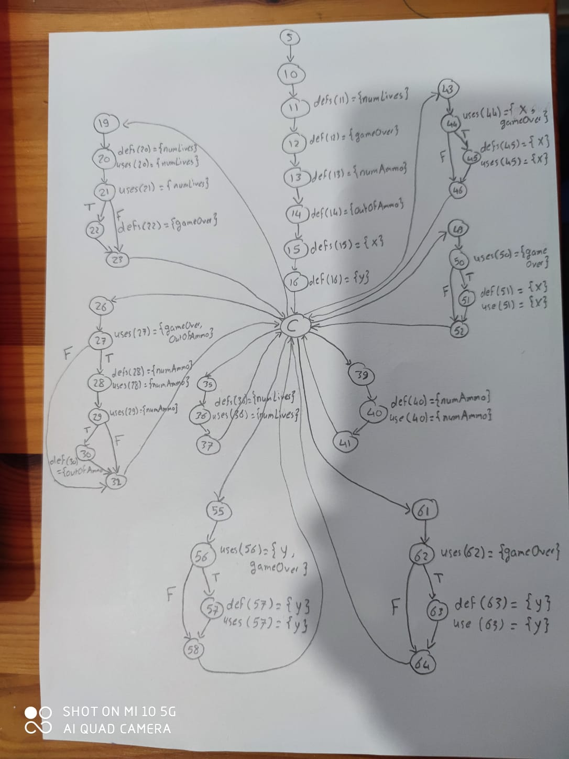

|  |  |  |  |  |  |  |
| --- | --- | --- | --- | --- | --- | --- |
| No | Variable | Def | Use | DU-Path | All-Def | All-Uses |
| 1 | numLives | 11 | 20 | 11->16->C->19->20 | ✓ | ✓ |
| 2 | numLives | 11 | 36 | 11->16->C->35->36 |  | ✓ |
| 3 | numLives | 20 | 20 | 20->21->23->C->19->20 | ✓ | ✓ |
| 4 | numLives | 20 | 21 | 20->21 |  | ✓ |
| 5 | numLives | 20 | 36 | 20->21->23->C->35->36 |  | ✓ |
| 6 | numLives | 36 | 20 | 36->37->C->19->20 | ✓ | ✓ |
| 7 | numLives | 36 | 36 | 36->37->C->35->36 |  | ✓ |
|  |  |  |  |  |  | ✓ |
| 8 | gameOver | 12 | 27 | 12->16->C->26->27 | ✓ | ✓ |
| 9 | gameOver | 12 | 44 | 12->16->C->43->44 |  | ✓ |
| 10 | gameOver | 12 | 50 | 12->16->C->49->50 |  | ✓ |
| 11 | gameOver | 12 | 56 | 12->16->C->55->56 |  | ✓ |
| 12 | gameOver | 12 | 62 | 12->16->C->61->62 |  | ✓ |
| 13 | gameOver | 22 | 27 | 22->23->C->26->27 | ✓ | ✓ |
| 14 | gameOver | 22 | 44 | 22->23->C->43->44 |  | ✓ |
| 15 | gameOver | 22 | 50 | 22->23->C->49->50 |  | ✓ |
| 16 | gameOver | 22 | 56 | 22->23->C->55->56 |  | ✓ |
| 17 | gameOver | 22 | 62 | 22->23->C->61->62 |  | ✓ |
|  |  |  |  |  |  | ✓ |
| 18 | numAmmo | 13 | 28 | 13->16->C->26->27->28 | ✓ | ✓ |
| 19 | numAmmo | 13 | 40 | 13->16->C->39->40 |  | ✓ |
| 20 | numAmmo | 28 | 28 | 28->29->32->C->26->27->28 | ✓ | ✓ |
| 21 | numAmmo | 28 | 29 | 28->29-> |  | ✓ |
| 22 | numAmmo | 28 | 40 | 28->29->32->C->39->40 |  | ✓ |
| 23 | numAmmo | 40 | 28 | 40->41->C->26->27->28 | ✓ | ✓ |
| 24 | numAmmo | 40 | 40 | 40->41->C->39->40 |  | ✓ |
|  |  |  |  |  |  | ✓ |
| 25 | outOfAmmo | 14 | 27 | 14->16->C->26->27 |  | ✓ |
| 26 | outOfAmmo | 30 | 27 | 30->32->C->26->27 | ✓ | ✓ |
|  |  |  |  |  |  | ✓ |
| 27 | x | 15 | 44 | 15->16->C->43->44 | ✓ | ✓ |
| 28 | x | 15 | 45 | 15->16->C->43->44->45 |  | ✓ |
| 29 | x | 15 | 51 | 15->16->C->40->50->51 |  | ✓ |
| 30 | x | 45 | 44 | 45->46->C->43->44 | ✓ | ✓ |
| 31 | x | 45 | 45 | 45->46->C->43->44->45 |  | ✓ |
| 32 | x | 45 | 51 | 45->46->C->49->50->51 |  | ✓ |
| 33 | x | 51 | 44 | 51->52->C->43->44 | ✓ | ✓ |
| 34 | x | 51 | 45 | 51->52->C->43->44->45 |  | ✓ |
| 35 | x | 51 | 51 | 51->52->C->49->50->51 |  | ✓ |
|  |  |  |  |  |  | ✓ |
| 36 | y | 16 | 56 | 16->C->55->56 | ✓ | ✓ |
| 37 | y | 16 | 57 | 16->C->55->56->57 |  | ✓ |
| 38 | y | 16 | 63 | 16->C->61->62->63 |  | ✓ |
| 39 | y | 57 | 56 | 57->58->C->55->56 | ✓ | ✓ |
| 40 | y | 57 | 57 | 57->58->C->55->56->57 |  | ✓ |
| 41 | y | 57 | 63 | 57->58->C->61->62->63 |  | ✓ |
| 42 | y | 63 | 56 | 63->64->C->55->56 | ✓ | ✓ |
| 43 | y | 63 | 57 | 63->64->C->55->56->57 |  | ✓ |
| 44 | y | 63 | 63 | 63->64->C->61->62->63 |  | ✓ |

It is infeasible to fulfill the All Def-Use Path coverage, because there is a loop with the “C” node, we will end having infinite possible paths.