Cairo University  
Faculty of Computers and Information



**CS251**

**Software Engineering I**

Social Networks

Software Design

Philopater Emad

Mina Shafik

Islam Ebrhaim

Abdlerhman Assem

Contents

Instructions [To be removed] 3

Team 3

Document Purpose and Audience 3

System Models 3

I. System Decomposition 3

II. Class diagrams 6

Important Algorithm 7

III. Sequence diagrams 7

Class - Sequence Usage Table 9

Ownership Report 10

Policy Regarding Plagiarism: 10

References 10

Authors 10

# Team

|  |  |  |  |
| --- | --- | --- | --- |
| **ID** | **Name** | **Email** | **Mobile** |
| 20160179 | Philopater Emad | philowmad@gmail.com | 01210030244 |
| 20160336 | Abdlerhman assem |  |  |
| 20160255 | Mina shafik wadee |  |  |
| 20160320 | Islam ebrhaim |  |  |

## Audience

The audience includes, the users, the project management, the system analysts (i.e., the developers who participate in the requirements), and the system designers (i.e., the developers who participate in the system design).

**The purpose**: of this document is analysis of the requirements for the “back-end API” software for social media. For development phase.

# Introduction

## Software Purpose

The purpose of this software is to make people easy to communicate with each other and make life easier

## Software Scope

In our project we are going to develop a back-end API for social network to enable user to be communicated with other users and to be able to share posts and images and contact with them by messages.

In this system user will have the full experience of being communicated in a full social media network.

This system will enable user to communicate with others by sending them messages, sharing photos with them and also share status (posts) with them.

This system facilitates communicating between users as it enables them to create groups which contain specific number of users who can chat with each other and share photos and status (posts).

This system has two types of users, normal user and premium user which have advanced features.

This system is designed to handle a specific number of users.

More specifically it will be a social media network for a small community such as university or college.

# System Models

## I. System Decomposition

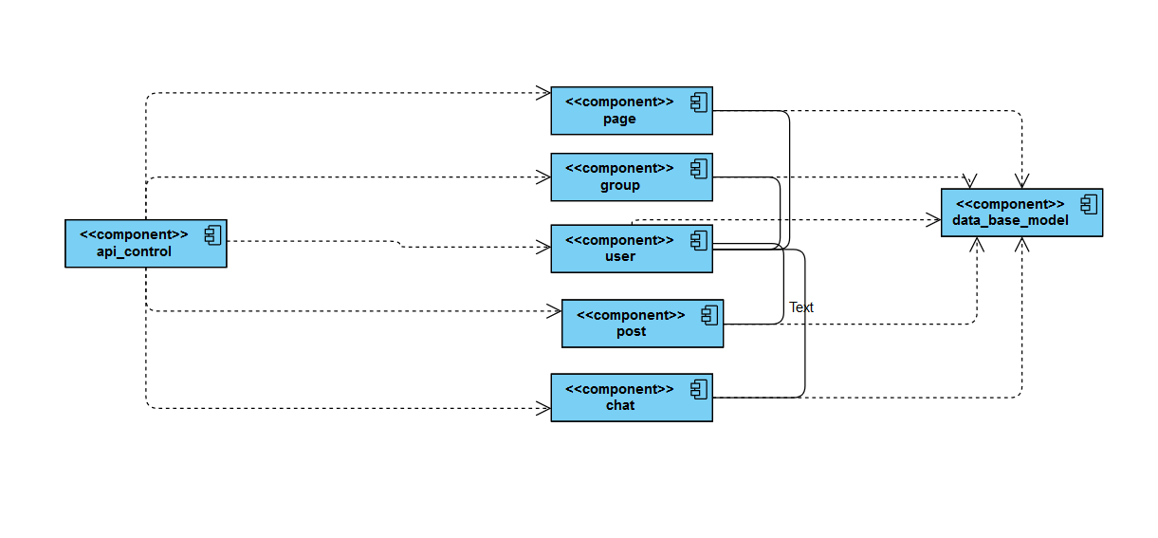

## II. Class diagrams

* **.**

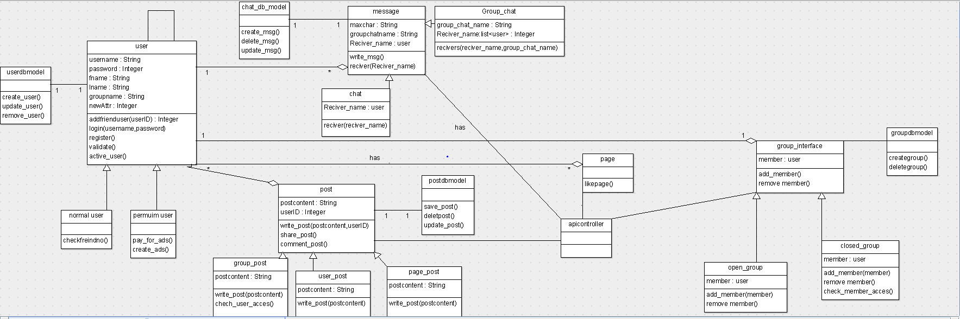

**Same class diagram but with packages :**

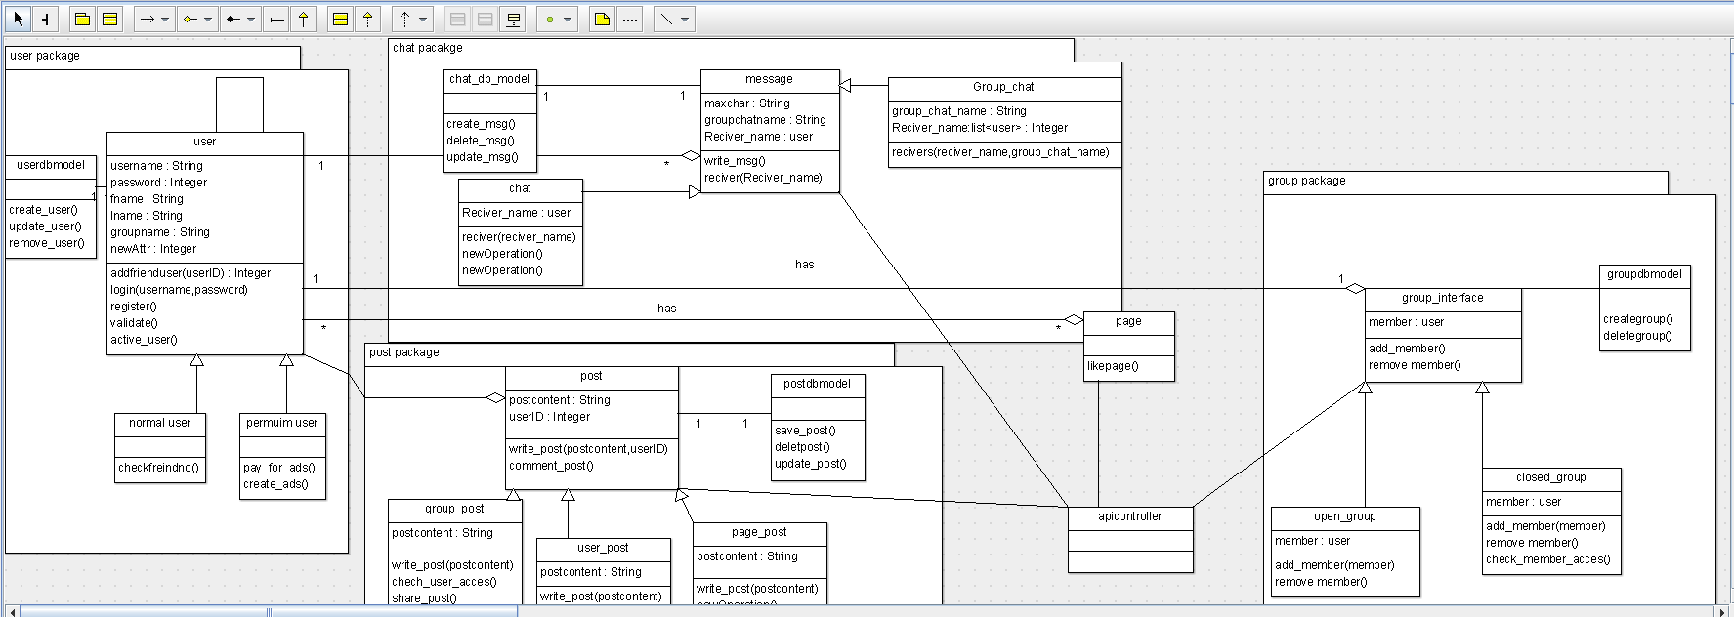

| **Class ID** | **Class Name** | **Subsystem ID** | **Description & Responsibility** |
| --- | --- | --- | --- |
| 01 | User | 01 | This class take all information about the user (name, password ,… eg.) |
| 02 | Normal user | 01 | This class Inherit from the user class its responsibility is to split users |
| 03 | Premium user | 01 | This class Inherit from the user class its responsibility is to split users |
| 01 | message | 02 | The mean class of the message contain all main function of message components |
| 02 | Chat | 02 | Contain the receiverName which receive message |
| 03 | Group chat | 02 | This class has the main responsibility of the group chat its name ane recievers names list |
| 01 | Post | 03 | Contain the main component of the post it’s a main class and small class takes from it all information about the post (conent , userID) |
| 02 | Group post | 03 | This class is for the group post only |
| 03 | User post | 03 | Inherit from the post class and this is responsible for the post on every user profile |
| 04 | Page post | 03 | Responsible for posts in every page |
| 01 | Group interface | 04 | Contain all information about group |
| 02 | Open group | 04 | Inherit from group interface and it make a public group |
| 03 | Closed group | 04 | Inherit from group interface and it make a private group |

## III. Sequence diagrams

**Msg sequence:**

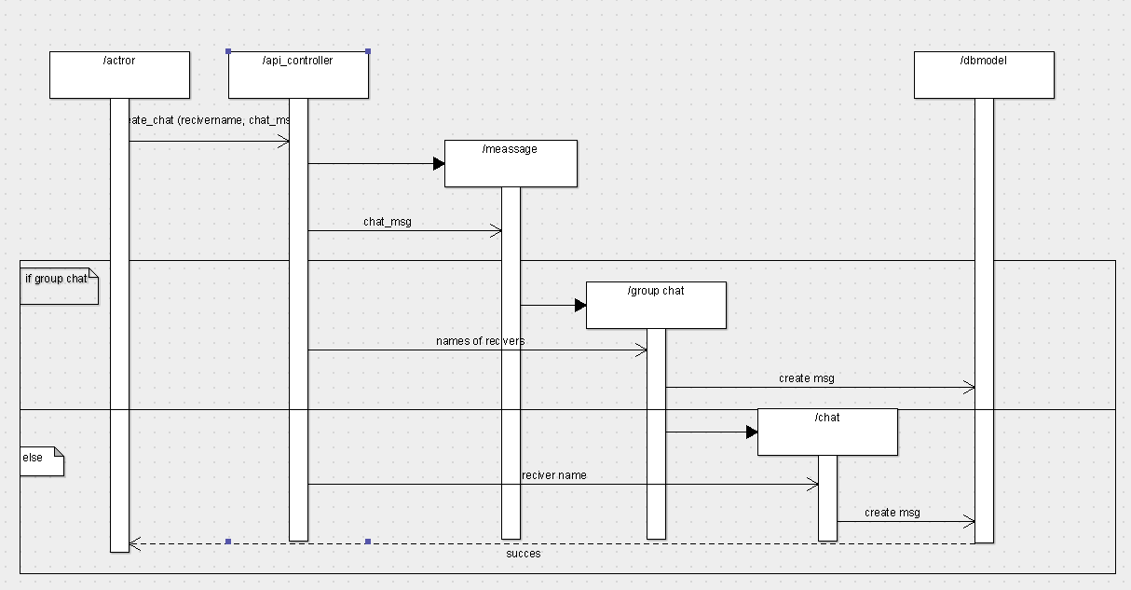

**Group post**

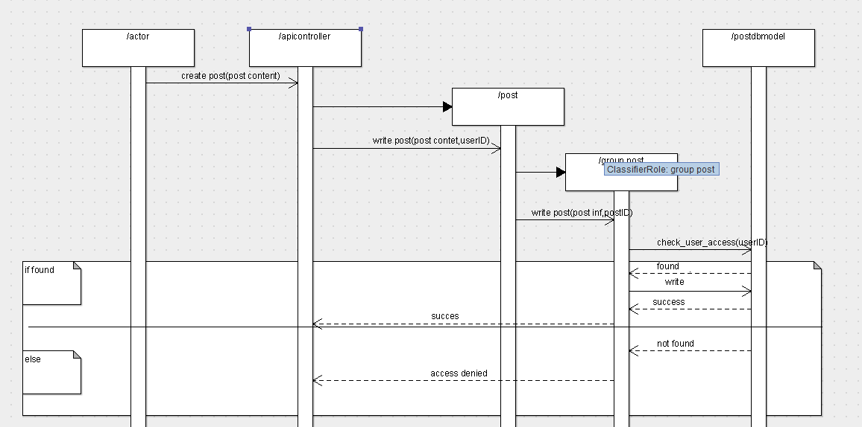

**Page post**

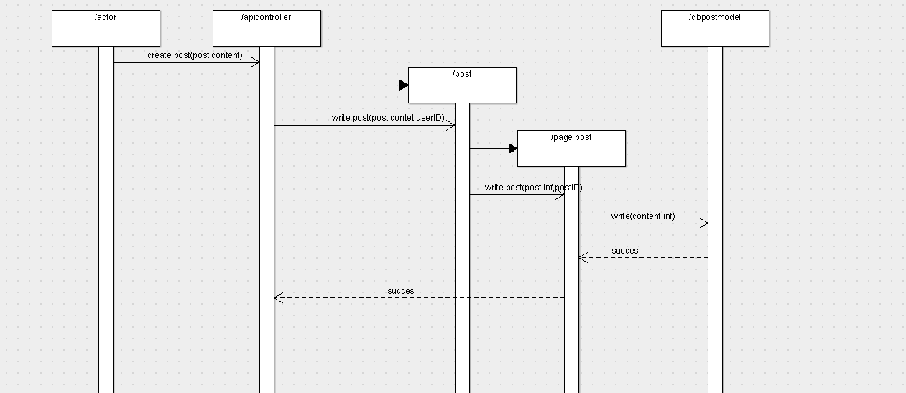

**Sequence of join group:**

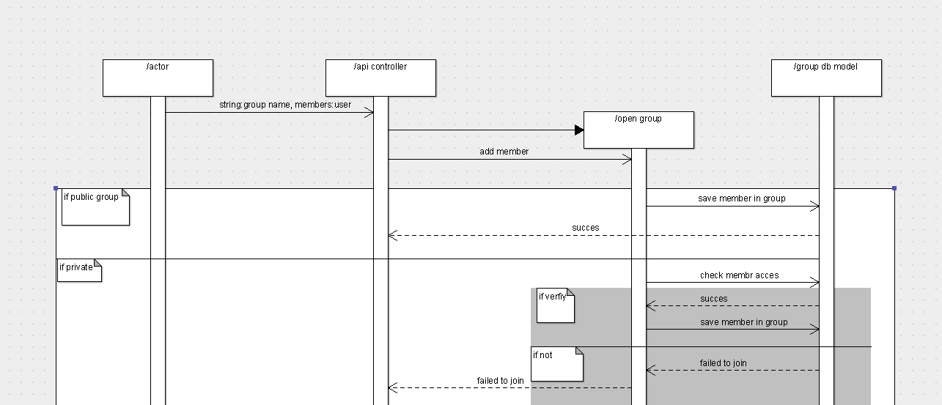

**Login sequence:**

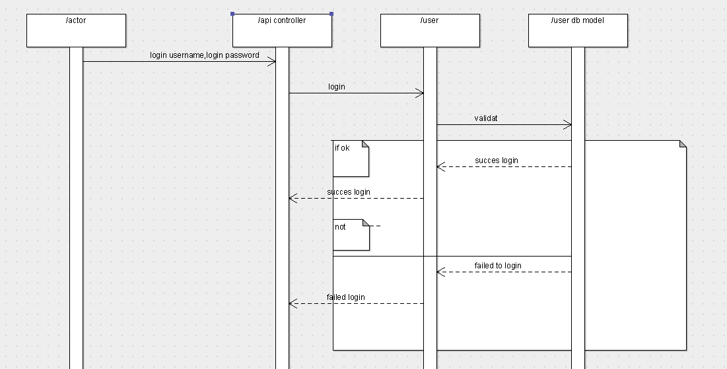

**Register sequence:**

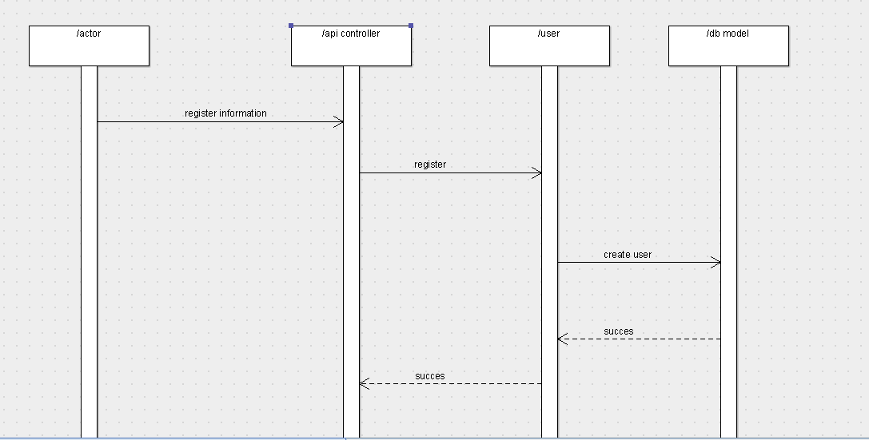

### Class - Sequence Usage Table

**.**

| **Class Name** | **Sequence Diagrams** | **Overall used methods** |
| --- | --- | --- |
| E.g. Employee | 1, 3, 5 (means Seq Ids 1, 3, 5 used Employee class) | Save, GetData |
|  |  |  |