1. **Cheap Basket – Menu**

In Figure 1 you see the functionalities of Cheap Basket application. This is the main menu of the application. You can scan products’ barcode or you can search for product‘s information. Also the Basket option is used for viewing or modifying your baskets. Finally the applications providesthe option “Settings” which is for customize cheap basket according to your preferences.

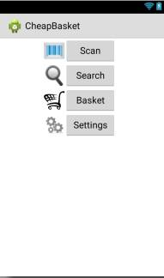

Figure 1

If the user clicks “Scan” button, the camera will open up and he will be able to scan a barcode of a product. The “Search” button will take him to a screen where he will be able to search a product by name or by a category from the database. After the user clicks the “Basket” button, the screen with the current baskets will show up and he will be able to manage his baskets. The “Settings” menu will give user some options to enable or disable for best user interaction.

1. **Scan Mode screen**

When the user selects the “Scan” button, a screen with the camera will appear so the user is able to scan products’ barcode.The camera should be at a distance from the product.Notice that when the camera is active will get to idle state if the Take a picture button is not pressed in an interval ofseconds.

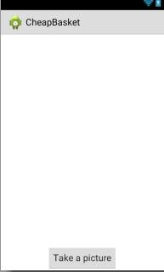

1. **Settings screen**

The screenshot below shows the settings where you can adjust the sound,the maximum distance between shop and my location, set the distance from my location in kilometers and the last option is map rotation.

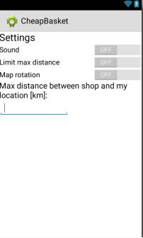

1. **Baskets screen**

From the main menu when you select “Basket” option, a list of all customers basket will appear where you can click the baskets to see the products included or add a new basket to the current list.

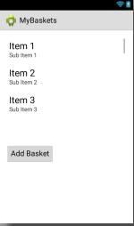

1. **My Basket (Sample basket)**

Selecting one of the baskets, the bellow window will appears containing all the basket products and the quantity of products you added in the selected basket. Also includes the shops where you find the cheapest products and the total price.In addition, in this window you can adjust – edit or delete the basket.

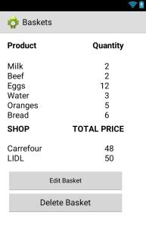

1. **Search Mode**

The screenshot bellow shows what customers sees when from the main menu selects “Search” button. The application will guide him to search a product by its name or generally to search for a product/s by category. Each category has a list of products that user can just click to select.

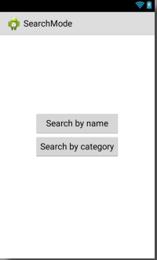

1. **Search product**

In this screen shot we see the window that appears to the user after he selected to “search a product” from the search main menu. The searching will be based on product name which the user has to write it down on the corresponding textfield. It will start searching for the product and its price by pressing “find prices of the product“.

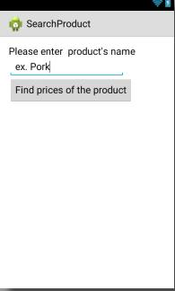

1. **Search Category**

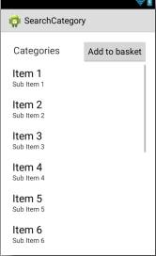On the below window you can see the products a category contains. This menu will appear to the user after he had selected “search” from the main menu and then “search by category”. You can select one of the listing products and add it to your basket.The list will have the following categories: a) Meat, b) Fish, c) Fruits and Vegetables, d) Cereals and e) Dairy. The user can in this point select one of the available categories and a list of products will be displayed, a list related with the selected category.

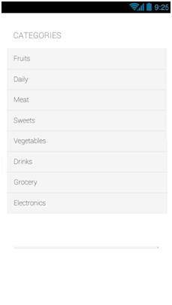

1. **Results**

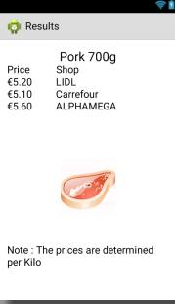This screen below shows what appears to the user after selecting search the product, which you chose in the previous phase selecting by name. Screenshot showsto the customer the product with a picture and other information about product such as weight or producer. Another interesting thing is that the customer sees stores where the product is on sale. The customer then selects from supply stores and then click Add to add to your basket.