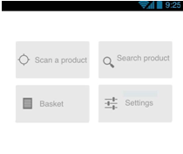

When the user selects the “Scan a product” button, a screen with the camera will appear so the user is able to take a photo of the products’ barcode. When button “Search a product” is pressed a screen with a text above “Choose a category” will appear and will have the following categories as a list: a) Meat, b) Dairy, c) Vegetables, d) Fruits and e) Sweets. “Basket” button will transfer user to the basket screen where a button “Create a basket” will be on top and a list with the current baskets or a message of “No baskets” will appear if there are or no any baskets. The button “Settings” will direct user to a screen with the following options: 1) Sound (next to an on/off switch), 2) Show recent items (next to an on/off switch), 3) Maximum Distance between shops and my location (next to a textbox to write the value in “km”).

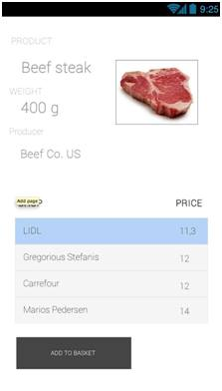

This screenshot shows what appears to the user after search the product, that you chose in the previous phase. Screenshot showing the customer the product with a picture and other information about product such as weight or producer. Another interesting thing is that the customer sees stores where the product is on sale. The customer then selects from supply stores and then click Add to add to your basket.

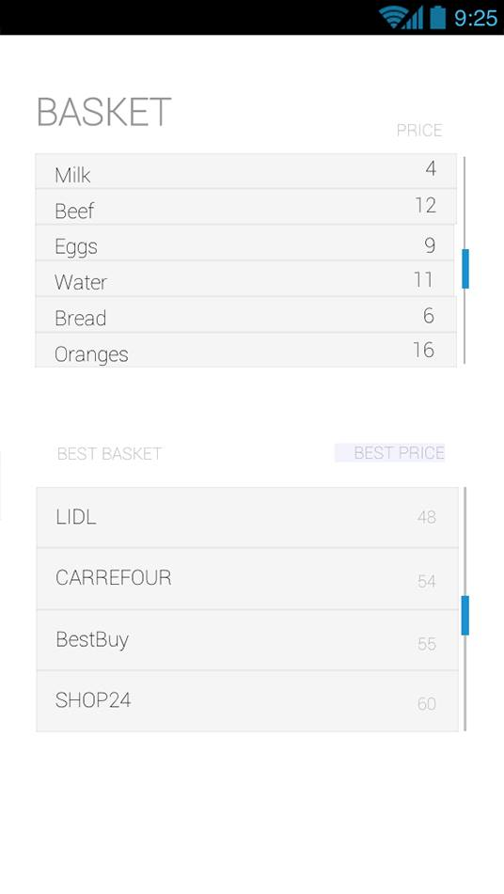

4

After the user clicks on “Add to basket” button, the screen with the current baskets will show up and he will click at a basket to add the product/products. After that, the products included in that basket will appear in a new screen and below them will be a table with the shops available to buy all products and the total price from each shop. If user clicks a shop from the list will show up the store’s details such name, telephone, address and distance with each text below other and at the bottom will be a button “Get Directions” which will open the maps application and will show you the route to drive to the selected shop. The screen with the baskets will also have a button to return to main screen with the main menu.

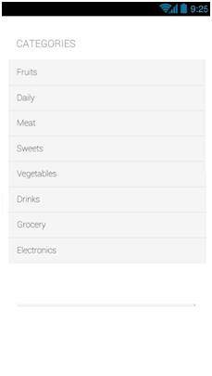

In the next phase the category the customer has the option to see all the options from which you can choose. In this category customer sees and can choose from fruits, daily, meat, sweets, vegetabes, drinks, grocery and electronics.

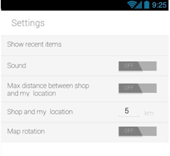

The last screenshot shows the settings where you can adjust enjoyed the sound, another important point is the maximum distance Between shop and my location, the next item is to set the distance from my location in miles. Last setting is map rotation.