EMPLOYEE TABLE:

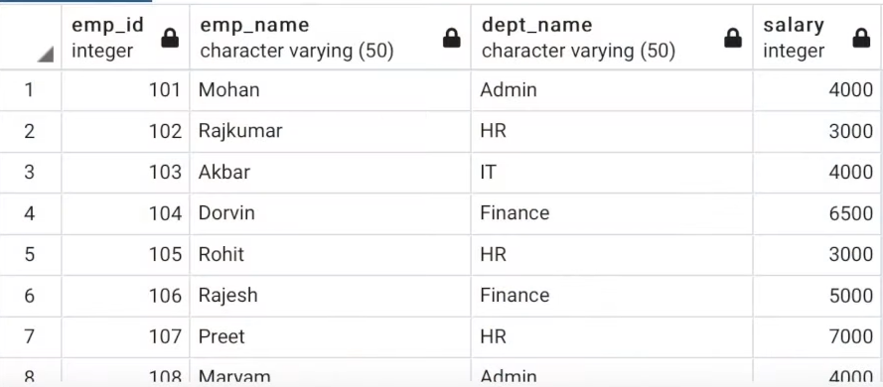

Q-> MAX SALARY EARNED BY AN EMPLOYEE?

SELECT MAX(SALARY) AS MAXIMUM FROM EMPLOYEE;

O/P:

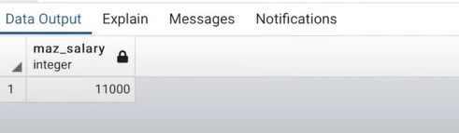

Q->DEPT NAME AND MAXIMUM SALARY FOR THE EMPLOYEE IN EACH DEPARTMENT?

SELECT DEPT_NAME, MAX(SALARY) AS EACH_MAX FROM EMPLOYEE GROUP BY DEPT_NAME;

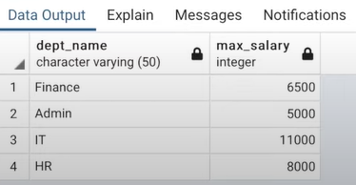

Q-> ALL DETAILS AND MAXIMUM SALARY FOR THE EMPLOYEE IN EACH DEPARTMENT?

-Since we could not use aggregate functions here, so window functions come in use

🡪PROCEDURE:

SELECT E.*, MAX(SALARY) OVER() AS MAX_SALARY FROM EMPLOYEE E;

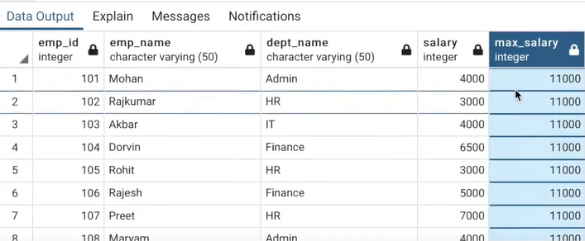

HERE NO COLS IS GIVEN IN OVER() WINDOW FUNCTION SO SQL WILL CREATE ONE WINDOW FOR THAT SINGLE(MAX) ROW AND APPLY THE MAX(SALARY) FUNCTION. THAT’S WHY WE GOT SAME REPEATED VALUES IN MAX_SALARY

MAXIMUM SALARY CORRESPONDING TO EACH DEPARTMENT, THEREFORE:

SELECT E.*, MAX(SALARY) OVER(PARTITION BY DEPT_NAME) AS MAX_SALARY FROM EMPLOYEE E;

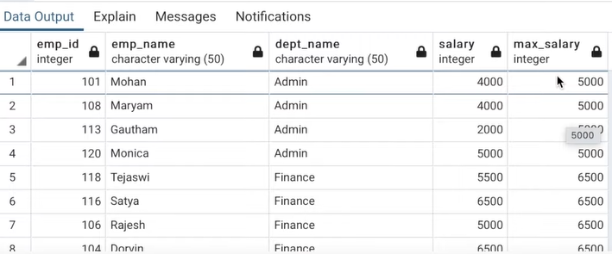

Q-> ASSIGN ROW NUMBER(S.NO) TO EACH ROW OF TABLE

SELECT E.*, ROW_NUMBER() OVER() AS RN FROM EMPLOYEE E:

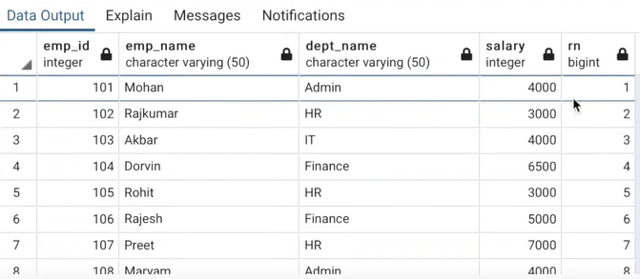

Q-> ASSIGN ROW NUMBER TO EACH ROW , DEPARTMENT WISE?

SELECT E.*, ROW_NUMBER() OVER(PARTITION BY DEPT_NAME) AS RN FROM EMPLOYEE E;

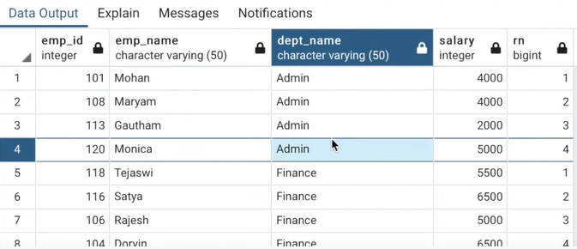

* For each dept, the row number is reset

Q-> FETCH THE RECORD FOR FIRST TWO EMPLOYEES THAT JOINED THE COMPANY IN EACH DEPT.(assume emp id of employee who joined previously(old) is less than newbies)

PROCEDURE->

SELECT E.*, ROW_ NUMBER () OVER(PARTITION BY DEPT_NAME) AS RN FROM EMPLOYEE E;

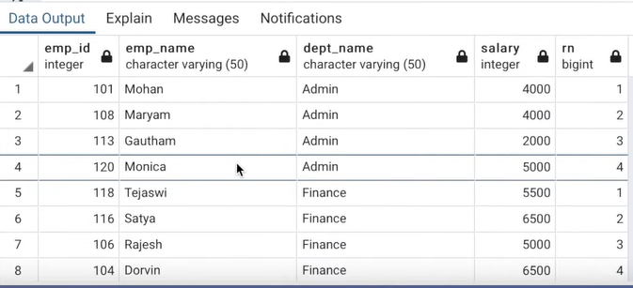

The id’s are not sorted yet, so-

SELECT E.*, ROW_NUMBER() OVER(PARTITION BY DEPT_NAME ORDER BY EMP_ID) AS RN FROM EMPLOYEE E;

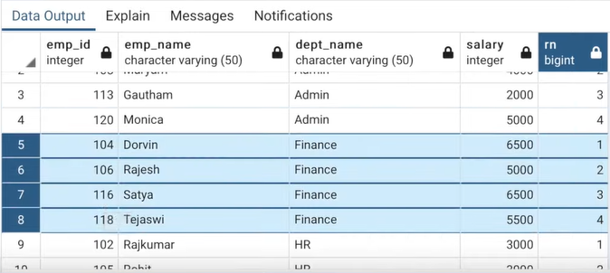

Now I want only top two employees who are oldest:

SELECT * FROM (

(SELECT E.*, ROW_NUMBER() OVER( PARTITION BY DEPT_NAME ORDER BY EMP_ID ) AS RN FROM EMPLOYEE E) X

WHERE X.RN<=2;

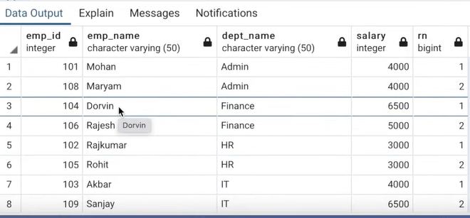

Therefore, only 8 rows are there.

Q-> FETCH THE DETAILS OF TOP 3 EMPLOYEE EARNING THE MAX SALARY?

SELECT * FROM(

SELECT E.*, ROW_NUMBER () OVER( PARTITION BY DEPT_NAME ORDER BY SALARY ASC ) AS RN FROM EMPLOYEE E)X

WHERE X.RN<=3;

OR-

PROCEDURE-

SELECT E.*, RANK() OVER(PARTITION BY DEPT_NAME ORDER BY SALARY DESC) AS RNK FROM EMPLOYEE E;

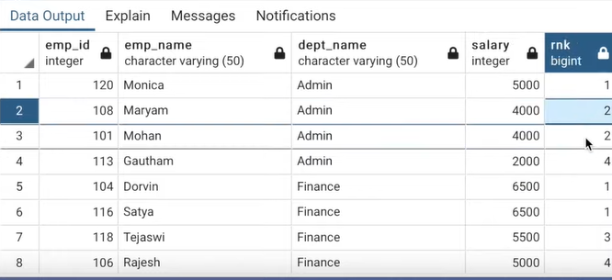rank assignes same rank to duplicate values(4000 me 2) and then resumes with the original indexing

NOW-

SELECT * FROM(

SELECT E.*, RANK() OVER(PARTITION BY DEPT_NAME ORDER BY SALARY DESC) AS RNK FROM EMPLOYEE E)X

WHERE X.RNK<=3;

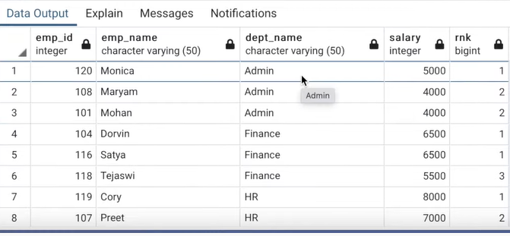

RANK() SKIPS THE INDEX WHEN PREV TUPLE HAD A DUPLICATE VALUES,

DENSE_RANK() DOES NOT SKIP THE INDEX WHEN PREV TUPLE HAD A DUPLICATE VALUES,

RANK() INDEXES AS PER CONDITION EX-

SELECT E.*,

RANK() OVER(PARTITION BY DEPT_NAME ORDER BY SALARY DESC) AS RNK,

DENSE_RANK() OVER(PARTITION BY DEPT_NAME ORDER BY SALARY DESC) AS DENSE_RNK,

ROW_NUMBER() OVER(PARTITION BY DEPT_NAME ORDER BY SALARY DESC) AS RN

FROM EMPLOYEE ;

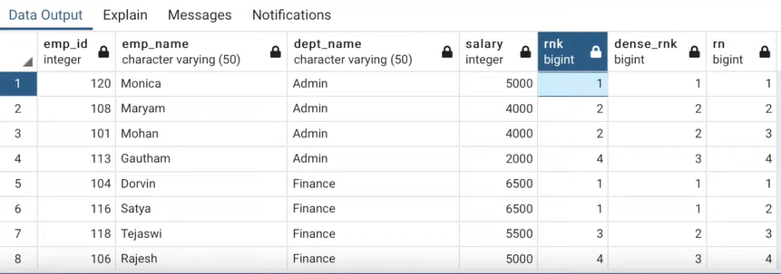

Q-> FETCH THE COL WITH THE PREV RECORD OF EACH ROW?

LAG(COL_NAME) FETCHES THE VALUES OF PREV RECORDS, HERE 1ST ROW THUS WILL HAVE NULL VALUE QKI 1ST ROW KI KOI PREV ROW HE HI NHI

SYNTAX- LAG(COL_NAME, N,M) N-> nth NUM OF RECORD PRIOR TO CURRUNT ROW, M-> THE VALUE TO SET IF NO RECORD ARE FOUND

SELECT * ,LAG(SALARY) OVER(PARTITION BY DEPT_NAME ORDER BY DEPT_ID) AS PREV_EMP_SALRY FROM EMPLOYEE;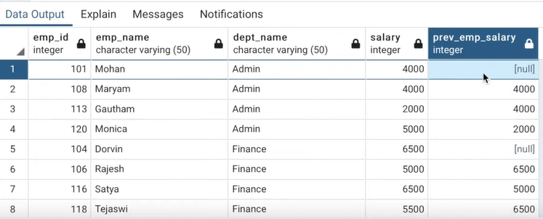

SELECT * ,LAG(SALARY,2,0) OVER(PARTITION BY DEPT_NAME ORDER BY DEPT_ID) AS PREV_EMP_SALRY FROM EMPLOYEE;

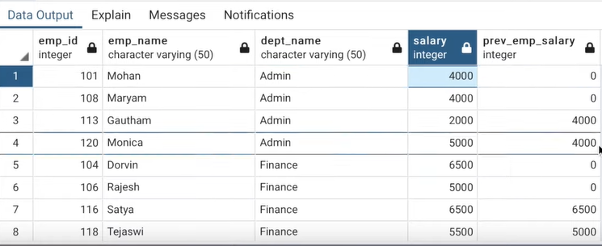

SELECT * ,

LAG(SALARY) OVER(PARTITION BY DEPT_NAME ORDER BY DEPT_ID) AS PREV_EMP_SALRY,

LEAD(SALARY) OVER(PARTITION BY DEPT_NAME ORDER BY DEPT_ID) AS NEXT_EMP_SALRY

FROM EMPLOYEE;

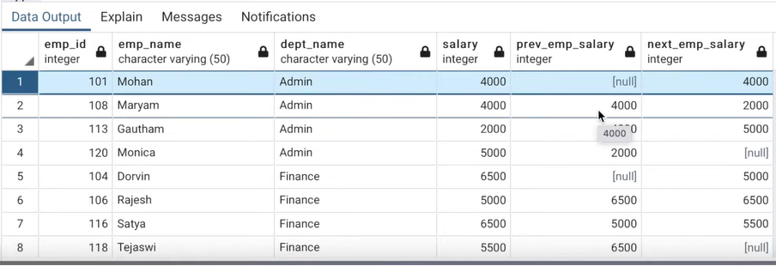

Q->FETCH A QUERY TO DISPLAY IF THE SALARY OF AN EMPLOYEE IS HIGHER/EQUAL OR LOWER THAN PREV EMPLOYEE?

SELECT * FROM(

SELECT * ,

LAG(SALARY) OVER(PARTITION BY DEPT_NAME ORDER BY DEPT_ID) AS PREV_EMP_SALRY,

LEAD(SALARY) OVER(PARTITION BY DEPT_NAME ORDER BY DEPT_ID) AS NEXT_EMP_SALRY

FROM EMPLOYEE)X WHERE

CASE

WHEN X.PREV_EMP_SALARY>SALARY THEN “HIGHER”

WHEN X.PREV_EMP_SALARY=SALARY THEN “EQUAL”

ELSE “LOWE”

END STATUS