Cairo University  
Faculty of Computers and Information



**CS251**

**Software Engineering I**

**Project Name**: - Game-based educational platform **Software Design**

**Team Names: -** 1-Ahmed Mohamed Abd El-Aziz Sayed

2-Ahmed Ali Mohamed Eissawy

3-Philopater Milad

4-Ahmed Abu-Bakr Elgabry

November & 2016

Contents

Instructions [To be removed] 3

Team 3

Document Purpose and Audience 3

System Models 3

I. Class diagrams 3

Important Algorithm 5

II. Sequence diagrams 5

Class - Sequence Usage Table 7

Ownership Report 8

Policy Regarding Plagiarism: 8

References 8

Authors 8

# Team

|  |  |  |  |
| --- | --- | --- | --- |
| **ID** | **Name** | **Email** | **Mobile** |
| 20120059 | Ahmed Mohamed Abd El-Aziz Sayed | ahmedtaghian@rocketmail.com | 01064139044 |
| 20110483 | Ahmed Ali Mohamed Eissawy | Ahmedeissawy93@gmail.com | 01065564104 |
| 20120275 | Philopater Milad |  |  |
| 20120006 | Ahmed Abu-Bakr Elgabry |  |  |

# 

# Document Purpose and Audience

The purpose to show the design of the project that will be used also in the implementation and make implementation easier.

# System Models

# I. Class diagrams

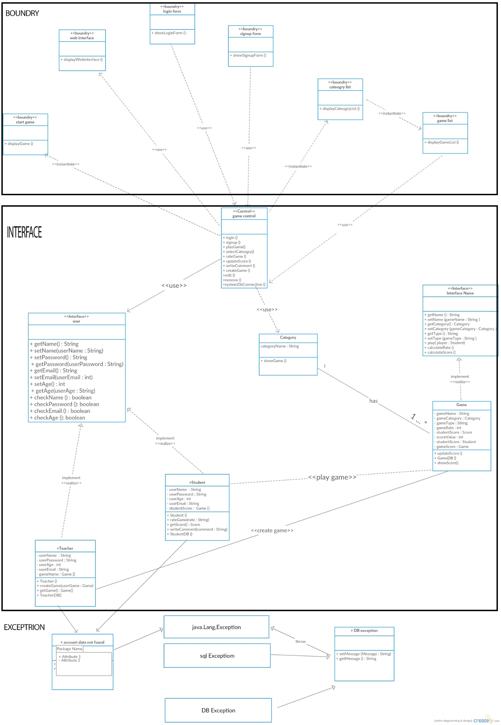

| **Class ID** | **Class Name** | **Description & Responsibility** |
| --- | --- | --- |
| 1 | Web Interface | Display the site services to the user |
| 2 | Login Form | Allows the user to use the site by entering username and password |
| 3 | Signup Form | Allows the user to create an account to login to the site |
| 4 | Category list | Allows the user to choose the category of the game |
| 5 | Game list | Display the list of the games |
| 6 | Start game | Allows the user to play the game |
| 7 | Game control | Connect classes to each other |
| 8 | Category | Retrieve the category list to the controller game to view it to the user |
| 9 | Game | Implement the game rules |
| 10 | User(student and Teacher) | Save data about student and teacher |
| 11 | Account data not found | Check the exception if the data of the user not correctly |
| 12 | DB Exception | Check if there is no connection with the DB or if the DB retrieve wrong results |

## II. Sequence diagrams

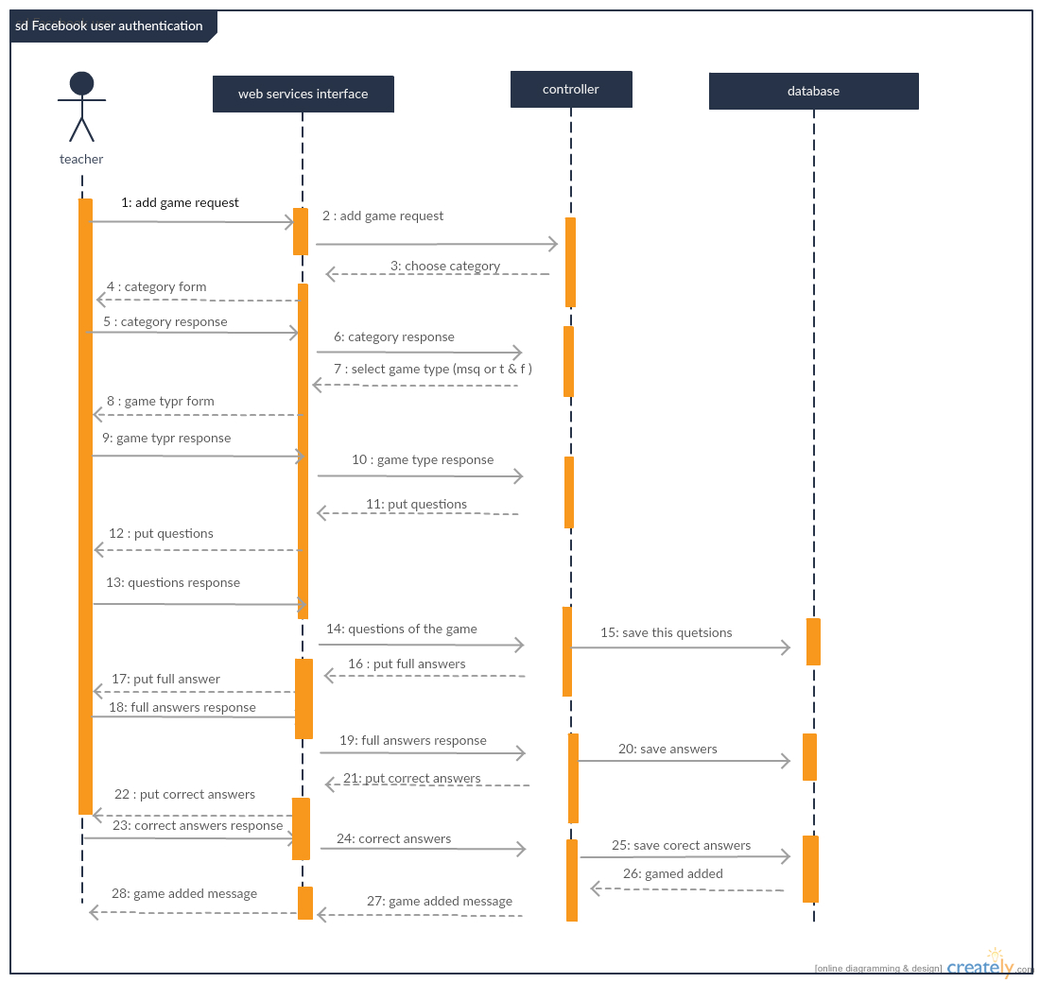

### 

### 

### 

### Class - Sequence Usage Table

| **Class Name** | **Sequence Diagrams** | **Overall used methods** |
| --- | --- | --- |
| Web Interface | 1 | Add game |
| Login form | 2 | Login |
| Sign up form | 3 | Sign up |
| Category list |  |  |
| Game list |  |  |
| Start game |  |  |
| Game control | 1,2,3 | Save data , get data and check data |
| Category |  |  |
| Game | 2 | Update score , calculate score |
| User | 3 | Login , sign up |
| teacher | 1 | Add game |
| student | 2 | Play game |

# 

# Ownership Report

|  |  |
| --- | --- |
| **Item** | **Owners** |
| Class diagram | *Ahmed Elgabry, Philopater Milad* |
| Sequence diagram | *Ahmed Mohamed Abd El-Aziz, Ahmed Ali Eissawy* |

# Policy Regarding Plagiarism:

# References

https://github.com/philopater/ProjectSoftware.git

# Authors

* Mostafa Saad and Mohammad El-Ramly (Edited by Mohamed Samir)