Machine Learning Task

First Section:

- Which topics are most popular?
These are the topics popularity sorted from highest to lowest:
web development 4132
generative AI 3749
machine learning 3260
quantum computing 1581
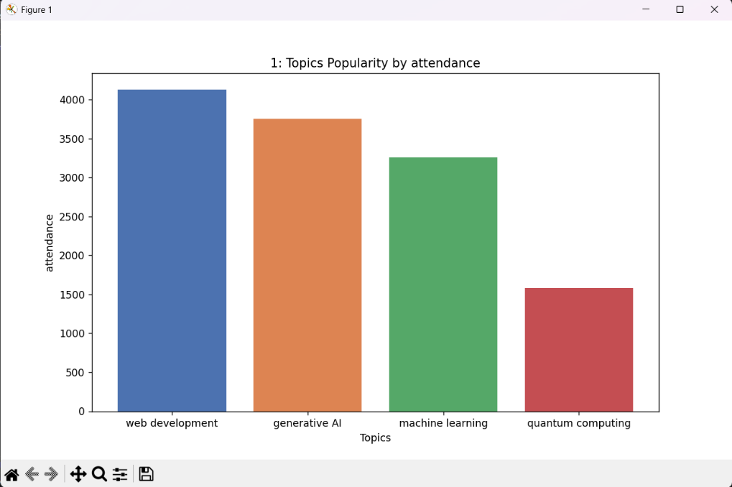
So, it shows that the most attended topic and the most popular is Web Development.
Figure 1: Topics Popularity by attendance (Matplotlib.pyplot)

- Which events are most popular?
These are the event type popularity sorting from highest to lower:
Workshop 7049
Contest 4092
Talk 1581
So, it shows that the most attended event and the most popular is the Workshop.
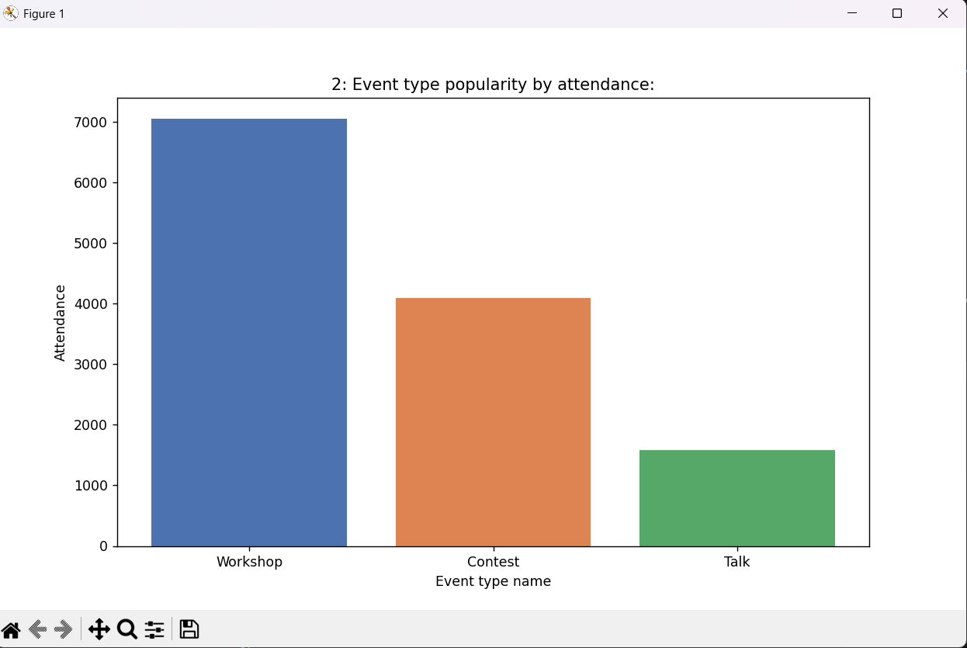
Figure 2: Event type popularity figure (Matplotlib.pyplot)
- Which events are most rated?
These are the event type feedback ratings, sorted from highest to lowest:
Workshop 4.908642
Contest 4.869231
Talk 4.197500
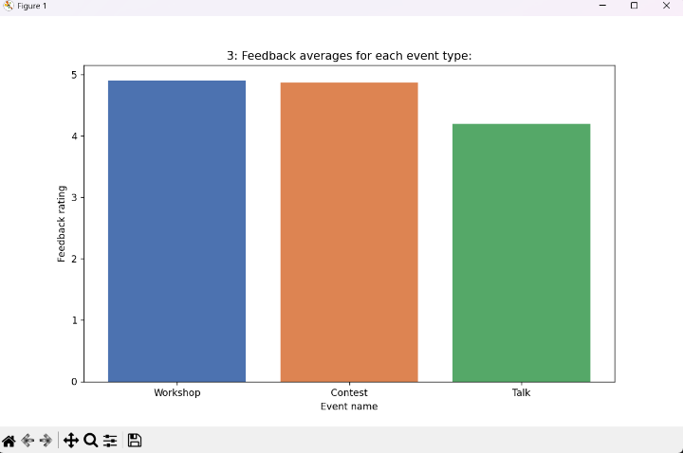
So, it show that the most rated event type is the Workshop.
Figure 3: Feedback ratings average for each event type
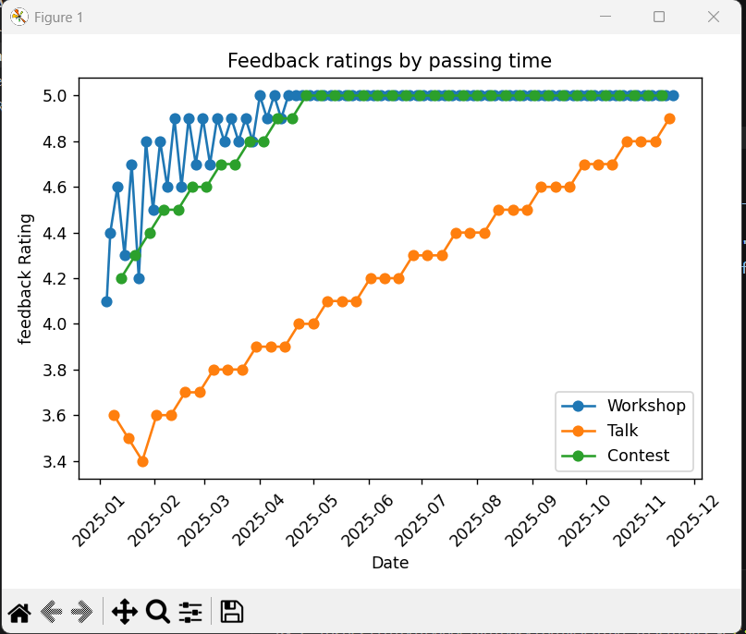
Figure 4: Feedback ratings by passing time

- Do harder topics (like quantum computing) get better or worse ratings?
These are the sorting of each topic according to its difficulty and its rating, and it is sorted from the most difficult to the lowest:

quantum computing 5.000 4.1975
machine learning 4.000 4.8800
generative AI 3.000 4.9575
web development 2.975 4.8500
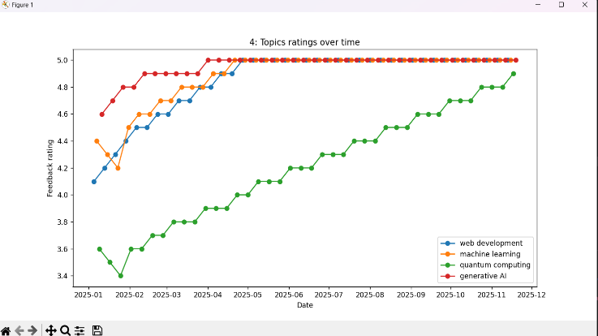
So, the Data shows that the most difficult topic got the least feedback rating, which is Quantum Computing
Figure 5: Topics Ratings over Time
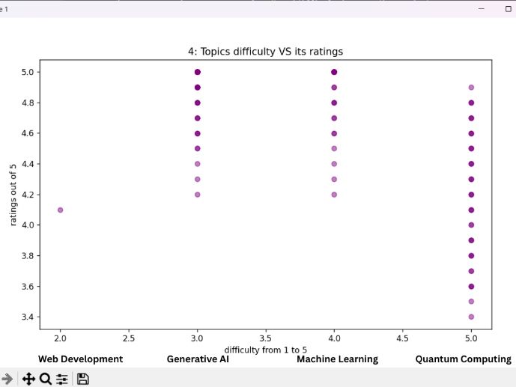
Figure 6: Topic difficulty VS its rating

- Is there a pattern between difficulty vs Ratings or no clean relationship?
Yes, there is, as Quantum computing is considered the hardest topic, and it got the lowest average of ratings, and also when the subject becomes too easy, such as web development, its ratings also become not that high. All of that is shown in analysis 4.

- Which attracts more students, longer events or shorter ones?
This is the list of data, which shows that whenever the duration time increases, the number of students increases.
3.5 109.571429
2.5 90.621622
3.0 64.250000
2.0 49.000000
1.5 40.000000
1.0 21.000000
This shows that the largest number of students attended the 3.5-hour events.
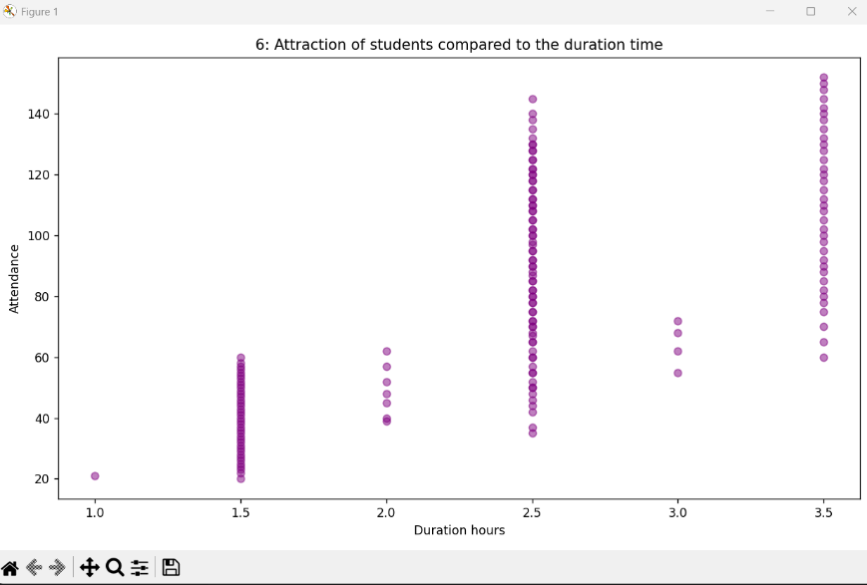
Figure 7: Attraction of students compared to the duration time

- The most attended topic:
After listing the most popular topics according to their attendance numbers:
web development 4132
generative AI 3749
machine learning 3260
quantum computing 1581
It was conducted the most attended topic is Web Development.
- The Most Rated Topic:
After listing all the topics with their average feedback ratings:
generative AI 4.9575
machine learning 4.8800
web development 4.8500
quantum computing 4.1975
It was deduced that the most rated topic is Generative AI, with average feedback ratings of 4.9575.
- The most efficient topic in terms of the average attendance per duration in hours:
After listing the topics from the most efficient to the least efficient:
generative AI 38.150000
machine learning 32.697500
web development 30.034524
quantum computing 26.525000
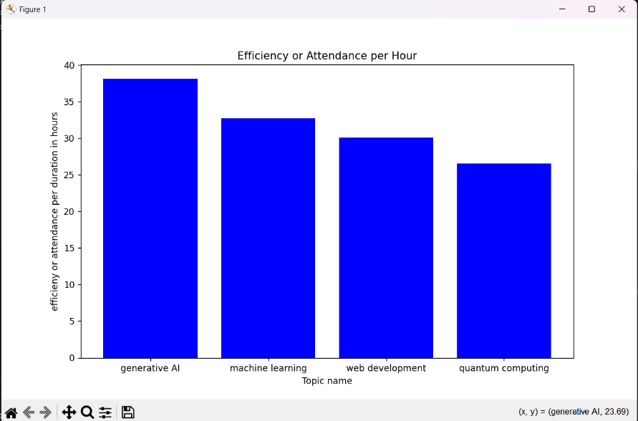
Figure 8: Efficiency for each topic sorting in descending order

Second Section:

- What should the club focus on next semester?
The club should focus on Web Development the most, as it is the most popular one, then Generative AI and Machine Learning, as they are considered not that hard and also attended a lot, and all of these should be made as Workshops, which is the most attended event, while the club should decrease the amount of events for Quantum Computing as it is considered very hard (5 scale) and least rated.
- Should the club decrease or increase event difficulty?
I think the answer simply depends on the topic, for example, a topic like Quantum computing got the 5.0 on the hardness scale, so it should be easier to get higher feedback, while topics like Web Development are too easy with high feedback, so I guess there should be levels for it until it reaches intermediate to great difficulty to be still good. Finally, I think Machine learning and Generative AI should maintain their difficulty as they get good feedback and a good number of attendees.
- What is the best event in terms of Topic, Duration, and Difficulty overall?
Web Development is the best topic, and the best duration is around 2.5 hours or 3.5 hours, as they showed the largest number of attendance, and the best hardness is Medium hardness.

- What is the club doing wrong?
Firstly, the club should decrease the difficulty of topics like Quantum Computing to increase its feedback. Secondly, the club should increase the number of Workshops and decrease Talks as they are the least attended. Thirdly, the club should increase the time duration to around 3.5 hours or 2.5 hours, as they showed the largest number of attendees.
- If you could collect one more column of data, what would it be and why?
I think it should be ‘Student Experience’, so then we can determine if Quantum Computing is hard for beginners, by seeing feedback of seniors and well-experienced students, so then we can determine the difficulty level for each topic.

