Practice Final Exam 2

- A study was done to determine the proportion of teenagers that own a car. The true proportion of teenagers that own a car is the:
  - statistic
  - parameter
  - population
  - variable

Questions 2 - 3 refer to the following data:
value | frequency
0  1  2  3  6 | 1  4  7  9  4

- The box plot for the data is:
a.
0 | 2 | 3 | 6

b.
0 | 1 | 3 | 6
c.
0 | 3 | 6
d.
0 | 1 | 3 | 6

- If 6 were added to each value, the 15th percentile would be:
  - 6
  - 1
  - 7
  - 8

Questions 4 - 5 refer to the following situation:
Suppose that the probability of a drought in any independent year is 20%. Out of those years in which a drought occurs, the probability of water rationing is 10%. However, in any year, the probability of water rationing is 5%.

- What is the probability of both a drought and water rationing occurring?
  - 0.05
  - 0.01
  - 0.02
  - 0.30

- Which of the following is true?
  - drought and water rationing are independent events
  - drought and water rationing are mutually exclusive events
  - none of the above

Questions 6 - 7 refer to the following situation:
Suppose that a survey yielded the following data:
favorite pie type
gender | apple | pumpkin | pecan
female | 40 | 10 | 30
male | 20 | 30 | 10

- Suppose that one individual is randomly chosen. The probability that the person’s favorite pie is apple or the person is male is:
  - 40/60
  - 60/140
  - 120/140
  - 100/140

Suppose H_{o} is: Favorite pie type and gender are independent.
- The p-value is:
  - ≈ 0
  - 1
  - 0.05
  - cannot be determined

Questions 8 - 9 refer to the following situation:
Let’s say that the probability that an adult watches the news at least once per week is 0.60. We randomly survey 14 people. Of interest is the number that watch the news at least once per week.

- Which of the following statements is FALSE?
  - X~ B(14, 0.60)
  - The values for x are: 1, 2, 3, ..., 14
  - μ = 8.4
  - P(X = 5) = 0.0408

- Find the probability that at least 6 adults watch the news.
  - 6/14
  - 0.8499
  - 0.9417
  - 0.6429

- The following histogram is most likely to be a result of sampling from which distribution?

  - Chi-Square
  - Exponential
  - Uniform
  - Binomial

The ages of campus day and evening students is known to be normally distributed. A sample of 6 campus day and evening students reported their ages (in years) as:
18; 35; 27; 45; 20; 20

- What is the probability that the average of 6 ages of randomly chosen students is less than 25 years?
  - 0. 2935
  - 0. 4099
  - 0. 4052
  - 0. 2810

- If a normally distributed random variable has µ = 0 and σ = 1 , then 97.5% of the population values lie above:
  - - 1.96
  - 1.96
  - 1
  - - 1

Questions 13 - 15 refer to the following situation:
The amount of money a customer spends in one trip to the supermarket is known to have an exponential distribution. Suppose the average amount of money a customer spends in one trip to the supermarket is $72.

- What is the probability that one customer spends less than $72 in one trip to the supermarket?
  - 0.6321
  - 0.5000
  - 0.3714
  - 1

- How much money altogether would you expect next 5 customers to spend in one trip to the supermarket (in dollars)?
  - 72

  - 5184
  - 360

- If you want to find the probability that the average of 5 customers is less than $60, the distribution to use is:
  - N ( 72 , 72 )
  - N ( 72 , 72/√5)
  - Exp ( 72 )
  - Exp( )
Questions 16 - 18 refer to the following situation:
The amount of time it takes a fourth grader to carry out the trash is uniformly distributed in the interval from 1 to 10 minutes.

- What is the probability that a randomly chosen fourth grader takes more than 7 minutes to take out the trash?

- Which graph best shows the probability that a randomly chosen fourth grader takes more than 6 minutes to take out the trash given that he/she has already taken more than 3 minutes?
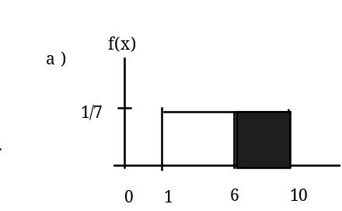 | 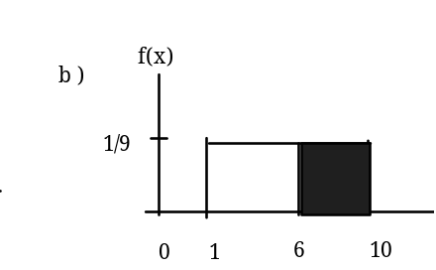
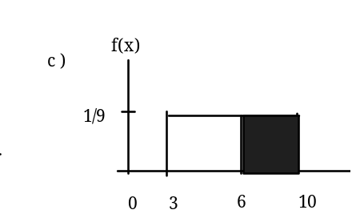 | 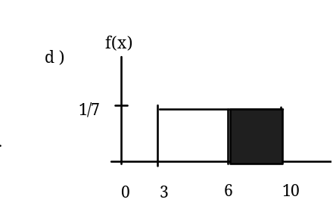

- We should expect a fourth grader to take how many minutes to take out the trash?
  - 4. 5
  - 5. 5
  - 5
  - 10

Questions 19 - 21 refer to the following situation:

At the beginning of the quarter, the amount of time a student waits in line at the campus cafeteria is normally distributed with a mean of 5 minutes and a standard deviation of 2 minutes.

- What is the 90th percentile of waiting times (in minutes)?
  - 1.28
  - 90
  - 8.29
  - 7.56

- The median waiting time (in minutes) for one student is:
  - 5
  - 50
  - 2. 5
  - 2

- A sample of 10 students has an average waiting time of 5. 5 minutes. The 95% confidence interval for the true population mean is:
  - ( 4.46 , 6.04 )
  - ( 4.26 , 6.74 )
  - ( 2.4 , 8.6 )
  - ( 1.58 , 9.42 )

- A sample of 80 software engineers in Silicon Valley is taken and it is found that 20% of them earn approximately $50,000 per year. A point estimate for the true proportion of engineers in Silicon Valley who earn $50,000 per year is:
  - 16
  - 0. 2
  - 1
  - 0. 95

- If P ( Z < z α ) = 0. 1587 where Z ~ N ( 0 , 1 ) , then α is equal to:
  - - 1
  - 0. 1587
  - 0. 8413
  - 1

- A professor tested 35 students to determine their entering skills. At the end of the term, after completing the course, the same test was administered to the same 25 students to study their improvement. This would be a test of:
  - independent groups
  - 2 proportions
  - dependent groups
  - exclusive groups

A math exam was given to all the third grade children attending ABC School. Two random samples of scores were taken.
 | n | x | s
Boys | 55 | 82 | 5
Girls | 60 | 86 | 7

- Which of the following correctly describes the results of a hypothesis test of the claim, “There is a difference between the mean scores obtained by third grade girls and boys at the 5 % level of significance”?
  - Do not reject Ho. There is no difference in the mean scores.
  - Do not reject Ho. There is a difference in the mean scores.
  - Reject Ho. There is no difference in the mean scores.
  - Reject Ho. There is a difference in the mean scores.

- In a survey of 80 males, 45 had played an organized sport growing up. Of the 70 females surveyed, 25 had played an organized sport growing up. We are interested in whether the proportion for males is higher than the proportion for females. The correct conclusion is:
  - The proportion for males is the same as the proportion for females.
  - The proportion for males is not the same as the proportion for females.
  - The proportion for males is higher than the proportion for females.
  - Not enough information to determine.

- From past experience, a statistics teacher has found that the average score on a midterm is 81 with a standard deviation of 5.2. This term, a class of 49 students had a standard deviation of 5 on the midterm. Do the data indicate that we should reject the teacher’s claim that the standard deviation is 5.2? Use α = 0.05.
  - Yes
  - No
  - Not enough information given to solve the problem

- Three loading machines are being compared. Machine I took 31 minutes to load packages. Machine II took 28 minutes to load packages. Machine III took 29 minutes to load packages. The expected time for any machine to load packages is 29 minutes. Find the p-value when testing that the loading times are the same.
  - the p–value is close to 0
  - p–value is close to 1
  - Not enough information given to solve the problem

Questions 29 - 31 refer to the following situation:

A corporation has offices in different parts of the country. It has gathered the following information concerning the number of bathrooms and the number of employees at seven sites:

Number of employees x | 650 | 730 | 810 | 900 | 1020 | 1070 | 1150
Number of bathrooms y | 40 | 50 | 54 | 61 | 82 | 110 | 121

- Is there a correlation between the number of employees and the number of bathrooms significant?
  - Yes
  - No
  - Not enough information to answer question

- The linear regression equation is
  - = 0.0094 – 79.96 x
  - = – 79.96 + 0.0094 x
  - = 79.96 – 0.0094 x
  - = – 0.0094 + 79.96 x

- If a site has 1150 employees, approximately how many bathrooms should it have?
  - 69
  - 121
  - 101
  - 86

Suppose that a sample of size 10 was collected, with = 4.4 and s = 1.4 .
- Which graph represents the p-value when testing:
Ho : σ 2 = 1.6 vs. Ha : σ 2 ≠ 1.6
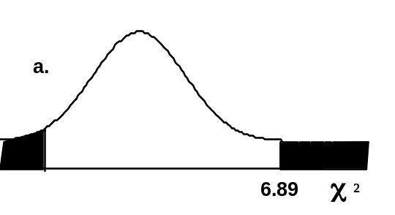 | 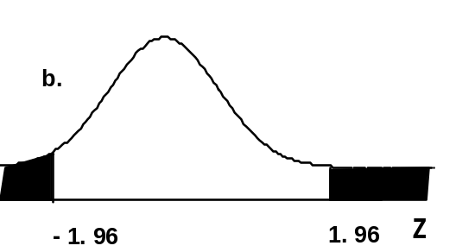
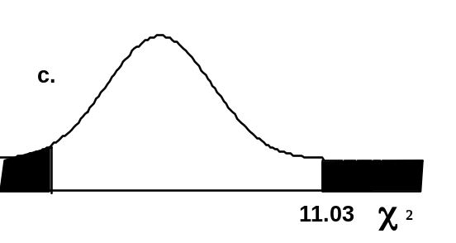 | 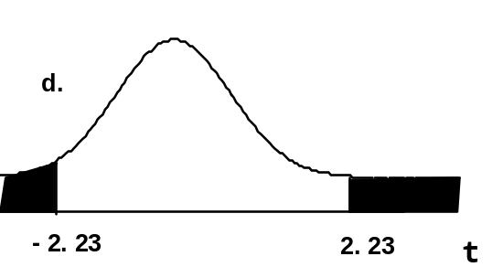

64 backpackers were asked the number of days their latest backpacking trip was. The number of days is given in the table below:

# of days | 1 | 2 | 3 | 4 | 5 | 6 | 7 | 8
Frequency | 5 | 9 | 6 | 12 | 7 | 10 | 5 | 10

- Conduct an appropriate test to determine if the distribution is uniform.
  - The p–value is > 0.10 , the distribution is uniform.
  - The p–value is < 0.01 , the distribution is uniform.
  - The p–value is between 0.01 and 0.10, but without α there is not enough information
  - There is no such test that can be conducted.

- Which of the following assumptions is made when using one-way ANOVA?
  - The populations from which the samples are selected have different distributions.
  - The sample sizes are large.
  - The test is to determine if the different groups have the same averages.
  - There is a correlation between the factors of the experiment.

