Survival analysis of events attributed to PJI in patients that undergone TJA surgeries

REPORT: analise_dados_LT_2021-v01

**From:** Felipe Figueiredo **To:** Lucio Toledo

**Date:**  2021-04-11

Table of Contents

Table of Contents 1

1 Abbreviations 2

2 Introduction 3

2.1 Objectives 3

2.2 Data reception and cleaning 3

3 Methods 3

3.1 Variables 3

3.1.1 Outcome and time definition 3

3.1.2 Covariates 4

3.2 Statistical analyses 4

3.2.1 Statistical packages 4

4 Results 4

4.1 Study population and follow up 4

4.2 Mortality 4

4.3 2-year survival rates 8

5 Exceptions and Observations 9

6 Conclusions 9

7 References 9

8 Appendix 9

8.1 Exploratory data analysis 9

8.2 Alternative results table 17

8.3 Analytical data-set 17

**Document version**

|  |  |
| --- | --- |
| Version | Alterations |
| 01 | Initial version |

# Abbreviations

* PJI:
* SD: standard deviation
* SIRS: systemic inflammatory response
* TJA:

# Introduction

## Objectives

Perform a Kaplan-Meier survival analysis on the deaths caused by PJI after a TJA surgical procedure. Additionally, explore possible risk factor for PJI mortality in bi-variate analyses.

## Data reception and cleaning

**Analytical data-set**

1. ID
2. Age; continuous
3. Sex; binary
4. time (date PJI diagnosis – date last follow up)
5. event (death due to PJI)
6. death (all causes)
7. Joint; binary
8. SIRS; binary
9. Multi-germ infection; binary
10. Complication; binary
11. Surgery type; categorical
12. Surgery success; binary

Obs: Complication Type was considered for analysis, but could not be safely converted to a categorical variable. It was dropped.

# Methods

## Variables

### Outcome and time definition

The event of interest for this analysis is death caused by the PJI. For the main analysis patients that died from other causes were censored. The time to event was defined as the number of years between the diagnosis of PJI and the last follow up noted.

There were multiple outcomes to consider regarding the mortality in PJI patients. These causes were categorized as being caused by PJI (event of interest), other causes of death and survival (censored). This multi-state outcome was used to assess the competing risks of death under the PJI risk. The follow up time of all participants was considered in the person-year at risk.

### Covariates

* Sex; binary
* Joint; binary
* Complication; binary
* SIRS; binary
* Multi-germ infection; binary
* Surgery success; binary
* Surgery type; categorical

## Statistical analyses

Demographic characteristics were described with mean (SD) or proportions, where appropriate. Kaplan-Meier curves were computed for the at-risk study population for the event of interest. For all covariates considered the 2-year survival rates were computed for the event of interest. The all-cause mortality was assessed using the competing risks overall figure. Bi-variate analyses were performed using the log-rank test for all covariates considered. All statistical analyses considered the significance level of 5%.

### Statistical packages

This analysis was performed using statistical software R version 4.0.5. Packages used for survival analyses were survival version 3.2.10 and survminer version 0.4.9.

# Results

## Study population and follow up

Of the 54 participants were included, 21 (39%) were male and 33 (61%) were female. Average (SD) age was 64.3 (11.6) years, ranging from 32 to 88 years. Time under observation ranged from 4 days to 16.35 years, where all 54 participants contributed with a total of 239 person-years of follow up.

## Mortality

44 of the 54 patients survived until the last follow up observation. Of the deaths recorded, 5 from other causes and 5 could be attributed to PJI (Fig 1). All deaths attributed to PJI occurred before the deaths unrelated. Figure 2 shows the Kaplan-Meier estimate of the mortality rate attributed to PJI. Times of death ranged from 4 days to 2.13 years. The survival rate at the end of study follow up was 89.7% so the median time of survival could not be estimated. The 1-year survival rate was estimated as 96% (91% – 100%) and the 2-year survival rate was estimated as 92% (85% – 100%).

Times of deaths unrelated to PJI ranged from 2.37 years to 13.17 years (Fig 1). It is noticeable that, while this analysis does not give proof that there is a significant difference between times of death between all causes, this sample seem to indicate that most patients die from PJI within 2 years of the diagnosis (Fig 2).

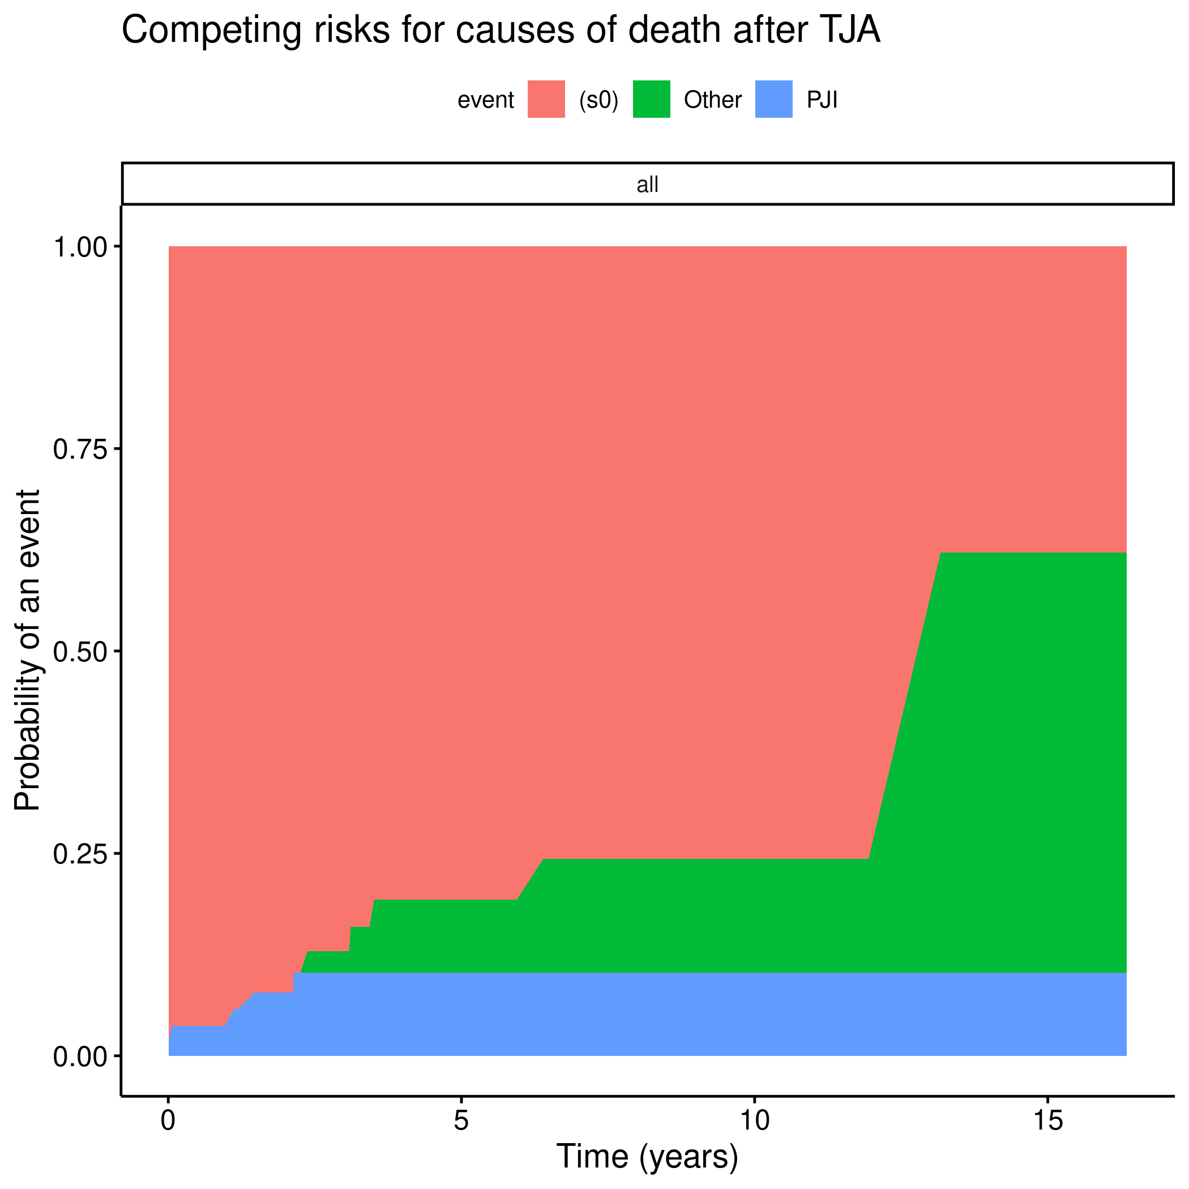 **Figure 1** Mortality due to all causes.

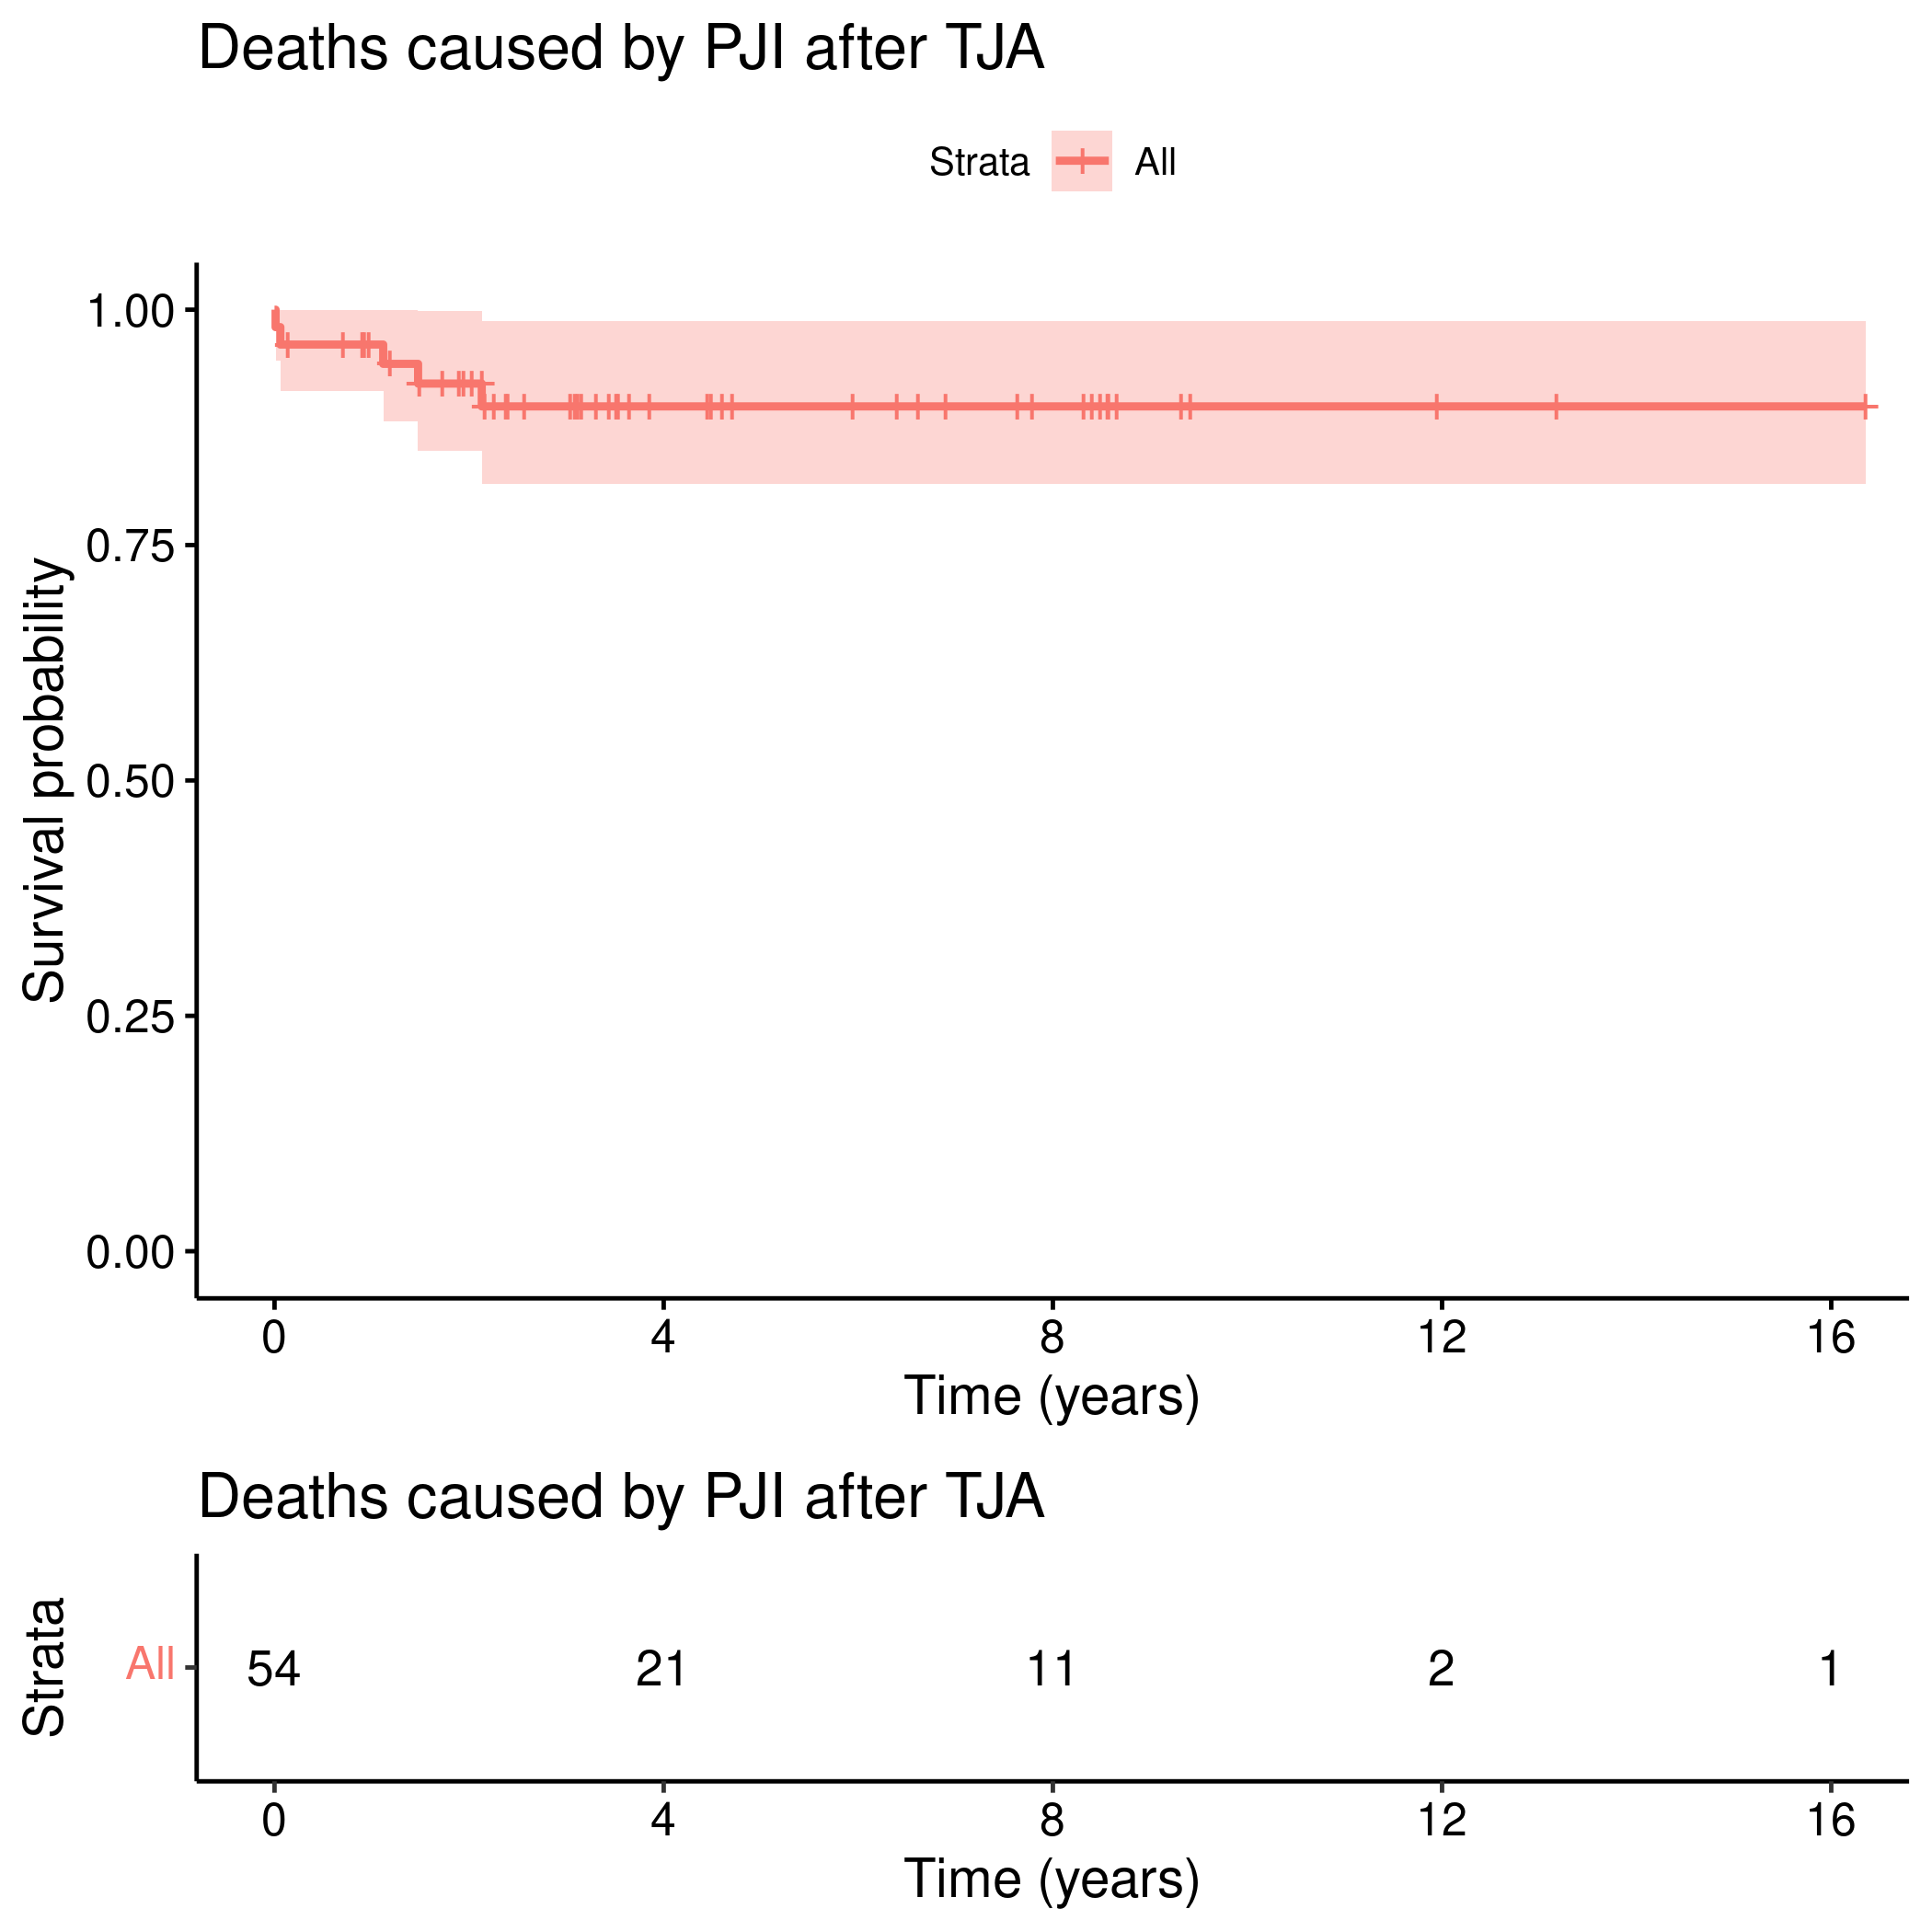 **Figure 2** Mortality confirmed to be caused by PJI.

## 2-year survival rates

Table 1 shows the 2-year survival rates across all covariates considered. In this sample surgical complications decreased the survival (log-rank p=0.038), and most events were related to the procedure of Spacer, where the median time of survival was 3.14 weeks (log-rank p=0.002).

**Table 1** Survival rates for 2-year.

|  |  |  |
| --- | --- | --- |
| Characteristic | 2-year survival | p |
| Overall | 92% (85%, 100%) |  |
| Sex |  | 0.275 |
| F | 93% (85%, 100%) |  |
| M | 90% (79%, 100%) |  |
| Joint |  | 0.703 |
| Hip | 92% (83%, 100%) |  |
| Knee | 92% (82%, 100%) |  |
| Complication |  | 0.038 |
| N | 100% (100%, 100%) |  |
| Y | 82% (68%, 100%) |  |
| SIRS |  | 0.056 |
| N | 97% (92%, 100%) |  |
| Y | 77% (57%, 100%) |  |
| Multigerm |  | 0.938 |
| N | 92% (84%, 100%) |  |
| Y | 92% (77%, 100%) |  |
| surg.success |  | 0.060 |
| Failure | 84% (67%, 100%) |  |
| Success | 100% (100%, 100%) |  |
| surg.type |  | 0.002 |
| Amputation | — (—, —) |  |
| Arthrodesis | 100% (100%, 100%) |  |
| Exarticulation | 100% (100%, 100%) |  |
| Girdlestone | 67% (30%, 100%) |  |
| Spacer | 50% (19%, 100%) |  |
| TJA | 97% (93%, 100%) |  |

Although a significant difference in the status of surgery success was not detected it could be possible that there is a true association between these predictos. This variable had 18 missing values in the sample that were dropped from the analysis. Oh the other hand the effect of a surgical complication is strong enough to be detected even in the presence of 13 missing values in the sample.

# Exceptions and Observations

# Conclusions

# References

# Appendix

## Exploratory data analysis

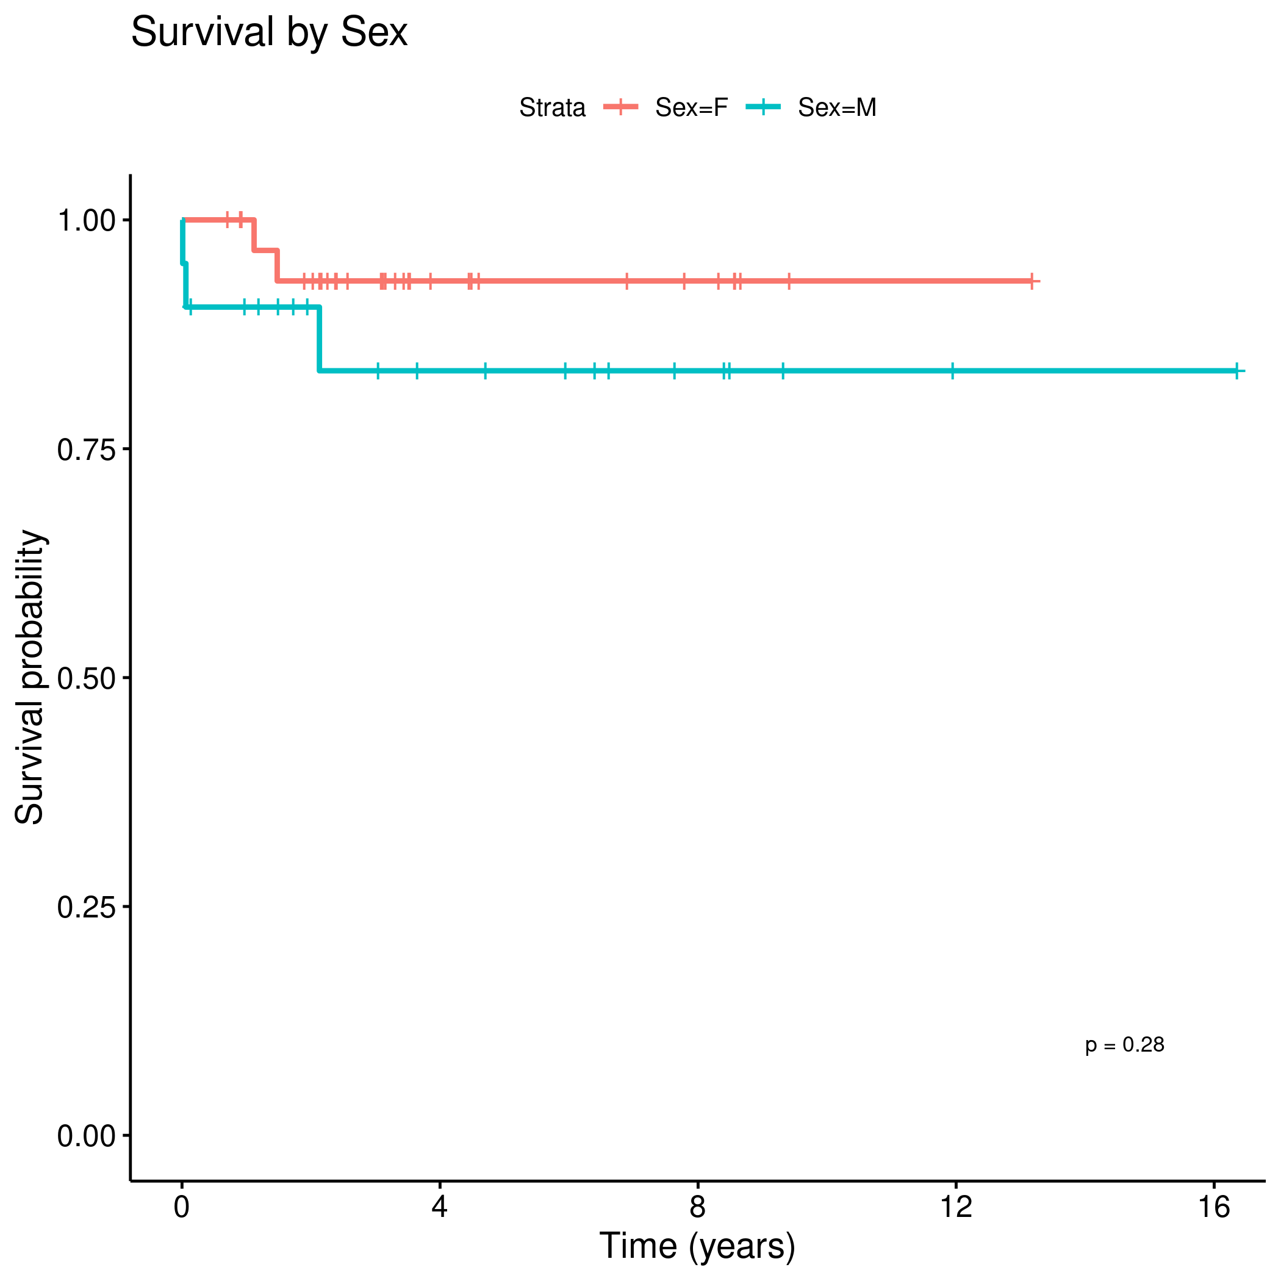 **Figure 3** Mortality by Sex.

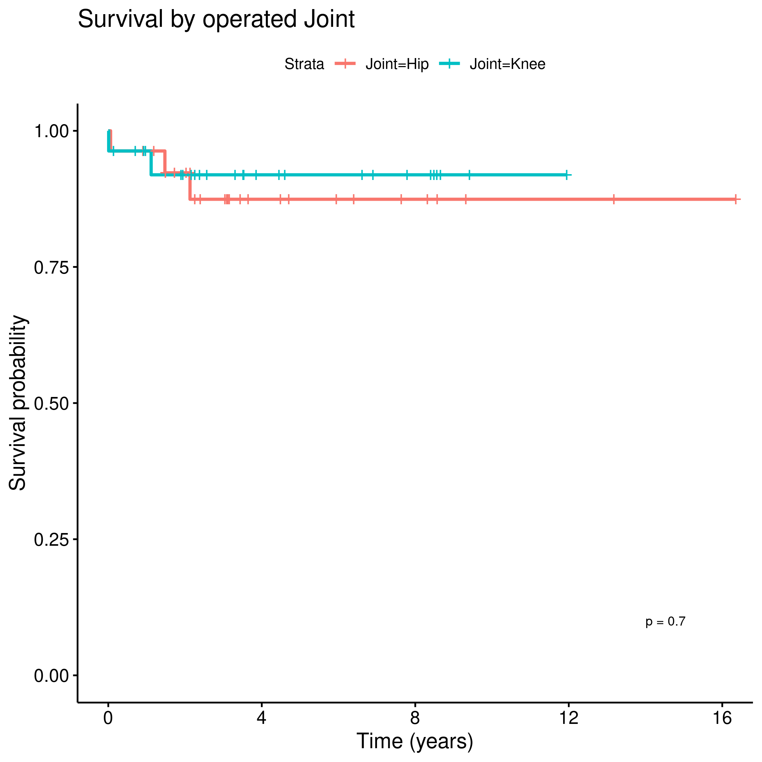 **Figure 4** Mortality by joint.

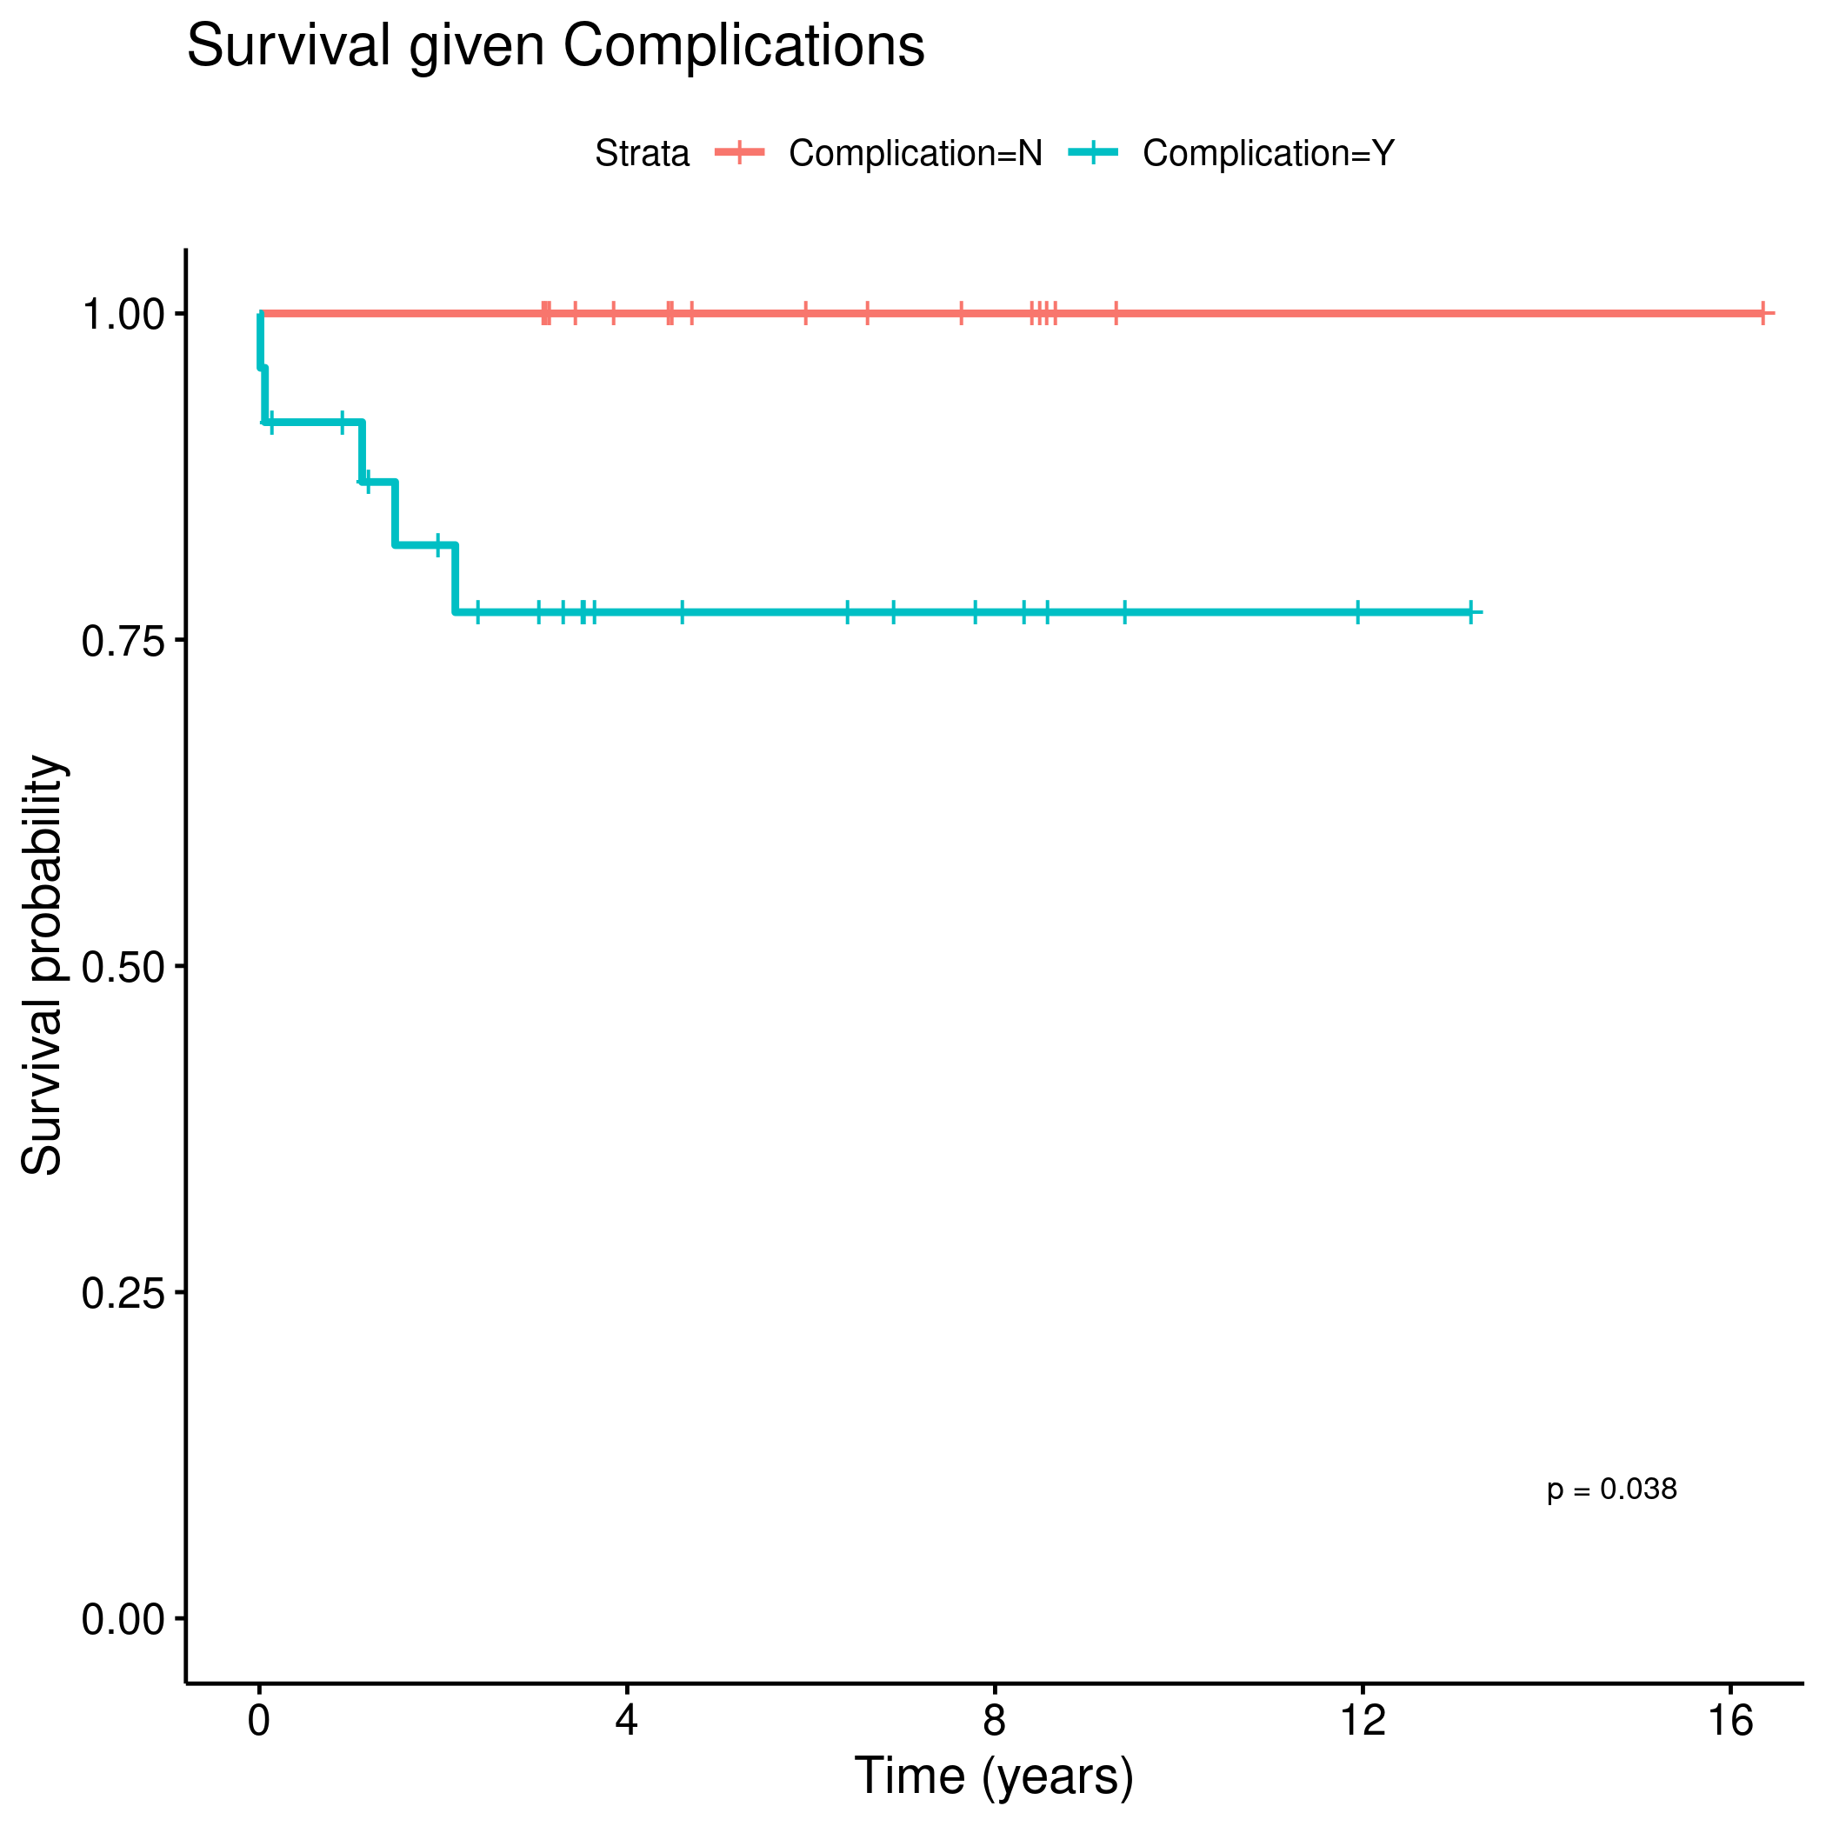 **Figure 5** Mortality under presence of surgical complication.

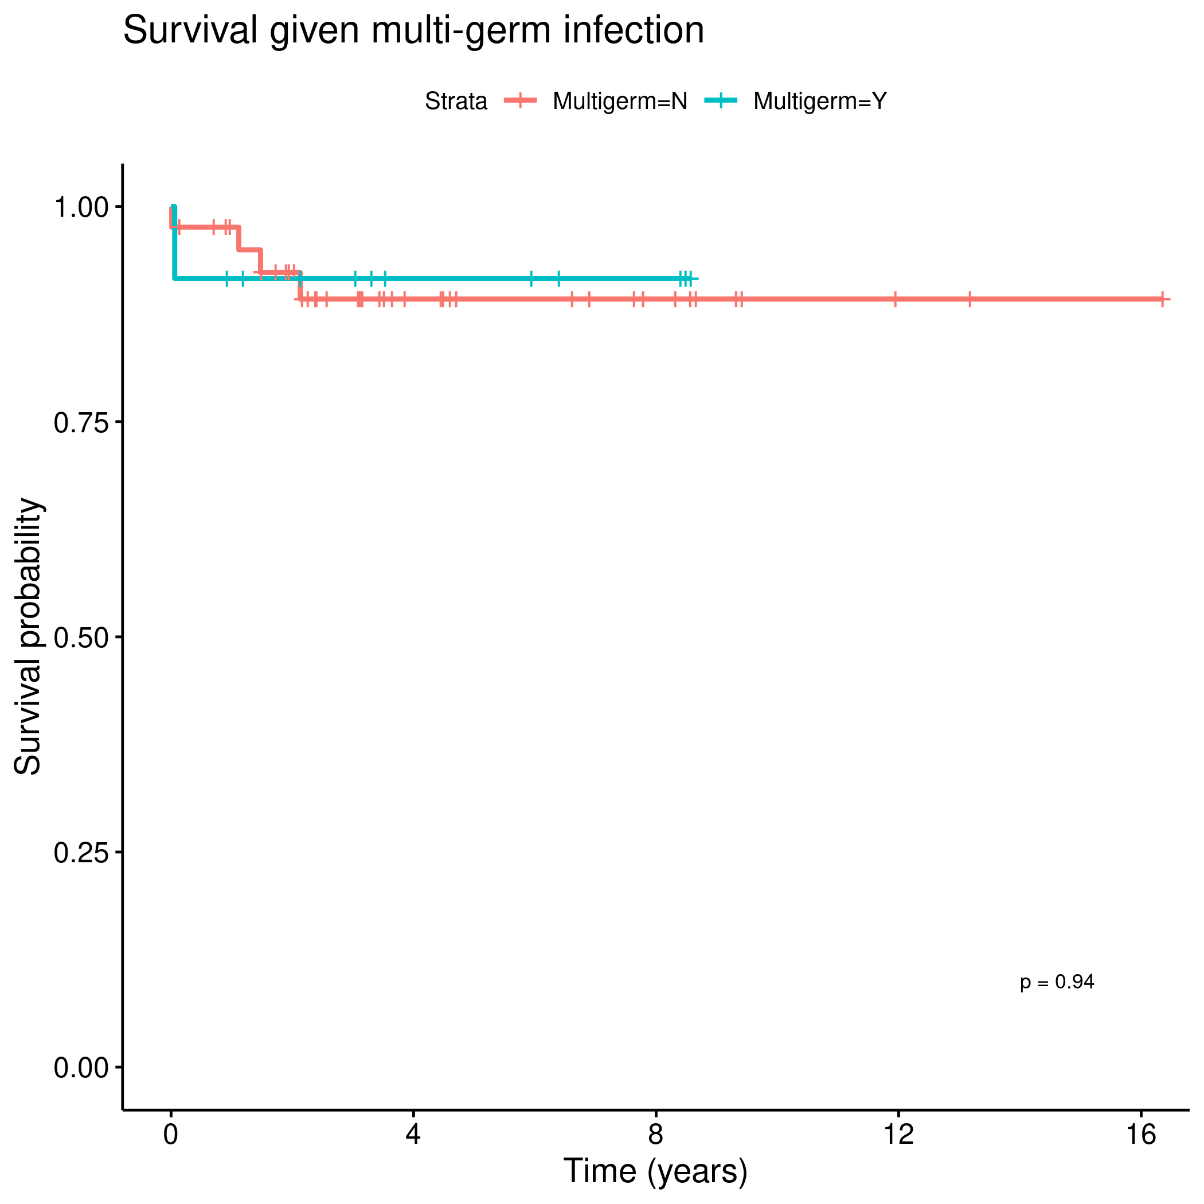 **Figure 6** Mortality by Multi-germ.

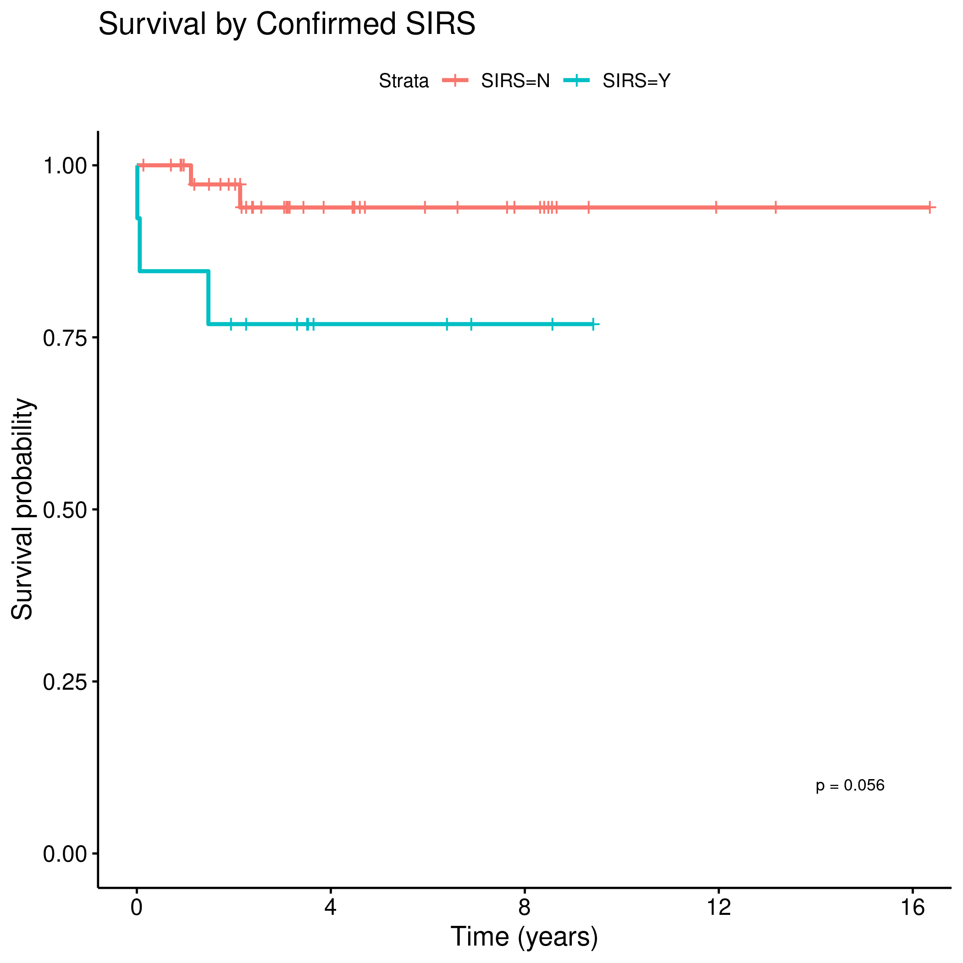 **Figure 7** Mortality by SIRS.

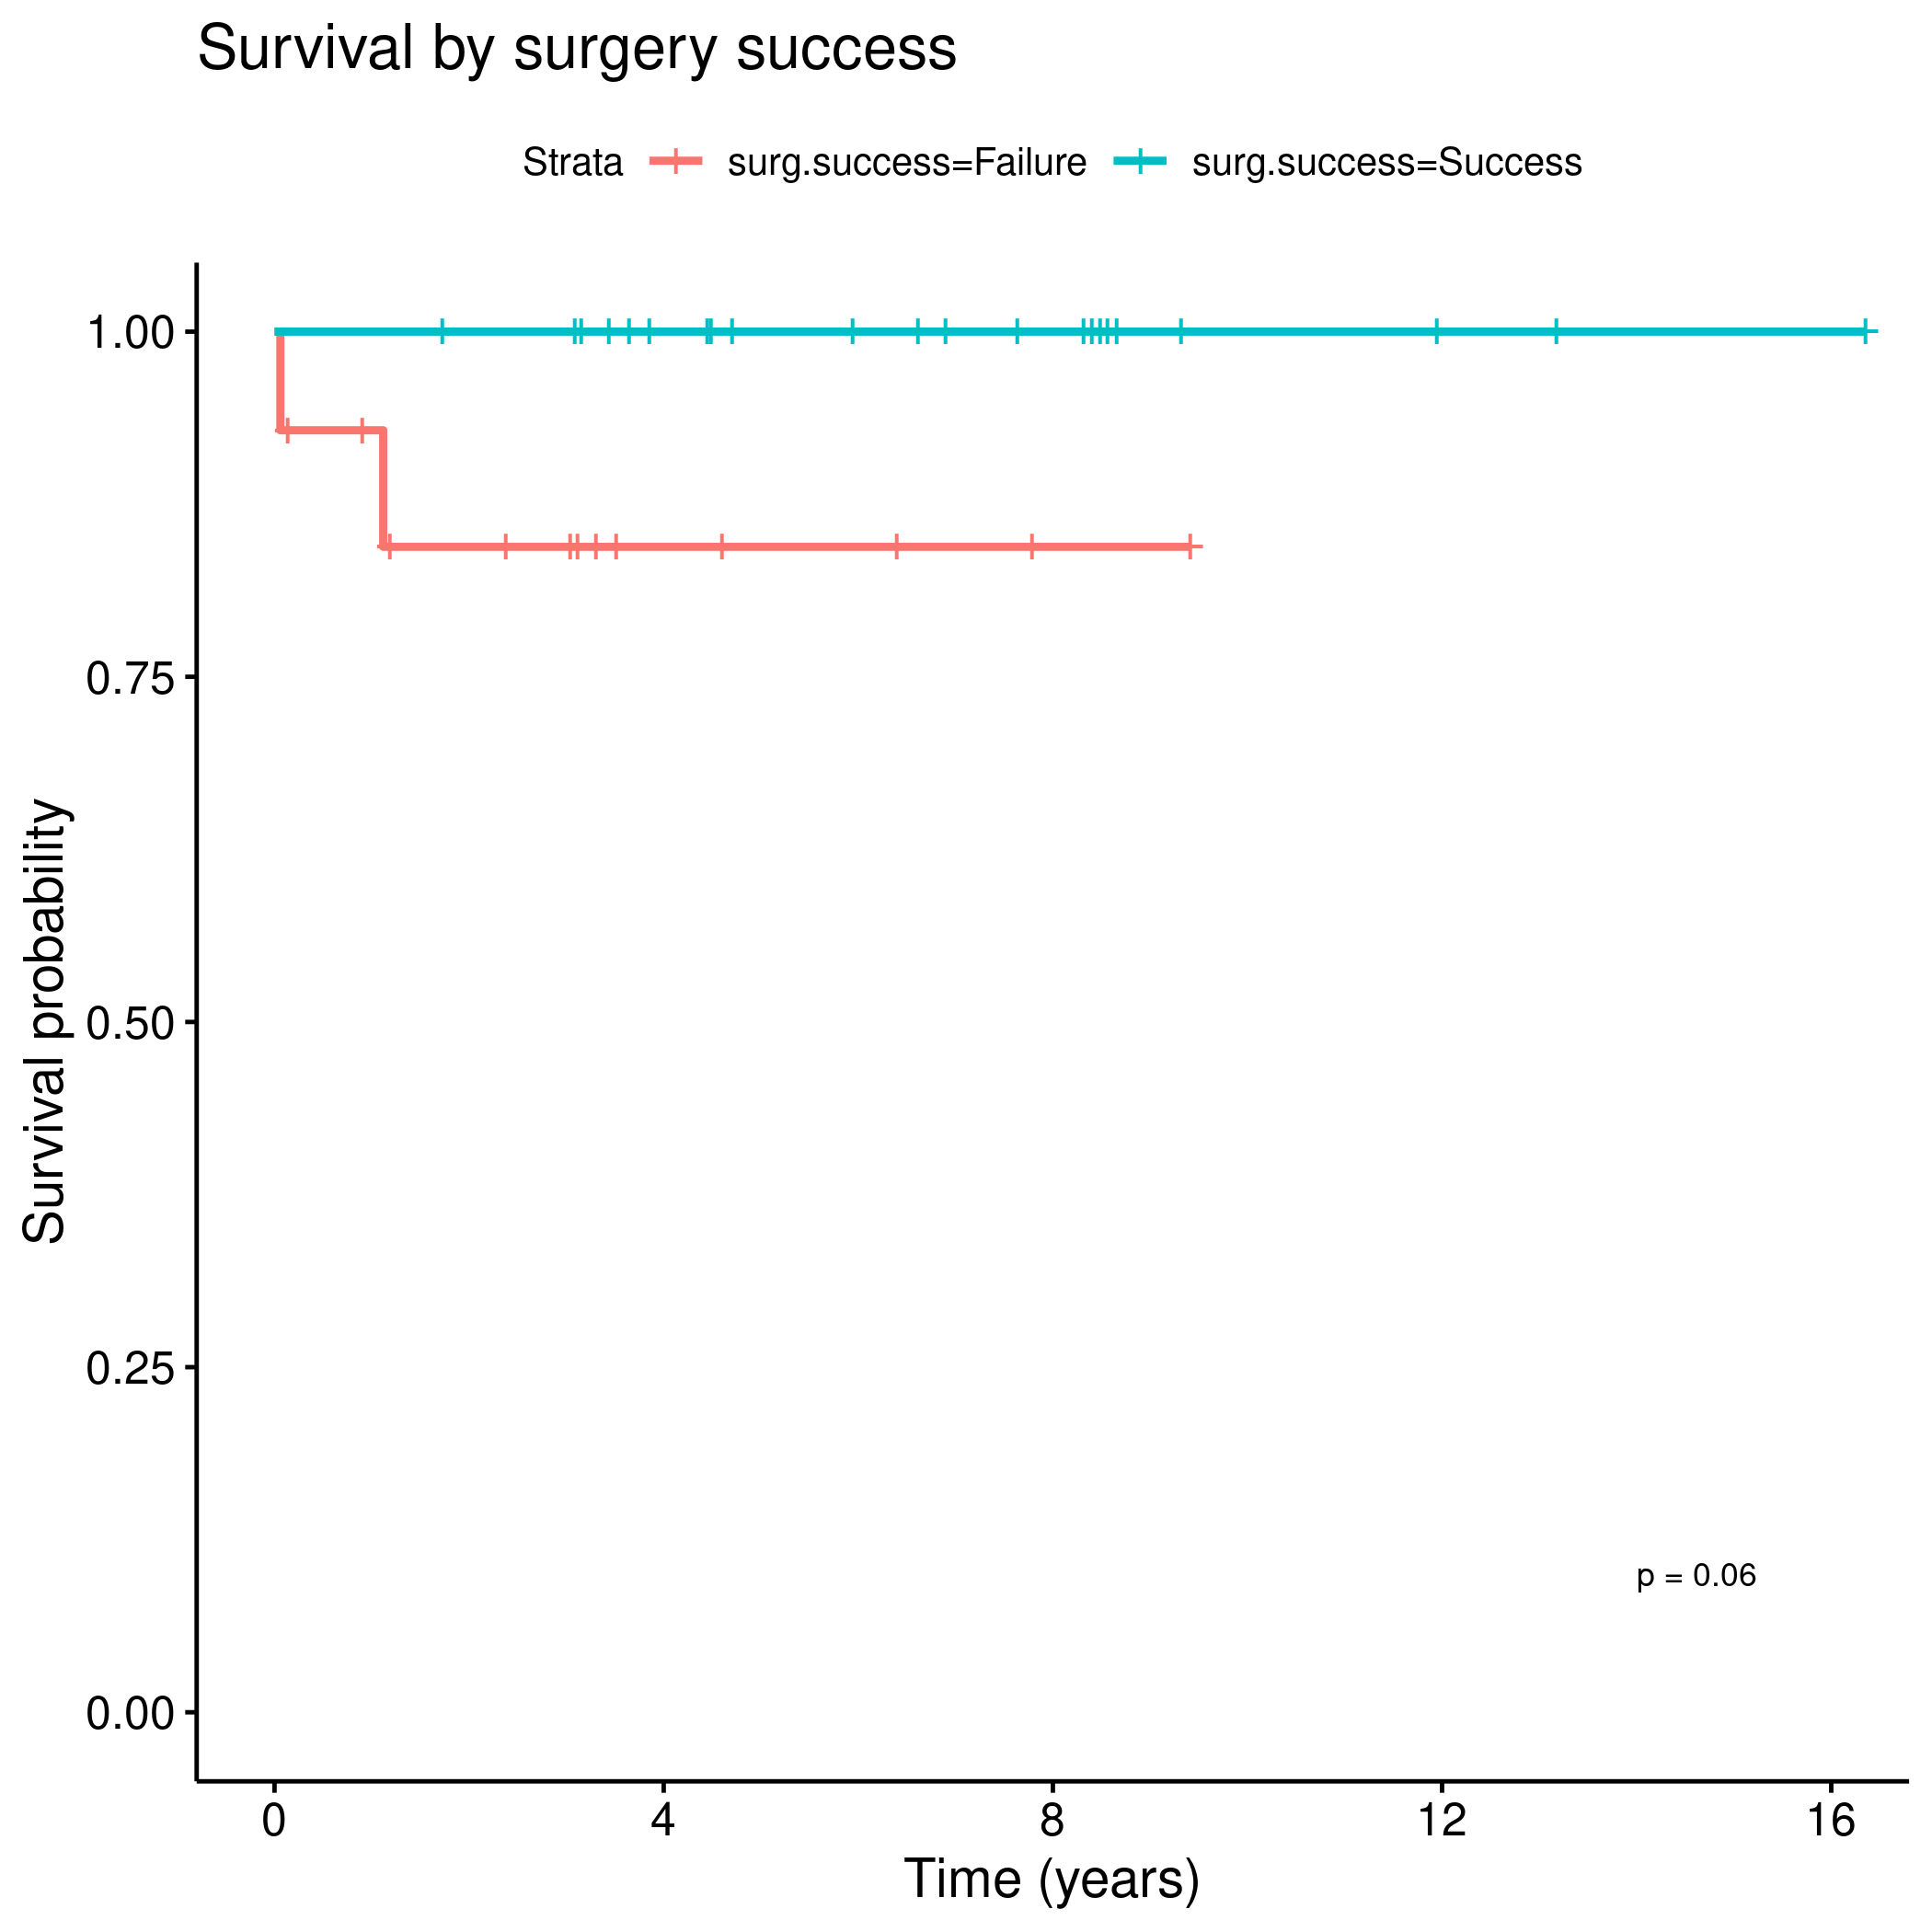 **Figure 8** mortality by status of the TJA.

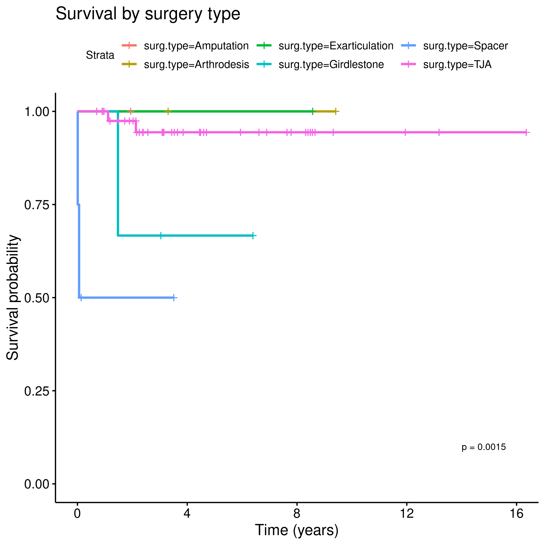 **Figure 9** Mortality by surgery outcome.

## Alternative results table

**Table 2** Optional version of Table 1, adding 1-year survival rates.

|  |  |  |  |
| --- | --- | --- | --- |
| Characteristic | 1-year survival | 2-year survival | p |
| Overall | 96% (91%, 100%) | 92% (85%, 100%) |  |
| Sex |  |  | 0.275 |
| F | 100% (100%, 100%) | 93% (85%, 100%) |  |
| M | 90% (79%, 100%) | 90% (79%, 100%) |  |
| Joint |  |  | 0.703 |
| Hip | 96% (89%, 100%) | 92% (83%, 100%) |  |
| Knee | 96% (89%, 100%) | 92% (82%, 100%) |  |
| Complication |  |  | 0.038 |
| N | 100% (100%, 100%) | 100% (100%, 100%) |  |
| Y | 92% (81%, 100%) | 82% (68%, 100%) |  |
| SIRS |  |  | 0.056 |
| N | 100% (100%, 100%) | 97% (92%, 100%) |  |
| Y | 85% (67%, 100%) | 77% (57%, 100%) |  |
| Multigerm |  |  | 0.938 |
| N | 98% (93%, 100%) | 92% (84%, 100%) |  |
| Y | 92% (77%, 100%) | 92% (77%, 100%) |  |
| surg.success |  |  | 0.060 |
| Failure | 93% (80%, 100%) | 84% (67%, 100%) |  |
| Success | 100% (100%, 100%) | 100% (100%, 100%) |  |
| surg.type |  |  | 0.002 |
| Amputation | 100% (100%, 100%) | — (—, —) |  |
| Arthrodesis | 100% (100%, 100%) | 100% (100%, 100%) |  |
| Exarticulation | 100% (100%, 100%) | 100% (100%, 100%) |  |
| Girdlestone | 100% (100%, 100%) | 67% (30%, 100%) |  |
| Spacer | 50% (19%, 100%) | 50% (19%, 100%) |  |
| TJA | 100% (100%, 100%) | 97% (93%, 100%) |  |

## Analytical data-set

Due to confidentiality the data-set used in this analysis cannot be shared online in the public version of this report.