Association between leadership commitment and telework satisfaction at NASA (2020): unweighted sex-adjusted stratified analysis

DOCUMENT: SAR-2022-010-GJ-v01

**From:** Felipe Figueiredo **To:** techsavvy32 (fiverr.com)

2022-02-19

Table of Contents

**Association between leadership commitment and telework satisfaction at NASA (2020): unweighted sex-adjusted stratified analysis**

**Document version**

|  |  |
| --- | --- |
| **Version** | **Alterations** |
| 01 | Initial version |

# Abbreviations

# Context

## Objectives

## Data reception and cleaning

# Methods

## Variables

### Primary and secondary outcomes

### Covariates

## Statistical analyses

This analysis was performed using statistical software R version 4.1.2.

# Results

## Study population and follow up

The raw database contained 10588 surveys, of which 1183 incomplete cases were removed. Of the complete cases 1920 participants did not agree nor disagree with at least one of the survey questions. These did not meet the inclusion criteria and were also removed from the analysis. After the inclusion and exclusion criteria were applied the final number of surveys in the analysis is 7485. Table 1 shows the characteristics of the surveys included in the final analysis.

**Table 1** Characteristics of the study population.

|  |  |
| --- | --- |
| **Characteristic** | **N = 7,485** |
| **Sex, n (%)** |  |
| Male | 4,764 (64%) |
| Female | 2,721 (36%) |
| **How satisfied are you with the Telework program in your agency?, n (%)** |  |
| Strongly disagree | 22 (0.3%) |
| Disagree | 87 (1.2%) |
| Agree | 1,911 (26%) |
| Strongly Agree | 5,465 (73%) |
| **Managers promote communication among different work units., n (%)** |  |
| Strongly disagree | 129 (1.7%) |
| Disagree | 328 (4.4%) |
| Agree | 3,709 (50%) |
| Strongly Agree | 3,319 (44%) |

One third of the employees at NASA are women (36.4%, Table 1). Both survey questions addressed in this study showed most NASA employees demonstrated high levels of satisfaction when the survey was conducted. The proportion of employees that agree or strongly agree with the satisfaction question (q58 – How satisfied are you with the Telework program in your agency?) was 98.5%. The proportion of employees that agree or strongly agree with leadership commitment (q29 – Managers promote communication among different work units (for example, about projects, goals, needed resources)) was 93.9%. Figure 1 shows how both sexes answered these questions.

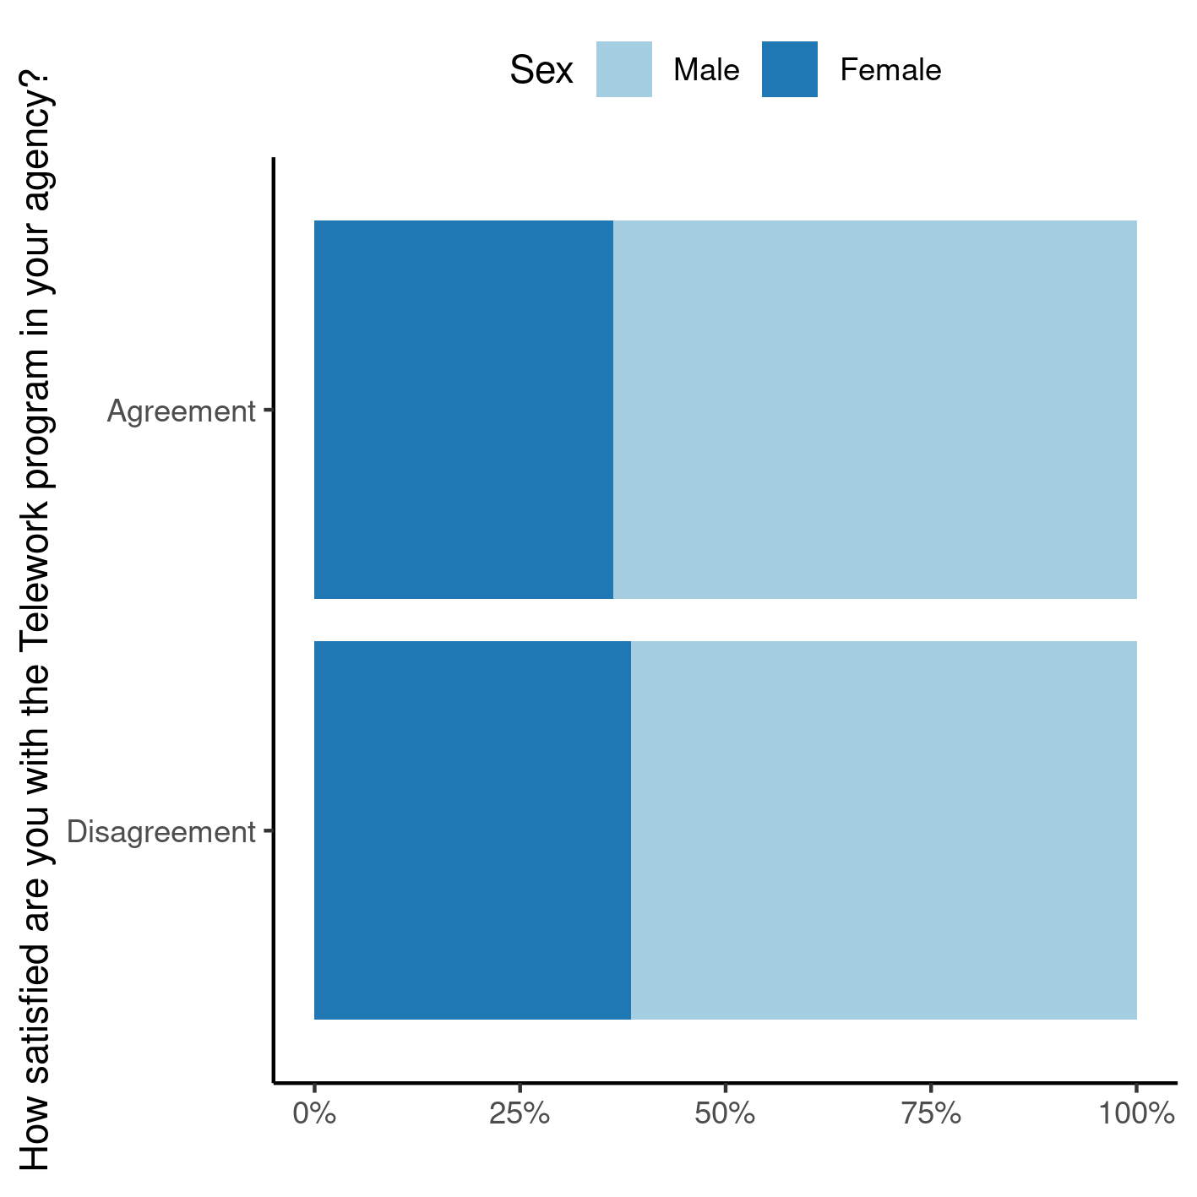

**Figure 1** Dichotomized survey responses, by sex.

Men and women tended to answer the satisfaction question at the same rates in 2020. Of the 7376 NASA employees that are in agreement with the satisfaction question, 36.3% were women, and of the 109 employees that are in disagreement, women were 38.5% (Figure 1).

## Association between leadership commitment and telework satisfaction

**Table 2** caption

|  |  |  |  |
| --- | --- | --- | --- |
|  | **How satisfied are you with the Telework program in your agency?** | |  |
|  | Disagreement | Agreement | **Total** |
| **Managers promote communication among different work units** |  |  |  |
| Overall | | | |
| Disagreement | 34 | 423 | 457 |
| Agreement | 75 | 6,953 | 7,028 |
| **Total** | 109 | 7,376 | 7,485 |
| Males | | | |
| Disagreement | 21 | 248 | 269 |
| Agreement | 46 | 4,449 | 4,495 |
| **Total** | 67 | 4,697 | 4,764 |
| Females | | | |
| Disagreement | 13 | 175 | 188 |
| Agreement | 29 | 2,504 | 2,533 |
| **Total** | 42 | 2,679 | 2,721 |

Odds ratios + chi-square:

* Overall: OR: 7.47, 95% CI: [4.86, 11.24], p<0.001
* Adjusted CMH: OR: 7.41, 95% CI: [4.88, 11.25], p<0.001
* Men: OR: 8.21, 95% CI: [4.73, 13.83], p<0.001
* Women: OR: 6.45, 95% CI: [3.17, 12.42], p<0.001

# Observations and Limitations

# Conclusions

One third of NASA employees in this study are women. Both men and women tended to derive satisfaction at the workplace in similar rates in 2020.

# References

* **SAP-2022-010-GJ-v01** – Analytical Plan for Association between leadership commitment and telework satisfaction at NASA (2020): unweighted sex-adjusted stratified analysis

# Appendix

## Exploratory data analysis

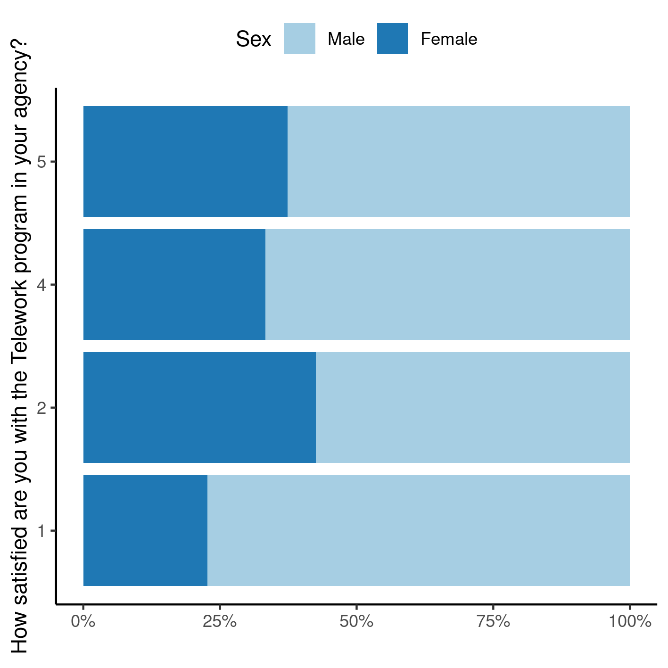

**Figure A1** Raw survey responses, by sex.

## Availability

Both this document and the corresponding analytical plan (**SAP-2022-010-GJ-v01**) can be downloaded in the following address:

<https://philsf-biostat.github.io/SAR-2022-010-GJ/>

## Analytical dataset

Due to confidentiality the data-set used in this analysis cannot be shared online in the public version of this report.

**Table A1** Analytical dataset structure

| id | dsex | dv | iv | dv2 | iv2 |
| --- | --- | --- | --- | --- | --- |
| 1 |  |  |  |  |  |
| 2 |  |  |  |  |  |
| 3 |  |  |  |  |  |
| … |  |  |  |  |  |
| N |  |  |  |  |  |