Time-adjusted effect of socioeconomic status in mortality rates after brain injury: cohort study

DOCUMENT: SAR-2023-016-BH-v01

**From:** Felipe Figueiredo **To:** Brennan Hickson

2023-09-29

Table of Contents

**Table of Contents**

1 Abbreviations 2

2 Context 2

2.1 Objectives 2

3 Methods 2

4 Results 2

4.1 Study population and follow up 2

4.2 Time-adjusted effect of SES on mortality 8

5 Observations and Limitations 12

6 Conclusions 12

7 References 12

8 Appendix 13

8.1 Exploratory data analysis 13

8.2 Modeling strategy 15

8.2.1 Approaches to control for time-dependent covariates 15

8.2.2 After location/SES imputation 23

8.2.3 Final model specification 23

8.3 Availability 27

8.4 Associated analyses 27

8.5 Analytical dataset 28

**Time-adjusted effect of socioeconomic status in mortality rates after brain injury: cohort study**

**Document version**

|  |  |
| --- | --- |
| **Version** | **Alterations** |
| 01 | Initial version |

# Abbreviations

* FIM: Functional Independence Measure
* HR: hazards ratio
* SD: standard deviation
* SES: socioeconomic status

# Context

This analysis expands on a previous analysis with a similar objective (**SAR-2023-004-BH-v02**), by employing more flexible modeling strategies to include time-dependent covariates that were dropped from the previous analysis. In the process the raw FIM scores were substituted by their quartiles.

## Objectives

To determine the effect of socioeconomic status of the neighborhood on mortality of patients with brain injury, accounting for time-dependent covariates.

# Methods

The data procedures, design and analysis methods used in this report are fully described in the annex document **SAP-2023-016-BH-v01**.

This analysis was performed using statistical software R version 4.3.0.

# Results

## Study population and follow up

There initially were 76,665 observations on 19,303 study participants considered for inclusion. After excluding follow up measurements during the COVID-19 pandemic to mitigate confounding on mortality causes there were 69,440 observations left in the study sample. After applying the inclusion criteria for the study period between 2010-01-01 and 2018-12-31 and considering the status at the last available follow up time for each individual a total of 24,282 participants were included in the analysis.

The epidemiological profile of the participant included in the study was a male participant (5,838 (73%)) with an average (SD) age of 45 (20) years.

Races were not homogeneously available in the study population with 5,256 (66%) individuals being white; 3,458 (43%) were single (never married) at the time of injury, and most participants were well educated with 3,574 (45%) at greater than high school level. A total of 4,711 (59%) were employed and 3,753 (48%) participants lived in an urban area.

**Table 1** Epidemiological, demographic and clinical characteristics of study participants.

| **Characteristic** | **N = 7,979** |
| --- | --- |
| **SES quintiles, n (%)** |  |
| Prosperous | 1,428 (22%) |
| Comfortable | 1,339 (20%) |
| Mid-Tier | 1,237 (19%) |
| At-Risk | 1,296 (20%) |
| Distressed | 1,291 (20%) |
| Missing | 1,388 |
| **Sex:, n (%)** |  |
| Male | 5,838 (73%) |
| Female | 2,134 (27%) |
| Missing | 7 |
| **What is your race?, n (%)** |  |
| White | 5,256 (66%) |
| Black | 1,241 (16%) |
| Hispanic | 1,072 (13%) |
| Other | 398 (5.0%) |
| Missing | 12 |
| **What is your marital status?, n (%)** |  |
| Single (Never Married) | 3,458 (43%) |
| Married | 2,748 (35%) |
| Divorced | 986 (12%) |
| Separated | 264 (3.3%) |
| Widowed | 485 (6.1%) |
| Other | 17 (0.2%) |
| Missing | 21 |
| **Age at Injury, Mean (SD)** | 45 (20) |
| Missing | 21 |
| **Substance Problem Use, n (%)** | 2,919 (38%) |
| Missing | 297 |
| **Education, n (%)** |  |
| Greater Than High School | 3,574 (45%) |
| Less Than High School | 1,522 (19%) |
| High School/GED | 2,819 (36%) |
| Missing | 64 |
| **At time of injury, what was your employment status?, n (%)** |  |
| Employed | 4,711 (59%) |
| Unemployed | 871 (11%) |
| Other | 2,355 (30%) |
| Missing | 42 |
| **Urbanization based on zip code of address at discharge., n (%)** |  |
| Suburban | 2,336 (30%) |
| Rural | 1,742 (22%) |
| Urban | 3,753 (48%) |
| Missing | 148 |
| **Prior to this injury, has a physician ever told you that you have a seizure disorder?, n (%)** | 59 (5.7%) |
| Missing | 6,935 |
| **Spinal cord injury:, n (%)** | 456 (5.7%) |
| Missing | 23 |
| **Cause of injury:, n (%)** |  |
| Vehicular | 3,593 (45%) |
| Violence | 709 (8.9%) |
| Falls | 2,715 (34%) |
| Other | 937 (12%) |
| Missing | 25 |
| **Primary rehabilitation payor:, n (%)** |  |
| Private Insurance | 4,109 (52%) |
| Public Insurance | 3,151 (40%) |
| Other | 690 (8.7%) |
| Missing | 29 |
| **Residence after rehab discharge:, n (%)** |  |
| Private Residence | 6,298 (79%) |
| Other | 1,649 (21%) |
| Missing | 32 |
| **Days From Injury to Rehab Discharge, Mean (SD)** | 46 (36) |
| **FIM Motor at Discharge quartiles, n (%)** |  |
| Q1 | 2,101 (27%) |
| Q2 | 2,016 (26%) |
| Q3 | 1,843 (23%) |
| Q4 | 1,897 (24%) |
| Missing | 122 |
| **FIM Cognitive at Discharge quartiles, n (%)** |  |
| Q1 | 2,085 (26%) |
| Q2 | 2,028 (26%) |
| Q3 | 1,948 (25%) |
| Q4 | 1,875 (24%) |
| Missing | 43 |

The observed overall mortality was 13.5% in the study period. The distribution of cases appear homogeneous across SES quintiles (Figure 1), ranging from 10.6% to 13.5%. We will test the effect of SES quintiles on the hazard rate in the next section. See also Figure A2 in the appendix for the distribution of sexes in each SES quintile in the study population.

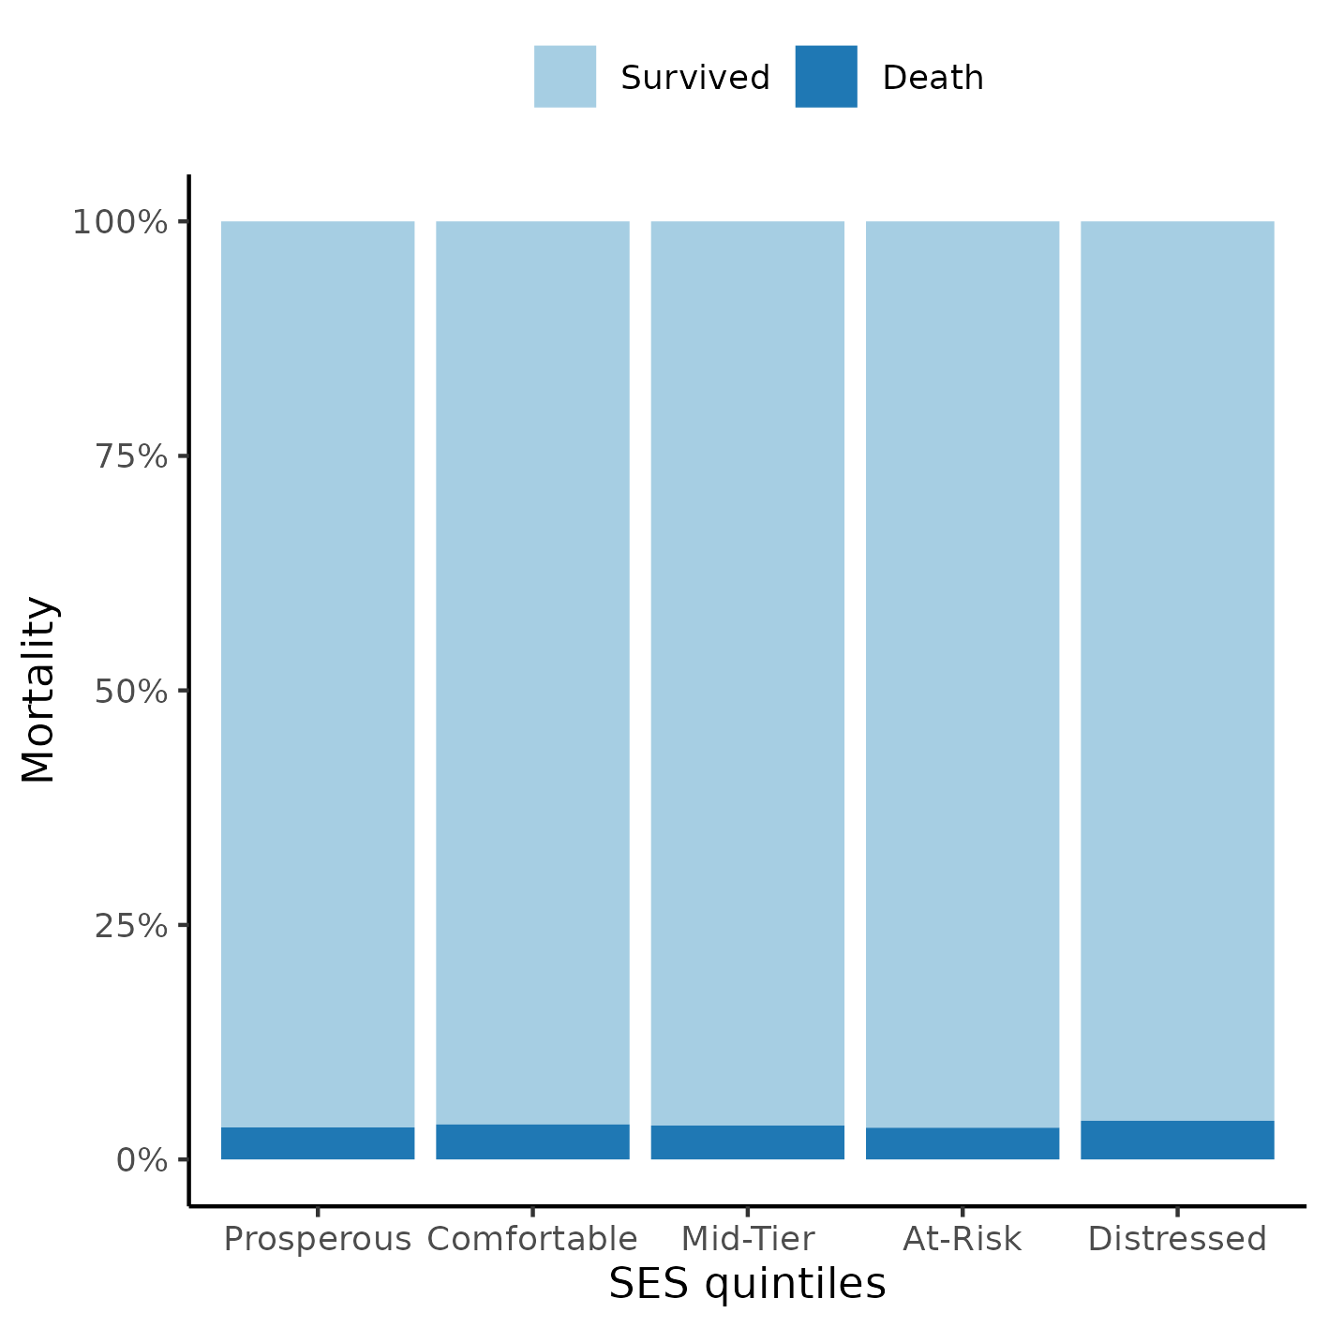

**Figure 1** Proportion of cases per SES quintiles.

## Time-adjusted effect of SES on mortality

The previous seizure disorder diagnosis was missing for most of the study population and was not included in the model as a covariate to preserve study power. After excluding participants with missing data from other variables a total of 19,013 complete cases were available for analysis. The Days From Injury to Rehab Discharge was removed from the model due to violations of the proportional hazards assumption (see section 8.2 in the appendix).

The survival curves of both sexes by SES quintiles can be seen in Figure 2. Overall, the distressed neighborhoods appear to have a lower survival probability then other neighborhoods. This appears to be true for both sexes, and males had a higher risk of dying than females in all neighborhoods. This plot was cropped at 50% survival for presentation purposes, see Figure A3 in the appendix for an uncropped version.

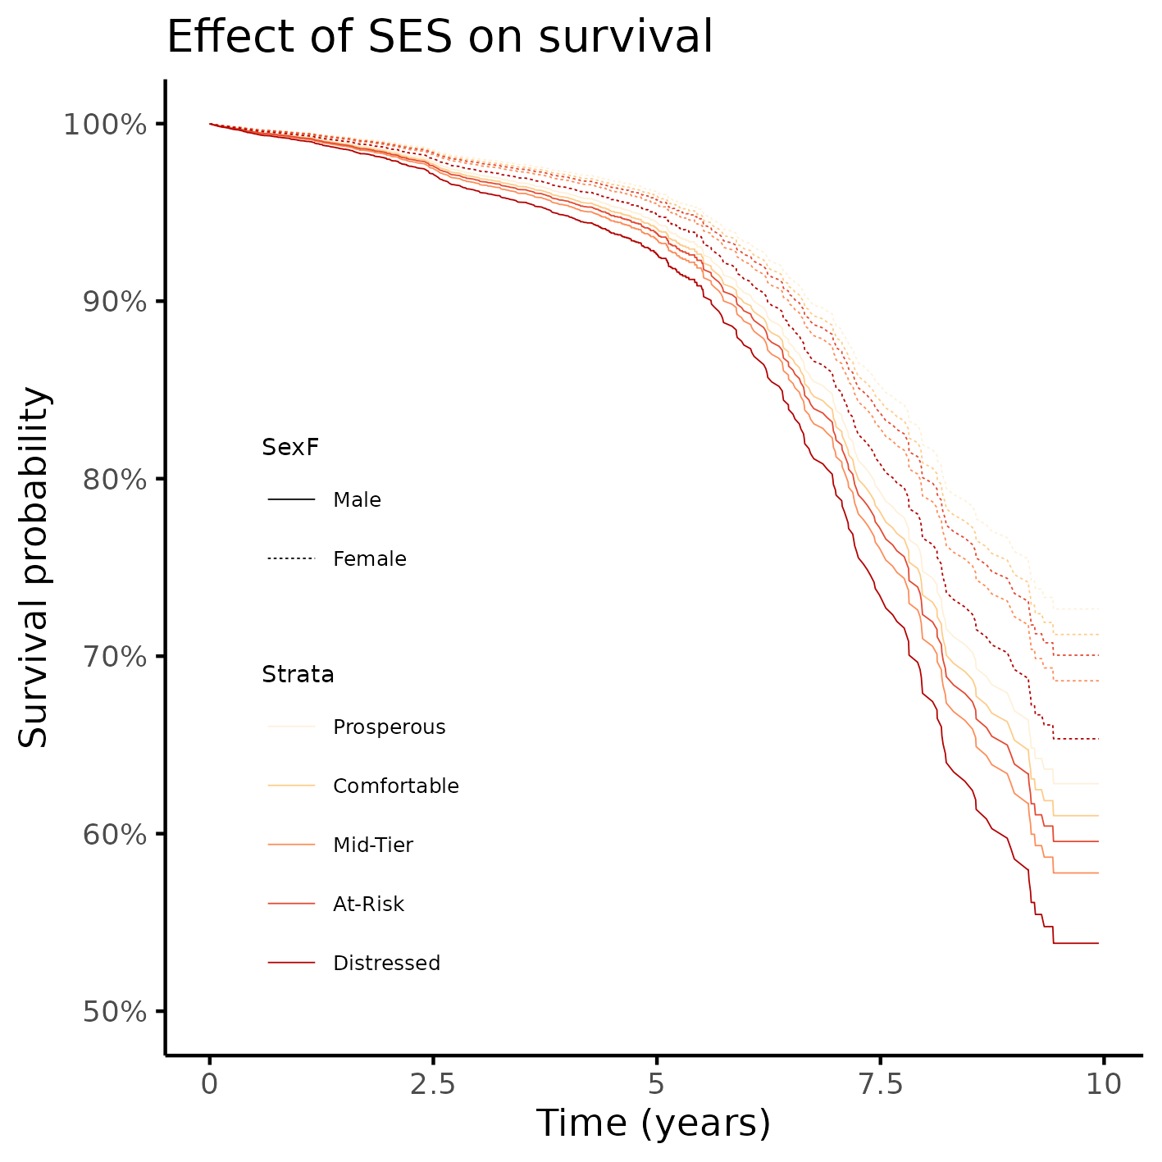

**Figure 2** Survival of participants, by sex and by SES quintiles.

When considering only the crude effect of SES on mortality neighborhood to which the individuals were discharged was associated with mortality (Table 2). ~~Participants who were discharged to an at-risk neighborhood had increased chance of dying (HR = 1.12, 95% CI = 0.89 to 1.42), when compared to those discharged to a prosperous neighborhood.~~ Participants discharged to a distressed neighborhood also had a higher mortality risk (HR = 1.33, 95% CI = 1.33 to 1.33), when compared to those discharged to a prosperous neighborhood.

Notes:

* ~~note drift of point estimates toward the null~~
* note reliability of precision / CIs lengths don’t change much
* possible evidence of confounding of the effect, after controlling for clinical + geo
* multiple: time-varying exposure is associated with the outcome up to model 5
* interaction: association with FIMMOTD, but not FIMCOGD
* interaction: direct association is lost when considering interactions (is it pulling the effect?)

**Table 2** Effect of SES on mortality; HR estimates were adjusted for sex, race, age, education, employment status, rehabilitation payer, spinal cord injury, substance abuse, FIM scores quartiles, residence after rehab discharge, urbanization and stratified by cause of injury.

|  | Crude estimate | Model 2 | Model 3 | Model 4 | Model 5 | Model 6 | | | | | | |
| --- | --- | --- | --- | --- | --- | --- | --- | --- | --- | --- | --- | --- |
| **Characteristic** | **HR**1 | **p-value** | **HR**12 | **p-value** | **HR**13 | **p-value** | **HR**14 | **p-value** | **HR**15 | **p-value** | **HR**16 | **p-value** |
| **SES quintiles** |  |  |  |  |  |  |  |  |  |  |  |  |
| Prosperous | — |  | — |  | — |  | — |  | — |  | — |  |
| Comfortable | 1.13 | 0.291 | 1.08 | 0.521 | 1.07 | 0.578 | 1.07 | 0.566 | 1.06 | 0.623 | 1.11 | 0.661 |
| Mid-Tier | 1.10 | 0.420 | 1.20 | 0.156 | 1.18 | 0.203 | 1.18 | 0.202 | 1.18 | 0.207 | 0.86 | 0.584 |
| At-Risk | 1.12 | 0.337 | 1.18 | 0.177 | 1.15 | 0.254 | 1.15 | 0.279 | 1.11 | 0.400 | 0.86 | 0.561 |
| Distressed | 1.33 | **0.014** | 1.44 | **0.005** | 1.40 | **0.008** | 1.41 | **0.007** | 1.33 | **0.027** | 1.39 | 0.168 |
| **SES quintiles * FIM Motor at Discharge quartiles** |  |  |  |  |  |  |  |  |  |  |  |  |
| Comfortable * Q2 |  |  |  |  |  |  |  |  |  |  | 1.86 | **0.042** |
| Mid-Tier * Q2 |  |  |  |  |  |  |  |  |  |  | 1.18 | 0.636 |
| At-Risk * Q2 |  |  |  |  |  |  |  |  |  |  | 1.31 | 0.383 |
| Distressed * Q2 |  |  |  |  |  |  |  |  |  |  | 1.07 | 0.804 |
| Comfortable * Q3 |  |  |  |  |  |  |  |  |  |  | 1.09 | 0.812 |
| Mid-Tier * Q3 |  |  |  |  |  |  |  |  |  |  | 1.02 | 0.954 |
| At-Risk * Q3 |  |  |  |  |  |  |  |  |  |  | 0.97 | 0.928 |
| Distressed * Q3 |  |  |  |  |  |  |  |  |  |  | 0.96 | 0.921 |
| Comfortable * Q4 |  |  |  |  |  |  |  |  |  |  | 2.05 | 0.131 |
| Mid-Tier * Q4 |  |  |  |  |  |  |  |  |  |  | 2.00 | 0.151 |
| At-Risk * Q4 |  |  |  |  |  |  |  |  |  |  | 2.38 | **0.040** |
| Distressed * Q4 |  |  |  |  |  |  |  |  |  |  | 2.73 | **0.019** |
| **SES quintiles * FIM Cognitive at Discharge quartiles** |  |  |  |  |  |  |  |  |  |  |  |  |
| Comfortable * Q2 |  |  |  |  |  |  |  |  |  |  | 0.57 | 0.085 |
| Mid-Tier * Q2 |  |  |  |  |  |  |  |  |  |  | 1.26 | 0.536 |
| At-Risk * Q2 |  |  |  |  |  |  |  |  |  |  | 0.82 | 0.554 |
| Distressed * Q2 |  |  |  |  |  |  |  |  |  |  | 0.59 | 0.103 |
| Comfortable * Q3 |  |  |  |  |  |  |  |  |  |  | 0.74 | 0.408 |
| Mid-Tier * Q3 |  |  |  |  |  |  |  |  |  |  | 1.77 | 0.147 |
| At-Risk * Q3 |  |  |  |  |  |  |  |  |  |  | 1.48 | 0.263 |
| Distressed * Q3 |  |  |  |  |  |  |  |  |  |  | 0.80 | 0.521 |
| Comfortable * Q4 |  |  |  |  |  |  |  |  |  |  | 0.60 | 0.174 |
| Mid-Tier * Q4 |  |  |  |  |  |  |  |  |  |  | 0.85 | 0.704 |
| At-Risk * Q4 |  |  |  |  |  |  |  |  |  |  | 1.57 | 0.237 |
| Distressed * Q4 |  |  |  |  |  |  |  |  |  |  | 1.10 | 0.801 |
| 1HR = Hazard Ratio | | | | | | | | | | | | |
| 2Adjusted by demographic variables | | | | | | | | | | | | |
| 3Adjusted by demographic + geographical variables | | | | | | | | | | | | |
| 4Adjusted by demographic + geographical + clinical variables | | | | | | | | | | | | |
| 5Adjusted by demographic + geographical + clinical variables + FIM scores | | | | | | | | | | | | |
| 6Adjusted by demographic + geographical + clinical variables + FIM scores + Interactions | | | | | | | | | | | | |

# Observations and Limitations

**Recommended reporting guideline**

The adoption of the EQUATOR network (<http://www.equator-network.org/>) reporting guidelines have seen increasing adoption by scientific journals. All observational studies are recommended to be reported following the STROBE guideline (von Elm et al, 2014).

# Conclusions

The epidemiological profile of the study participant is an 31 years old white male, that has greater than high school level of education, is actively employed and lives in an urban setting.

There appears to be a crude effect of SES on mortality, where participants that were discharged to either a comfortable or a distressed neighborhood had increased risk of death when compared to those discharged to a prosperous neighborhood. After controlling for other variables there is no association between SES and mortality.

# References

* **SAP-2023-016-BH-v03** – Analytical Plan for Time-adjusted effect of socioeconomic status in mortality rates after brain injury: cohort study
* **SAR-2023-004-BH-v02** – Effect of socioeconomic status in mortality rates after brain injury: cohort study
* von Elm E, Altman DG, Egger M, Pocock SJ, Gøtzsche PC, Vandenbroucke JP; STROBE Initiative. The Strengthening the Reporting of Observational Studies in Epidemiology (STROBE) Statement: guidelines for reporting observational studies. Int J Surg. 2014 Dec;12(12):1495-9 (<https://doi.org/10.1016/j.ijsu.2014.07.013>).

# Appendix

## Exploratory data analysis

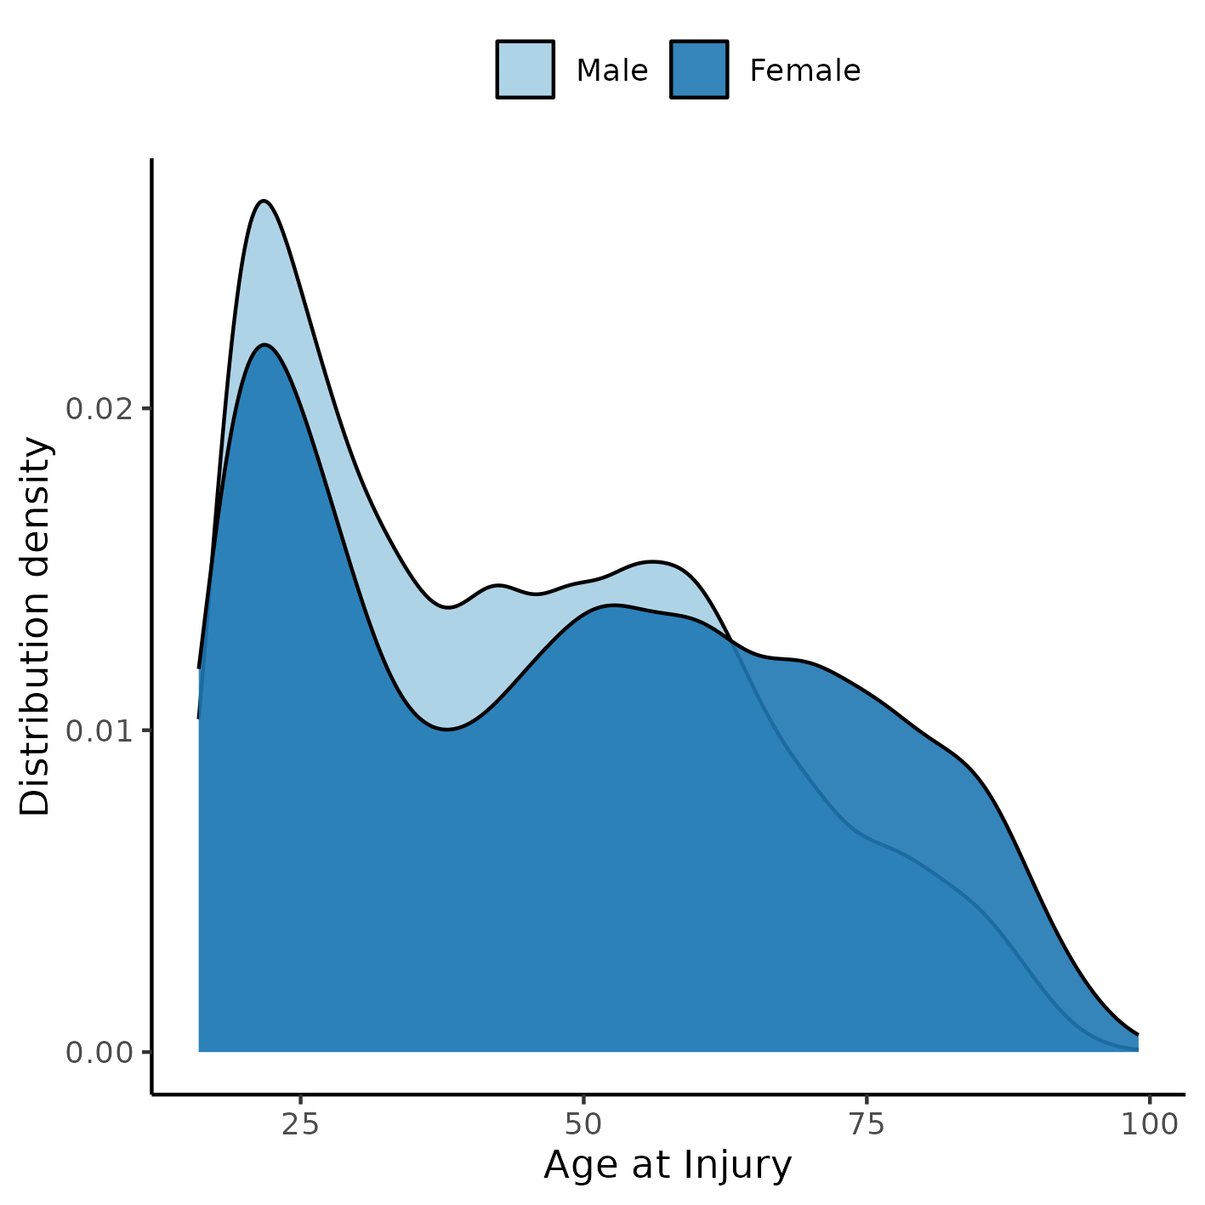

**Figure A1** Distribution of age in the study population.

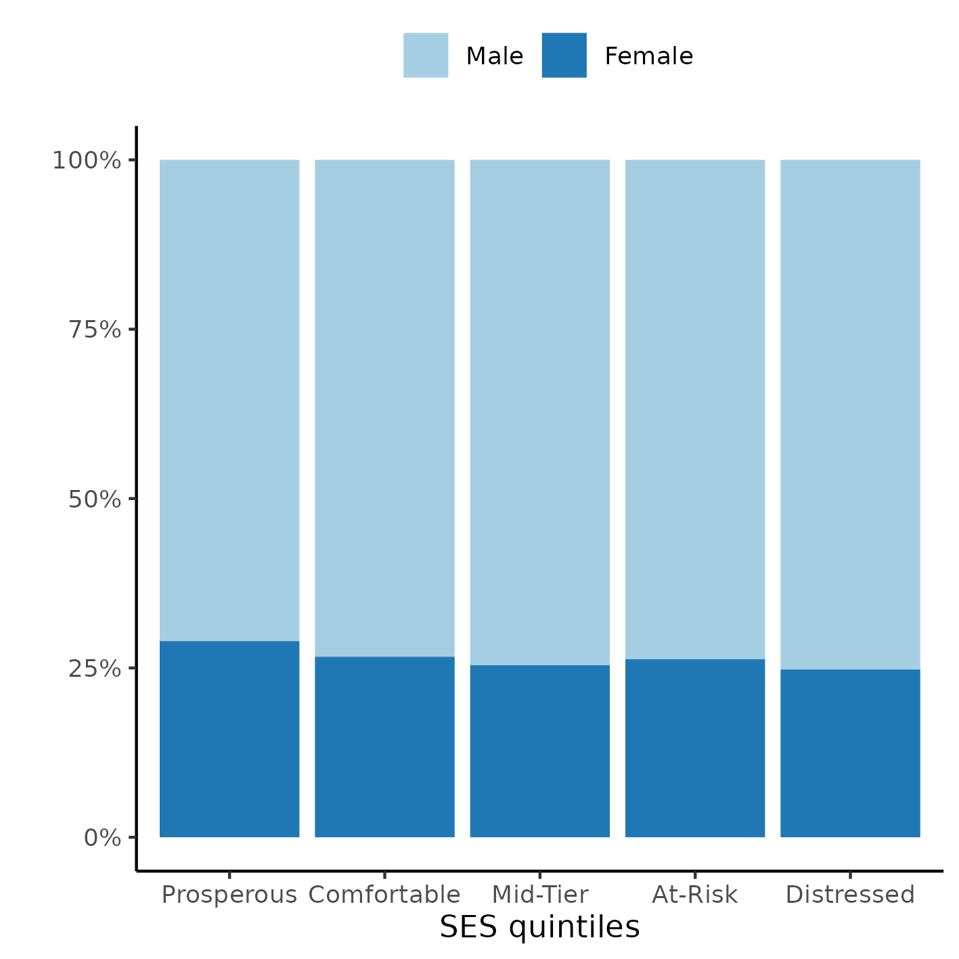

**Figure A2** Distribution of SES in the study population.

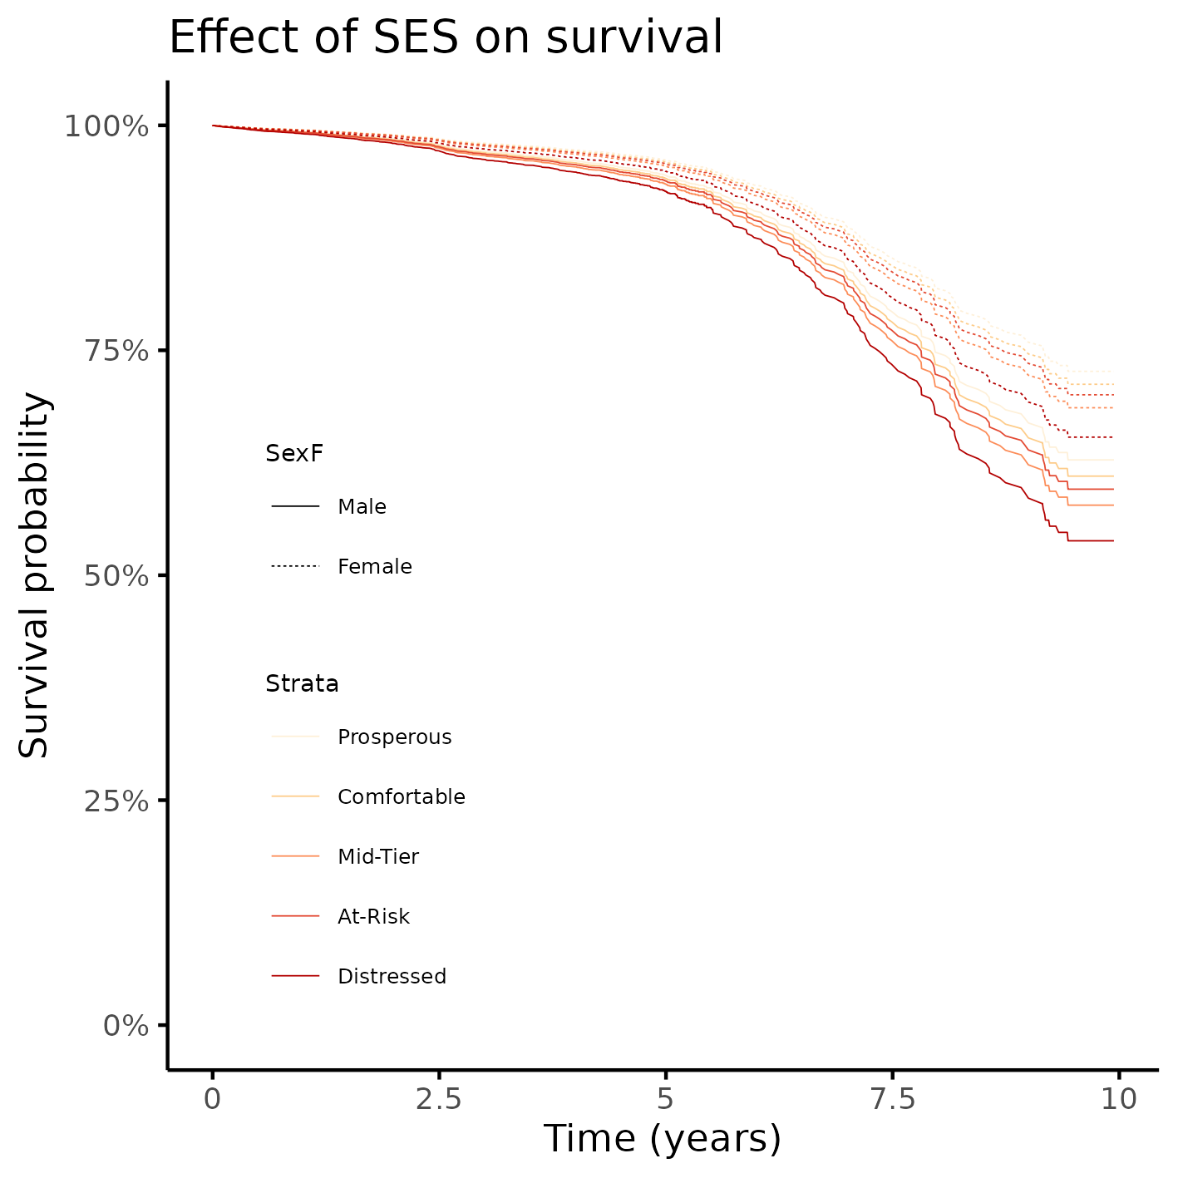

**Figure A3** Alternative version of figure 2.

## Modeling strategy

### Approaches to control for time-dependent covariates

#### Before location/SES imputation

Imputation was done in a separate analysis and is described in the report **SAR-2023-017-v01**.

##### Schoenfeld and Martingale residuals

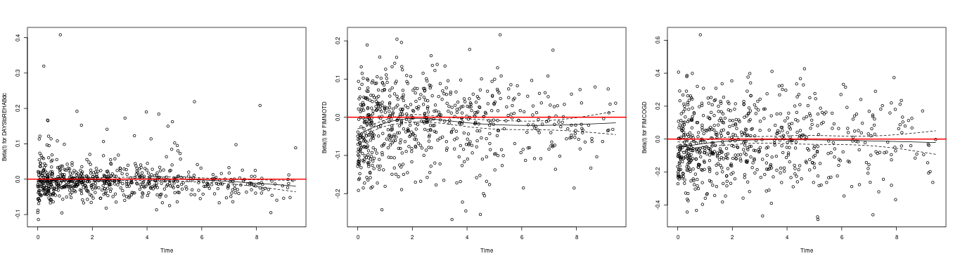

**Figure A4** caption

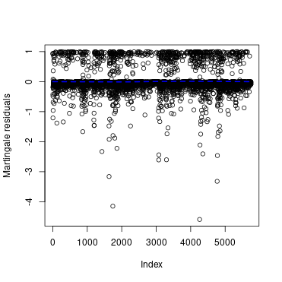

**Figure A5** caption

Notes:

* cause, days, fimmot and fimcog are time-dependent (fail schoenfeld test) (A4)
* a few observations might be outliers, but do not appear to be influential (A5)

##### Martingale residuals of covariates against the null model

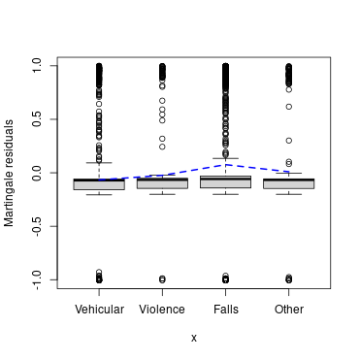

**Figure A6** caption

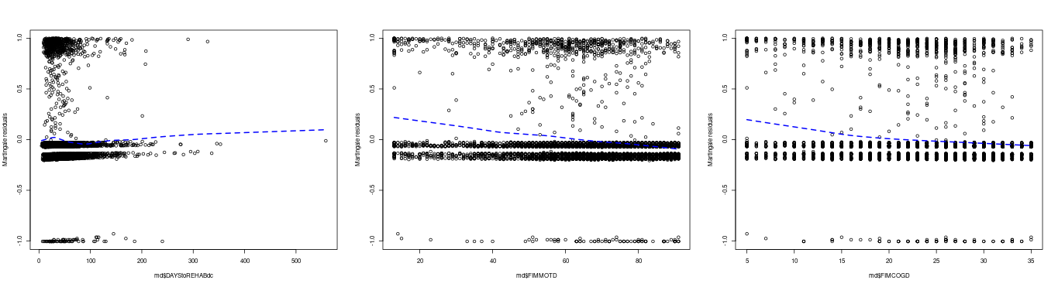

**Figure A7** caption

Notes:

* Cause has an extreme non-PH violation, falls are much higher risk (A6)
* this justifies stratifying by Cause
* individuals with lower days/fimmot/fimcog have higher non-PH risk (A7)
* days is much worse than FIM scores (highly non-linear) (A7)

##### Stratification by cause of injury

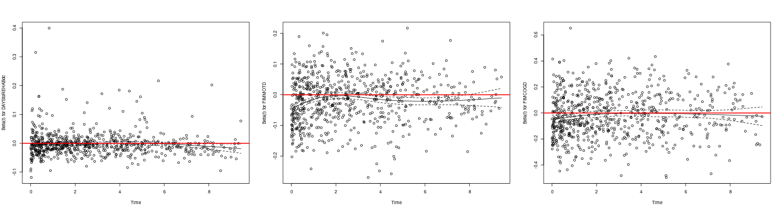

**Figure A8** caption

Notes:

* stratifying by cause helps with non-PH of the 3 vars (A8)

##### Time split

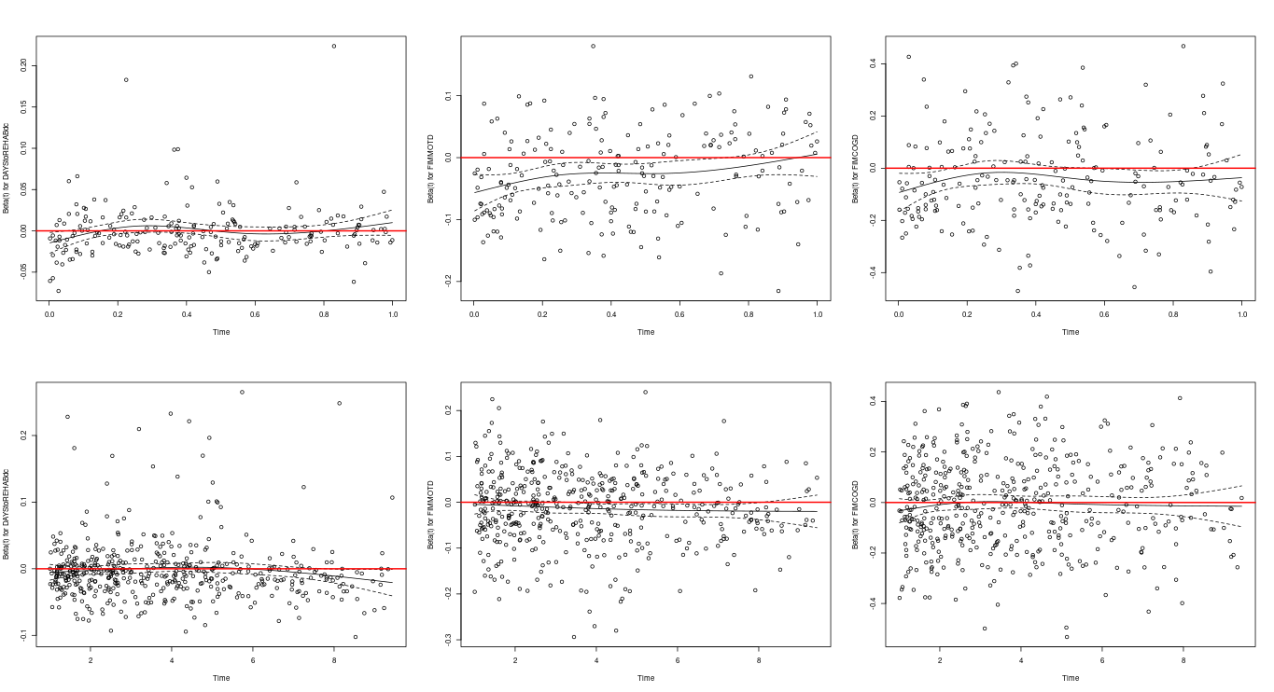

**Figure A9** caption

Notes:

* time split at 1yr doesn’t help further (A9)

##### Non-linear fitting

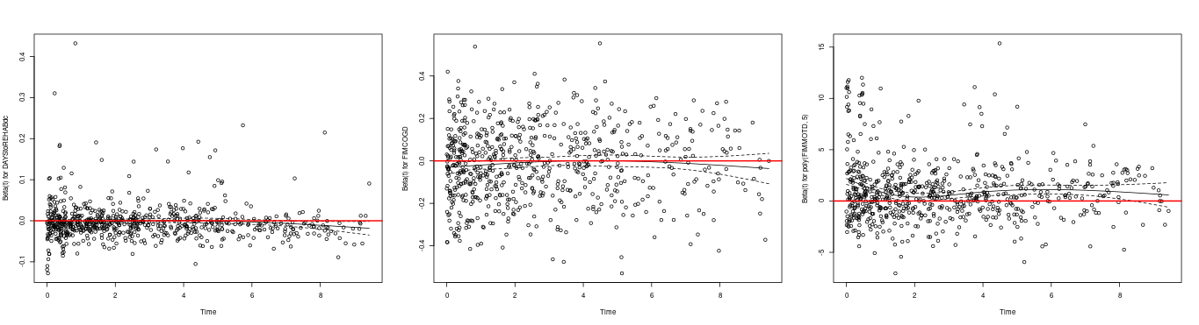

**Figure A10** caption

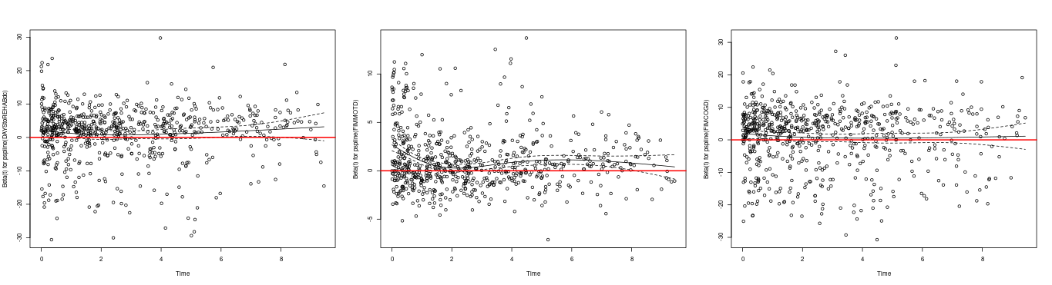

**Figure A11** caption

Notes:

* polynomials (A10) and splines (A11) appear to help stabilize residuals, but not enough

##### Interaction with time

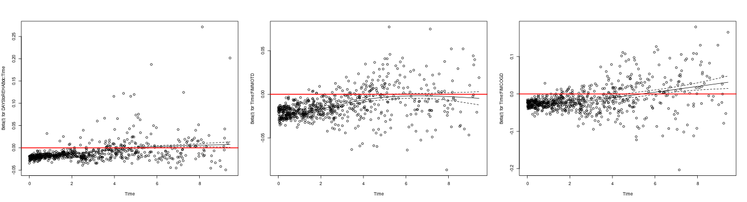

**Figure A12** caption

Notes:

* makes non-PH worse, not helpful at all (A12)

##### FIM scores quartiles

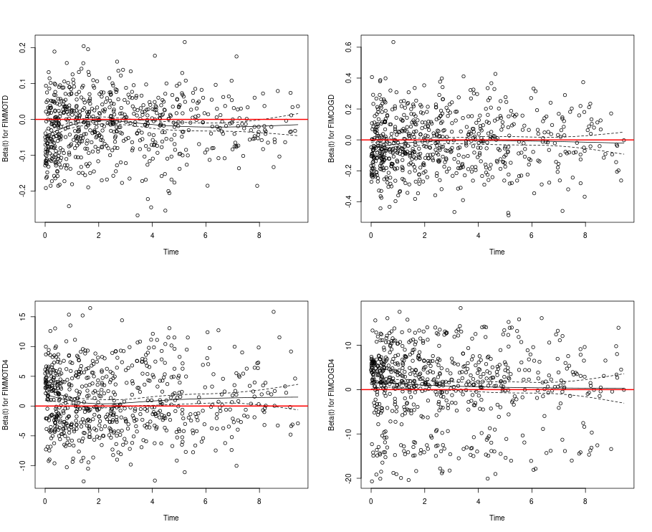

**Figure A13** caption

Notes:

* days still non-PH (A13)
* FIM scores seem PH enough (A13)

#### Best model specification

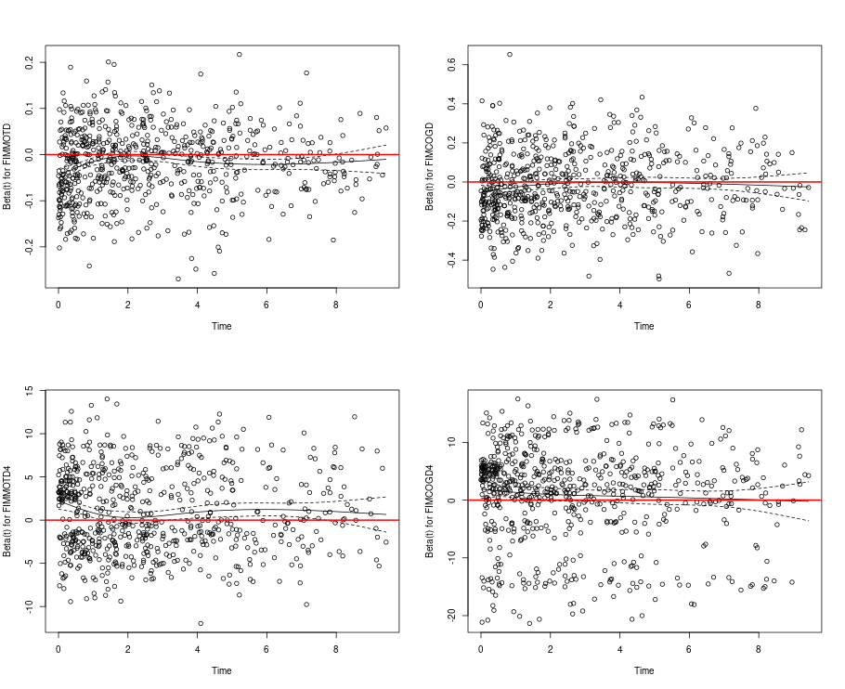

**Figure A14** caption

Notes:

* removing days makes residuals appear PH (A14)
* passes schoenfeld test
* final model: strat by cause + FIM quartiles + drop days

### After location/SES imputation

### Final model specification

**Table A1** Alternative version of Table 2, showing effects from all covariates included in the models.

|  | Crude estimate | Model 2 | Model 3 | Model 4 | Model 5 | Model 6 |
| --- | --- | --- | --- | --- | --- | --- |
| **Characteristic** | **HR** **(SE)**12 | **HR** **(SE)**12 | **HR** **(SE)**12 | **HR** **(SE)**12 | **HR** **(SE)**12 | **HR** **(SE)**12 |
| **SES quintiles** |  |  |  |  |  |  |
| Prosperous | — | — | — | — | — | — |
| Comfortable | 1.13 (0.118) | 1.08 (0.118) | 1.07 (0.119) | 1.07 (0.119) | 1.06 (0.119) | 1.11 (0.210) |
| Mid-Tier | 1.10 (0.121) | 1.20 (0.122) | 1.18 (0.123) | 1.18 (0.124) | 1.18 (0.124) | 0.86 (0.239) |
| At-Risk | 1.12 (0.121) | 1.18 (0.123) | 1.15 (0.124) | 1.15 (0.124) | 1.11 (0.124) | 0.86 (0.236) |
| Distressed | 1.33* (0.115) | 1.44** (0.123) | 1.40** (0.125) | 1.41** (0.125) | 1.33* (0.126) | 1.39 (0.210) |
| **Sex:** |  |  |  |  |  |  |
| Male |  | — | — | — | — | — |
| Female |  | 0.64*** (0.088) | 0.65*** (0.088) | 0.67*** (0.089) | 0.69*** (0.089) | 0.68*** (0.089) |
| **What is your race?** |  |  |  |  |  |  |
| White |  | — | — | — | — | — |
| Black |  | 0.82 (0.118) | 0.81 (0.121) | 0.80 (0.122) | 0.79 (0.122) | 0.77* (0.122) |
| Hispanic |  | 0.70* (0.161) | 0.67* (0.166) | 0.66* (0.166) | 0.65** (0.167) | 0.62** (0.168) |
| Other |  | 0.72 (0.206) | 0.74 (0.207) | 0.73 (0.207) | 0.71 (0.208) | 0.68 (0.210) |
| **Age at Injury** |  | 1.04*** (0.002) | 1.04*** (0.002) | 1.04*** (0.003) | 1.04*** (0.003) | 1.04*** (0.003) |
| **Education** |  |  |  |  |  |  |
| Greater Than High School |  | — | — | — | — | — |
| Less Than High School |  | 1.18 (0.114) | 1.18 (0.114) | 1.16 (0.115) | 1.10 (0.116) | 1.13 (0.117) |
| High School/GED |  | 1.45*** (0.086) | 1.45*** (0.087) | 1.42*** (0.087) | 1.41*** (0.088) | 1.41*** (0.089) |
| **At time of injury, what was your employment status?** |  |  |  |  |  |  |
| Employed |  | — | — | — | — | — |
| Unemployed |  | 2.25*** (0.136) | 2.14*** (0.136) | 1.85*** (0.142) | 1.80*** (0.142) | 1.82*** (0.142) |
| Other |  | 2.17*** (0.100) | 2.13*** (0.100) | 1.98*** (0.105) | 1.82*** (0.106) | 1.79*** (0.106) |
| **Residence after rehab discharge:** |  |  |  |  |  |  |
| Private Residence |  |  | — | — | — | — |
| Other |  |  | 1.68*** (0.083) | 1.64*** (0.085) | 1.42*** (0.087) | 1.41*** (0.089) |
| **Urbanization based on zip code of address at discharge.** |  |  |  |  |  |  |
| Suburban |  |  | — | — | — | — |
| Rural |  |  | 1.02 (0.114) | 1.01 (0.114) | 1.01 (0.114) | 1.00 (0.116) |
| Urban |  |  | 1.15 (0.094) | 1.10 (0.094) | 1.13 (0.094) | 1.15 (0.095) |
| **Primary rehabilitation payor:** |  |  |  |  |  |  |
| Private Insurance |  |  |  | — | — | — |
| Public Insurance |  |  |  | 1.36** (0.095) | 1.32** (0.095) | 1.33** (0.096) |
| Other |  |  |  | 1.16 (0.184) | 1.09 (0.185) | 1.13 (0.186) |
| **Spinal cord injury:** |  |  |  | 1.18 (0.175) | 1.19 (0.176) | 1.17 (0.179) |
| **Substance Problem Use** |  |  |  | 1.22* (0.092) | 1.25* (0.092) | 1.23* (0.093) |
| **Days From Injury to Rehab Discharge** |  |  |  | 1.00 (0.001) | 1.00 (0.002) | 1.00 (0.002) |
| **FIM Motor at Discharge quartiles** |  |  |  |  |  |  |
| Q1 |  |  |  |  | — | — |
| Q2 |  |  |  |  | 0.72** (0.102) | 0.57** (0.212) |
| Q3 |  |  |  |  | 0.69** (0.120) | 0.68 (0.239) |
| Q4 |  |  |  |  | 0.55*** (0.143) | 0.28*** (0.348) |
| **FIM Cognitive at Discharge quartiles** |  |  |  |  |  |  |
| Q1 |  |  |  |  | — | — |
| Q2 |  |  |  |  | 0.87 (0.105) | 1.10 (0.223) |
| Q3 |  |  |  |  | 0.81 (0.111) | 0.76 (0.255) |
| Q4 |  |  |  |  | 0.65** (0.128) | 0.70 (0.256) |
| **SES quintiles * FIM Motor at Discharge quartiles** |  |  |  |  |  |  |
| Comfortable * Q2 |  |  |  |  |  | 1.86* (0.306) |
| Mid-Tier * Q2 |  |  |  |  |  | 1.18 (0.323) |
| At-Risk * Q2 |  |  |  |  |  | 1.31 (0.308) |
| Distressed * Q2 |  |  |  |  |  | 1.07 (0.299) |
| Comfortable * Q3 |  |  |  |  |  | 1.09 (0.357) |
| Mid-Tier * Q3 |  |  |  |  |  | 1.02 (0.358) |
| At-Risk * Q3 |  |  |  |  |  | 0.97 (0.357) |
| Distressed * Q3 |  |  |  |  |  | 0.96 (0.335) |
| Comfortable * Q4 |  |  |  |  |  | 2.05 (0.467) |
| Mid-Tier * Q4 |  |  |  |  |  | 2.00 (0.453) |
| At-Risk * Q4 |  |  |  |  |  | 2.38* (0.442) |
| Distressed * Q4 |  |  |  |  |  | 2.73* (0.442) |
| **SES quintiles * FIM Cognitive at Discharge quartiles** |  |  |  |  |  |  |
| Comfortable * Q2 |  |  |  |  |  | 0.57 (0.330) |
| Mid-Tier * Q2 |  |  |  |  |  | 1.26 (0.346) |
| At-Risk * Q2 |  |  |  |  |  | 0.82 (0.329) |
| Distressed * Q2 |  |  |  |  |  | 0.59 (0.312) |
| Comfortable * Q3 |  |  |  |  |  | 0.74 (0.367) |
| Mid-Tier * Q3 |  |  |  |  |  | 1.77 (0.365) |
| At-Risk * Q3 |  |  |  |  |  | 1.48 (0.350) |
| Distressed * Q3 |  |  |  |  |  | 0.80 (0.351) |
| Comfortable * Q4 |  |  |  |  |  | 0.60 (0.381) |
| Mid-Tier * Q4 |  |  |  |  |  | 0.85 (0.415) |
| At-Risk * Q4 |  |  |  |  |  | 1.57 (0.389) |
| Distressed * Q4 |  |  |  |  |  | 1.10 (0.369) |
| 1*p<0.05; **p<0.01; ***p<0.001 | | | | | | |
| 2HR = Hazard Ratio, SE = Standard Error | | | | | | |

## Availability

All documents from this consultation were included in the consultant’s Portfolio.

The portfolio is available at:

<https://philsf-biostat.github.io/SAR-2023-016-BH/>

## Associated analyses

This analysis is part of a larger project and is supported by other analyses, linked below.

**Effect of socioeconomic status in mortality rates after brain injury: cohort study**

<https://philsf-biostat.github.io/SAR-2023-004-BH/>

**Sensitivity of mortality rates to the imputation of missing socioeconomic data: cohort study**

<https://philsf-biostat.github.io/SAR-2023-017-BH/>

## Analytical dataset

Table A2 shows the structure of the analytical dataset.

**Table A2** Analytical dataset structure

|  |  |  |  |  |  |  |  |  |  |  |  |  |  |  |  |  |  |  |  |  |  |  |
| --- | --- | --- | --- | --- | --- | --- | --- | --- | --- | --- | --- | --- | --- | --- | --- | --- | --- | --- | --- | --- | --- | --- |
| **id** | **exposure** | **outcome** | **Time** | **SexF** | **Race** | **Mar** | **AGE** | **PROBLEMUse** | **EDUCATION** | **EMPLOYMENT** | **RURALdc** | **PriorSeiz** | **SCI** | **Cause** | **RehabPay1** | **ResDis** | **DAYStoREHABdc** | **FIMMOTD** | **FIMCOGD** | **FollowUpPeriod** | **FIMMOTD4** | **FIMCOGD4** |
| 1 |  |  |  |  |  |  |  |  |  |  |  |  |  |  |  |  |  |  |  |  |  |  |
| 2 |  |  |  |  |  |  |  |  |  |  |  |  |  |  |  |  |  |  |  |  |  |  |
| 3 |  |  |  |  |  |  |  |  |  |  |  |  |  |  |  |  |  |  |  |  |  |  |
| … |  |  |  |  |  |  |  |  |  |  |  |  |  |  |  |  |  |  |  |  |  |  |
| N |  |  |  |  |  |  |  |  |  |  |  |  |  |  |  |  |  |  |  |  |  |  |

Due to confidentiality the data-set used in this analysis cannot be shared online in the public version of this report.