

The Sharpfin Project

Patching Your Reciva Radio
Instructions for Sharpfin Patch-Server version 0.7
07th January 2012

Patching the Reciva Radio
The Reciva based radios contain an embedded 'barracuda' module, which is a small computer, running Linux. The Sharpfin project goals are to provide alternative software for this radio, putting the control of the functionality directly with the end user.
These patch instructions assume that you are a Windows user, and a novice. A command-line version of the patchserver is available for Linux users.

Warning
Firstly, a word of warning. The barracuda module has no accessible hardware serial port, it does not have a sophisticated bootloader, and does not provide network access unless the Reciva radio application (or alternative) is successfully running.

If you manage to stop your radio booting, your only recovery mechanism is to use the JTAG port on the back of the module. Note that at the present time, this has not been actively perused.

There are protection mechanisms in place to try and prevent this. The apps disk is write protected, and our upgrade patchfiles do not tamper with any of the reciva installed applications or configurations.

How to Patch ...
The patching is performed by using the radio's firmware upgrade system, and for that, we need an alternative upgrade server.

Download the patchserver
- The Windows version requires that you install cygwin
- Download and install this from: www.cygwin.com

- Visit http://www.pschmidt.it/sharpfin/index.php/Enabling_Login and download:
- The patchserver for your computer

- Install the patchserver
- Unlike the previous version, you don't need to download any patchfiles

Stop Services
- If you have a DNS server or Web server running on your machine, stop it now.

Note: Some programs have a built-in webserver, such as peer-to-peer programs and telephone programmes (such as Skype). If the webserver feature won't start, have a good look at all running programs..

Find Out all of Your Addresses
There are 4 network configuration parameters you will need to know when you patch your radio. The first set of parameters you will find on your PC (the one on which the patchserver will run).
- Run a command shell (Start / Run, and type cmd, or search for cmd if you are using Vista)
- At the command prompt, type 'ipconfig'
- In the message that scrolls past, you should see a section similar to this:
Link-local IPv6 Address . . . . . : fe80::d518:8cf:dd4d:b784%10
IPv4 Address. . . . . . . . . . . : 192.168.2.17
Subnet Mask . . . . . . . . . . . : 255.255.255.0
Default Gateway . . . . . . . . . : 192.168.2.1
- Note the Ipv4 Address (this is your PCs Address), the Subnet Mask and Default Gateway.
- Write them down here:

PC Address: ________________________________
Subnet Mask: ________________________________
Default Gateway: ________________________________

- Next, switch on your radio, and select Configure / Network Config / View
- Move through the menus
- Make a note of the IP Address

Radio Address: ________________________________

Run the patchserver
- Start the patchserver, by double-clicking on the patchserver-launcher.exe program. (or run ./patchserver on a Linux machine). On Windows Vista, you will need to right-click, and run the program as the Administrator.
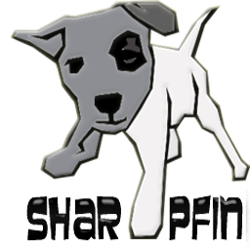
- Read Carefully, and accept the agreement
- The program will now connect to the internet, and download a list of available patches. You may need to Unblock ports on your firewall at this stage.

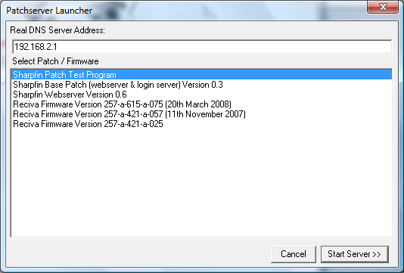
- Next, you will be presented with a selection dialog, which you must use to select your required patch or firmware release. Start by selecting Sharpfin Patch Test Program (a benign demo patchfile):

- The Real DNS Server Address is automatically obtained from Windows, however, you can change it if you wish.

- Once you have selected your patch / firmware, press the “Start Server>>” button.

The patchserver will now launch the main server application, which is waiting for a connection.

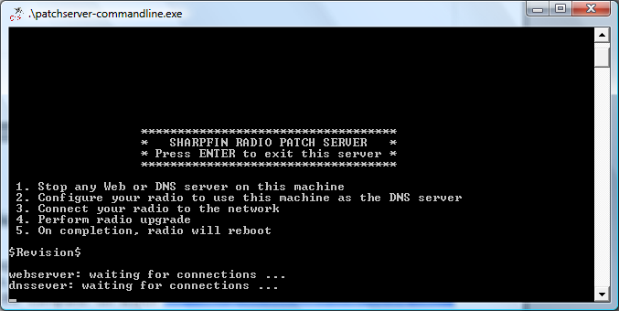

Turn on the Radio and Configure the DNS
- The next step is to turn on your Reciva Radio, and configure your DNS to use the computer on which the patchserver is running.
- Select Configure / Network Config / Edit Config.
- When prompted for Auto (DHCP)? Select No.

Auto (DHCP)?
Yes / <No>

- Enter your (Radio Address) first
- Enter your (Subnet Mask) next
- Enter your (Default Gateway) next
- Then enter your (PC Address) instead of the DNS
- Do not enter a DNS Server #2
- You will see the patchserver output screen update during this activity

Perform an Upgrade
- To patch the radio, select Configure / Upgrade Firmware
- When Prompted “Are You Sure?”, Select Yes
- The upgrade process will download the patch file from your patch server and install
- The Sharpfin Patch Test Program patchfile will display a message on the radio screen for 5 seconds
- Following upgrade, the radio will re-boot

Patch Testing
Complete
Output of Sharpfin Patch Test Program

Select Your Patchfile
Once you are comfortable with the process, you can download and install a real patchfile, or perform a firmware upgrade.

The “Sharpfin Base Patch” is the basic patchfile required to give you access to the radio, and install a webserver, from which you will be able to perform maintenance in future. When you apply the patch, you will see the following on the LCD.

Upgrading  Firmware | The radio is downloading the patch from the patchserver.
Patching  Starting | The radio disk has been made writeable, and the Sharpfin patch script is running.
Patching  Sharpfin Base | The base Sharpfin files are being installed.
Patching  Telnet Server | The Telnet Server Configuration files, are being installed. This includes creating the admin and user accounts.
Patching  Web Server | The Web server files are being installed in /opt/webserver.
Patching Done  rebooting | The disk is now read-only again, and the radio will reboot.

Finish Up
Finally, there are just two steps remaining:

- Stop the patchserver by pressing ENTER.
- Re-configure the Radio's DNS server (probably by re-enabling DHCP in Config / Network Config / Edit Network)

Frequently Asked Questions

I've installed Cygwin, but the patchserver cannot find it, and give the error cygwin1.dll not found.

Once installed, the cygwin programs need to be put into the system Path. The patchserver checks the path for Cygwin, and if it is not found, guesses that you installed it in the default c:\cygwin directory. If it cannot find either, it cannot continue. Either modify the path to include cygwin's bin directory, or install cygwin in the default c:\cygwin.

I've run patchserver, and get the error message 'cannot bind to port', and the program exits.

The patchserver needs to run a Domain Name server and Web Server (ports 53 and 80 respectively). You must ensure that any existing DNS or Web server (check your P2P software and Voice over IP, such as Skype) are shut down. If patchserver was aborted, it is possible it left these ports open. The operating system will free them up within a minute or so.

I switch on my radio, and it says “Cannot Connect to Network”

You need to double check that you have set the correct DNS address on the radio. When you boot the radio, you should see several dns queries go past on the patchserver output screen.

Patchserver Reports DNS Server TIMEOUT

This is a symptom of a slow local or global network connection. Domain Name Server lookups provide no guarantee of response, so applications tend to try again and again if the server does not respond in time. Patchserver is acting as a relay, and will TIMEOUT if it does not receive a response from your real DNS in 3 seconds. This is nothing to worry about, as the radio will retry several times. If the radio reports DNS problems, simply try again – this is non-fatal.

My Computer Complains that patchserver is Untrusted

We have not digitally signed the patchserver, so you will have to agree to run the program without its signature.

My Computer Asks me if I want to Block This Application

Your computer is running a firewall, and the patchserver needs to connect to the internet to look up names. You need to select Unblock/Enable to allow the patchserver to work. Check your firewall software for further details.

Something Else Doesn't Work

Please visit the Sharpfin Website (http://www.pschmidt.it/sharpfin/) and Sharpfin Forum: (http://groups.google.co.uk/group/sharpfin)

The Sharpfin project goals are to produce a completely open source internet radio application for the Reciva based radios.

The Sharpfin project wiki can be found at http://www.pschmidt.it/sharpfin/
The Sharpfin source code can be found at https://github.com/philsmd/sharpfin/
The Sharpfin forum can be found at http://groups.google.co.uk/group/sharpfin/

The Sharpfin project will not be party to and does not condone any attempt to reverse engineer any of Reciva's proprietary applications or protocols.

The Sharpfin project will not be held responsible for losses or damage through the use of any of their software or methods (you must agree to this in order to patch your radio).

