

CCM Software
ePortal Room Booking

Introduction
The room booking functionality has been greatly improved in this version of ePortal.
The Room Booking module allows you to:
- Make a Booking
- Check Availability (new)
- Locate a Booking
When making a booking you can refine the type of room you require in greater detail than previously possible.
It was not possible to check the availability of rooms in earlier versions of the ePortal Room Booking module. In this version, you can check availability based on room details (room number, location) and the required dates.
As in previous versions, you can quickly locate bookings based on various criteria.

Booking a Room for a Single Specific Date
To book a room:
- Select Booking | Make Booking. The Book a Room page is displayed.
- Select a start time and duration from the drop-down lists. The minimum duration for any single room booking is 15 minutes.
- Select the date. Click the calendar button and select the date you require:
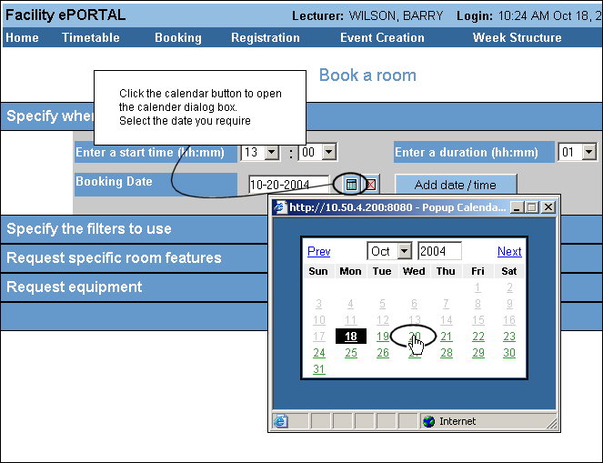
Figure 1-1 Select the date you require from the Pop up Calendar
- Click the Clear button to remove the date, if required:
- Click Add date/time. The room booking is added to the booking list.
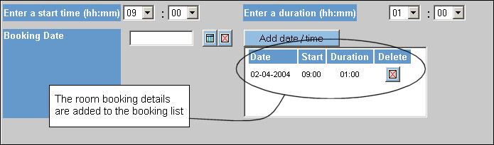
Figure 1-2 Your room booking is visible in the booking list
- Click Submit. Any available rooms for your specified date and time are displayed:
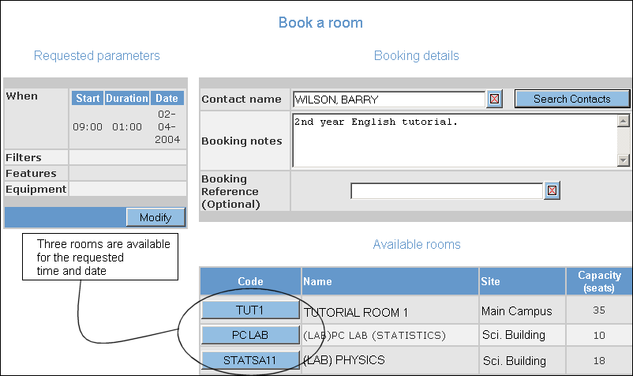
Figure 1-3 Three rooms are available for the selected date and start time
- If you want to change any booking details at this point (date, start time, duration), click Modify. You are returned to the initial Book a Room screen.
- Type a description of the booking and a Booking Reference number (optional). These make the booking easier to locate at a later date but are not mandatory.
- Click the Code button for the room you require (TUT1 in Figure 1-3, for example). Ensure that the capacity suits your requirements. The Booking result screen is displayed, summarising the booking information. At this point you have booked the room.
- Click Finish. You are returned to the Facility ePortal home page. Alternatively, click Book another room to finalise the current booking and to make a new booking.

Refining Your Room Booking Using Filters
You may have specific requirements for the type of room you want to book. It may need to have wheelchair accessibility; you may want to use a DVD player etc.
You can refine the type of room that you want to book based on:
- Room type and location (for example, it must be within the main Science building)
- The fixed equipment/features available in the room (for example, it must have a blackboard)
- The potential to use equipment in a given room (for example, it must have a network connection for a laptop)

To select a room that exactly matches your requirements:
- Select the date and time as outlined in section 1.1.
- Click Show on the Specify Filters to use column heading (note: its information is hidden by default).
- Select your requirements from the drop-down lists. Each filter will be applied to the record set that is returned from your query.
- Click Show on the Request specific room features column heading (note: its information is hidden by default).
- Select the feature that the room must have (WHITEBOARD, for example). Click > to add it to your requested features list.
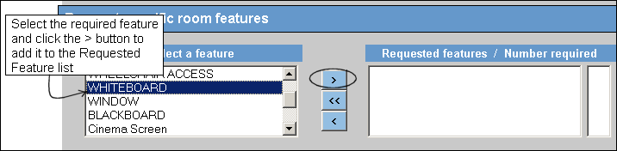
Figure 1-4 Select the required room feature and add it to the Requested Features list
- Click Show on the Request equipment column heading (note: its information is hidden).
- Select the equipment you require for the room. Click > to add the item(s) to your overall room requirements.
When you request equipment, you are requesting that the room can support the use of this equipment not the equipment itself. For example, if you request a room with “Radio Microphone” this means that the room has the equipment to allow you to use a radio microphone but the actual microphone may not be available in that specific room. You may need to book this equipment separately.
- Click Submit.

Adding Multiple Items to the Requested List
You may want to specify more than one item in the required room. For example, you may want a room with at least 10 computer points.
To request a room with more than one computer point:
- Click the Computer Point item from the features list.
- Click > to transfer it to the Requested feature list.
- Double-click the number in the right-hand quantity list:
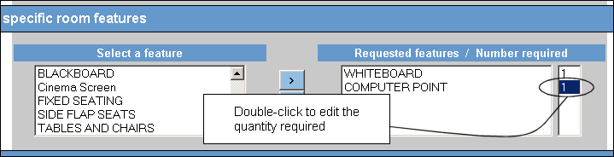
Figure 1-5 Double-click the quantity
- You are prompted to change the number as required.
- Type this number and click OK. The number is changed. Only rooms that have a minimum of 10 computer points will be returned.
When specifying a number of items, results are returned that are equal to or greater than that amount.
- Click Submit.

Booking a Room Over a Series of Weeks
It is possible to book the same room, at the same time and day, over a specified week range or ranges.
To book the same room for the first semester (11 weeks):
- Select the start time and duration from the drop-down lists.
- Select the Day on which you require the room from the drop-down list.
- Type the week range or select the week range name from the drop-down list, see Figure 1-6. The week name is configured in Facility CMIS and it may be more convenient to select a week range from this drop-down list.
It is not possible to combine a week range and a week range name. If you type data and then select an option from the drop-down list, the data in the drop-down list takes precedence and is processed.
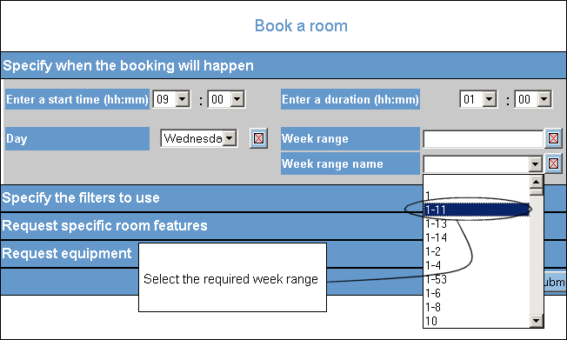
Figure 1-6 Select the Week range name from the drop-down list

Specifying Week Ranges
If required, you can specify various week ranges within the same room booking.
For example, you may want to book a room for week 1 to 8, week 12, 14, 15 and from week 17-21.
To book a room for these dates:
- Select the start time, duration and day from the drop-down lists.
- Type 1-8,12,14,15,17-21 in the Week range text box.
- Click Submit. Only rooms that are available at the selected times will be returned.
- Select a room if one is returned. Because it may be difficult to find a room that matches all the week ranges, and individual weeks, you specify, it may not be possible to find a single room for this type of booking.

Checking Room Availability
To check whether a room is available or not you need to know either the:
- Room code
Or
- Room number

To check a room’s availability:
- Select Booking | Check availability from the main menu.
- Select the Site from the drop-down list.
- Type the Room Code or Room name. If you do not know the exact name or room code, type an approximate name or code and the system will return close matches (note: these do not need to be case-sensitive).
- Click Search by code (if you searched on the code number) or Search by name (if you searched on the name). A pop up is displayed:
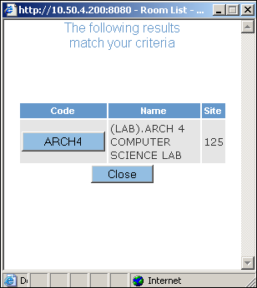
Figure 1-7 Room details are displayed if the room is available
- Click the required Code button (for example, ARCH4 in Figure 1-7). The Code and Name fields are automatically populated.
- Select the Booking Date.
- Click Submit. Room availability details are displayed. The Room Details are displayed in the top portion of the screen including the room capacity and features.
- The Room Availability on the selected date is also displayed (Figure 1-8).
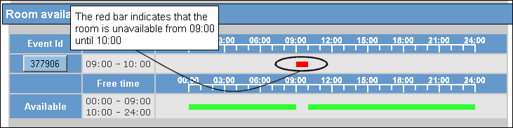
Figure 1-8 The red bar indicates room unavailability
- Click Try again if you want to check availability for a different room.

It is possible to book the selected room at this point.
To book the room:
- Select any time range within the green band. In Figure 1-8, all times, except 09:00 to 10:00, are available.
- Select a start time and duration and click Submit. The Book a Room screen is displayed, summarizing the booking details.
- Add booking notes or a booking reference if required (to aid retrieval later if you want to find the booking- see section 1.5).
- Click Submit. The Booking Result screen is displayed.
- Click Finish.

Locating a Booking
Locate a booking based on:
- Today’s bookings (all the bookings that have been made by all users for the current day)
- The bookings you (i.e. the logged on user) have made
- The bookings that have been made for a particular room
- A refined search

Refined Search
To locate a booking using a refined search:
- Select Booking | Locate Booking.
- Click Refined Search. The Refine Booking Search screen is displayed.
- Type your search criteria as required.
You must select at least one marked search criterion from a drop-down list and one other field.
- Click Search.

