# Pan-Atlantic Website

### STATEMENT OF WORK

|  |
| --- |
| Peter field |
| Pan-Atlantic |
| p. 902.430.4104 |
| e. peter@fieldexperts.com |

#### PROJECT OVERVIEW

The following document outlines the costs involved in building a new web presence for the Pan-Atlantic. The initiation of this process is marked by a discovery phase that involves a discussion with Pan-Atlantic stakeholders on their long-term vision for the web. These discussions feed the information architecture for the new site and culminate a site map that will form the bases for a web interface design. The site map will be forwarded to a professional web designer who will develop a look and feel for the new site. Following a client review of design, the project will enter the development phase where the designer’s vision is transformed into an online business solution. The life span of this project will range from 3-4 weeks following the completion of the discovery process.

#### SCOPE OF WORK

**Core Work**

* Discovery – Define and plan the work
* Design – Create a custom design web interface
  + **Deliverable**: 2 JPEG files showing the intended look and feel of the design.
* Content Management – Deploy a Drupal content management tool in a Unix/Apache hosting environment.
  + **Deliverable**: Functional Website with an extensible content management system.
* Assist with the selection of a hosting environment.
* Setup the domain and email accounts
* Provide 2 hours of training on the content management system.

#### OUT OF SCOPE

* Copywriting
* Video Production
* Stock Photography
* Hosting Fees
* Domain Costs

#### PRICING & ESTIMATED TIMELINE

Basic Requirements

|  |  |  |
| --- | --- | --- |
| Work Elements | Completed by* | Cost |
| **Discovery** – Prepare a site map for the site. This phase is deals with information architecture and page structure. | Oct 19, 2009 | $300.00 |
| **Design** – Prepare a look and feel for the site. Produce a snapshot of what the home and internal pages. | Oct 26, 2009 | $1000.00 |
| **Site Construction –** Transform the site design into an HTML template and deploy it in a Drupal framework. | Nov 9, 2009 | $2800.00 |
| **Testing, Training & Warranty** – Review Drupal site for errors. 90 Day warranty on any issues. Training on the CMS | Nov 9, 2009 | $500.00 |
| **Deployment** – Setup the hosting and deploy the Drupal CMS. | Nov 18, 2009 | $150.00 |
| **Total Amount – (Excluding HST)** |  | **$4750.00** |

*\*”Completed by” is an estimated date for delivery assuming that all required information is provided upon the completion of the Engagement Planning phase.*

#### PAYMENT TERMS

Milestone 1: Discovery and Design - 35% of Total Payment Due

Milestone 2: Site Development – 35% of Total Payment Due

Milestone 3: Final Deployment Site live – Remainder Due on go liveSITE MAP

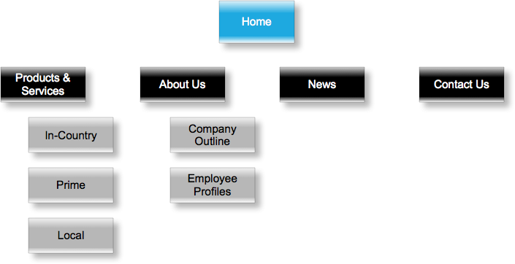

#### OUR APPROACH

**Discovery & Ideas** – we plan the work before we work the plan. When most hear this they think “da!”, that’s not rocket science. The scary thing is there are a lot of projects that skip the planning phase and race into development. We like to ask lots of questions first, generate ideas evaluate them and pick the ones that best suite the project goal. We take the best ideas and use them to develop an online strategy. A roadmap for how we’re going to meet and hopefully surpass our objectives.

**Creative** – No website should have anything less than “kick-ass” creative. The look and feel of your online brand has to be professional, but even more importantly it has to reflect your brand. When it comes to creative development we have a series of resources for both custom and template design. Depending on your budget, you can design down to the pixel or select the right fit from our catalogue of templates.

**Copywriting** - Yes Virginia, there are web copywriters! A lot of people don’t realize how important it is to ensure what you say online is written with the medium in mind. Having well written copy can help increase your site conversion rates as well boost search engine rankings. If you’re not a writer and need help putting the words together we have people who can help build the content for you.

**Development** – once we have a design and we know where we are going, the next step is to start the building process. This is where the pedal hits the metal. Our developers get to work building the site architecture. It’s not a black box so don’t expect us to go away and come back with a finished product. Our approach to development involves iterations of client reviews where we get you involved in the process. We build it, show it to you and change it to fit your input. At the end of the day we want you to have ownership in the project from start to finish so there are no surprises at the end.

**Deployment**– This is quite often the easiest part of the whole process. Working closely with you, we help find the right hosting service, if necessary move your email accounts, transfer your domain and help ensure that there is no downtime for your business throughout the deployment process. It is all about making it painless and simple.

**Results**– the moment the site goes live, we begin to measure performance. Using Google Analytics to quantify site traffic and monitor usability, we take numbers and turn them into detailed insights that can be used to help improve your online ROI. From drop-off points, to most popular pages, to search engine optimization benchmarks, we can help you measure your site’s performance.

#### Sign-Off

I, ___________________________, qualified signatory for Pan-Atlantic, hereby sign-off on the content of this scope document. I confirm that the contents of this document meet the requirements and functionality to be completed as part of this project. I understand that additional changes outside the scope of this document and not explicitly stated in this document are subject to additional charges beyond the prices provided in this document. I understand that upon paying for this scope document that Pan-Atlantic owns the content of this document and may use it for any other purpose.

I, _________________________, independent contractor for Swinney Marketing, hereby sign-off on this scope document as being completed to match the features and functionality requested by Pan-Atlantic I have given Pan-Atlantic sufficient time to review the content of this document and make any revisions necessary in order to create a feature complete product as defined by the input of Pan-Atlantic I understand that upon paying for this scope document that Swinney Marketing gives up any rights to the ownership of content of this document.

Pan-Atlantic

Date: Signature:

Swinney Marketing

Date: Signature: