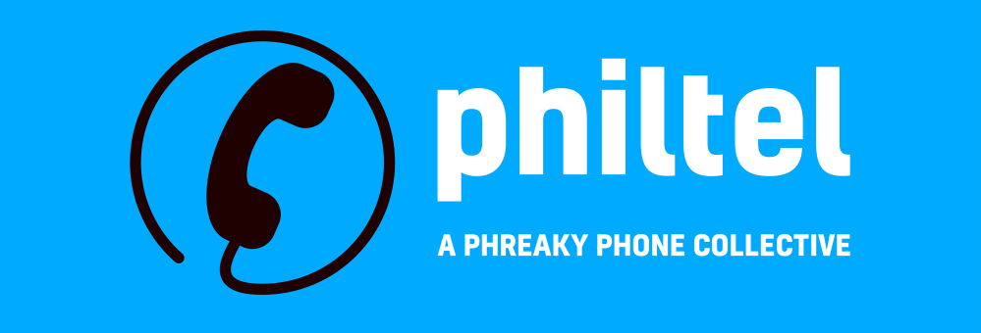
We’re an amateur phone collective installing new-to-us, free-to-use payphones in Philadelphia that allow calls anywhere in the US! https://philtel.org

PhilTel is powered by VoIP (Voice over IP, essentially calls made over the Internet), which means cost to us can be around $0.001/min, or less than a cup of coffee a month with typical usage.

PhilTel is entirely donation-funded. We do not charge for service, we don’t have ads, and we don’t collect your data. If you have an old payphone, we want it!

Aside from connection to the public telephone network, PhilTel is also connected to PhreakNet, a telephone collector/enthusiast network that simulates the mid-20th century North American phone network (including 2600Hz trunks, MF/SF signaling, coin trunks, call tandeming, party lines, and distinctive ring cadences).

Want to call yourself?

PhilTel phones use 11-digit dialing, please dial your number in the following format:

1-NPA-NXX-XXXX

You should hear the phone ringing as the call goes through.

Want to call our phones here?

Call the following number:

1-267-876-4900

The phones will ring in a round-robin. Pick up a phone to answer the call!


Phone Retrofitting
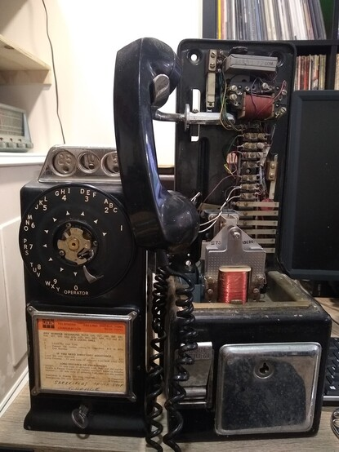
Older 3-slot payphones and single-slot payphones operated by the phone company can be easily modified to use a standard phone line.
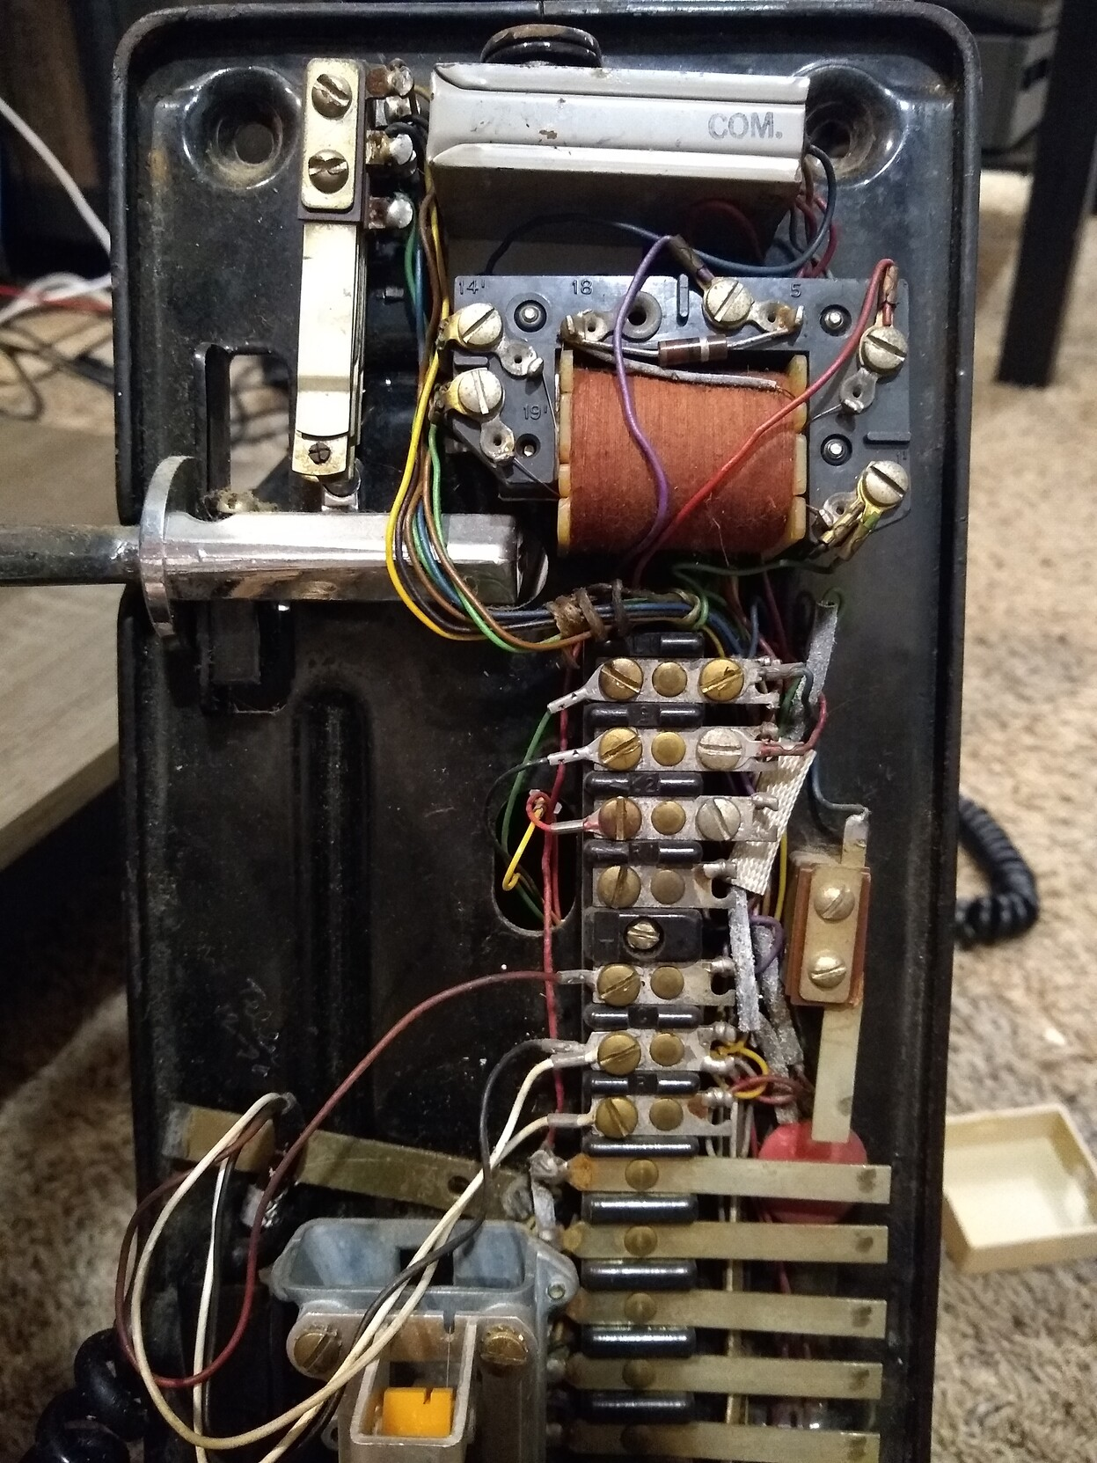

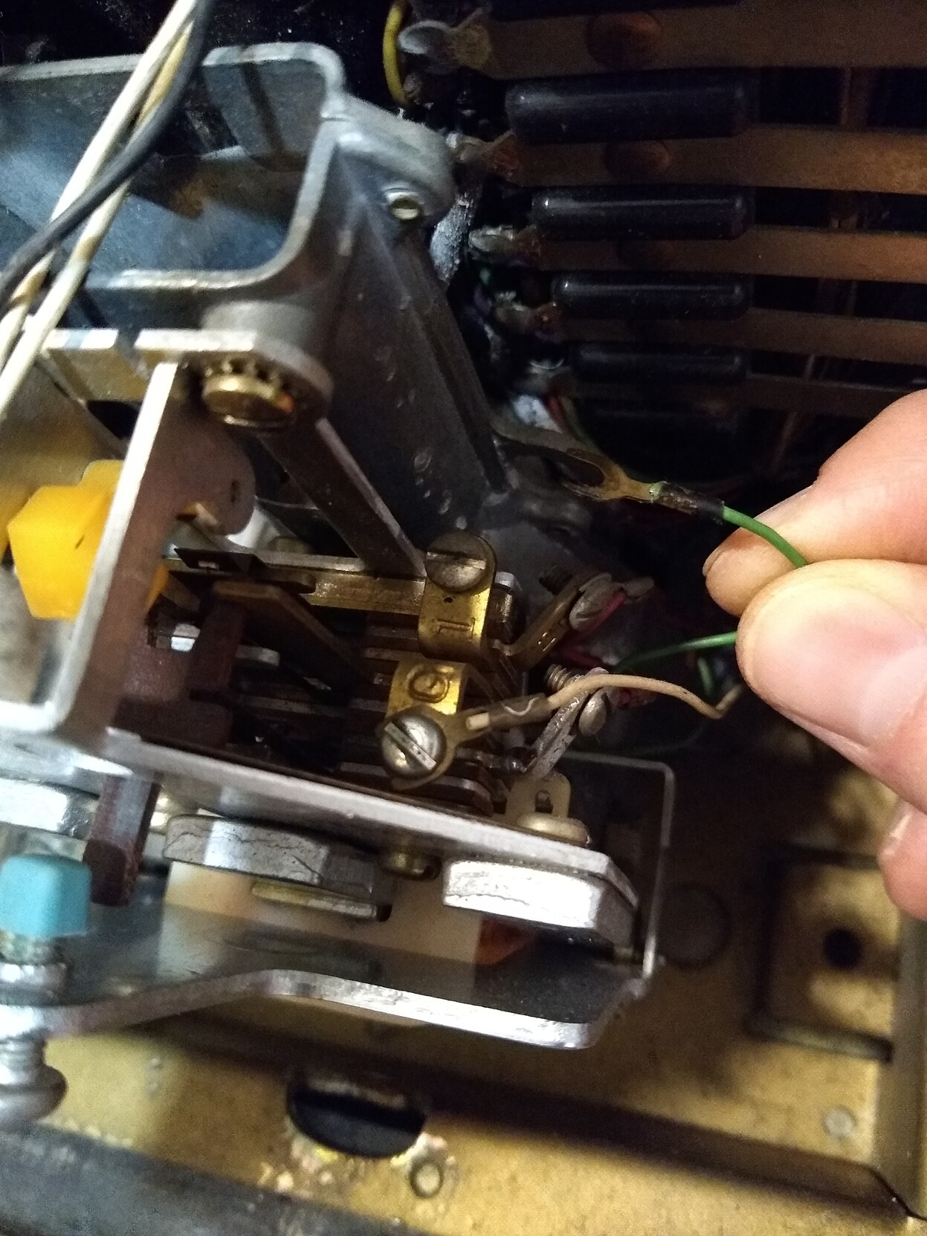
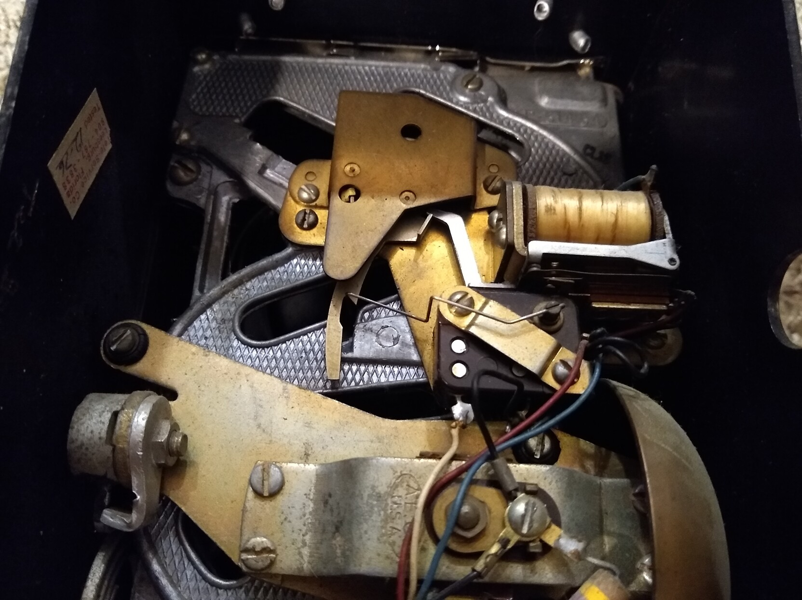

Phone Retrofitting
Customer-owned coin-operated payphones (COCOTs) originally owned by independent payphone companies from the 1980s to today have “smart” boards that need to be reprogrammed or replaced.

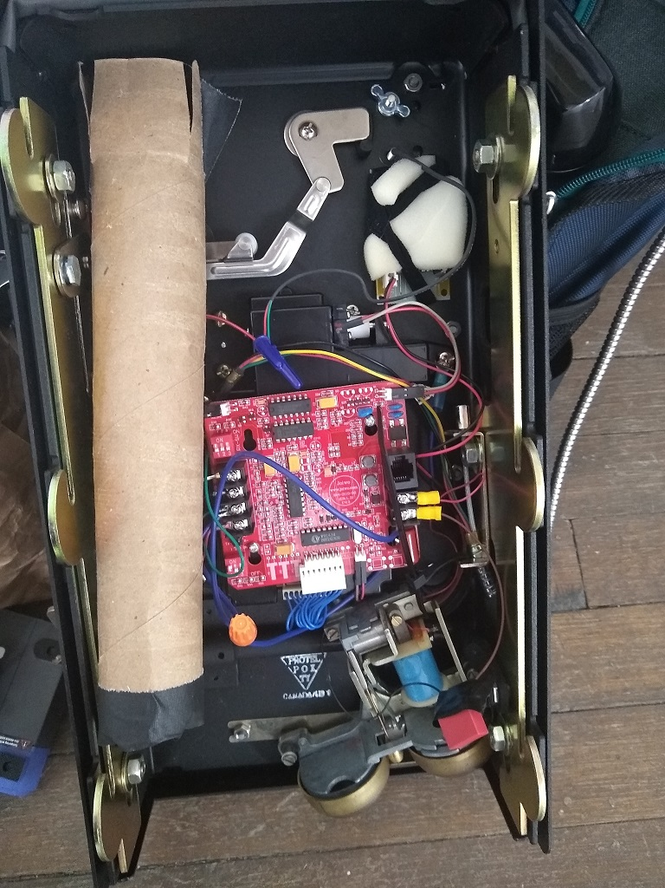
We typically replace smart boards with 2110V boards meant for armored phoned, but we can now program Protel boards!
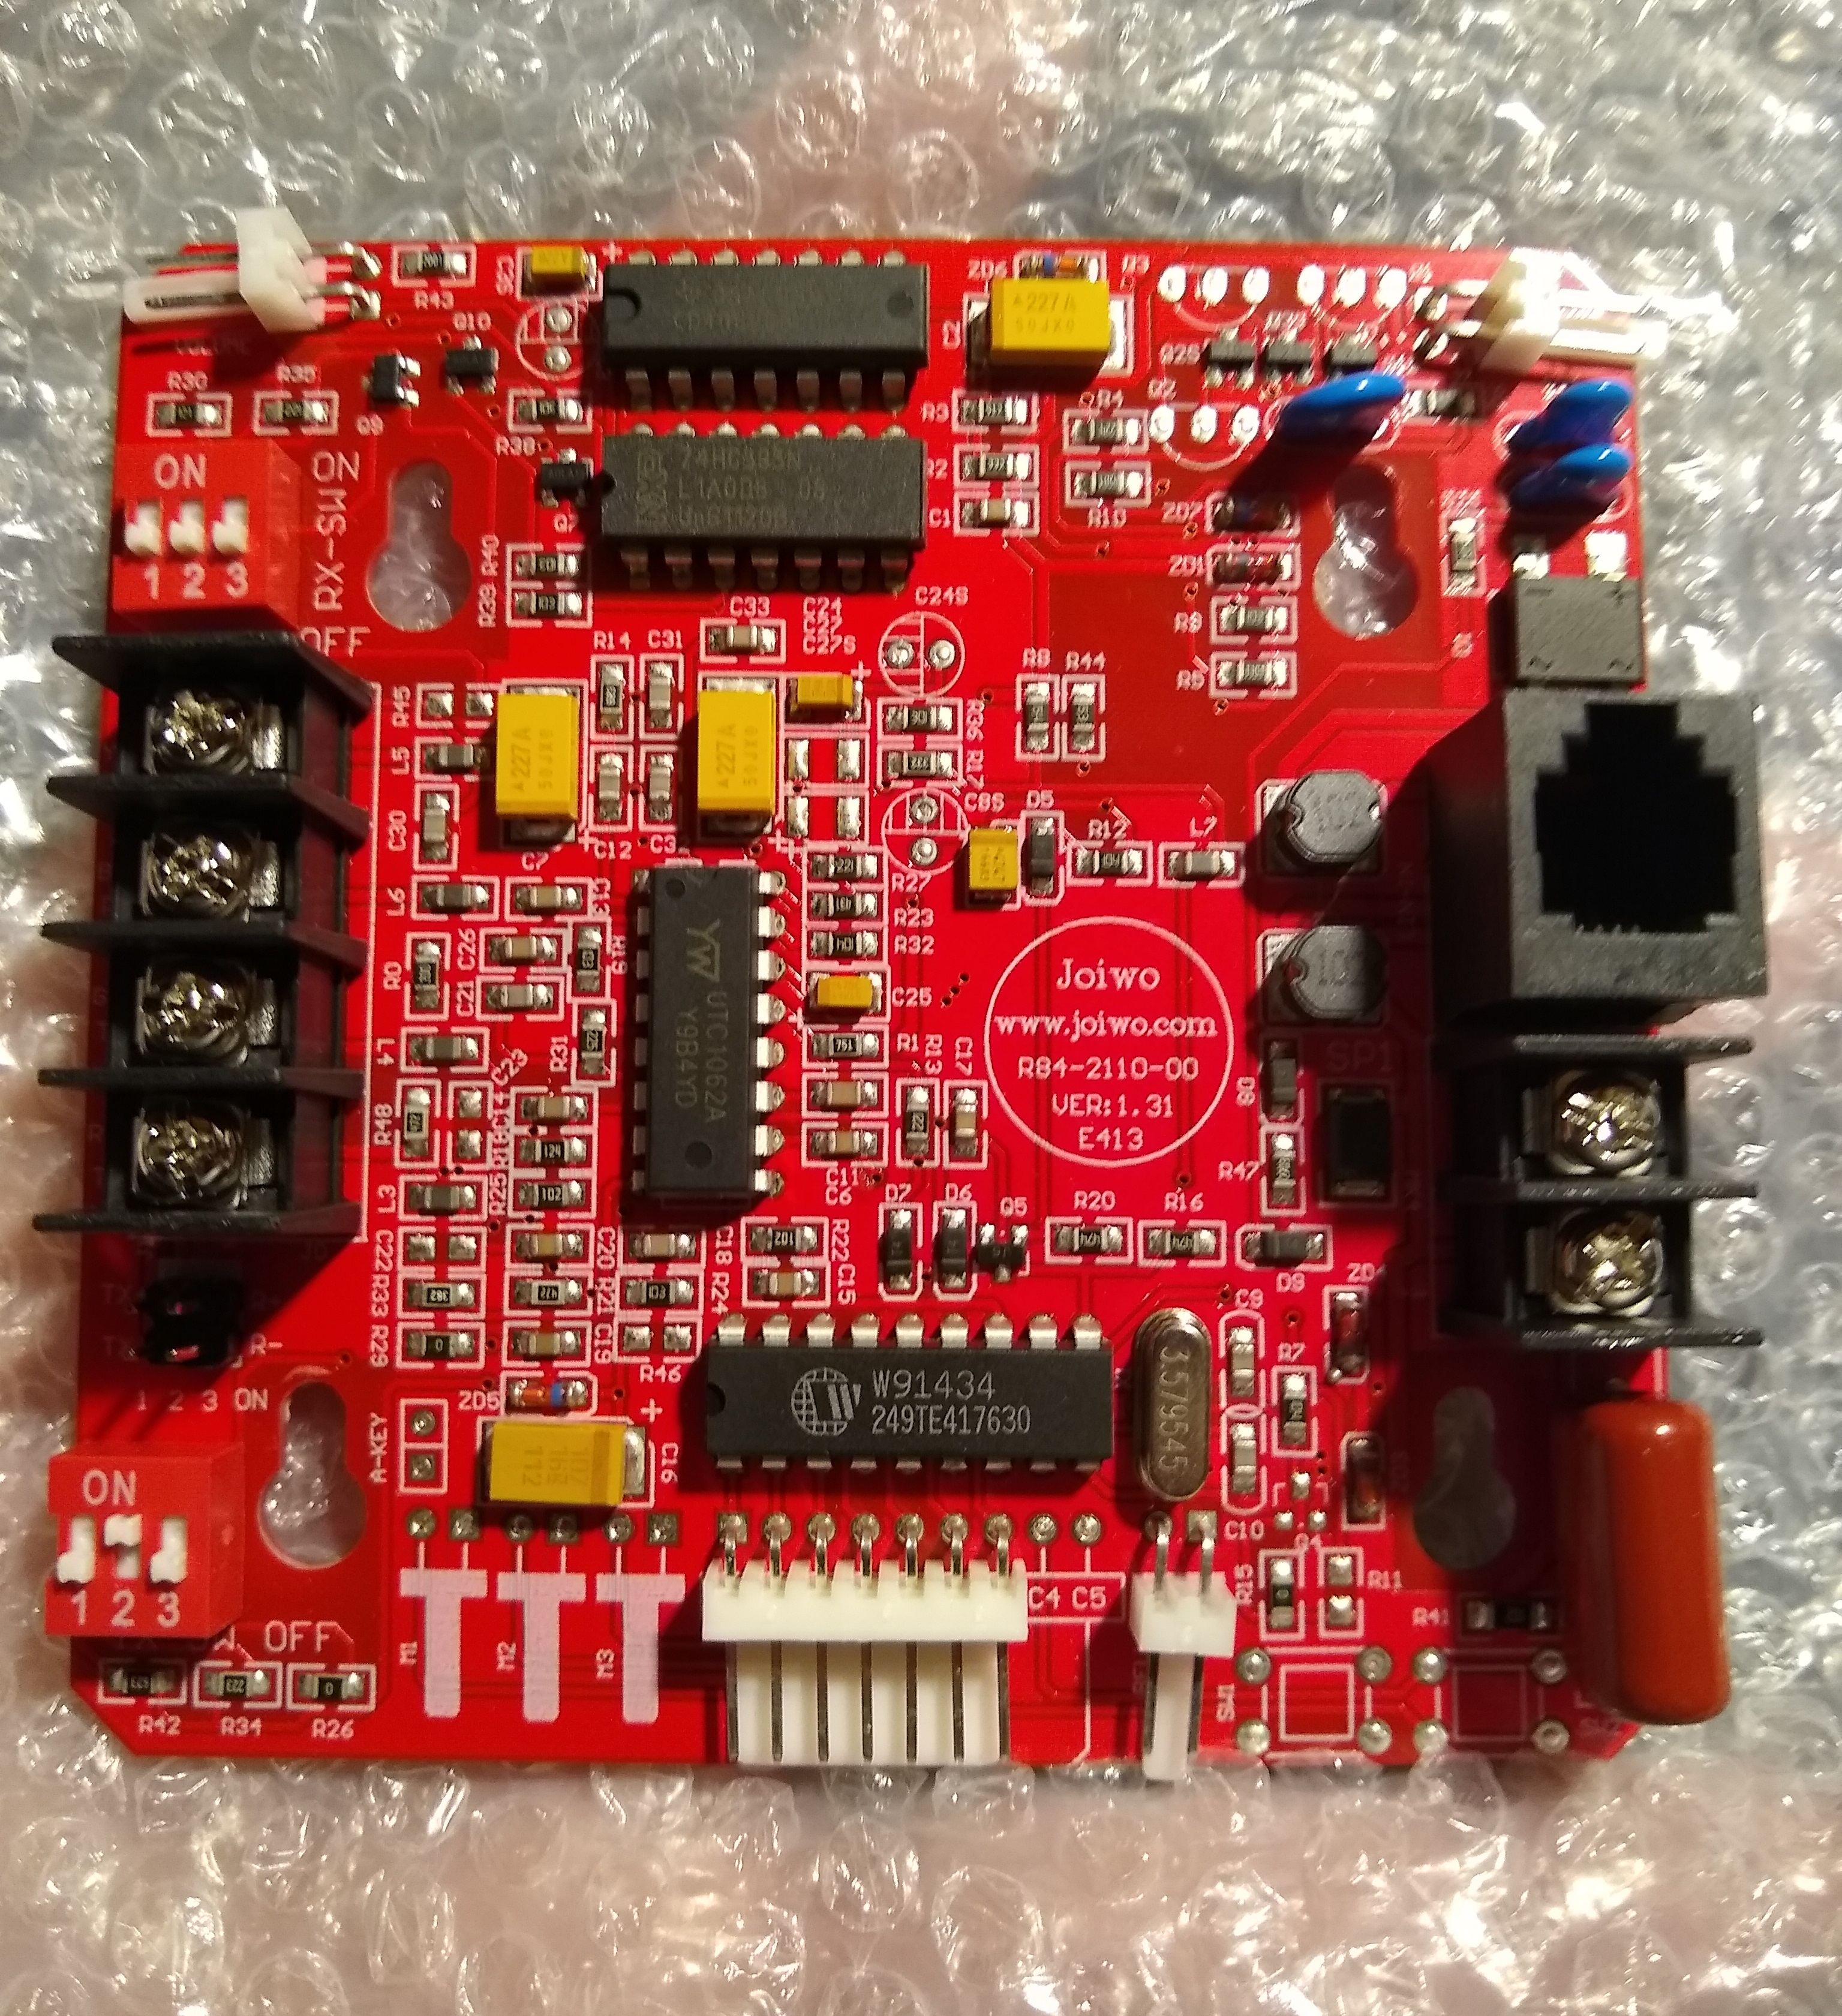
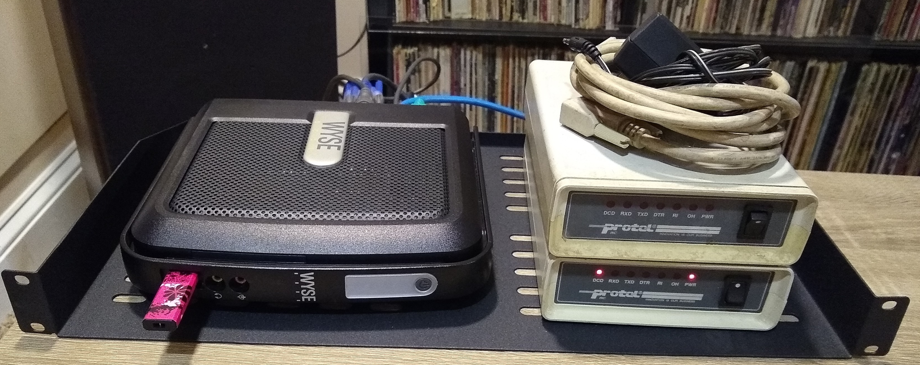

Locations
Our flagship phone is installed at Iffy Books at 404 S 20th St in Rittenhouse.
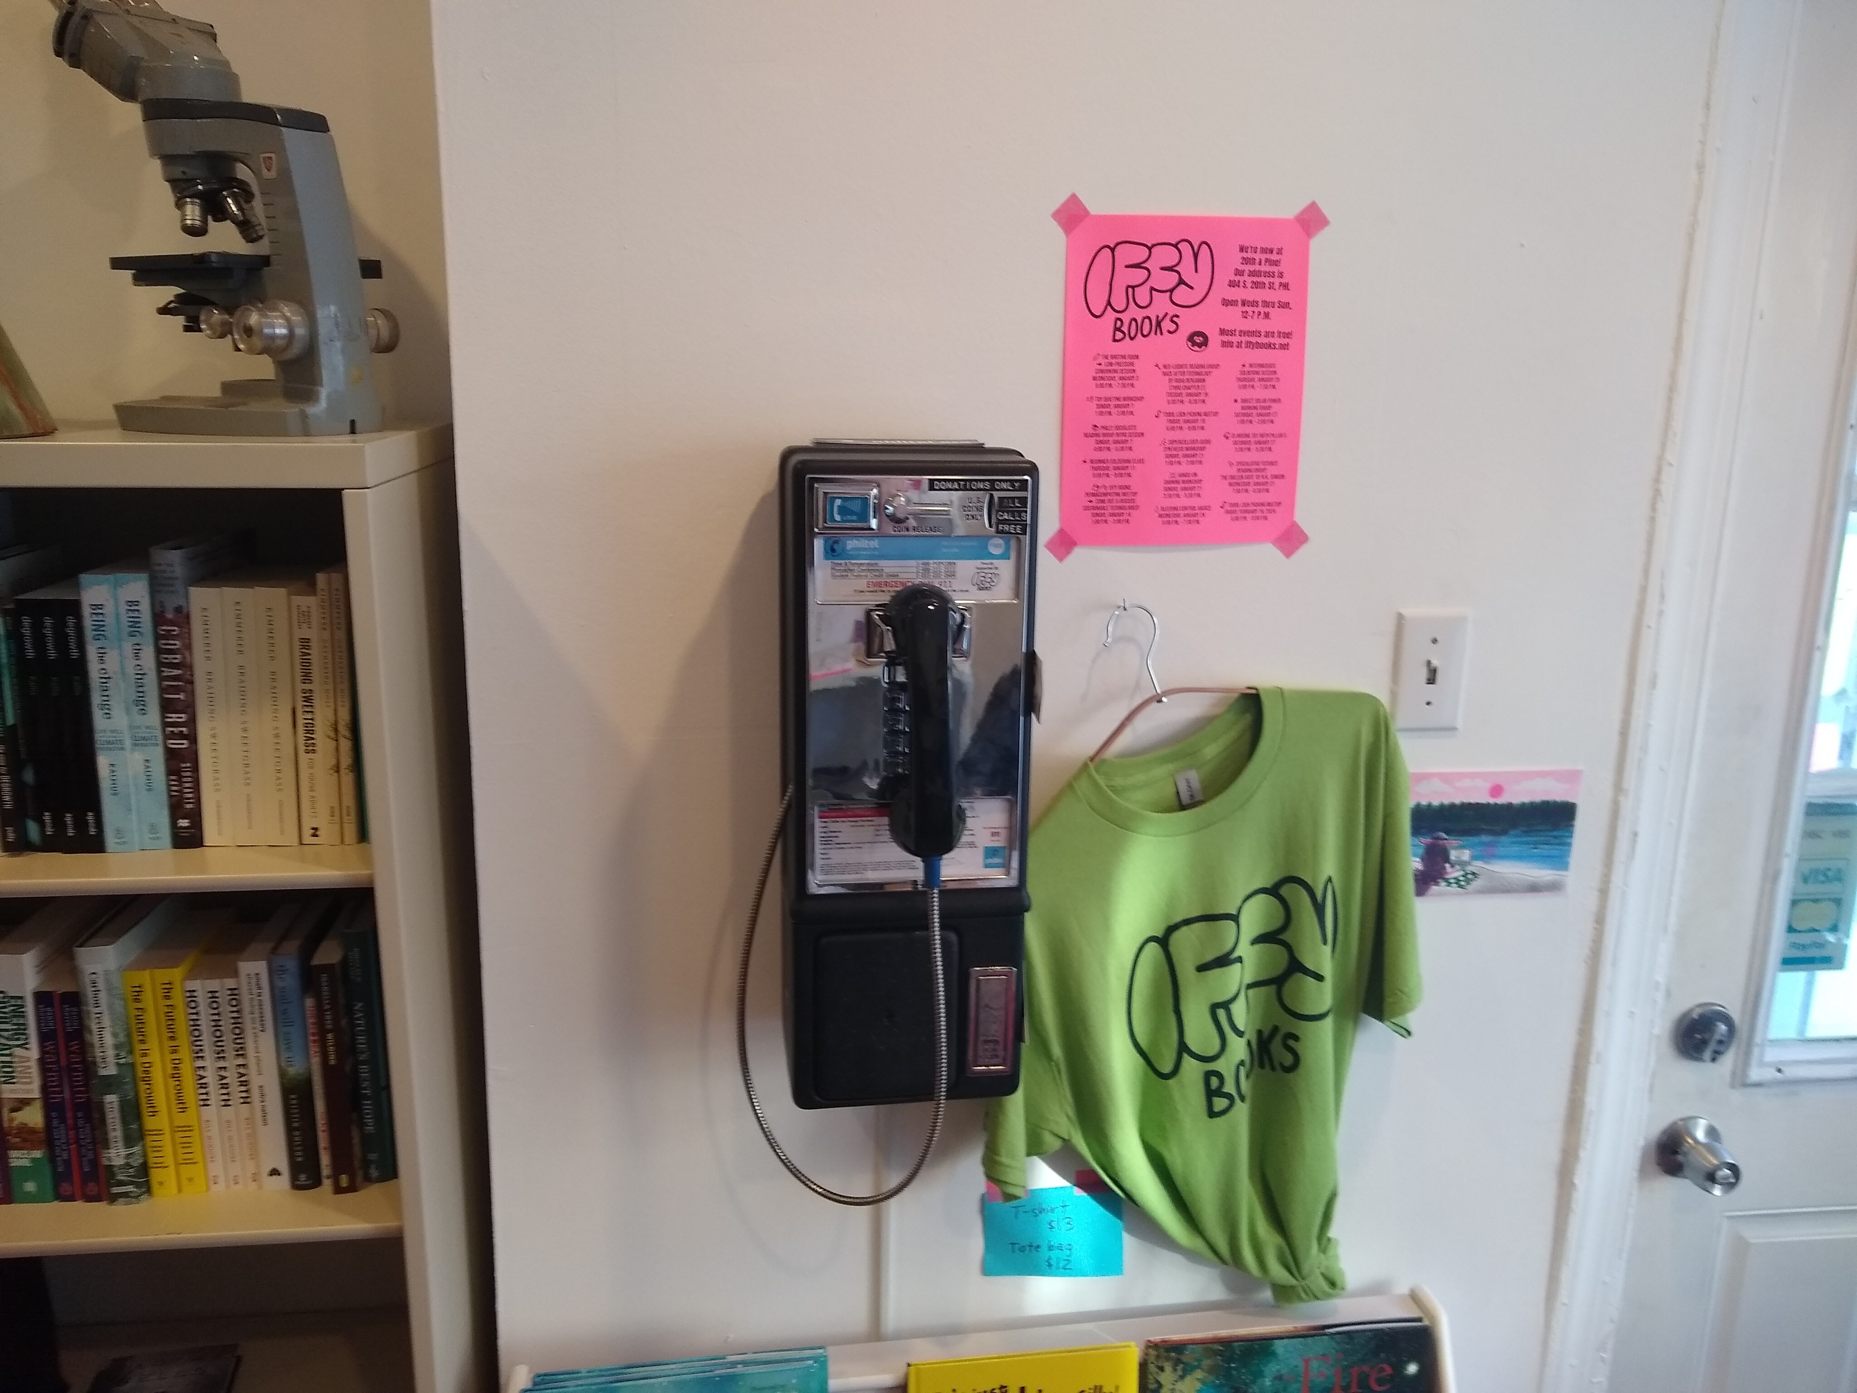


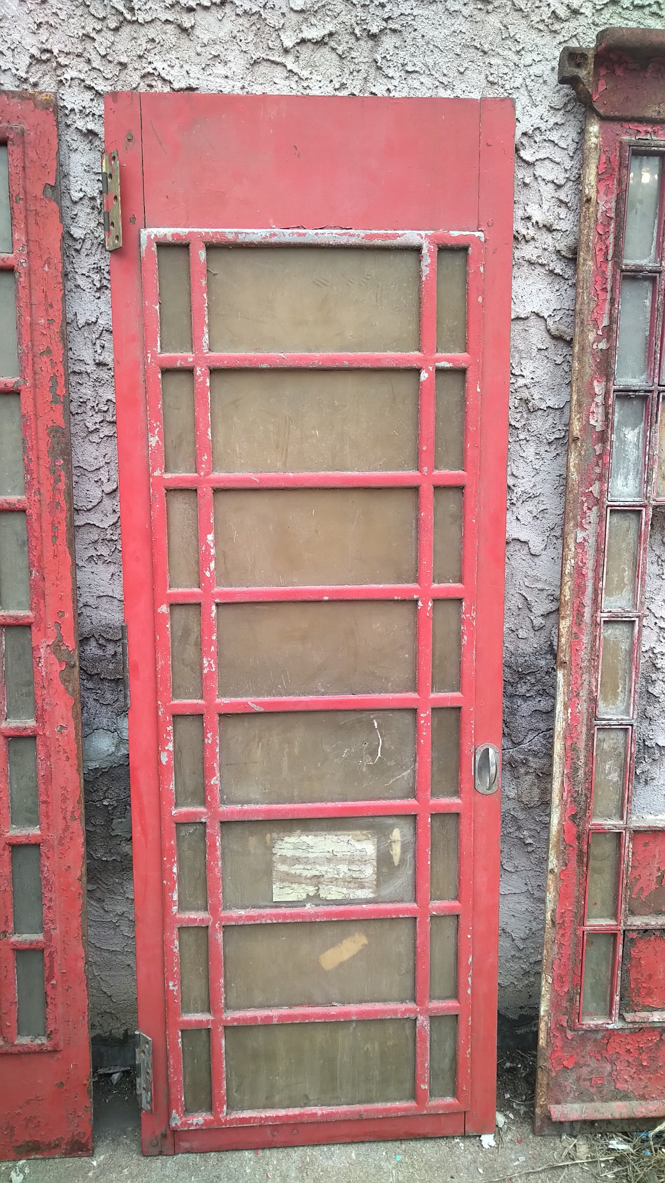
We are working on a second phone at Thunderbird Salvage at 2441 Frankford Ave in Kensington, to be installed in a British K6 phone box.
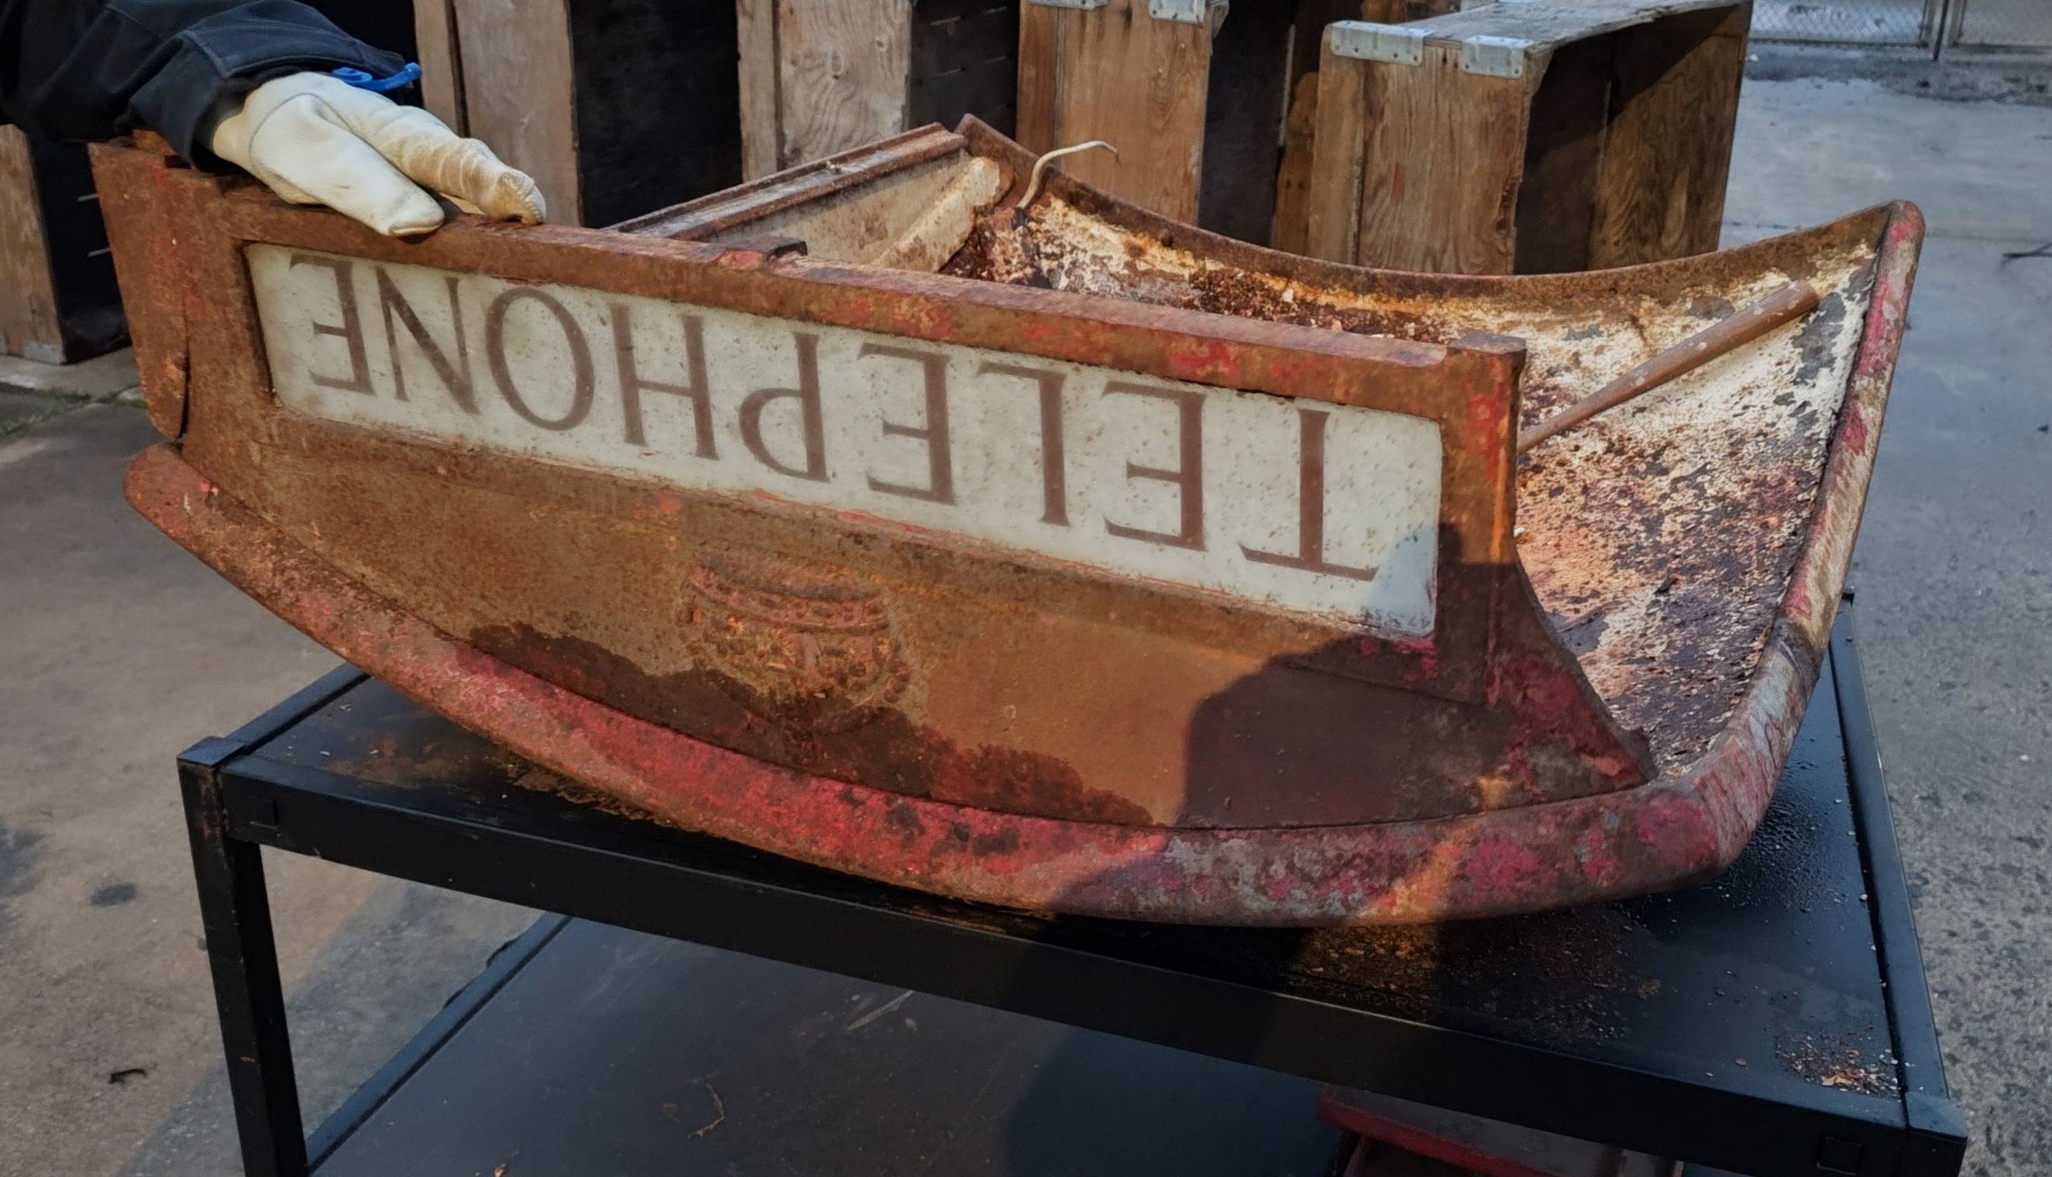
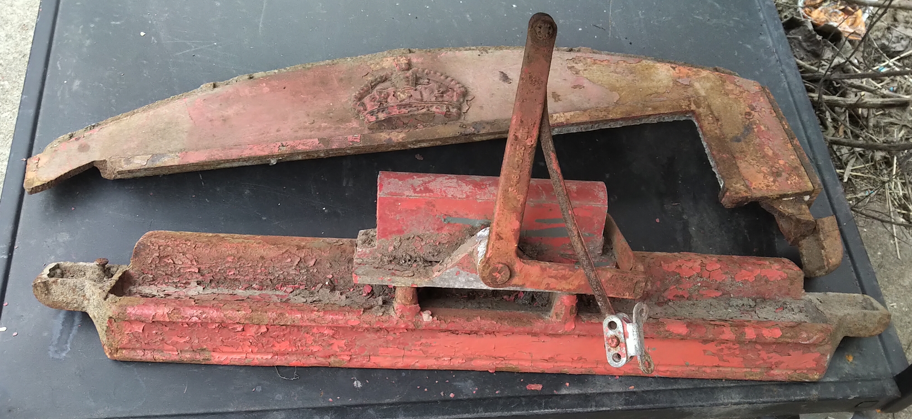

Fun Numbers

- Time & Temperature → 1-400-POP-CORN
(1-400-767-2676)
- Echo Test → 1-400-747-9931
- WXPN 88.5 FM Philadelphia → 1-400-231-3976
- Addition Math Game → 1-400-231-6110
- Talking Clock → -400-442-2124
- Decision Maker Yes or No → 1-400-442-3909
- MF Boogie #1 → 1-400-747-2010
- MCI ANAC → 1400-444-4444
- All Circuits Busy → 1400-231-9891
- Facility Trouble → 1-400-231-9892
- Various Announcements → 1-400-444-7808
- Tone Sweep → 1-400-234-9979
- Mechanical Milliwatt → 1-400-234-9960
- “Jenny” → 1-400-867-5309
- “The Simplicity” Hold Music → 1-400-231-4593
- Not In Service → 1-400-231-9895
- Working Number → 1-400-231-9400
- Always Busy → 1-400-355-9970
- Reorder → 1-400-355-9971

