

SCHOOL OF ADVANCED TECHNOLOGY

ICT - Applications & Programming

Computer Engineering Technology – Computing Science

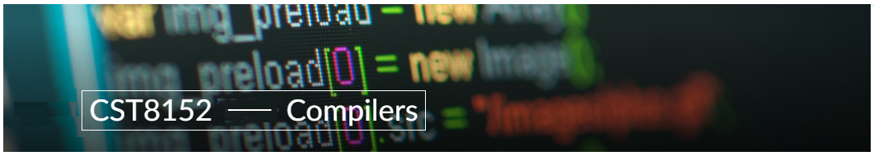

A21
Model Definitions (RE/Automaton)

Lab Professor / Lab Session:
Paolo Sousa / 012

Team:
Tasfia Khan Aohana - ID: 041076039 / Philogene Villanueva - ID: 041064813

Language Name: Amber
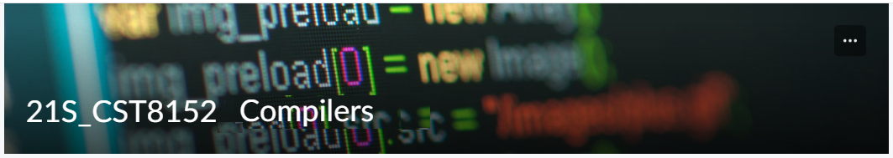

MODEL TASK FOR ASSIGNMENT 2.1 – AMBER

Task 1: Language Symbols (2.0 marks)

List examples: Define main symbols to be used:
- Special symbols (ex: “{“, “(“, “<=”, etc.)
- Comments
- Variables
- Functions
- Literals (numbers, strings)
- Keywords
- Datatypes

Answer:
Special symbols: ‘//’, ‘/*, ‘*/’, ‘&&’, ‘||’, ‘!’`, ‘==’, ‘!=’, ‘<’, ‘<=’, ‘>’, ‘>=’, ‘+’, ‘-’, ‘*’,’%’, ‘=’, ‘(‘, ‘)’, ‘{‘, ‘}’
Comments: //this-is-single-line-comment
/*this-is-multi-line-comment*/
Variables:
- Integer var: var variable_name int32
-Boolean var: var variable_name bool
-Float var: var variable_name float32
-String var: var variable_name string
-Char var: var variable_name char

Function: func fname datatype(parameter datatypes) {…}

Literals:
-Integer: 42,4_2,0600,0_600,0o600,0O600 // second character is capital letter 'O',0xBadFace,0xBad_Fac
-Floating Point: 0., 72.40, 072.40 // == 72.40, 2.71828, 1.e+0, 6.67428e-11, 1E6, .25, .12345E+5, 1_5. // == 15.0, 0.15e+0_2 // == 15.0, 0x1p-2 // == 0.25, 0x2.p10 // == 2048.0, 0x1.Fp+0 // == 1.9375, 0X.8p-0 // == 0.5, 0X_1FFFP-16 // == 0.1249847412109375, 0x15e-2 // == 0x15e - 2 (integer subtraction)
-String: `abc`, `\n, \n`, "\n", "\"", "Hello, world!\n", "日本語", "\u65e5本\U00008a9e", "\xff\u00FF"

Keywords: break, func, else, if, switch, const, type, for, return, var

Datatypes: int, float, string

Task 2: RE – Regular Expression (3.0 mark)

Lexeme Classes: Define the classes to be used in your regular expression:

Answer:
L (letters): A-Z | a-z
D (digits): 0-9
S (single-forward slash): /
T (star): *
P (period): .
Q (quote): ‘
O (Other): ^[L.D.S.P.Q]

Define the RE to be used for: variables, literals, and keywords:

Answer:
* Comments: ST(^TS)*TS
* Variables:
-String : L(L|D)*
-Integer : L(L|D)*
-Float : L(L|D)*

* Methods: L(L|D)*
* Literals:
- Int: D+
- Float: D+PD+
- Strings: Q(^Q)*Q = Q(L|D|S|P|Q|O)*Q
* Keywords: L+ ∈ {break | func | else | if | switch | const | type | for | return | var}

Task 3: TD – Transition Diagram (3.0 marks)

Activity: Starting from the previous lexeme classes and obeying the RE, it is possible to define the automata for your language:

Answer (draw / copy image of the automata):

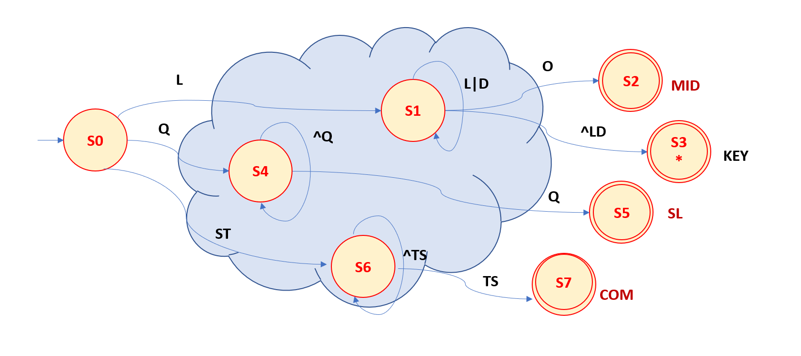

Task 4: TT – Transition Table (2.0 marks)

Activity: Now, it is possible to define the TT for these lexemes:

Answer (Transition Table):

Input |  | Input Symbol |  |  |  |  |  |  | Output
State\ Classes | 0 |  | 1 | 2 | 3 | 4 | 5 | 6 | Type
 | L(A-Z) |  | D (0-9) | S (/) | T (*) | P (.) | Q (‘) | O | -
S0 | 1 |  | ES | 6 | ES | ES | 4 | ES | NOFS [0]
S1 | 1 |  | 3 | 1 | ES | 1 | 1 | 2 | NOFS [1]
S2 | FS |  | FS | FS | FS | FS | FS | FS | FSNR (MID) [2]
S3 | FS |  | FS | FS | FS | FS | FS | FS | FSWR (KEY) [3]
S4 | 4 |  | 4 | 4 | 4 | 4 | 5 | 4 | NOFS [4]
S5 | FS |  | FS | FS | FS | FS | FS | FS | FSNR (SL) [5]
S6 | 6 |  | 6 | 6 | 7 | 6 | 6 | 6 | NOFS [6]
S7 | 7 |  | 7 | 7 | 8 | 7 | 7 | 7 | NOFS[7]
S8 | 7 |  | 7 | 9 | 7 | 7 | 7 | 7 | NOFS[8]
S9 | FS |  | FS | FS | FS | FS | FS | FS | FSNR (COM) [9]
S10

Task: Git Hub

Link: git@github.com:philvilla25/compilerProject.git

Update: Oct 10th 2023.

Adapted from resources developed by Prof. Svillen Ranev (Algonquin College, 2019)

