Algonquin College Logo

# SCHOOL OF ADVANCED TECHNOLOGY

### ICT - Applications & Programming

### Computer Engineering Technology – Computing Science

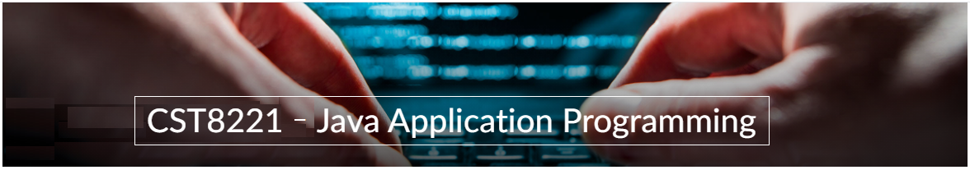

A31

Game C/S Model – Collaboration Diagram

Team:

Akpoguma Daniella - Id: 041075624 / Philogene Villanueva - Id: 041063813

TM Model C/S Proposal

***This template is suggested (not mandatory) to answer A31 Specification.***

|  |  |
| --- | --- |
| **Part**  **1** | **C/S Architecture** |

* 1. **UC Model (1pt)**

🛠 Define the UC diagram and the UC table (actors and functionalities).

**Fig. 1** – C/S Model for Chat[1]

**UC Diagram** (change this diagram to accommodate the actors and functionalities to be used):

**Actors table** (example):

|  |  |
| --- | --- |
| **Actors** |  |
| [Actor name] | [Description] |
| Server | Represents the server side component |
| User | Represents the person using the application |
|  |  |

**UC table** (example):

|  |  |
| --- | --- |
| **Use Cases** | **USER** |
| [UC Name] | [Description] |
| Login | Allows user to login the Turing Machine Application |
| View Task | Enables the user to view the list of task |
| Create Task | Allows user to create task |
| Update Task Status | Enables user to update the status of a task |
| Sync Task | Synchronizes task between user and server |
|  |  |

|  |  |
| --- | --- |
| **Use Cases** | **SERVER** |
| [UC Name] | [Description] |
| Authenticate User | Authenticates user during login process |
| Fetch Task | Retrieves task from server to display to the user |
| Update task Status | Allows server to update the status of a task |
| Synch Task | Synchronizes task between user and server |

* 1. **ClassD (2pt)**

🛠 To draw the diagram, you can use tools (ex: <https://app.diagrams.net/>) or desktop applications (ex: Visio / Powerpoint) or simply take photos from drawings.

**Class Diagram** (change this diagram to accommodate the actors and functionalities to be used):

UML for User

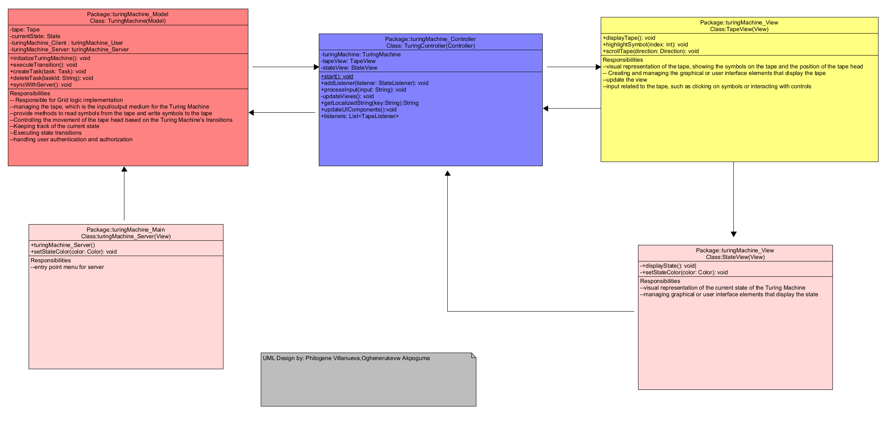

UML for Server

**Fig. 3** – ClassD for a chat[2]

**Class table** (example):

|  |  |
| --- | --- |
| **Class name** | **TuringMachine (Model)** |
| Inner Fields[3] | tape: instance of tapeView  currentState: instance of the current state  user: User instance  server: Server instance |
| Relationships[4] | TuringController class |
| Methods | initializeTuringMachine(): void  executeTransition(): void  createTask(task: Task): void  deleteTask(taskId: String): void  syncWithServer(): void |

|  |  |
| --- | --- |
| **Class name** | **TuringController (Controller)** |
| Inner Fields[5] | turingMachine: instance of model class  tapeView : instance of tapeView  stateView: instance of stateView |
| Relationships[6] | TuringController class  TapeView class  StateView class |
| Methods | initializeTuringMachine(): void  executeTransition(): void  createTask(task: Task): void  deleteTask(taskId: String): void  syncWithServer(): void |

|  |  |
| --- | --- |
| **Class name** | **TapeView (View)** |
| Inner Fields[7] |  |
| Relationships[8] | TuringController class  StateView class |
| Methods | displayTape(): void  highlightSymbol(index: int): void  scrollTape(direction: Direction): void |

|  |  |
| --- | --- |
| **Class name** | **StateView (View)** |
| Inner Fields[9] |  |
| Relationships[10] | TuringController class  TapeView class |
| Methods | displayState(): void|  setStateColor(color: Color): void |

*Create tables for all classes.*

* 1. **UML Collaboration Diagram**

*Describe the collaboration diagram to be used.*

* + - ***Example****:*

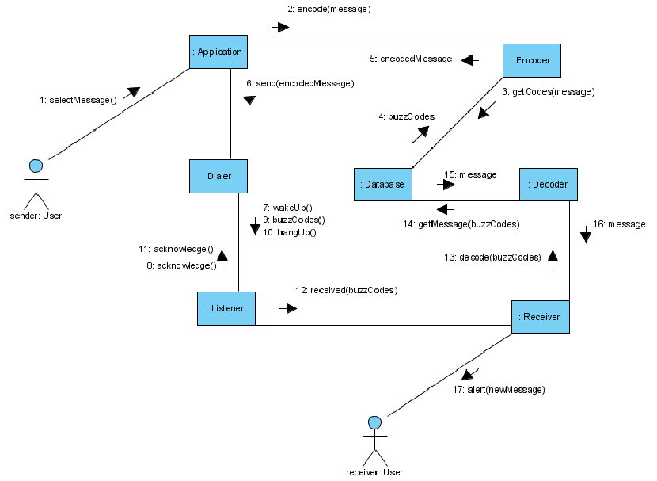

**Fig. 4** – Collab model for a chat[11]

**References**

*[Include eventual references used here]*

Algonquin College

Fall, 2023

1. See <https://www.researchgate.net/figure/System-Architecture-Use-Case-Diagram-Client-side-Functionality_fig2_318502492>.
2. See <https://www.codeproject.com/Articles/443660/Building-a-basic-HTML-client-server-application>.
3. The inner fields and relationships together are properties from the class.
4. In the diagram, you can see relationships (ex: association / aggregation) between classes. In the implementation, these relations imply in the inclusion of other classes as fields.
5. The inner fields and relationships together are properties from the class.
6. In the diagram, you can see relationships (ex: association / aggregation) between classes. In the implementation, these relations imply in the inclusion of other classes as fields.
7. The inner fields and relationships together are properties from the class.
8. In the diagram, you can see relationships (ex: association / aggregation) between classes. In the implementation, these relations imply in the inclusion of other classes as fields.
9. The inner fields and relationships together are properties from the class.
10. In the diagram, you can see relationships (ex: association / aggregation) between classes. In the implementation, these relations imply in the inclusion of other classes as fields.
11. See <https://www.researchgate.net/figure/Collaboration-diagram_fig1_268362338>.