Algonquin College Logo

# SCHOOL OF ADVANCED TECHNOLOGY

### ICT - Applications & Programming

### Computer Engineering Technology – Computing Science



A31

Game C/S Model – Collaboration Diagram

Team:

Akpoguma Daniella - Id: 041075624 / Philogene Villanueva - Id: 041063813

TM Model C/S Proposal

***This template is suggested (not mandatory) to answer A31 Specification.***

|  |  |
| --- | --- |
| **Part**  **1** | **C/S Architecture** |

* 1. **UC Model (1pt)**

🛠 Define the UC diagram and the UC table (actors and functionalities).

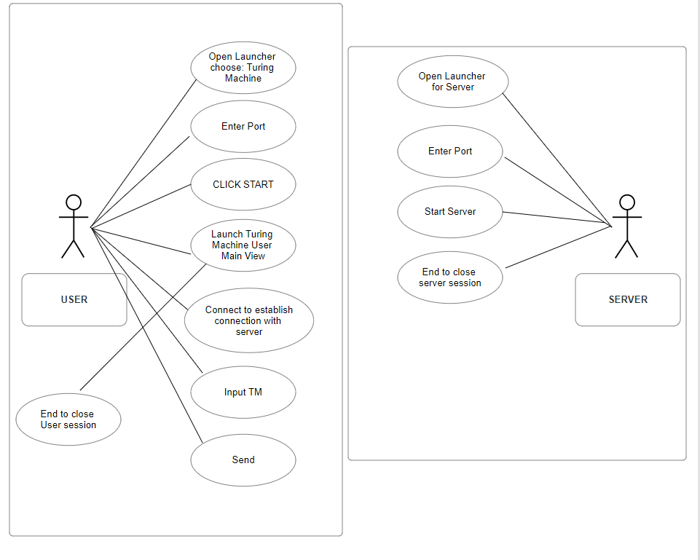

**Fig. 1 – C/S Model for Chat**

**Actors table**:

|  |  |
| --- | --- |
| **Actors** | **DESCRIPTION** |
| Server | The Server actor embodies the server-side component of the application. It is responsible for managing and processing requests from users. |
| User | The User actor represents an individual interacting with the application. Users initiate requests, provide input, and receive outputs from the system. |

**UC table**:

|  |  |
| --- | --- |
| **Use Cases** | **CLIENT DESCRIPTION** |
| Login | This use case facilitates users in accessing the Turing Machine application by providing a login process, to gain access to the application's features and functionalities |
| View Task | Users can utilize this use case to explore and review the list of tasks available within the Turing Machine application |
| Create Task | This use case allows users to generate new tasks within the Turing Machine application. |
| Update Task Status | Users have the ability to modify and update the status of a task using this use case. |
| Sync Task | This use case enables users to synchronize tasks seamlessly between their local environment and the server. |

|  |  |
| --- | --- |
| **Use Cases** | **SERVER DESCRIPTION** |
| Authenticate User | This use case involves the server's responsibility to authenticate users during the login process, ensuring a secure and valid entry into the Turing Machine application. |
| Fetch Task | This use case is responsible for retrieving task information from the server. It enables the server to send task data to the user for display. |
| Update task Status | This use case empowers the server to update the status of a task based on user interactions, and the consistency of task statuses across the entire application. |
| Sync Task | This use case facilitates the synchronization of tasks between the user and the server. |

* 1. **ClassD (2pt)**

🛠 To draw the diagram, you can use tools (ex: <https://app.diagrams.net/>) or desktop applications (ex: Visio / Powerpoint) or simply take photos from drawings.

**Class Diagram** (change this diagram to accommodate the actors and functionalities to be used):

UML for User

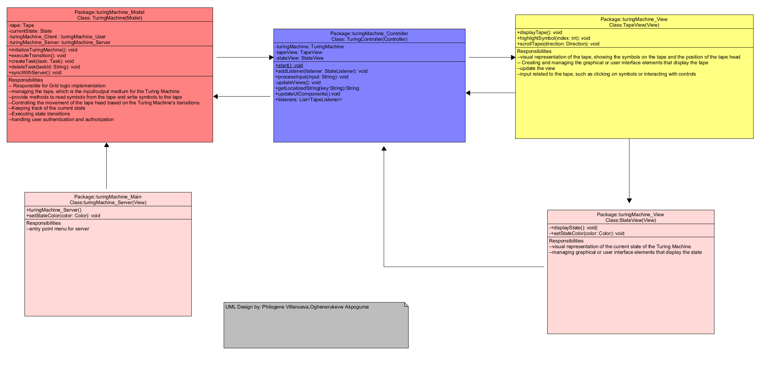

UML for Server

**Fig. 3** – ClassD for a chat[1]

**Class table**:

|  |  |
| --- | --- |
| **Class name** | **TuringMachine (Model)** |
| Inner Fields[2] | tape: instance of tapeView  currentState: instance of the current state  user: User instance  server: Server instance |
| Relationships[3] | TuringController class |
| Methods | initializeTuringMachine(): void  executeTransition(): void  createTask(task: Task): void  deleteTask(taskId: String): void  syncWithServer(): void |

|  |  |
| --- | --- |
| **Class name** | **TuringController (Controller)** |
| Inner Fields[4] | turingMachine: instance of model class  tapeView : instance of tapeView  stateView: instance of stateView |
| Relationships[5] | TuringController class  TapeView class  StateView class |
| Methods | initializeTuringMachine(): void  executeTransition(): void  createTask(task: Task): void  deleteTask(taskId: String): void  syncWithServer(): void |

|  |  |
| --- | --- |
| **Class name** | **TapeView (View)** |
| Inner Fields[6] |  |
| Relationships[7] | TuringController class  StateView class |
| Methods | displayTape(): void  highlightSymbol(index: int): void  scrollTape(direction: Direction): void |

|  |  |
| --- | --- |
| **Class name** | **StateView (View)** |
| Inner Fields[8] |  |
| Relationships[9] | TuringController class  TapeView class |
| Methods | displayState(): void|  setStateColor(color: Color): void |

* 1. **UML Collaboration Diagram**

*Describe the collaboration diagram to be used.*

* + - ***Example****:*

**Fig. 4** – Collab model for a chat[10]

**References**

OpenAI. (2020). OpenAI GPT-3 (ChatGPT). Retrieved from <https://www.openai.com>

Algonquin College

Fall, 2023

1. See <https://www.codeproject.com/Articles/443660/Building-a-basic-HTML-client-server-application>.
2. The inner fields and relationships together are properties from the class.
3. In the diagram, you can see relationships (ex: association / aggregation) between classes. In the implementation, these relations imply in the inclusion of other classes as fields.
4. The inner fields and relationships together are properties from the class.
5. In the diagram, you can see relationships (ex: association / aggregation) between classes. In the implementation, these relations imply in the inclusion of other classes as fields.
6. The inner fields and relationships together are properties from the class.
7. In the diagram, you can see relationships (ex: association / aggregation) between classes. In the implementation, these relations imply in the inclusion of other classes as fields.
8. The inner fields and relationships together are properties from the class.
9. In the diagram, you can see relationships (ex: association / aggregation) between classes. In the implementation, these relations imply in the inclusion of other classes as fields.
10. See <https://www.researchgate.net/figure/Collaboration-diagram_fig1_268362338>.