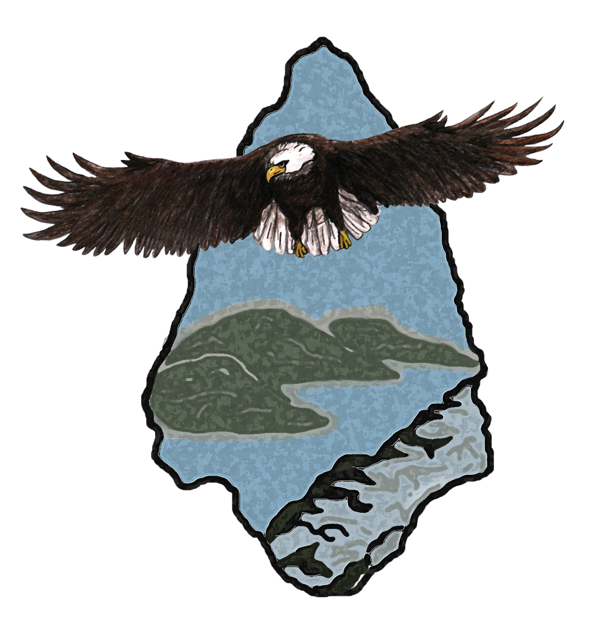
Friends of Morrow Mountain State Park
P. O. Box 306
Badin, NC 28009
morrowmountain.org

EVENT REGISTRATION/RELEASE FORM

MOTORCYCLE ACCIDENT WAIVER, RELEASE OF ALL LIABILITY AND ASSIGNMENT OF CLAIMS

As consideration for being allowed to participate in the event(s) described below I agree:

1. I acknowledge that motorcycle activity is a potentially hazardous activity which can be a test of a person's physical and mental limits and carries with it the potential for death, serious injury and property loss. The risks include, but are not limited to, those caused by terrain, facilities, temperature, weather, condition of riders equipment, vehicular traffic, actions of other people including, but not limited to organizers, participants, volunteers, spectators, agents, The Friends of Morrow Mountain State Park and its officers, directors and employees. These risks are not only inherent to riders, but are also present for passengers, spectators and volunteers. I hereby assume all of the risks of participating, viewing and/or volunteering in this event. I realize that liability may arise from negligence or carelessness on the part of the persons or entities organizing or conducting this event and hereby release them of all possible liability. I certify I am at least 18 years old. I promise not to sue and agree to pay all court costs and all attorney fees that result from my action, civil or otherwise.
2. I certify that I am physically fit with no known physical or mental impairment and have prepared
for participation in the event(s). I acknowledge that this Accident Waiver and Release of Liability
form will be used by the event holders, sponsors and organizers of the event(s), in which I may
participate and that it will govern my actions and responsibilities at said events. I certify that I
am not under the influence of any narcotic, alcohol or other drug that may impair my
understanding or judgment and that I will not at any time during the event(s) operate my
motorcycle under the influence of any narcotic, alcohol or drug. I certify that I have fully
adequate insurance to cover all medical claims, the motorcycle and any other equipment and any
damage or liability I may ultimately be found responsible for, during all travel to the point of my
entry into the Ride, the Ride, the period between the end of the Ride and my return to
my final destination. I further certify that I have all the insurance required by law and I am
licensed and competent to operate a motorcycle in a safe manner and my license has all
motorcycle endorsements or certificates required by my state of residence.
3. In consideration of my being permitted to participate in this event, I hereby take action for myself,
my executors, administrators, heirs, next of kin, successors, and assigns as follows: (A) Waive,
Release and Discharge from any and all liability for my death, disability, personal injury,
property damage, property theft or actions of any kind which may hereafter accrue to me during
the event or during my traveling to and from this event, THE FOLLOWING ENTITIES OR
PERSONS: The Friends of Morrow Mountain State Park, officers, directors, employees, ride organizers,
sponsors, representatives, agents, volunteers and (B) indemnify and Hold Harmless the entities or
persons mentioned in this paragraph from any and all liabilities or claims made by other
individuals or entities as a result of any of my actions during this event.
Accordingly, I do hereby release and discharge The Friends of Morrow Mountain State Park its officers,
directors employees, ride organizers, sponsors, representatives and agents, and their officers,
agents and its employees from all claims, demands, and causes of action of every kind whatsoever
for any death, damages and/or injuries which may result from my participation in this event.
This shall be construed broadly to provide a release and waiver to the maximum extent
permissible under applicable law.
4. I hereby consent to receive medical treatment, which may be deemed advisable in the event of injury,
accident and or illnesses during the event(s). I agree to pay for any and all costs related to medical
response, treatment and transport on my behalf.
5. I certify I will wear the personal protective equipment while operating my motorcycle at this event that is or may be required by the United States and/or any state in which my participation occurs and that my
motorcycle and all required personal protective equipment are in safe operational condition. I agree to
abide by the directions/rules given by the organizers of this event and understand that my privilege to ride
may be removed without refund if I am in violation of the rules set forth or acting/performing in an unsafe
manner, or any manner disruptive to the operation of the event(s). The engine displacement of my
motorcycle is at least 650cc, the minimum size allowed for participation.
6. I agree to pay for all expenses (including, but not limited to lodging, food, beverages, gasoline, oil,
repairs and maintenance and any other costs or expense I may incur) intending that the Friends of Morrow Mountain State Park shall be totally free of such costs and expense.
7. As additional consideration for being allowed to participate in the event(s) described below, I
hereby assign to The Friends of Morrow Mountain State Park any claim I have or might have, in contract or in tort in any way, shape, form or fashion arising out of its action, the actions of other riders or anyone that
participates in or comes in contact with participants in the event(s). This assignment is intended
by all parties to be a full and complete assignment of any claim I have against The Friends of Morrow Mountain State Park and its officers, directors, employees, ride organizers, sponsors, volunteers,
representatives and agents, or may have against entities and individuals listed in this paragraph
whether directly or through third parties. The intent of the parties is that The Friends of Morrow Mountain State Park and officers, directors, employees, ride organizers, sponsors, volunteers, representatives
and agents shall be liability free with regard to anything in any way connected with the event.
8. I hereby release The Friends of Morrow Mountain State Park from any and all claims based upon or arising out of the use, reproduction, distribution, display or performance of all or any part of the photographs or recording, or any derivative thereof, including any claim of invasion of privacy or right of publicity.

I hereby certify that I have read both pages of this Waiver, Release and Assignment of Claims in its
entirety. My signature below indicates that I fully understand it and agree to its contents.

Full Signature
(Signature indicates agreement to terms and conditions)

Printed name: Date:

NOTE: The remaining space may be used for a full event description, including the full title of event, the date(s) of event and location(s). Additional registration information, ie., full printed name and address, phone, email, emergency contact, and other information may be useful for the administration of the event.

[Disclaimer: This template for a "Participant Registration Release Form" is provided as a template only, but
may be used freely to develop waiver/releases for a variety of local Rider events. Any waiver or release
constructed from this template should be reviewed by both an experienced attorney and by the insurance agent providing event coverage. Ride organizers should ensure that liability coverage is secured. THERE IS NO IMPLIED PROTECTION FROM THE FRIENDS OF MORROW MOUNTAIN STATE PARK OR ANY OF ITS AGENTS OR EMPLOYEES.]

2

