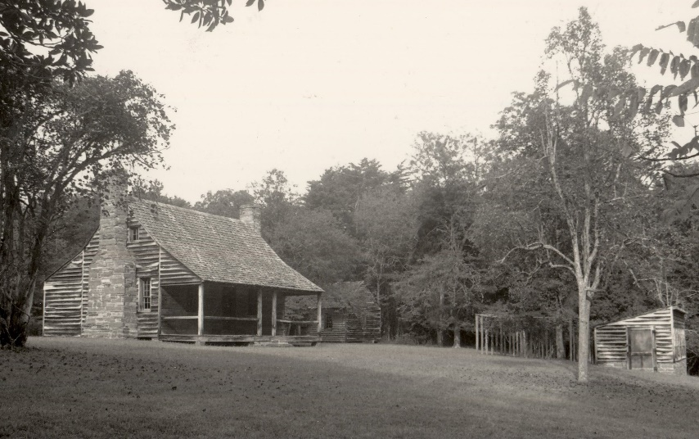

Stanly County Historical Society, Stanly County Museum,

& Morrow Mountain State Park

to present:

**The Kron Family: Life on Attaway Hill**

**By Joyce Lambert**

Sunday, September 20 – 2pm

Morrow Mountain State Park (Follow the signs to the Office)

~After the program tour the Kron homestead with a park ranger~

|  |  |
| --- | --- |
| **SEATING IS LIMITED – Register early!**  **Registration options:**  **1) call the Stanly County Public Library at 704-986-3755**  **2) visit our website http:\\historicstanly.org and click on the Event Registration tab**  **3) scan the QR code with your smartphone to access the online registration form**  **(Be sure to click SUBMIT to complete your registration)** | **C:\Users\Lewis\Documents\D Drive\CURRENT PROJECTS\Stanly County Museum Speaker ideas\QR CODE.JPG** |