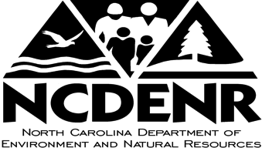

Pat McCrory, Governor John E. Skvarla, III, Secretary



N.C. Department of Environment and Natural Resources

Release: Immediate Contact: Charlie Peek

Date: Phone: 919-218-4622

**Morrow Mountain State Park will conduct prescribed burns**

# **RALEIGH** – The N.C. Division of Parks and Recreation plans to conduct prescribed burns of up to 1,650 acres at Morrow Mountain State Park in Stanly County between late January and the end of February, when conditions are suitable, according to Park Superintendent Greg Schneider.

An initial prescribed burn between Jan. 27 and Feb. 9 will affect visitor facilities including campgrounds, vacation cabins and trails. No reservations for overnight facilities will be accepted for that period. In addition, the park may temporarily close picnic areas, bridle trails, the Hattaway Mountain Trail, Quarry Trail, Laurel Trail, Rocks Trail and portions of the Morrow Mountain Trail.

The low-intensity, prescribed burn will be conducted in cooperation with the North Carolina Forest Service. In order to minimize smoke and assure the fire is controlled, the prescribed burn will only be carried out under strictly defined weather conditions of a fire management plan. On the selected day, the burn will begin in the late morning and will likely end by late afternoon.

Prescribed burns are used as a resource management tool by the state parks system. Some plant communities and animal species rely on periodic fire for their existence. The prescribed burn will also reduce the amount of potential wildfire fuel, which has increased following a 2013 storm that brought down hundreds of trees. The prescribed burn will help protect the park’s resources and neighboring landowners if lightning, arson or carelessness spark a wildfire.

On the day when a prescribed burn is to begin, an alert will be posted on the Morrow Mountain State Park page of the division’s website, [www.ncparks.gov](http://www.ncparks.gov). For further information, call the park office at (704) 982-4402.

###