Round 2
Neal and I weren’t very happy with our first round results and so I don’t think we were in any mood to take any chances in our game.

Neal played a relatively new idea to me in the Sicilian Dragon. I was anticipating Neal would allow me to go into a Chinese Dragon with lots of fire on the board, but it was just not to be. Neal has played some really nice games against Sicilian players, checkout his game against GM Kudrin!

Ok, in our game we reached the following position after seven moves:

1. e4 c5 2.Nf3 Nc6 3.Nc3 g6 4.d4 cxd4 5.Nxd4 Bg7 6.Be3 d6 7.h3

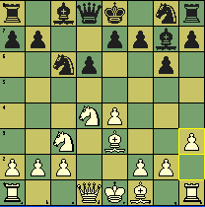

I simply couldn’t recall ever seeing this move. During the game I thought this must be wrong because white needs to break open the h-file quickly. The move does however control the g4 square as would the normal 7.f3.

Ok, as of this writing I haven’t found any information on this move and only about four games played dating back to 1999.

I decided to simply play some normal developing moves in the above position.

7…. Nf6 8.Qd2 0-0 9.0-0-0
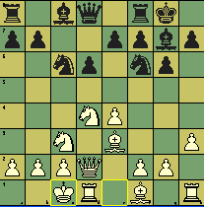
I think I was feeling overly cautious during the game. They say once black gets in d5 all is equal. So, why not play for equality? The game quickly goes through simplification through several exchanges.

9….. d5 10.Nxc6 bxc6 11.exd5 Nxd5 12.Nxc5 cxd5 13.Qxd5

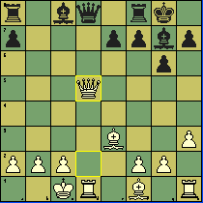

So, now black is down a pawn but all is well. The text move forces a draw but I could have played the known line with 13…. Qc7 and I think the Queen sacrifice; 14.Qxa8 Bf5 15.Qxf8+ Kxf8 would have been interesting. However, I would prefer white.

13….. Rb8

I believe white must trade queens and agree to a forced draw. Maybe you can try something else.
Let me know if you come up with anything.

14. Qxd8 Bxb2+ 15.Kb1 Bd4 Draw agreed

Looking back at this game provokes feelings of disappointment. I am really having a problem with 7.h3. Analyzing the position now and reflecting on the moment of game makes me realize why it is so important to maintain your creativity. What are your thoughts?

Neal showed me some lines in our post game discussion and he does have some interesting ideas behind this move. But I think as they say; “timing is everything” and Neal’s timing was perfect.
I hope Neal and I will revisit this opening again or maybe one you will play this variation.

