Round 3: Simpson vs Jones

Craig and I have played many games over the years and the very interesting thing is that black has won most of the games! I believe the reason for this is that our playing style is very aggressive. We very rarely offer or accept draws from each other and so our chess history was in his favor.

My preparation was dashed in game one against Oliver and my confidence was very low. I felt very out of touch with my creativity and so I was looking to keep the game away from heavy tactics.

1. Nf3 Nf6 2. d4 g6

The memory of the first round game was just too much for me to repeat 3.b3.

3. g3 Bg7 4. Bg2 O-O 5. O-O d6 6. c4 Nbd7 7. Nc3 e5 8. Qc2 c6 9. Rd1

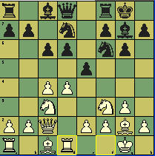
At this point I was happy with my position. The basic idea to bring my rook onto the d-file and add my queen to the protection of the e4 square is common. I believe black usually moves the Rook to e8 with good play and to ward off the threat of dxe4 (my rook is pinning one of the protectors to e5).

9…. Qb6

I felt this move wasn’t right, but it seemed to point out the draw back of my rook move. My f2 square was a little weaker now and his queen is x-raying f2. I was also concerned with the pressure on d4. Black has a queen, e-pawn, and Bishop (x-rayed) on the square. Ok, once I worked out the tactical considerations with his move I felt the drawbacks were in my favor.
Develop, watch for the breaks, and pay attention to key squares were my thoughts.

10. b3 exd4 11. Nxd4 Ng4
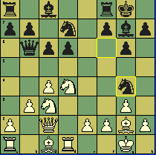
Wow. I internally screamed at myself; “What did I do wrong. How could he attack me without me violating any opening principles?” Ok, I focused on the simple 12.e3 and I felt everything was going to be ok. But I wanted a stronger move. I think the text move allowed me to keep the position flexible and I could exploit the d-pawn, knight on g4, and so on in the future.

12. Na4 Qxd4

I am in shock, my emotions spiked, did I miss something! I don’t think I considered this move. So the obvious point is that I am down a piece and I can only capture the Queen with my rook. You would think my response is a “no brainer”, just capture the Queen and think about it later. But I felt the strong need to reset mentally. I needed to get my thoughts and feeling in order before touching my piece. Here is what I did:
- I wrote down his move.
- I cleared my head of emotion
- I acknowledged my opponent’s courage
- Analyzed every move on the board
- Determined that I must capture the queen.
- Captured the queen.
This process may seem a little ridiculous to many of you. But I have found that whenever I am surprised by a move, I must remove my feelings from the decision process.

--Emotions give birth to bias--

Emotions can and will lead you into false conclusions. The faster you can objectively study the position, the better chance you will have at seeing things clearly.

13. Rxd4 Bxd4

I am now in a very analytical mode and the fact is that I only have a queen for a rook and a knight. I needed to remain in a stoic mind set because this position wasn’t clear. The immediate threat is the attack on my rook and on my f-pawn. I must be very careful because Craig could have unforeseen tactics looming.

14. Bb2 Bxf2+ 15. Kh1 Nde5

All seemed well for me but I must resist the feeling to relax. I wanted to play h3 and force the knight to move. But did I have better? My thoughts focused on the dark squared weaknesses around his King, the knights and the bishop, and his disconnected rooks. The text seemed to fit because it added more pressure to the board.

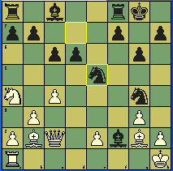

16. c5 b5 17. h3 Ne3 18. Qd2 Nf5 19. cxd6 Be3 20. Qe1

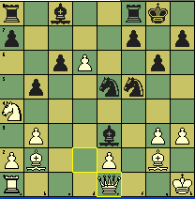

I was happy with my energy and my calculations. The position was shaping up nicely for me.

20…. Re8 21. g4 bxa4 22. gxf5 Bxf5 23. Qg3 Nd7 24. Rf1
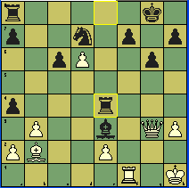

I believe the game is over now. But I still needed to be accurate.

24…. Be4 25. Bxe4 Rxe4

The text move maybe a little difficult for many of you to find because it involved a protected square, but with some focus I think you will agree with it.

26. Rxf7 Kxf7 27. Qf3 Bf4 28. Qxe4 Bg5 29. Qg4 1-0

Sacking a piece or a pawn in a game requires a lot of courage. But when you sack your Queen!
Wow you must have ice cold blood running through your veins.

