Simpson vs Joshua Mu
This was the last round of the invitational and we were all looking forward to going home. The disappointment of playing for a place in the standing as opposed to playing for the championship loomed over me. However, I wanted to finish strong and I was determined to play Joshua very hard.

I had played Joshua in the 2010 LPO, round 3 and he played my favorite variation in the Alekhine’s Defense. I was certainly looking forward to seeing him play this defense again.
The game we played in the LPO led to a position which a very good friend, Willie Johnson “Pop”, played against me for over 15 years. Pop and I must have played over a hundred speed games in that variation. We even met and talked with GM Lev Albert in the Manhattan Chess club on the opening. However Joshua deviated in this game.

1. e4 Nf6 2. e5 Nd5 3. c4 Nb6 4. d4 d6 5. exd6
We are now in the exchange variation of the Alekhine’s defense and in the LPO Joshua captured with the c-pawn.
5. … exd6 6. Nc3 Nc6 7. Be3 Be7 8.Bd3
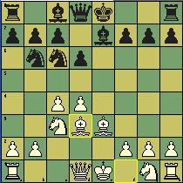
Ok we are now following the game from Hou Yifan-Short,N 2009. I wanted to attack his King side because I believed that in the Alekhine’s defense an inherited weakness is that the King’s Knight is no longer defending the Kingside. This knight has traveled to the b6 square.

8. … Nb4 9. Bb1 O-O 10. b3 Re8 11. h4
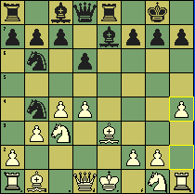
Is the text ambitious or foolish? My thought centered on the idea that his king is without proper defense because his knights are still living on the other side of the board. I believed my king is fine and if required, he will walk over to the g-square. My King’s Rook will become very active on the h-file and my bishops were beautifully placed on the b1-h7 diagonal and on the c1-h6 diagonal.
11. h4 c5 12. Nf3 Bg4 13.a3
I thought he was in trouble because he can’t move his knight without my Bxh7+ blowing up his kingside. E.g.: 13… Nc6 14.Bxh7+ Kxh7 15. Ng5+ Bxg5 16.hxg5+ Kg8 17.Qxg4 and I think white is just better.
13… cxd4
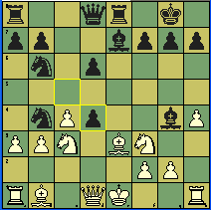

The text is testing me. All of my thoughts are focused on mate. I believe the energy in my position is calling for the attack, but how? I just couldn’t work out the moves.
- Qxd4
- axb4
- Bxh7+
- Bxd4
Well I guess this is what it means to be getting old. I couldn’t resolve the problems. I was getting tired and wanted to mate him. So, Bxd4 seemed to be the easiest move to calculate to a satisfactory position. But now that I look at it I really don’t know why I didn’t play Qxd4.
14. Bxd4 Bf6+ 15. Kf1 Bxf3 16. gxf3 Nc6 17. Bxb6 axb6 18. Qc2 g6 19. Ra2
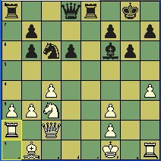
I was feeling pretty good about my position at this point. I had calculated these moves and I was very happy that there were no surprises.
My knight wants to go to d5 and my Bishop wants to go to e4. I think my king is fine and his weak light squares, isolated b and d pawns will hurt him in the end game.
Bxc3 20. Qxc3 d5
I think this was an excellent move because black can’t allow Be4.
21. h5 d4 22. Qd2 d3 23. hxg6 fxg6 24. Bxd3 Ne5 25. Be4 Qxd2 26. Rxd2 Rxa3 27. Kg2 Rxb3
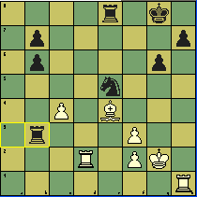
I was very happy that my calculations and judgment were in harmony throughout the game. That’s not to say I played without flaw, it is to say that all the moves up to this point was visualized and my opponent cooperated. Emotionally I was in complete sync and you can just imagine how I felt after the text move Rxb3??
28. Bd5+ Kh8 29. Re2 b5 30. f4 bxc4 31. fxe5 Rb5 32. Bxc4 Rbxe5 33. Rb2 Rg5+ 34. Kf1 Rb8 35. Rb6 Kg7 36. Rh4 Rf5
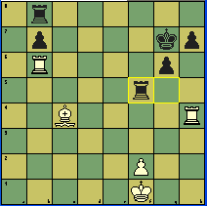
Ok, I am up a piece for two pawns. I was very concerned that I wouldn’t be able to convert this position into a win. I believed if he was able to trade one of the rooks his defense would be easier. So I played not to trade my rooks.
37. Bd3 Rf7 38. Be4 Rbf8 39. Rh2 Rb8 40. f3 Re8 41. Kg2 Ree7 42. Kg3 Re5 43. Rhb2 Rg5+ 44. Kf2 Ra5 45. Bxb7 Rh5 46. Ke3 Rh1 47. Bd5 Re7+ 48. Be4 Re1 49. Kf2 Rh1 50. R2b4 1-0
Joshua Mu will be a force to be reckoned with in the near future. I think he will achieve a master’s title in six months. Neal is doing a fine job with this future Chess Master!

