Getting prepared to play against a top Grand Master in the USCL can be a daunting task, especially when the rating difference is about 250 points and he is one of the top performers in the league’s history.

International Grand Master Boris Gulko has an ELO rating of about 2535, making him the # 25 among active chess players in the US and the 520th-highest rated active player in the world with a peak rating of 2644 in 2000, according to Wikipedia.

I did my normal preparation of collecting and reviewing recent games played by my opponent. Looking for trends, weaknesses, etc… But I soon realized that this type of preparation wasn’t going to give me much of an advantage. What I needed to focus on was improving my ability to play good moves and controlling my history of playing risky & overly aggressive moves. So, the night before the game I watched GM Maurice Ashley’s new DVD; Secret to Chess.

Now Maurice and I are very good friends and the concept behind identifying the weaknesses or flaws in each move is a topic we have conversed over many times. Critiquing moves is something that every chess player does and I would bet that Kotov’s model of determining candidate moves in a “tree of analysis” is the standard. But it wasn’t until I watched the DVD that Maurice’s concept of the “Drawback” inherent in each move began to really make sense. Identifying the “Drawback” is a great way to begin any analysis. Knowing how, when, or even if you should exploit the weakness is another thing. But I can assure you that good moves and ideas will magically appear in your thoughts and your chess performance will improve!

Let’s look at my game against GM Boris Gulko and my interpretation of Maurice’s “Drawback” concept.

The opening played is identified as the Sicilian Kan.
1.e4 c5 2.Nf3 e6 3.d4 cxd4 4.Nxd4 a6 5.Bd3 Bc5 6.Nb3 Be7 7.Nc3 d6 8.a4

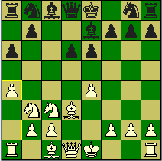

The opening moves and their order are beyond my ability to apply the “Drawback” concept and are best left for the theoreticians to explain. However, I deduced that the “Drawback” to 4….a6 was that it weakened the b6 square. But I wasn’t able to act on my belief until move eight. I believed that the b6 weakness would be inconsequential if back was allowed to play b5. Thus, 8.a4 made sense. Now my move also has the drawback of making the option for me to castle queen side very risky.

The game continued with normal looking moves:
8…b6 9.Be3 Bb7

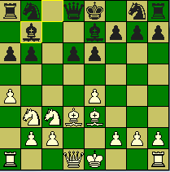

I thought it very interesting that even though the b6 square was now occupied with the b-pawn the square was still weak. But now the Bishop moved away from the c8-h3 diagonal and the g7 square was weakened earlier, so 10.Qg4 seemed to be the move to play. Basically the “Drawback” in the moves was guiding me along. This isn’t to say that I was void of going through the analysis of the moves and their consequences. In fact I used my time accordingly, but I spent much of it trying to verify my observations instead of just gathering information based on the “tree of analysis” model.

10…. Bf6 surprised me in that I just didn’t believe the Bishop belonged on that square.
The “Drawback” behind Bf6 was that the d6 pawn appeared very weak and moves eleven to thirteen were based on the weak d6 square.

10.Qg4 Bf6 11.Rd1 Nd7 12.Qg3 Qc7 13.0-0 Ne7

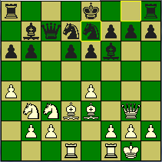

The above position was very difficult for me because my natural inclination was to play 14.Bb5 and let the complications begin. I spent much of my time working out the details to this move and my emotions were building. I was becoming frustrated in fighting with my intuitive compulsion to play with abandonment. I eventually settled down emotionally and the accumulative information I acquired from looking at the drawbacks in each move compelled me to play 14. Bf4. This move doesn’t look so difficult now. But during the game it was one of the hardest moves for me to find. The game continued with the natural move of Ne5 and my Bb5 works moves works nicely.

14.Bf4 Ne5 15.Bb5+
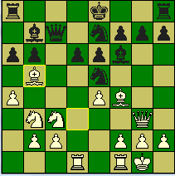

Black simply played 15…N7c6 and again my inclination was to continue with aggressive moves like 16.Nd4. But this time my thoughts weren’t supported with much emotion and regrouping my Bishops seemed best. The drawback with the Knight moves were that now they are stepping on each other and their scope is limited.

15…N7c6 16.Be2 0-0 17.Rd2 Rac8 18.Rfd1 Rfd8 19.Be3 Nb4 20.f4 Nd7
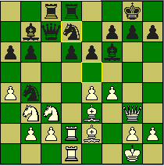

The above position was another difficult position for me. I wanted to do something against his Kingside. My thoughts centered on transferring my knight on b3 to f3 via d4.
Again I was getting rapped up in what I wanted to do and not focusing on the drawbacks in the position. So, why not take the d-pawn?

21.Rxd6 Nxc2 22.Bf2 Nb4 23.e5 Be7 24.R6d2 Nc5 25.Nd4 Ne4
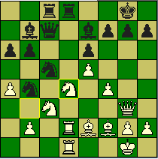

The clock was now becoming an issue and I believe we were both feeling the pressure.

26.Nxe4 Bxe4 27.Qe3 Bb7 28.f5 Bd5 29.Qg3 Kh8 30.Bg4 Bg5 31.Be3 Bxe3+ 32.Qxe3
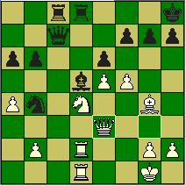

We moved fairly quickly from move twenty-six on. The above position is very difficult to play and when under time pressure even more difficult.
32…exf5 33.Nxf5 h5 34.Qg5 Qxe5 35.Qxh5+ Kg8 36.Nh6+ Black resigns 1-0

In all this was a wonderful game for me and I am truly grateful to have won. I believe Maurice is really onto something wonderful and I can’t wait to apply his “Drawback” concept again and again. I have been playing tournament chess for about thirty seven years and I reached a peak rating of 2427 USCF by using many conventional methods. I am very excited with this “Drawback” concept and I encourage all serious chess players to add this DVD to your study material. Believe me you will see an improvement in your chess performance.

