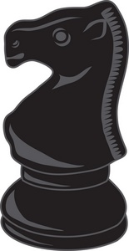

I-95/ROCKY MOUNT AREA CHESS QUAD I
RACQ I
SATURDAY, SEPTEMBER 25, 2010

- MUST BE USCF MEMBER
- ALL PAIRINGS WILL BE DONE IN QUADS ACCORDING TO RATINGS
- IF NECESSARY, THE BOTTOM GROUP WILL BE A HEX
- THREE ROUNDS OF GAME/50
- EVERYONE TO REGISTER BY 9:00 A.M.
- GAME TIMES OF 9:30 AM, 11:30 AM, AND 1:30 PM
- NO REQUESTED BYE FOR LAST ROUND
- ENTRY FEE OF $10
- FIRST PLACE IN EACH QUAD $20, SECOND PLACE $10
- TROPHIES OPTION AVAILABLE FOR THOSE DESIRING TROPHIES

LOCATION: CHURCH ON THE RISE, 3520 BISHOP ROAD, ROCKY MT, NC
(NEAR THE DUNN CENTER AND NORTH CAROLINA WESLEYAN COLLEGE)
ROCKY MT. INTERSTATE 95 EXITS: 138, 141, OR 145

CONTACTS: GORDAN RAY (252-243-7252), JEFF FUSSELL (252-446-5895), EVAN WHITTINGTON (252-336-3635)

LET’S PLAY SOME CHESS, “RACQ” EM UP!

