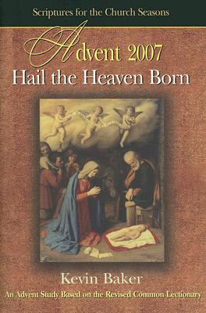

Beginning in December

Hail the Heaven Born is the 2007 Advent study based upon the Revised Common Lectionary texts. During the advent season, the scriptures call us to “prepare the way” of the Lord. All three of the synoptic gospels have John the Baptist announcing a highway by quoting these words from the prophet Isaiah. John the Baptist announced more than a highway, however. He announced a coming Messiah.

The introduction to this Advent study tells about a man’s reaction to a new highway being built in the small community. “It is going to change everything…life as we know it will never be the same.” The question for this community was how to prepare for the changes that the highway would bring. What changes can we expect in our lives as a result of preparing the way of the Lord? How do we prepare the way of the Lord?

Kevin Baker invites us to look at the sights and sounds of the advent season as signposts leading to a deeper reflection on these questions. As we “prepare the way of the Lord,” life as we know it may never be the same. We can discover renewed hope in the power and presence of God in Jesus Christ.

Contents
Introduction
Traveling Backwards Toward Bethlehem (Isaiah 2:1-5; Romans 13:11-14; Matthew 24:36-44)
O Christmas Tree, O Christmas Tree (Isaiah 11:1-10; Romans 15:4-13; Matthew 3:1-12)
Do You See What I See? (Isaiah 35:1-10; James 5:7-10; Matthew 11:2-11)
The Depths of Deity (Isaiah 7:10-16; Romans 1:1-7; Matthew 1:18-25)
God and Sinners Reconciled (Isaiah 9:2-7; Titus 2:11-14; Luke 2:1-20)

KEVIN BAKER senior pastor of Reconciliation United Methodist Church in Durham, N.C. He was one of the two founding pastors (one Anglo and the other African American) appointed to start this multicultural, multiracial congregation that is currently made up of Anglos, African Americans, Latinos, Native Americans, Africans, and others, with a total of 10 nationalities represented. Kevin has written for the Daily Bible Studies, The Christian Century, and was a former columnist for the North Carolina Christian Advocate.

Beginning in January

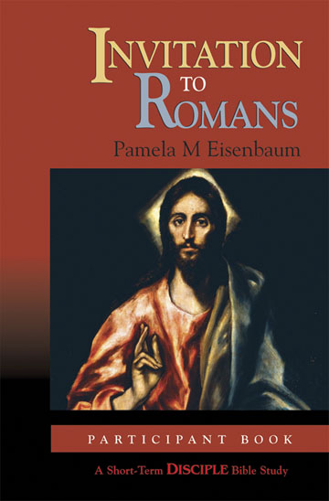

Sessions:
1. An Orientation to Romans
2. The Righteousness of God and the Faith of Jesus
3. Abraham, Father of All
4. Christ, the New Adam
5. Sin, Law, and Grace
6. Divine Purpose and Human Responsibility
7. The Salvation of Israel and the Nations
8. Love and Humility Are the Making of God's Kingdom

