CHRISTMAS EVE SERVICE
LESSONS & CAROLS
CANDLELIGHT COMMUNION

PRELUDE
CHIMING OF THE HOURS

GREETING: L: Merry Christmas!
P: MERRY CHRISTMAS!

PRAYER FOR THE HOLY SPIRIT

OPENING HYMN: #246 JOY TO THE WORLD

Lighting of the Christ Candle:
L: John 1.14: “The Word became flesh and made his dwelling among us. We have seen his glory, the glory of the one and only Son, who came from the Father, full of grace and truth.”
P: We light this candle as a symbol of Jesus Christ, the Word of God, the one and only Son of God, Emmanuel, God with us!

FIRST LESSON: God promises Abraham that by his descendants all the nations of the earth shall be blessed:
Genesis 22.15-18
CAROL: #707 Hymn of Promise, verse 1

SECOND LESSON: The king is coming and will usher in a reign of justice for the poor and peace for all of God’s creation:
Isaiah 11:1-4
CAROL: #211 O Come, O Come, Emmanuel, verses 1, 2, 4

THIRD LESSON: The angel Gabriel announces to the Virgin Mary that she will give birth to God's promised Son whose kingdom shall never end.
Luke 1:26 –35, 38
CAROL: #218: It Came Upon a Midnight Clear, verses 1, 4

FOURTH LESSON: Against a backdrop of emperors and taxes, Jesus is born.
Luke 2.1-7
CAROL: 230 O Little Town of Bethlehem, verses 1, 2, 4
FIFTH LESSON: The shepherds go to see the Savior of the world, lying in a manger.
Luke 2:8 –16
CAROL: 251 Go Tell it on the Mountain

SIXTH LESSON: The wise men follow a star to find the child Jesus, the King of the Jews.
Matthew 2:1 –11
CAROL: 254 We Three Kings 1-4

SEVENTH LESSON: John unfolds the great mystery of the Incarnation.
John 1:1 –14

SPECIAL MUSIC

SERVICE OF HOLY COMMUNION

LIGHTING OF THE CANDLES
HYMN: 239 Silent Night verse 1
BENEDICTION
POSTLUDE

Serving Today

Ushers: Tump Mills, David Mills
Acolytes: Jasmine Benson
Sound: Spencer Peele
Piano: Patty McCormick Organ: Lois Ray
Pastor: Lanny Lancaster

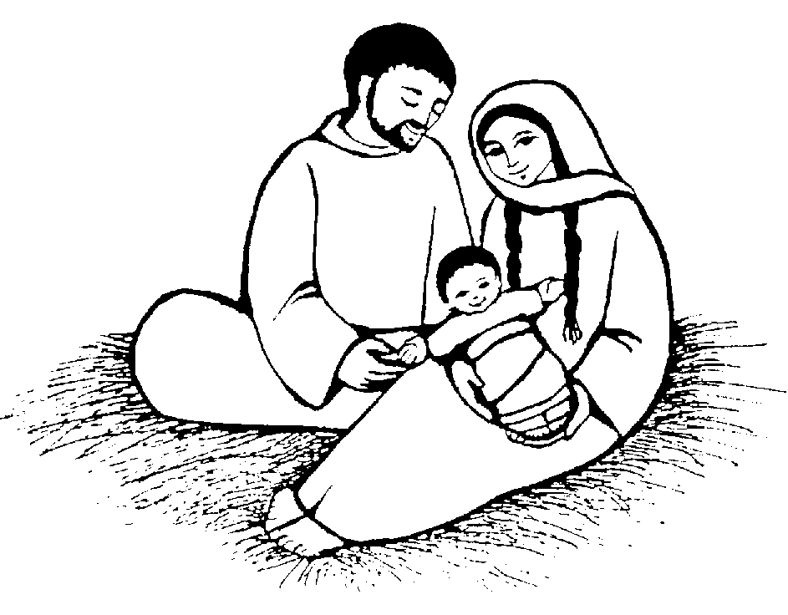

CHRISTMAS EVE SERVICE

LESSONS AND CAROLS
AND
CANDLELIGHT COMMUNION

DECEMBER 24, 2010

