**\*\*\*Special Welcome to our Guests! There is a place for you at Stony Hill! Please register on the fellowship pads on the inside aisle of each pew\*\*\***

**STONY HILL UNITED METHODIST CHURCH**

**28996 Stony Hill Rd. Albemarle, NC 28001 Phone: 704.982.7211**

**Pastor: “Lanny” Lancaster Ministers: The Whole Congregation**

**April 9, 2017 Palm Sunday**

Prelude and Lighting of the Candles

Christian Greeting: L: The Lord be with you! **P: And Also with You!**

Announcements and Passing of the Pew Pads

Palm Sunday Reading: Matthew 21.1-11

Prayer for the Holy Spirit

Procession with Palms

Hymn of Praise: 89 Joyful, Joyful We Adore Thee

The Mission of Stony Hill United Methodist Church is to: **FOLLOW JESUS, MAKE DISCIPLES, AND TRANSFORM THE WORLD.**

Psalm Reading: #764 Psalm 31 8:45: Bonnie Russell 10:45: Gay Nell Burris

Children’s Story

Morning Prayer & The Lord’s Prayer, #895

**Stewardship Scripture: 2CORINTHIANS 8.2-3a: “**In the midst of a very severe trial, their overflowing joy and their extreme poverty welled up in rich generosity. For I testify that they gave as much as they were able, and even beyond their ability.”

Worship with Our Tithes & Offerings

*Doxology 95 Praise God from Whom All Blessings Flow

Choir Anthem

Scripture: **Matthew 27.32-54**

Sermon: **“*The Crucified Christ”***

Hymn: 452 My Faith Looks Up to Thee

Benediction

Postlude

Greeter: 10:45 Kay Pope, Bonnie Ward Sound: Lee Smith

Ushers: 8:45 Dink Hathcock, Jack McRae Projection:

10:45: Dean Springer, Dewell Cook Piano: Sid Fields

Counters: Stephen Eudy, Jill Almond Organ: Elaine Crawley

Pastor: Michael “Lanny” Lancaster

Acolytes: 10:45 Gauge Eudy, Natalia Arita Assisted by: Bonnie Ward

**\*Jesus & Java Host for April:** 2–Bruce & Wanda Smith

9-Jim & Gayle Humphrey 16- Easter 23-Sid & Margaret Fields

30-Henry & Bonnie Springer

**Food Collection for April: Canned fruit**

**Every Week at Stony Hill**

**“The Connection”** Sundays: 8:45am: Worship Service with Modern worship music and traditional hymns with praise band, “generations” **Jesus and Java** 9:30am: coffee time, Fellowship Hall 9:45am: Sunday School for all ages **“Traditions”** 10:45am: Worship Service with traditional hymns and the Stony Hill Choir

5:00pm (during school year): Youth Group meeting

Wednesdays: 7:00pm: Choir

**Prayer Concerns:** Our State and Nation, Community Schools, The United Methodist Church, Tani Kepp, Bonnie Springer, Angie Peele, Aaron Ash, Bryan Starnes, Joe Mills, Nyoka Myers, Buck Thompson family, Jahala Burris family, Donald Shaver, “Sprinky” Burris Family, Edith Matheney, Ophelia Riggins, Lauren Gift, Mary Ellen Aldridge, Frank Sanders, Melissa Crisco, Jacob Kime, Valerie Putnam, Annette Steed family, Dorthina Samples, Billy Miller, Kenneth and Barbara Stoker, Theresa Henderson and family, Laura McIntyre, Ophelia Blalock, Sonia Simmons, Bryan Booth, Ned Stallings, Gerald Janey and family, Trent Bowers, Elaine Crawley, Victoria Hutchins, Bobby Clodfelter, UMAR, Andria Bell, Lin Senter, Tony Furr, Stella Senter, Pastor Lanny, Janet and family

Shut-ins: Wayne Mauldin, Ron & Loretta Allred, Gene Helms, Ruby Murray, Carolyn Terry, Gene Watkins

**\*\*\*If you have a prayer concern that you would like added or deleted from the list, please call or email Pastor Lanny at the parsonage or church office**

**Announcements**

**\*Food Challenge:** Last month, Stony Hill collected 38 pounds of food for help with the hungry in our community through Stanly Community Christian Ministries. The challenge for this month is 100 pounds. Please consider bringing five containers of the food of the month. Jesus said that when we feed the least of these, his brothers and sisters, we feed him!

**HOLY WEEK**

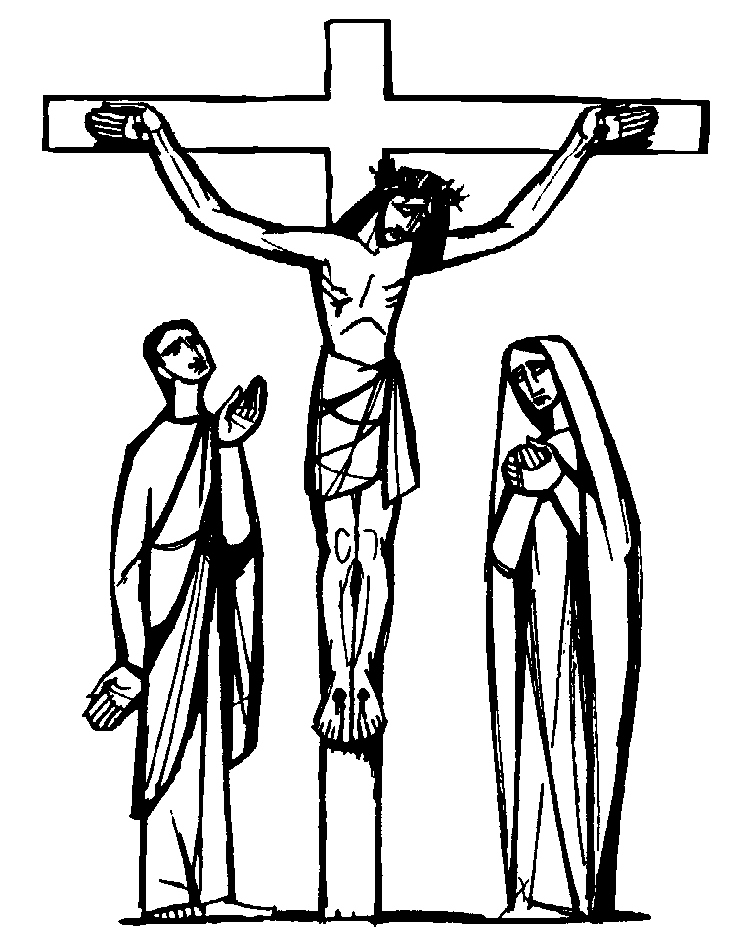*HOLY THURSDAY: APRIL 13: UPPER ROOM COMMUNION AT 8PM, COMMUNITY MEAL AT 6:30PM

*GOOD FRIDAY: APRIL 14: HANDS-ON STATIONS OF THE CROSS PRAYER EXPERIENCE AT 8PM, COMMUNITY MEAL AT 6:30PM

*HOLY SATURDAY: APRIL 15: EASTER EGG HUNT AT 2PM



*EASTER SUNDAY: APRIL 16: SUNRISE SERVICE AT 7AM FOLLOWED BY COMMUNITY BREAKFAST AT 7:30AM, MUSICAL CELEBRATION OF THE RESURRECTION AT 9AM

**“Transform the World”** at Badin School:

**\*Reading Buddies** / assisting teachers. If you would like to volunteer to be a reading or math buddy or assist teachers at Badin, volunteer forms are available. A background check is required.

**\*Check out** our church website: [www.stonyhillumc.org](http://www.stonyhillumc.org) , like us on Facebook, and follow us on Twitter! Check them for upcoming worship experiences and activities at the Church!

**\*Did you know** that you could set up an electronic payment or bank draft to manage your giving to the church? For more information, contact your bank.