**\*\*\*Special Welcome to our Guests! There is a place for you at Stony Hill! Please register on the fellowship pads on the inside aisle of each pew\*\*\***

**STONY HILL UNITED METHODIST CHURCH**

**28996 Stony Hill Rd. Albemarle, NC 28001 Phone: 704.982.7211**

**Pastor: “Lanny” Lancaster Ministers: The Whole Congregation**

**July 2, 2017 Fourth Sunday after Pentecost**

Prelude and Lighting of the Candles

Choral Call to Worship

Christian Greeting: L: The Lord be with you! **P: And also with you!**

Announcements and Passing of the Pew Pads

Prayer for the Holy Spirit

Hymn of Praise: 717 Battle Hymn of the Republic

The Mission of Stony Hill United Methodist Church is to: **FOLLOW JESUS, MAKE DISCIPLES, AND TRANSFORM THE WORLD.**

Psalm Reading: #746 Psalm 13 8:45: Drinda Hathcock 10:45: Barbara Stoker

Children’s Story

**Morning Prayer &** The Lord’s Prayer, #895

**Stewardship Scripture: 1CHRONICLES 29.14: “**But who am I, and who are my people, that we should be able to give as generously as this? Everything comes from you, and we have given you only what comes from your hand.”

Worship with Our Tithes & Offerings

*Doxology 95 Praise God from Whom All Blessings Flow

Choir Anthem

Scripture & Sermon

Hymn: 696 America the Beautiful

Benediction

Postlude

Greeter: 10:45 Bernice Whitley, Nina Lowder Sound: Richard Wood

Ushers: 8:45 Jack McRae, Larry Kirk Projection:

10:45: David Mills, Tump Mills Piano: Sid Fields

Counters: Jill Almond, Stephen Eudy Organ: Elaine Crawley

Pastor: Michael “Lanny” Lancaster

Acolytes: 10:45 Gauge Eudy, Natalia Arita Assisted by: Bonnie Ward

**\*Jesus & Java Host for July:** 2-Bobby & Kathy Johnson 9-Lee & Christine Smith

16-David & Pat Mills 23-Charles & Karen Herlocker 30-Dink & Drinda Hathcock

**Food Collection for July: Macaroni & Cheese/Rice/Pasta**

**Every Week at Stony Hill**

**“The Connection”** Sundays: 8:45am: Worship Service with Modern worship music and traditional hymns with praise band, “generations” **Jesus and Java** 9:30am: coffee time, Fellowship Hall 9:45am: Sunday School for all ages **“Traditions”** 10:45am: Worship Service with traditional hymns and the Stony Hill Choir

5:00pm (during school year): Youth Group meeting

Wednesdays: 7:00pm: Choir

**Prayer Concerns:** Our State and Nation, Community Schools, The United Methodist Church, Ruby Murray family, Dewel Cook, Helen Giduz, Josh Holt, Jacob Lancaster, T.L. Troutman, Gary Wagoner, Tani Kepp, Betty Measmer family, Aaron Ash, Bryan Starnes, Joe Mills, Nyoka Myers, Buck Thompson family, Jahala Burris family, Donald Shaver, “Sprinky” Burris Family, Edith Matheney, Ophelia Riggins, Lauren Gift, Frank Sanders, Melissa Crisco, Jacob Kime, Valerie Putnam, Annette Steed family, Dorthina Samples, Billy Miller, Kenneth and Barbara Stoker, Theresa Henderson and family, Laura McIntyre, Ophelia Blalock, Sonia Simmons, Bryan Booth, Ned Stallings, Gerald Janey and family, Trent Bowers, Elaine Crawley, Victoria Hutchins, Bobby Clodfelter, UMAR, Andria Bell, Lin Senter, Tony Furr, Stella Senter, Ellen Lancaster, Pastor Lanny, Janet

Shut-ins: Mary Ellen Aldridge, Wayne Mauldin, Ron & Loretta Allred, Gene Helms, Ruby Murray, Carolyn Terry, Gene Watkins

**\*\*\*If you have a prayer concern that you would like added or deleted from the list, please call or email Pastor Lanny at the parsonage or church office**

**Announcements**

**HAPPY BIRTHDAY TO THE UNITED STATES OF AMERICA! PRAISE GOD FOR OUR FREEDOM AND MANY BLESSINGS!**

**Special Thanks to those leading the services today!**

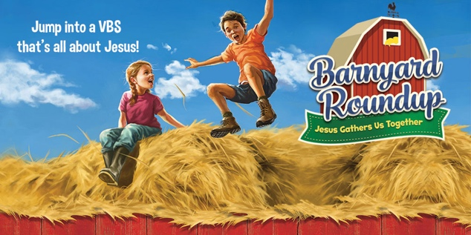**\*Save the Date!**

**And pray for Vacation Bible School:**

**July 23-July 27**

**\*Council Meeting** July 10 at 7pm

**“Transform the World”** at Badin School:

**\*Reading Buddies** / assisting teachers. If you would like to volunteer to be a reading or math buddy or assist teachers at Badin, volunteer forms are available. A background check is required.

**\*Check out** our church website: [www.stonyhillumc.org](http://www.stonyhillumc.org) , like us on Facebook, and follow us on Twitter! Check them for upcoming worship experiences and activities at the Church!

**\*Did you know** that you could set up an electronic payment or bank draft to manage your giving to the church? For more information, contact your bank.