**\*\*\*Special Welcome to our Guests! There is a place for you at Stony Hill! Please register on the fellowship pads on the inside aisle of each pew\*\*\***

**STONY HILL UNITED METHODIST CHURCH**

**28996 Stony Hill Rd. Albemarle, NC 28001 Phone: 704.982.7211**

**Pastor: “Lanny” Lancaster Ministers: The Whole Congregation**

**July 23, 2017 Seventh Sunday after Pentecost**

Prelude and Lighting of the Candles

Choral Call to Worship

Christian Greeting: L: The Lord be with you! **P: And also with you!**

Announcements and Passing of the Pew Pads

Prayer for the Holy Spirit

Hymn of Praise: 733 Come We that Love the Lord

The Mission of Stony Hill United Methodist Church is to: **FOLLOW JESUS, MAKE DISCIPLES, AND TRANSFORM THE WORLD.**

Psalm Reading: #854 Psalm 139 8:45: Bonnie Russell 10:45: John Henderson

Children’s Story

**Morning Prayer &** The Lord’s Prayer, #895

**Stewardship Scripture: MATTHEW 6.19-21: “**"Do not store up for yourselves treasures on earth, where moth and rust destroy, and where thieves break in and steal. But store up for yourselves treasures in heaven, where moth and rust do not destroy, and where thieves do not break in and steal. For where your treasure is, there your heart will be also.”

Worship with Our Tithes & Offerings

*Doxology 95 Praise God from Whom All Blessings Flow

Choir Anthem

Scripture: Psalm 23

Sermon: ***Do you need a shepherd?***

Hymn: 467 Trust and Obey

Benediction

Postlude

Greeters: 10:45 Jim & Gail Humphrey Sound: Lee Smith

Ushers: 8:45 Joe Ingram, Bob Scholl Projection:

10:45: Jim Humphrey, Bruce Smith Piano: Sid Fields

Counters: Dean Springer, Kathy Johnson Organ: Elaine Crawley

Pastor: Michael “Lanny” Lancaster

Acolytes: 10:45 Caleb Lemons, Gauge Eudy Assisted by: Bonnie Ward

**\*Jesus & Java Host for July:** 2-Bobby & Kathy Johnson 9-Lee & Christine Smith

16-David & Pat Mills 23-Charles & Karen Herlocker 30-Dink & Drinda Hathcock

**Food Collection for July: Macaroni & Cheese/Rice/Pasta**

**Every Week at Stony Hill**

**“The Connection”** Sundays: 8:45am: Worship Service with Modern worship music and traditional hymns with praise band, “generations” **Jesus and Java** 9:30am: coffee time, Fellowship Hall 9:45am: Sunday School for all ages **“Traditions”** 10:45am: Worship Service with traditional hymns and the Stony Hill Choir

5:00pm (during school year): Youth Group meeting

Wednesdays: 7:00pm: Choir

**Prayer Concerns:** Our State and Nation, Community Schools, The United Methodist Church, Bobby Mills, Ruby Murray family, Dewel Cook, Josh Holt, Jacob Lancaster, Tani Kepp, Aaron Ash, Bryan Starnes, Joe Mills, Nyoka Myers, Buck Thompson family, Jahala Burris family, Donald Shaver, “Sprinky” Burris Family, Edith Matheney, Ophelia Riggins, Lauren Gift, Frank Sanders, Melissa Crisco, Jacob Kime, Dorthina Samples, Billy Miller, Kenneth and Barbara Stoker, Theresa Henderson and family, Laura McIntyre, Ophelia Blalock, Sonia Simmons, Bryan Booth, Ned Stallings, Gerald Janey and family, Trent Bowers, Elaine Crawley, Victoria Hutchins, Bobby Clodfelter, UMAR, Andria Bell, Lin Senter, Tony Furr, Stella Senter, Pastor Lanny, Janet and family

Shut-ins: Mary Ellen Aldridge, Wayne Mauldin, Ron & Loretta Allred, Gene Helms, Ruby Murray, Carolyn Terry, Gene Watkins

**\*\*\*If you have a prayer concern that you would like added or deleted from the list, please call or email Pastor Lanny at the parsonage or church office**

**Announcements**

**\*Soul Food:** worship and food outreach ministry: Monday, July 31 at 6pm at First St. United Methodist Church. For more information, please contact Pat Mills

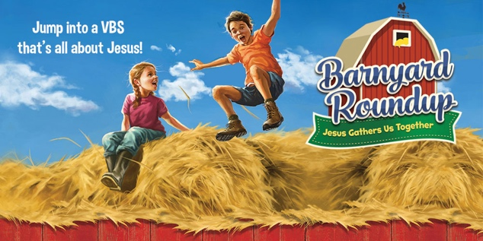**\*Vacation Bible School!**

**Pray for the mission to make disciples, for the children and leaders**

**TONIGHT AT 5PM-7PM!!!**

**MONDAY-THURSDAY FROM 5:30PM-8PM**

**\*Homecoming, CELEBRATING 213 YEARS OF FOLLOWING JESUS, MAKING DISCIPLES, AND TRANSFORMING THE WORLD! Sunday, Aug. 6:** welcoming Rev. Laura Auten, District Superintendent of the Uwharrie District, who will be preaching at 8:45am and 10:45am, covered dish luncheon following, seating will be available inside and outside (weather permitting)

**“Transform the World”** at Badin School:

**\*Reading Buddies** / assisting teachers. If you would like to volunteer to be a reading or math buddy or assist teachers at Badin, volunteer forms are available. A background check is required.

**\*Check out** our church website: [www.stonyhillumc.org](http://www.stonyhillumc.org) , like us on Facebook, and follow us on Twitter! Check them for upcoming worship experiences and activities at the Church!

**\*Did you know** that you could set up an electronic payment or bank draft to manage your giving to the church? For more information, contact your bank.

**\*The Sunshine Group** will meet Tuesday, July 25, 10:30 AM in the fellowship hall of Badin Baptist Church.   A musical program by the Golden Strings will be presented by Cecil Almond, on guitar, Ellen Almond Smith and Martha O'Neill, on violins.  Bring your favorite covered dishes, $1.00, a guest, and of course, yourself, for a time of good fellowship and wonderful food.